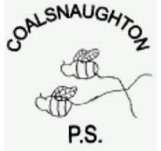 Coalsnaughton Primary School

Pupil Equity Funding Update
June 2020
For a few years now the Scottish Government has allocated special funding for all schools in Scotland called Pupil Equity Funding (PEF).
What is the Pupil Equity Fund (PEF)?
Pupil Equity Funding is money that the school receives to help us provide the best possible opportunities for children’s learning. In particular, it is there to help the school support children who experience barriers to learning and who might be falling behind or not getting the same chances in their education because their family is experiencing poverty or other financial difficulties. This money is given to schools as part of the Scottish Government’s Scottish Attainment Challenge.
This newsletter will provide you with information about how we used this funding to support our children this session. We have met with a fair few challenges. Staff absence, recruitment, Covid restrictions, protocols, risk assessments and a second period of lockdown! However, we have managed to achieve some great things.
How much money did Coalsnaughton receive this session?
We received £35,281. For every child that was registered for a free school meal, the school received £1,200 in addition to our normal budget. That is why it is so important that although your child receives a free school meal P1-3 (and in August P4 will start to receive one too) that you fill in the paperwork and apply for free school meals officially.
If you think you may be eligible then complete the form online https://www.clacks.gov.uk/learning/freeschoolmeals/
If you are eligible you will be entitled to put your child into the breakfast club for free, will get a clothing grant payment of £100 and you will receive a payment of £100 for free meals both at Christmas and Easter holidays and if your child is unable to attend school any time next year due to Covid related absences then you would get a payment of £23 per fortnight they were absent!
How was this money used in Coalsnaughton this session?
National guidance was provided to help us plan how we could effectively invest our Pupil Equity Funding to improve educational outcomes for our learners.The funding was used to address the attainment gap. Through the consultation process and data gathering within the school last session we identified specific areas to be targeted in order to support our children who are affected by deprivation/barriers.
The areas identified were:
- Early intervention and effective transitions from Nursery to P1.
- Targeted Support for Learning interventions for Numeracy, Literacy and Health & Wellbeing.
- Specific children identified as requiring additional support for social and emotional needs.
- Access to and use of Digital Technology.

The areas identified above were targeted through specific interventions:

- We have worked with Speech Therapy colleagues and have implemented LIFT and TALK Clacks Language programmes N-P3. Providing resources where necessary and working hard to revisit our Bronze Communication Award and start work towards our Silver Communication Award.
- A Learning Assistant was appointed 3 days a week to enhance the existing support team to support Literacy and Numeracy throughout the school.
- Resources were purchased to support specific groups. These children were identified through our tracking meetings and data.
- A Class Teacher was appointed to Acting Principal Teacher. This role involved supporting the Digital Literacy Strategy and sharing good practice throughout the school. The Acting Principal Teacher has also successfully supported our Probationer Teacher.
- We are lucky to have a trained Counsellor from Wellbeing Scotland, Margo Campbell, one day per week. Margo works with our children who have been identified as requiring additional support for social and emotional reasons. This was funded by the Scottish Attainment Challenge and the school has set aside money from the PEF to develop a ‘Nurture’ space for Margo and the children to work in.
- Our Senior Early Years Worker, Mrs Laura MacMillan has worked closely with the P1 teacher Mrs Meaghan Watt in order to support effective transition into P1. We have purchased resources to support a Transition Project N-P1.
- Our Early Intervention Team Worker, Mrs Karen Smith, has been funded by the Scottish Attainment Challenge. We have used the PEF money to purchase resources to support individuals and groups.
- We have developed our library and have funded a Coalsnaughton Reading Spine.
- A new shed was funded and after consultation with the children and Loose Parts Play resources were purchased.
- Resources for Outdoor Learning e.g. books, tools etc.
- All our Pupil Equity Pupils P3-7 have access to a laptop or Chromebook for remote learning and homework.
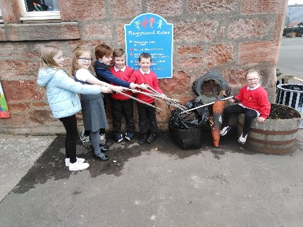
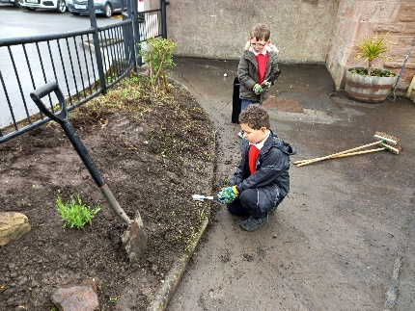
The Litter Picking Crew Members of the Gardening Group
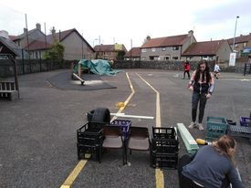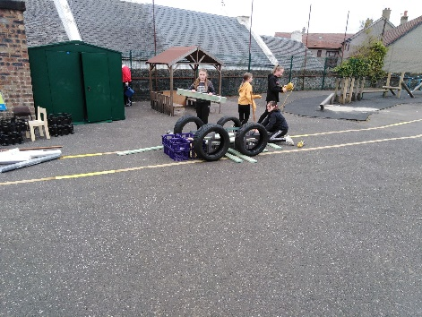
Loose Parts in Action!

We are committed to ensuring the best possible outcomes for all our children and in doing so we need to ensure strong partnerships with you our parents.
We have been allocated £32, 286.00 with an additional top up of £5,293.00. That equates to 40,579.00.
After discussion with the children:
- We will appoint a 25 hour replacement for Mrs Monk who has resigned. (This is an increase from 16 hours.) We will extend the Principal Teacher post until June 2022. The children feel that 1-1 and group work support helps them with their learning.
- The children would like more ‘Loose Parts Play’ resources to develop their thinking skills, problem-solving skills and creativity.
- Staff will be trained in Emotion Works and this will help support the Health & Wellbeing of our children. Emotion Work resources will be purchased to support the implementation of the Emotion Works programme.
- The children want to continue to develop their outdoor space and would like the gardening group to continue.
- We will continue with our Library Development.
- Writing will be a focus and writing journals and resources will be purchased,
- Online Learning Journals will be purchased P1-P7 to strengthen pupil assessment and enhance parental engagement in learning.
We would welcome any comments or thoughts! Is there anything that you feel we could do to improve pupil experience and help support the learning of our children? If you have any questions relating to the information provided in this newsletter please do not hesitate to contact me. Further information is available on the Education Scotland website. http://www.gov.scot/Topics/Education/Schools/Raisingeducationalattainment/pupilequityfund
Kind Regards
Colleen
Colleen ClarkBurns (Headteacher)

