Coalsnaughton Primary School
Primary 1
Provisional Enrolment Form 2021/22
Due to on-going COVID-19 restrictions, enrolment procedures will look different this year. To ensure we reduce the risks of community infection we have devised this provisional enrolment form. We are strongly encouraging digital completion of this form. Please use the link below to access the form.

Provisional enrolment deadline is 29 January 2021.
https://forms.office.com/Pages/ResponsePage.aspx?id=oyzTzM4Wj0KVQTctawUZKYyjSveZJ6RAlHWTuhB_qzdUMk5TWk5XUE81MVBBRkFFQUlLOU5ONFNWMS4u
OR
use the QR Code
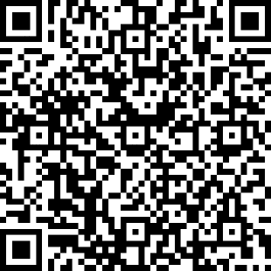
If you have any questions or require a paper copy, or would like the link for the form sent to you, you can email the school office directly using coalsnaughton@edu.clacks.gov.uk, email the Headteacher using clcclarkburns@glow.sch.uk or call on 01259 452204. (If no answer leave a message and we will return your call.
I look forward to hearing from you.
Colleen ClarkBurns (Headteacher)

