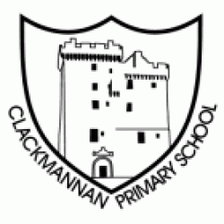

Standards and Quality Report 2025-26
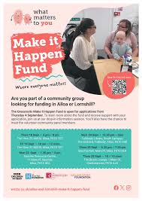

Clackmannan Primary School and ELC

Bronze Rights Respecting Schools Award Make it Happen Fund- £500 grant x 2


Make £5 grow- Enterprise Project £2000 Virgin Money Digital Technologies Grant
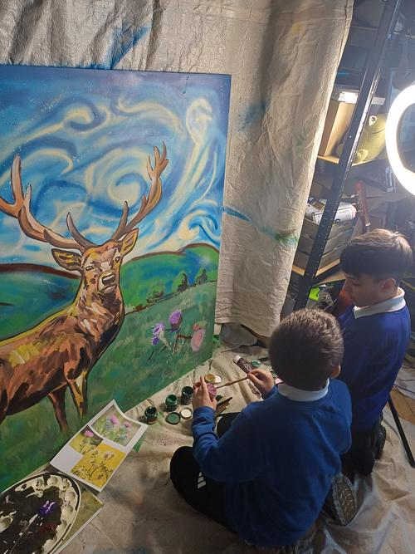
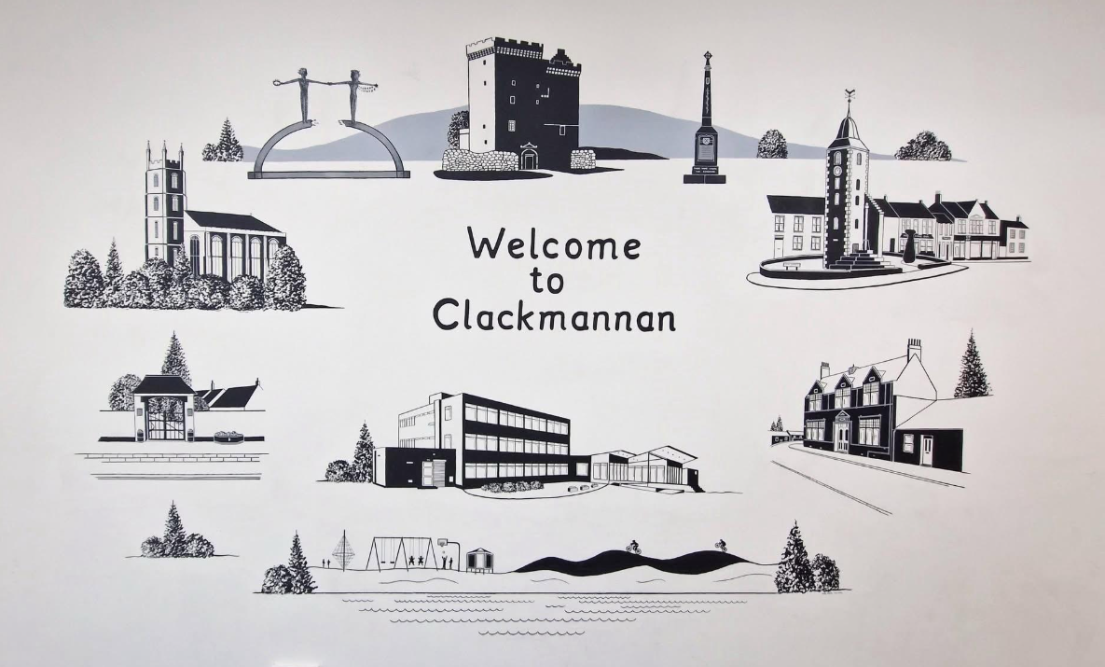

Clackmannan Ladz Project with Kyle Blain Bobby Rennie Mural
Section B1 - School Context
Clackmannan Primary School has a current roll of 184 learners with eight primary classes and an ELC which is a mixed provision of 47 two year olds, pre pre and preschool children in full day sessions. We have a flexible learning space to support learners with significant additional support needs, named Thistle, and a nurture space in school, named Bluebell.

71% of learners reside in Quintile 1 and a further 11.4% live in Quintile 2. 17% of learners live in Q4 & 5. 46% of learners have Additional Support Needs and are supported through Staged Intervention processes. This is an increase of 21% in 6 years. 35% of learners are in receipt of FME, which is an increase of 12% in the last three sessions. A few learners are care experienced.

School Improvement Planning has reflected national and local priorities in the policy contexts of the Scottish Equity Fund, Pupil Equity Funding, the National Improvement Framework and Education Scotland policy and guidance.

How do we gather evidence?

The following pages of this report provide a summary of the progress we have made in each priority and evidenced by a triangulated evidence approach of direct observation, people’s views and quantitative data.

● Direct Observations
● Learning conversations with children and annual pupil survey
● Data from identified cohorts
● Professional dialogue with the team self-evaluating performance in line with features of effective practice and challenge questions from How Good Is Our School 4 (HGIOS 4), How Good is our Early Learning and Childcare (HGIOELC 4)
● Professional dialogue with the team evidencing progress collaboratively on
performance, in line with the NIF drivers
● Sampling the views from learners, families and staff and documentation – including
planning, reports to families, staff meetings, school improvement collegiates, PRDs and Staged Intervention meetings.

Section B2 – Performance Information
Attainment - Overall TPJ

Progress towards Local Authority Stretch Aims

P1 P4 and P7 combined | Stretch Aim  25/26 | Clackmannan  25/26 | Percentage exceeding
Literacy | 76% | 77.8% | - 1.8%
Numeracy | 79% | 84% | - 5%

Attainment Over Time

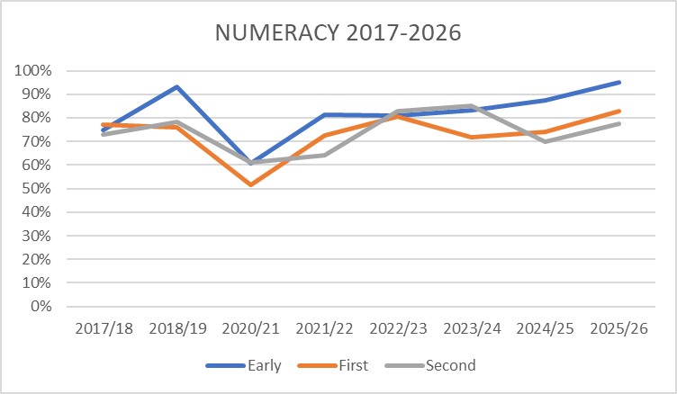

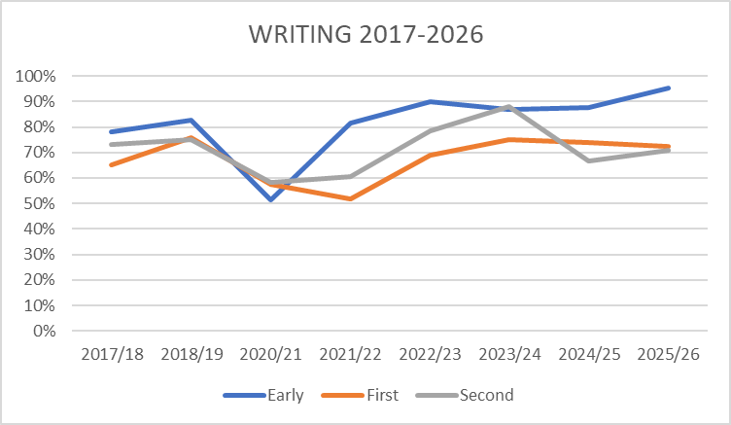

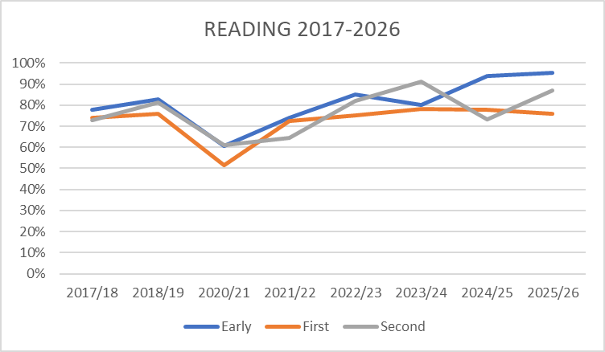
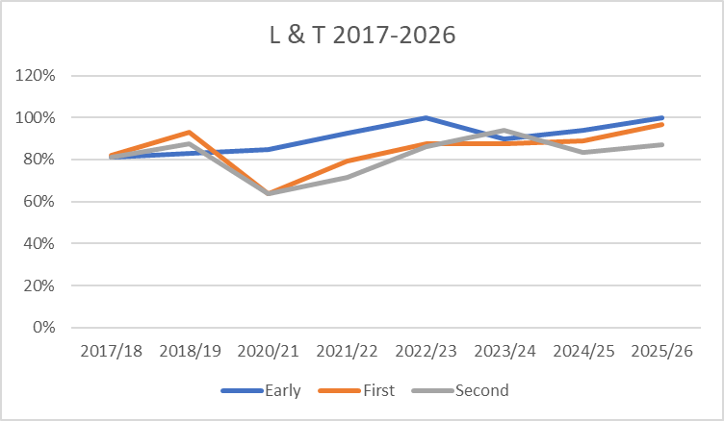

Attendance

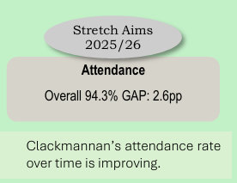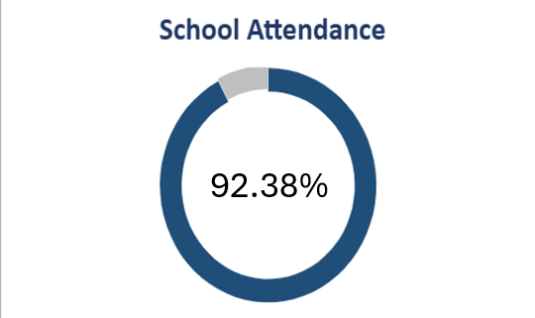

Family Survey

Questions | Responses
Staff treat my child fairly and with respect | 95%
I feel my child is safe at school | 90%
I feel the staff know my child as an individual | 80%
My child receives the help she/he needs to do well | 85%
The school/ELC supports my child’s emotional wellbeing | 75%
My child is making good progress at school/ELC | 90%
I get regular, helpful feedback about how my child is learning and developing e.g. written reports, informal feedback | 90%
The information I receive about how my child is doing reaches me at the right time | 75%
I feel comfortable approaching the school/ELC with questions, suggestions and or a problem | 85%
I feel encouraged to be involved in the work of the Parent Council | 85%
I am satisfied with the quality of the teaching in the school/ELC | 85%
The school/ELC is well led and managed | 100%
The school/ELC encourages children to treat others with respect | 80%
The schoolELC deals well with any bullying | 70%
Overall I am satisfied with the school/ELC | 90%

Actions are already planned for session 2026-27 to address issues raised in this survey.

Our Successes and Achievements in 2025-26

- Consistent use of visuals and Makaton signing to support learners across the whole school resulted in achievement of Silver Communication Environment Award. ELC secured their Gold award again in June 2026.
- Keeping the Promise award presented to mark the ongoing commitment to supporting our care experienced learners.
- Parent Council awarded two separate ‘Make it Happen’ grants for exciting, innovative community and school projects
- Improved digital technologies experiences for learners thanks to Virgin Money £2000 grant for new resources
- High quality experiences and expert knowledge and skills shared with pupils across the school due to sustained quality partnerships with local artists, Bobby Rennie and Kyle Blain, local police officers, Reverend Wicks, Conservation Volunteers, Forth Valley Sensory Team and Who Cares, Scotland?
- Opportunities for all learners to explore new experiences due to fully funded whole school trips to Forefront Pantomime at Alloa Town Hall and Stirling Castle.
- Author and illustrator visits offered children the chance to be inspired by experts and bring learning to life.
- Powerful, important key messages were shared and discussed by the different classes following assemblies led by the Inclusion group. Anti bullying workshop for P5-7 learners arranged by the group was extremely well received by all who attended.
- Increased attendance at Family Conferences and Family Learning experiences resulted in families feeling more informed and included in their child’s learning.
- Highly successful Parent Council fundraising events enabled donations to be made towards costs of whole school trips and improvements to the P6/7 open area and library, designed and costed by the learners.
- Teams/individuals were entered into every sporting event in the PE calendar, with representatives from classes across the school taking part with confidence and pride.

Section B2 - Review of Progress
NIF Priority :  - Closing the attainment gap between the most and least disadvantaged children and young people  - Improvement in skills and sustained, positive school-leaver destinations for all young people  - Improvement in attainment, particularly in literacy and numeracy. |  |  | School Improvement Priority/Priorities:  By June 2027, there will be a clear digital progression from ELC-P7 enhancing learning and teaching across the curriculum through the use of digital technology resulting in increased attainment for all learners (and, in particular, learners with ASN)
NIF Driver:  - inclusive and relevant curriculum and assessment  - highly skilled workforce supporting ASN  - an education system engaging in digital technology |  |  | HGIOS4 QIs:  1.3 Leadership of change  2.3 Learning, teaching and assessment  3.1 Ensuring wellbeing, equity and inclusion  3.2 Raising attainment and achievement
Progress and Impact

- Baseline survey sent in Sept to gather teacher confidence in digital skills
- Priorities identified and supports/training put in place
- Digital group led 2 CAT sessions to share skills for identified priorities (Clicker, Google Classroom and accessibility features) All staff reported feeling more confident to use these in class.
- Clicker used in P6 and P7 with key learners and evidence of impact clearly visible. Learners are able to produce more detailed extended pieces of writing with greater independence.
- Clicker being trialled in P6 and P6 and learners upskilling P3 learners prior to them starting P4 in August and receiving their 1:1 device.
- Resources and possible supports are outlined in documents shared in the Google Drive for teachers to access as required

Next Steps
- Continue to offer CAT sessions for the staff team to ensure all staff feel upskilled and confident to use the identified accessibility tools in class for supporting learners
- Accessibility tools will be explicitly taught and used by learners across the school to support learning and enable accurate assessment of progress and understanding.
- Transition notes to specifically outline the tools that are most effective for learners with ASN
- Digital progression framework to be created by the digital team from ELC-P7. Learners will experience high quality digital lessons which are carefully planned with clear progression across the school. Children will be clear about what they need to know, do and understand at each level.

NIF Priority :  - Improvement in children and young people’s health and wellbeing  - Closing the attainment gap between the most and least disadvantaged children and young people  - Improvement in skills and sustained, positive school-leaver destinations for all young people  - Improvement in attainment, particularly in literacy and numeracy. |  |  | School Improvement Priority/Priorities:  By June 2027, all early and first level learners will have access to high quality developmentally appropriate spaces, interactions and experiences, and engagement for 90% of all learners on the Leuven scale will be 4 or 5.
NIF Driver:  - inclusive and relevant curriculum and assessment  - high levels of achievement across the curriculum for all learners, with action to close the poverty-related attainment gap  - highly skilled workforce supporting ASN  - improving relationships and behaviour, and attendance |  |  | HGIOS4 QIs:  1.3 Leadership of change  2.3 Learning, teaching and assessment  3.1 Ensuring wellbeing, equity and inclusion  3.2 Raising attainment and achievement
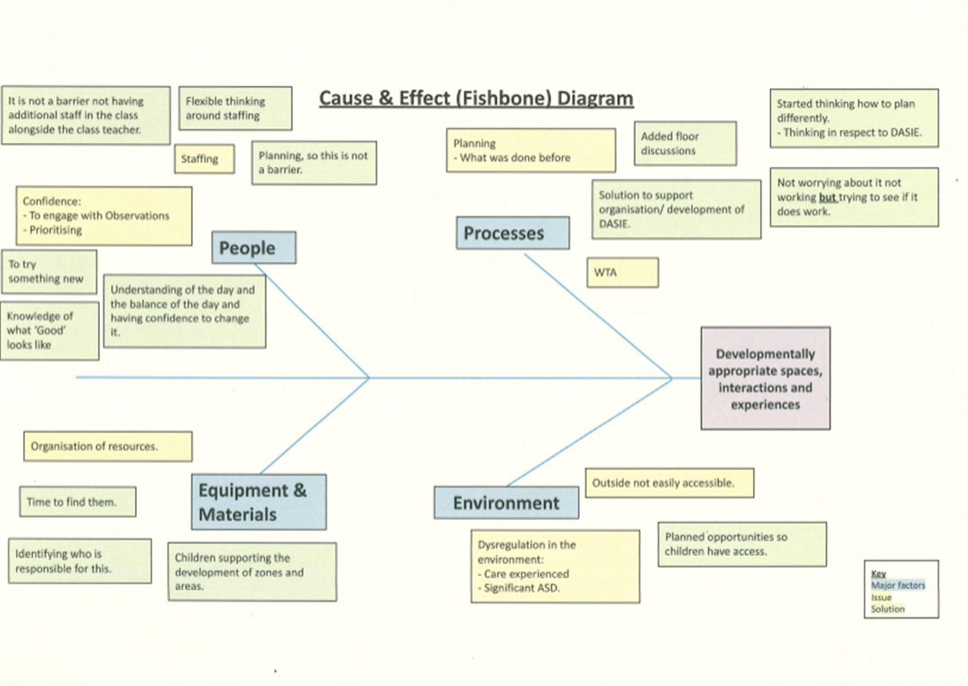
Progress and Impact

Fishbone exercise helped the team establish key areas to address to make the impact required.

Our driver diagram set out our clear aim and the primary and secondary drivers. Change theories were considered and then the class teacher was able to implement these and measure impact.

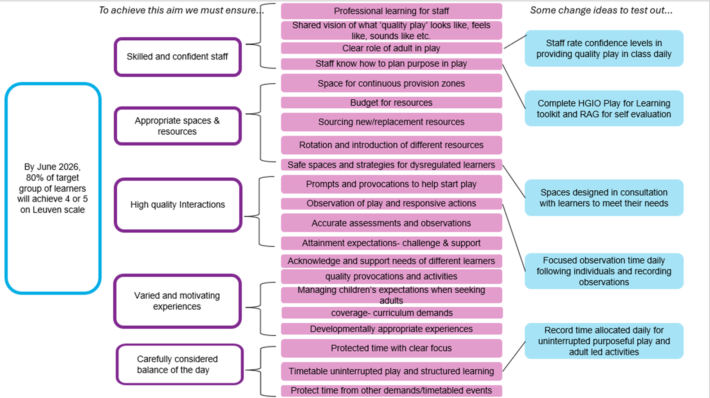

Class teacher designed an observation schedule and systematically carried out observations to measure engagement of learners, interactions with others and effectiveness of spaces to support their learning. Class teacher also logged notes on meta skills observed during observations. This information allowed her to carefully plan next steps in learning, make adaptations to spaces and adjust adult led/adult initiated and child led approaches accordingly.
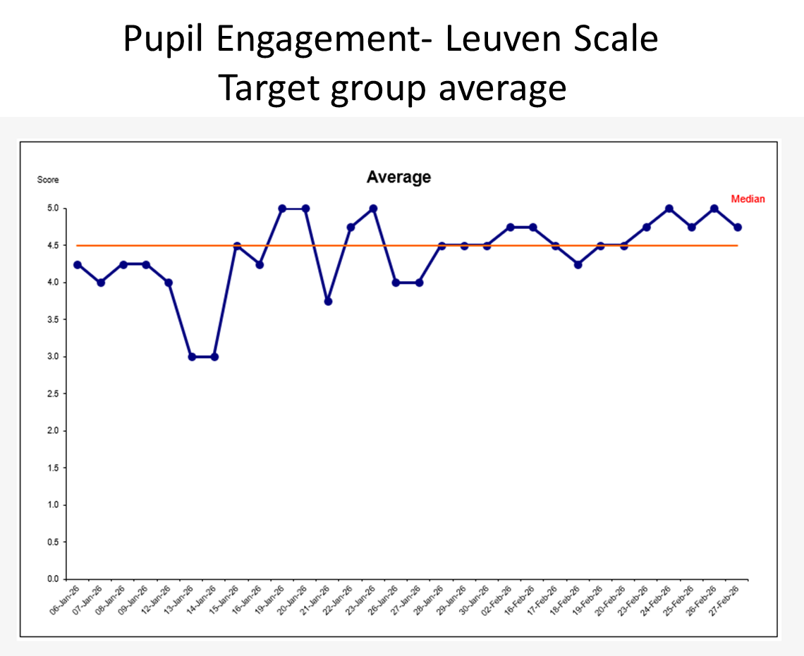

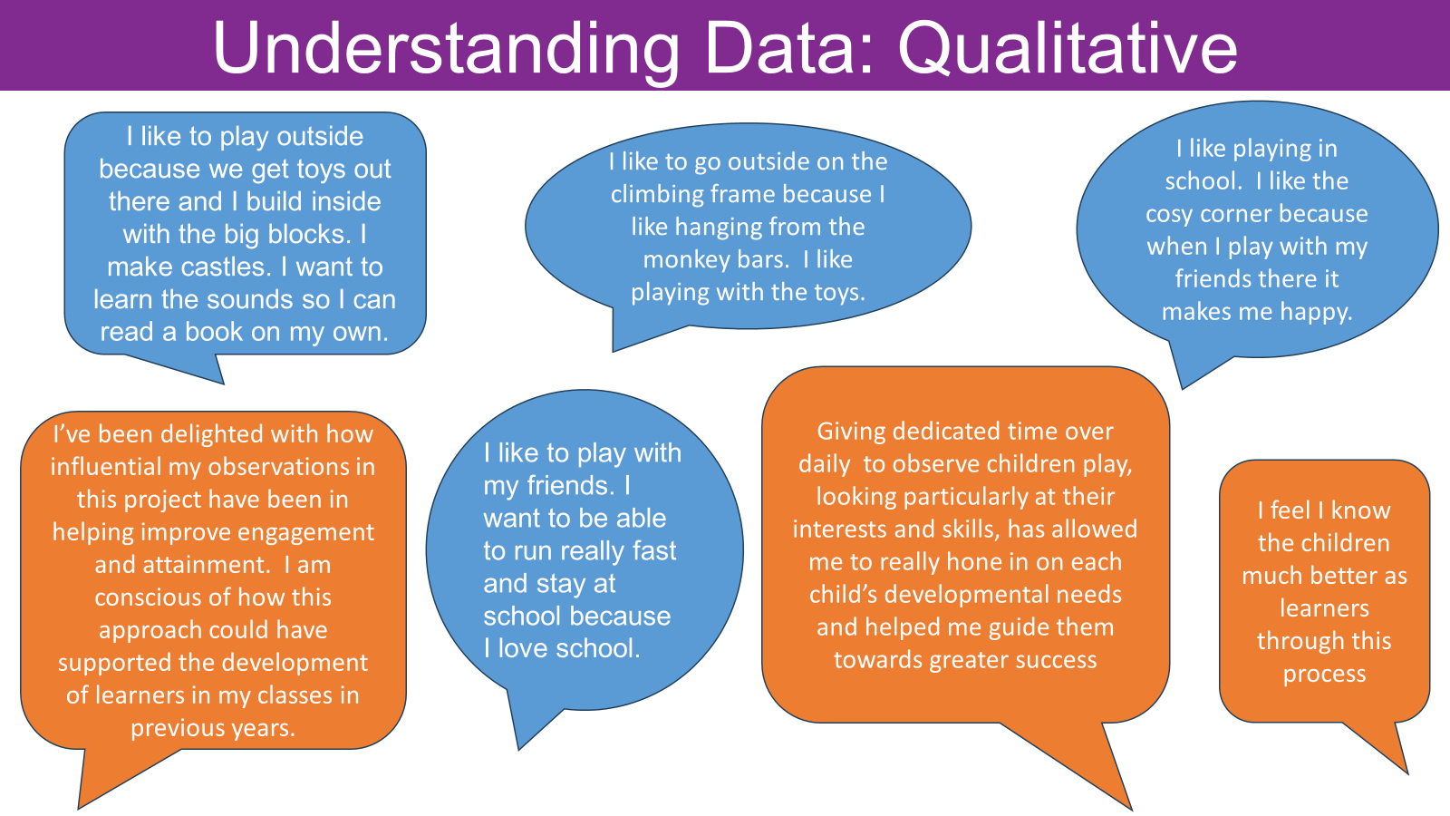

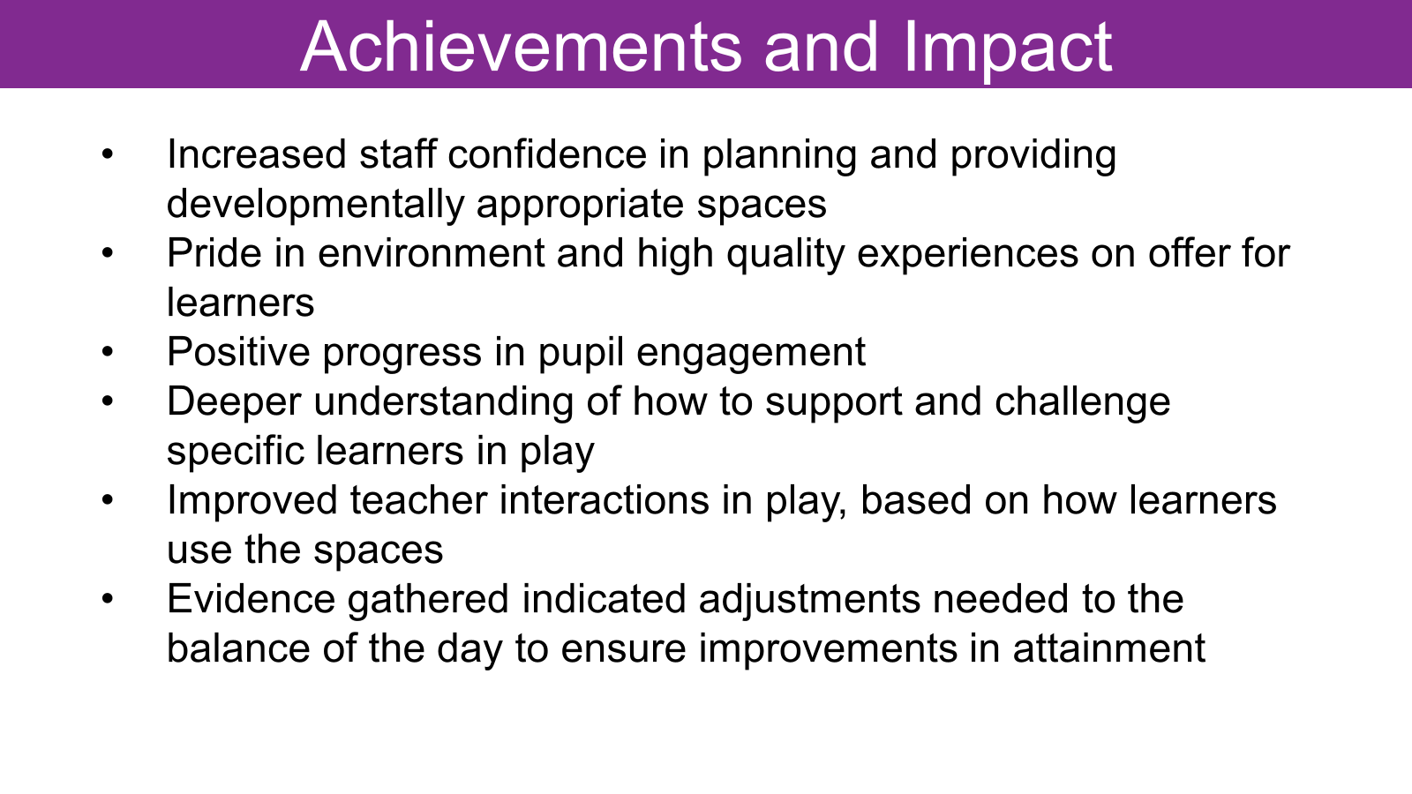

Next Steps

- In session 2026-27, there will be a new P1 teacher and she will continue to use the core provision document to help plan appropriate spaces for learners. The previous P1 teacher has shared findings from the DASIE project last session and work in this area will continue.
- Evaluations from last session will be shared with class teachers at Early and First level to ensure consistency of approach and continued focus on improving spaces, interactions and experiences in line with Realising the Ambition.
- Leuven scale will be used to measure engagement of learners and observation schedules will be used to encourage close scrutiny of spaces, interactions and experiences.
- Balance of adult led, adult initiated and child led approaches will be carefully planned in line with the developmental needs of the learners.
NIF Priority :  - Improvement in attainment, particularly in literacy and numeracy.  - Closing the attainment gap between the most and least disadvantaged children and young people |  |  | School Improvement Priority/Priorities:  By June 2027, there will be sustained attainment into and across first level in literacy, with P2 and P3 attainment in reading being at least 78%
NIF Driver:  - high levels of achievement across the curriculum for all learners, with action to close the poverty-related attainment gap |  |  | HGIOS4 QIs:  1.3 Leadership of change  2.3 Learning, teaching and assessment  3.1 Ensuring wellbeing, equity and inclusion  3.2 Raising attainment and achievement
Progress and Impact
- Training completed June 2026
- Aug 2025- Active Literacy materials ordered
- Sept 2025 Working group plan on how to implement.
- Agreed start date Term 2 giving time to teach skills needed ie Elkonin boxes, diacritical marking
- SWST assessment completed to give baseline.
- Dec 2025-Stage 1-5 fully implemented in all classes
- Feb 2026- staff reported:
P1- more children are achieving success when blending than before
P2- making good progress but some learners struggling with common words
P3- seeing improvement in spelling
P4- improvements noted in reading and spelling but not transferring spelling rules yet
P5- structure in place to support access for all learners.

- Mar 26-Working group created simplified user guides for each stage.
- Agreed to slow pace to allow consolidation for complexities in implementing an approach which is new to the learners in P2-P5.

- First level trajectories paused as we explored Talk for Writing.
- Pupil questionnaires to evaluate approach, attitudes and progress were created
- Improved reading attainment evidenced.

Reading attainment % on track
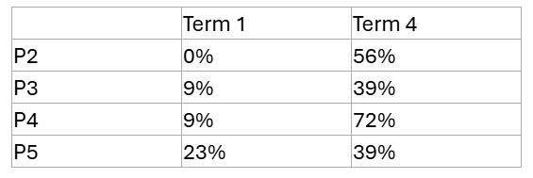

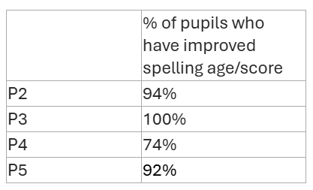

Next Steps

- Continue to embed Active Literacy across P1-P5 in session 2026-27. Learners will experience consistent approaches and learning will be progressive. There will be opportunities for consolidation and transference of skills across literacy from phonics to reading and spelling will be a priority
- Literacy working group to create reading and writing trajectories for first level
- Working group to support the continued implementation of the Talk for Writing approach alongside the CYPIC Writing intervention programme.
- Whole school strategy to be agreed to offer a consistent, progressive approach to writing. Learners will build their skills and confidence through the use of high quality model texts and clear toolkits for different genres to ensure appropriate depth of learning and challenge for all.
- Quality improvement strategies will be employed to ensure clear learning intentions, success criteria and peer/self assessment alongside tracking of progress using run charts to motivate learners and support improvement.
- Staff confidence will be increased through consultation sessions with modelled lessons, opportunities for professional dialogue and the co-creation of a whole school approach to writing.
ELC Improvement Progress
Introduction of floorbooks for recording learning experiences across the setting were very successful in ensuring pupil voice, depth of learning and progression was evident in all areas.

Robust tracing and monitoring systems, including developmental milestones, trajectories and progression pathways enable staff to identify children’s progress and next steps effectively. This supports timely interventions and helps ensure that learning experiences are appropriately matched to children’s developmental needs.

Staff make effective use of developmental milestones and progression pathways in literacy and numeracy to support children’s learning. As a result, children’s individual gaps are identified promptly and used to inform next steps in learning.

Staff provide a variety of provocations and learning experiences. They have used guidance on continuous provision to create well- considered playroom zones, supporting children to access a range of learning. The breadth and choice of learning in the environment keeps all children engaged.

Staff demonstrate a consistent approach to treating families with kindness and fairness. They show a clear understanding of the social and family contexts in which children live, which informs engagement with families. Targetted interventions, including the men only cuppa chat session focused on supporting men’s mental health. This was very well attended and positive feedback was received. The success of this event was sustained through the development of a follow- on gardening group involving parents and their children.

Section B4 - Evaluation of Quality Indicators
Quality Indicator | School Self-Evaluation (1-6) | Local VSE Evaluation  Date: May 2026
1.3 Leadership of change | 4 | 4
2.3 Learning, teaching and assessment | 4 | 4
3.1 Ensuring wellbeing, equity and inclusion | 4 | 5
3.2 Raising attainment and achievement | 3 | 4

