
Clackmannan ELC
Improvement Plan 2026/27

Our values at Clackmannan,
Are clear for all to see,
Wellbeing, Inclusion & Ambition,
To be the best that we can be!

Our vision is for our whole community to be inspired and for doors to be opened to the wider world.

Head of Establishment | Gayle Penman
Senior Early Years Educator | Jackie Lindsay

Priority | Long Term Improvement Outcome | Accountable Person
 | By June 2027, the gap between % of actual observations in each domain fully met by observation 3 will be more consistent across all areas, with an increase in social emotional literacy, problem solving and communication increased to over 65% fully met | Jackie Lindsay
 | By June 2027, learners will experience high quality provocations and a wide range of activities across all curricular areas | Jackie Lindsay

PRIORITY 1

Long Term Improvement Outcome
(Aspirational, Transformational; relates to improved outcomes for learners)
- By June 2027, the gap between % of actual observations in each domain fully met by observation 3 will be more consistent across all areas, with an increase in social emotional literacy, problem solving and communication increased to over 65% fully met

NIF Priority | NIF Outcome (short version) | HGIOS 4/HGIOELC
Placing the human rights and needs of every child and young person at the centre of education  Improvement in children and young people’s health and wellbeing  Closing the attainment gap between the most and least disadvantaged children and young people  Improvement in skills and sustained, positive school-leaver destinations for all young people  Improvement in attainment, particularly in literacy and numeracy. | - a globally respected, empowered, and responsive education system  - schools and early years settings working in excellent partnerships  - inclusive and relevant curriculum and assessment  - high levels of achievement across the curriculum for all learners, with action to close the poverty-related attainment gap  - highly skilled workforce supporting ASN  - improving relationships and behaviour, and attendance  - an education system engaging in digital technology | 1.3 Leadership of change  2.3 Learning, teaching and assessment  3.1 Ensuring wellbeing, equity and inclusion  3.2 Raising attainment and achievement / securing children’s progress

Rationale
We are in our third year of collecting data on our 2 year old learners and staff report feeling more confident when completing the observations.

Our recent data shows:
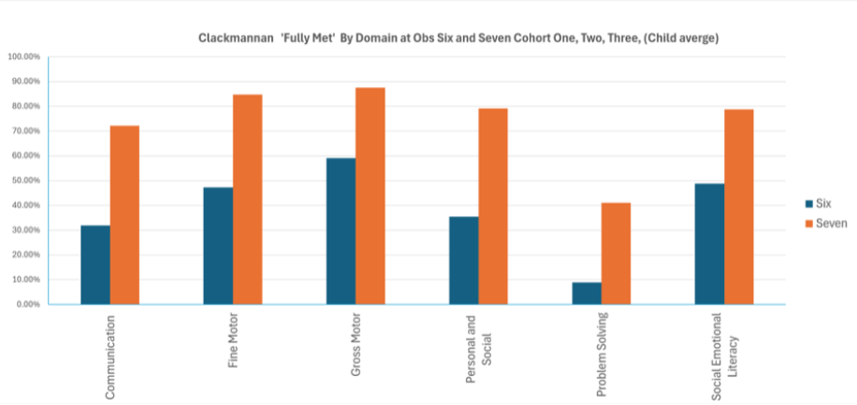
As the graph shows, the progress in problem solving did not increase in the same way other areas had. This leads us to consider how we support our learners to meet these milestones and how we best plan our spaces, experiences and interactions to help them develop in these areas.

Problem solving, Social and emotional literacy and communication, in particular, are the domains with the highest % of indicators not met at each observation (see bar charts below).

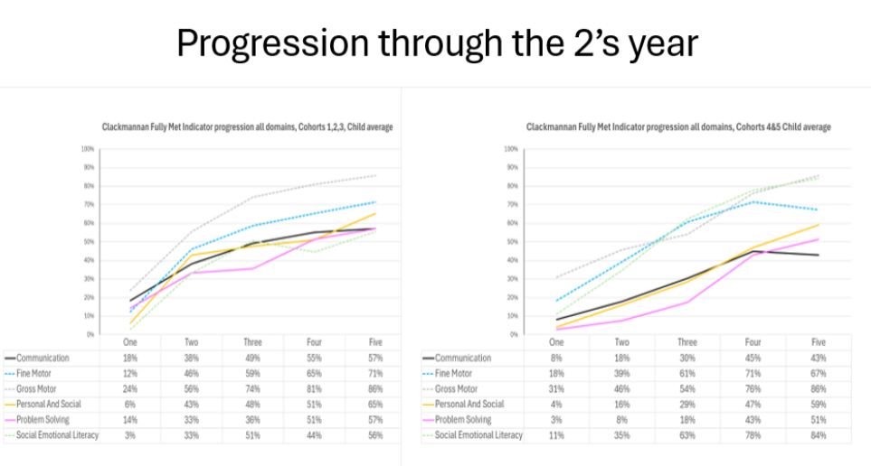
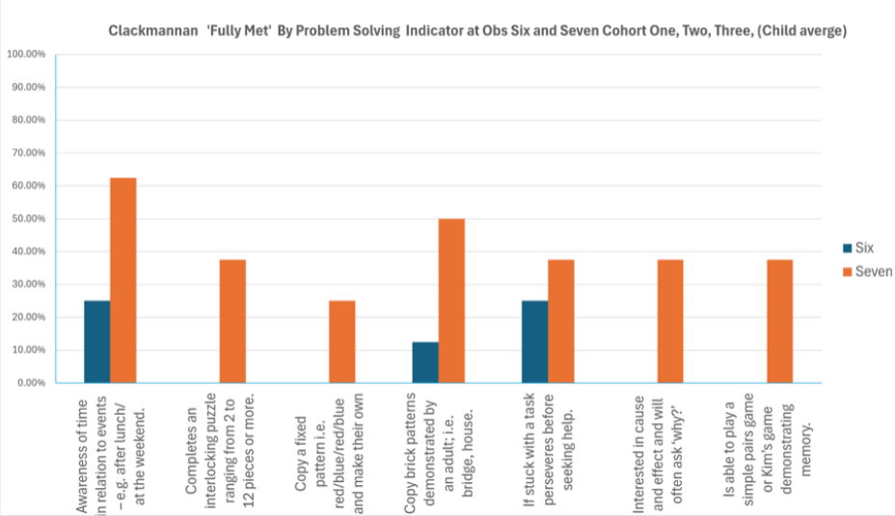

The Education Endowment Foundation (EEF) states that:
Overall, studies of communication and language approaches consistently show benefits for young children’s learning. This finding is based on multiple systematic reviews, meta-analyses and randomised controlled trials. These approaches can have a positive impact on various aspects of language and communication, including children’s spoken language skills and comprehension. All children appear to benefit, but some studies suggest that it is particularly important to use these approaches with children from socio-economically disadvantaged backgrounds, who often start with early years providers at an earlier stage in their language development.
The EEF states that Social and emotional learning (SEL) interventions seek to improve pupils’ decision-making skills, interaction with others and their self-management of emotions, rather than focusing directly on the academic or cognitive elements of learning. They suggest that SEL interventions might focus on the ways in which students work with (and alongside) their peers, teachers, family or community.
EEF Early Years Toolkit indicates that there can be positive results in raising attainment when effective parental engagement can be encouraged and supported. Staff feel this could be a very effective way of improving problem solving, communication and social and emotional learning for our learners. Specific ‘Cuppa Chats’ on these topics with practical examples for families to try at home will be offered alongside toys and games to borrow to support learning in these areas.

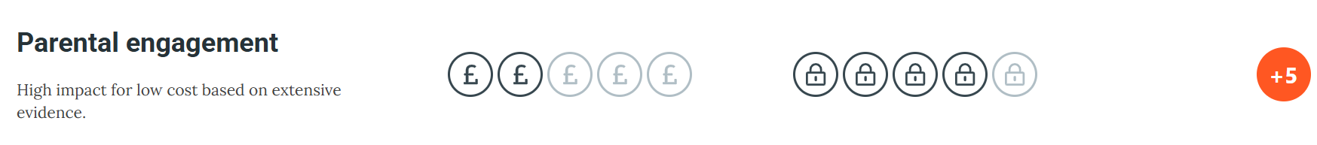

Improvement Outcomes | Measures of Success | Key Actions | Who | Timescales | Milestone Updates
By September 2026, almost all staff will have a shared understanding of the data and the key actions required  By February 2027, children will have regular opportunities to engage in targetted interactions and experiences and staff will observe and collect data at key points  By June 2027, the gap between % of actual observations in each domain fully met by observation 3 will be more consistent across all areas, with an increase in social emotional literacy, problem solving and communication increased to over 65% fully met | Baseline data from session 2025-26  Staff survey relating to confidence using data  Observations by SLT, peers  Moderation  Data from local authority following collection points  TPJ | - Results from 2s data shared with all senior leaders  - Data shared with wider staff team  - Observations made and trends found  - Planned ‘cuppa chats’ and monthly themes for families with resources available to borrow  - Careful planning to ensure provocations and appropriate experiences available for learners to fully meet expectations by observation points  - Selection of resources to be carefully considered  - Evaluation of interventions termly  - Ongoing data collection points/observations carried out  - Interactions, questioning & support to be planned and offered accordingly to scaffold and help learners develop skills | Julie Wild  Jackie Lindsay  Gayle Penman  ELC team  ELC team  ELC team  Jackie Lindsay and Suzie Aitken  ELC team  Suzie Aitken  Jackie Lindsay | June 2026  August/Sept2026  Sept onwards  Nov 2025  Termly collections  Feb 2027  May 2026 | Meeting with Julie Wild, GP, JL & SA to discuss data for 2s & 3s and identify gaps

PRIORITY 2

Long Term Improvement Outcome
(Aspirational, Transformational; relates to improved outcomes for learners)
- By June 2027, learners will experience high quality provocations and a wide range of activities across all curricular areas, with a particular focus on engaging effectively with digital technology.

NIF Priority | NIF Outcome (short version) | HGIOELC
Placing the human rights and needs of every child and young person at the centre of education  Improvement in children and young people’s health and wellbeing  Closing the attainment gap between the most and least disadvantaged children and young people  Improvement in skills and sustained, positive school-leaver destinations for all young people  Improvement in attainment, particularly in literacy and numeracy. | - a globally respected, empowered, and responsive education system  - schools and early years settings working in excellent partnerships  - inclusive and relevant curriculum and assessment  - high levels of achievement across the curriculum for all learners, with action to close the poverty-related attainment gap  - highly skilled workforce supporting ASN  - improving relationships and behaviour, and attendance  - an education system engaging in digital technology | 1.3 Leadership of change  2.3 Learning, teaching and assessment  3.1 Ensuring wellbeing, equity and inclusion  3.2 Raising attainment and achievement / securing children’s progress

Rationale
Scottish Government, First Minister, John Swinney, said, ‘Digital technology can make a significant contribution. Where our educators are supported through professional development, resources and leadership, digital technology can enrich learning and teaching, help to raise levels of attainment and close the attainment gap. The skilful deployment of digital technology in our schools and early learning settings will also ensure our learners develop a level of general and specialist digital skills that are so vital for learning, life and work in an increasingly digitised world.’

Enhancing learning and teaching through the use of digital technology document from Scottish Government (2016) states that the role of educators should be to:
- Ensure that the use of digital technology is a central consideration in the planning and delivery of any learning and teaching across Curriculum for Excellence.
- Provide a range of opportunities for learners to develop their digital skills across Curriculum for Excellence
- Work to identify opportunities to enhance assessment using digital technologies.

As part of our recent VSE, the report agreed that our identified next step with regards introducing increased opportunities to use digital technology across the setting to enhance learning would be appropriate at this time. Alongside this, the team identify the need to support families and learners in the appropriate and safe use of digital technologies in other aspects of their lives.

Improvement Outcomes | Measures of Success | Key Actions | Who | Timescales | Milestone Updates
By June 2027, learners will experience high quality provocations and a wide range of activities across all curricular areas, with a particular focus on engaging effectively with digital technology. | Varied and appropriate digital resources available in the setting for learners  Staff questionnaire regarding confidence in supporting the use of digital technologies  Observations of learners engagement with new digital technologies | Audit of current digital technology used in the setting  New resources purchased to support the introduction of different digital technologies to enhance learning  Support for staff to build confidence and understanding of the different technologies to be introduced to the setting  Carefully planned provocations introducing digital technologies to explore  Closely observe learners as they interact with the new resources  Evaluate impact of digital technologies on children’s learning across the curriculum  Work with families to share messages about safety online and careful monitoring of screen time | ELC team  Jackie Lindsay and Suzie Aitken  ELC team  Jackie Lindsay and Suzie Aitken  ELC team | Sept 2026  Oct 2026  Nov 2026  Feb 2027

