**Standards and Quality Report 2023-2024**

**Clackmannan Primary School and ELC** 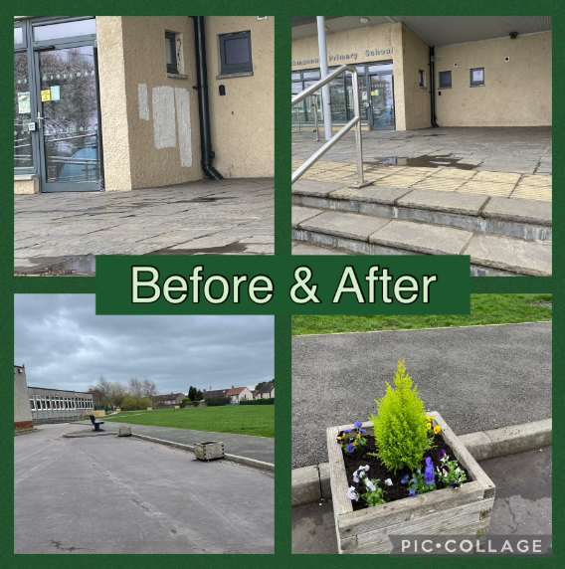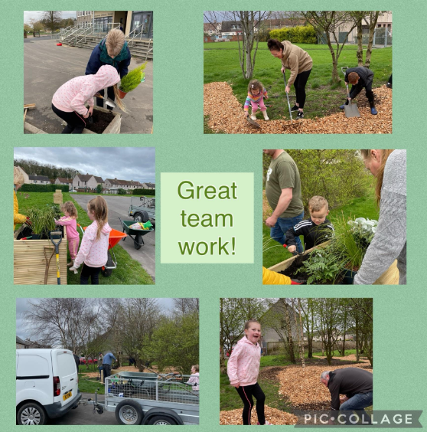

**Playground Improvements**

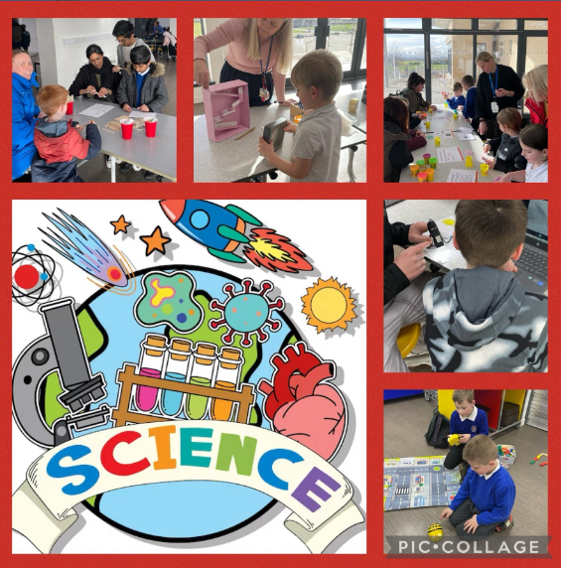

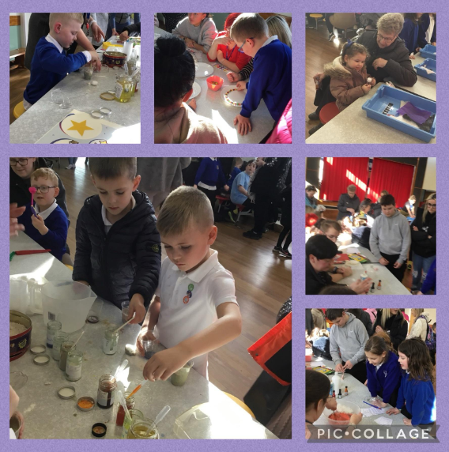

**Family Learning Exciting Events**

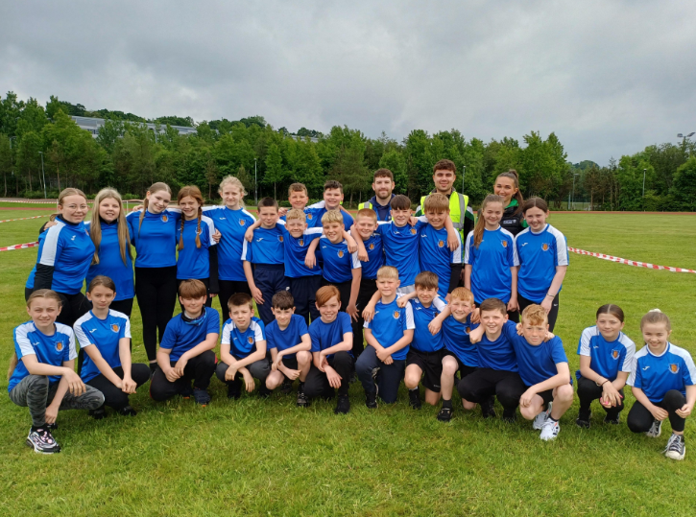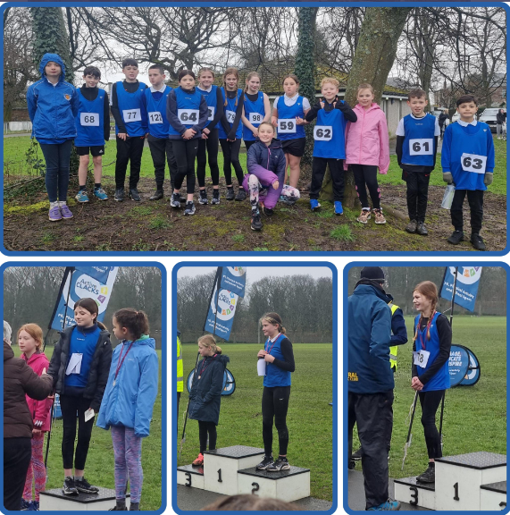

**Sporting Successes**

|  |  |  |  |
| --- | --- | --- | --- |
| **Section B1 - School Context** | | | |
| Clackmannan Primary School has a current roll of 208 learners with ten primary classes and an ELC which is a mixed provision of six two year olds, pre pre and preschool children in full day sessions.  28% of learners reside in Decile 2 and a further 27% live in Decile 3. 37% of learners have Additional Support Needs and are supported through Staged Intervention processes. This is an increase of 12% over four years. 29% of learners are in receipt of FME which is an increase of 5% in the last two sessions. A few learners are care experienced.  School Improvement Planning has reflected national and local priorities in the policy contexts of the Scottish Equity Fund, Pupil Equity Funding, the National Improvement Framework and Education Scotland policy and guidance.  **How do we gather evidence?**  The following pages of this report provide a summary of the progress we have made in each priority and evidenced by a triangulated evidence approach of direct observation, people’s views and quantitative data.  ● Direct Observations  ● Learning conversations with children and annual pupil survey  ● Data from identified cohorts  ● Professional dialogue with the team self-evaluating performance in line with features of effective practice and challenge questions from How Good Is Our School 4 (HGIOS 4), How Good is our Early Learning and Childcare (HGIOELC 4)  ● Professional dialogue with the team evidencing progress collaboratively on  performance, in line with the NIF drivers  ● Sampling the views from learners, families and staff and documentation – including  planning, reports to families, staff meetings, school improvement collegiates, PRDs and Staged Intervention meetings. | | | |
| **Section B2 – Performance Information** | | | |
| **Attainment - Overall TPJ**  **Progress towards Local Authority Stretch Aims**   |  |  |  |  | | --- | --- | --- | --- | | **P1 P4 and P7 combined** | **Stretch Aim**  **23/24** | **Clackmannan**  **23/24** | **Percentage exceeding** | | Literacy | 69% | 78.4% | * 9.4% | | Numeracy | 74% | 83.5% | * 9.5% |   **Attainment Over Time**          **Family Survey June 2024 (29 responses)**   |  |  | | --- | --- | | **Statement** | **Rating**  **Strongly agree/agree** | | | Happy with the quality of learning and teaching at our school | 93% | | Child is treated with respect by staff | 96% | | Child gets the help they need to do well | 93% | | School is well led and managed | 96% | | Staff know their child as an individual | 93% | | The school helps build their child’s confidence | 93% | | Feels the school encourages others to treat each other with respect | 83% | | Feels the school deals well with issues of bullying | 76% | | Are overall satisfied with the school | 96% |   **Our Successes and Achievements**   * 249 pupils attended sports events throughout the year, including ASN events, and we proudly had 100% participation in all sporting events offered in the annual programme. * There was 75% attendance at our Parent Council Halloween discos. * 4 pupils proudly represented our school in the annual Rotary Quiz at Alva Academy * Most P4-P7 pupils participated in the Scots Poetry competition in school with 12 finalists performing at assembly as class finalists. The two overall winners represented the school at the Regional Burns Competition at Strathdevon Primary. * 99.5% of our pupils attended the whole school trip to Edinburgh Zoo in April. * 3 Learning Assistants were trained in Resilient Rhythms and have used the approach with small groups and individuals across the school in Term 3 & 4. * 1 Learning Assistant was trained in Get Set Go, the Physio/Occupational Therapy movement programme, and has supported learners individually or in small groups * 7 Learning Assistants updated their Moving and Handling qualification this session. * We had 79% attendance at our May 2024 Family Conferences * 56 children attending FRIENDZ, TAKE 10 or wellbeing support groups. * 117 pupils attended sports after school and lunch clubs in preparation for sporting competitions * 15 were supported by our Support for Learning teacher in targeted lunchtime clubs, offering small group sessions to build social skills and confidence. * 68 pupils achieved either level 1 or level 2 Bikeability this session. * 2 families accessing period poverty bags monthly and supplies given termly to all P6 & P7 females. * 75 preloved clothing items accessed. * £521.30 was raised for our chosen charities this session. * 4 members of our teaching team trained in Seasons for Growth, a bereavement support programme, with 5 children offered the first block of support in Term 4. * There have been zero exclusions and attendance has been, on average, 91.2% | | | |
| **Section B2 - Review of Progress** | | | |
| **NIF Priority 2:**  Improvement in attainment, particularly in literacy and numeracy | | | **School Improvement Priority/Priorities:**  Improving writing |
| **NIF Driver:**  School Improvement | | | **HGIOS4 QIs:**  1.3 Leadership of change  2.3 Learning, teaching and assessment  3.1 Ensuring wellbeing, equity and inclusion  3.2 Raising attainment and achievement |
| **Progress and Impact**  Significant progress has been made in improving reading and writing experiences and attainment this session.   1. Reading attainment for Q1 P1 learners will increase by 20% by June 2024   This outcome has been achieved. 90% of Q1 P1 learners are on track in reading. This is a result of PEF interventions and universal approaches to improving pedagogies in reading.   1. By end May 2024, 70% of learners in P4, P5 & P6 will achieve the expected level in writing.   This outcome has been achieved in P4 with 75% of children achieving expected levels. P4 teachers attended high quality CYPIC training and closely followed the intervention programme with their learners, tracking and measuring progress throughout the session using paretos and run charts with significant success. P4 teachers report feeling more confident when teaching writing.          62,5% and 62.1% of learners achieved expected levels in P5 & P6 this session. With the planned roll out of the CYPIC Writing Intervention, we will target P6 & P7 learners in session 2024/25 to replicate the same impact evidenced with the focus on P4 learners this year. Our long term outcome, to have 75% of P7 learners achieving the appropriate level in writing, will be achieved by June 2025.  As a result of quantitative assessment data in session 2022/23, there was a need to focus on Tools for Writing. A progression framework was created and principles agreed so grammar, spelling and punctuation would be taught in context. This was a positive shift and was embedded this session.  The majority of teachers undertook high quality training during collegiate sessions with a focus on Tools for Writing and the new framework. As a result of this, our Principal teacher, who is our Literacy Lead, led specific support sessions with staff who had identified areas they wanted support with. 6 members of staff indicated that they would appreciate additional support. As a result of this, 93% of staff report that they have the appropriate support for their planning, preparation and assessment. All teachers strongly agree or agree that they are appropriately supported to undertake their role.  Progression of drama linked to teaching texts was created by the majority of teaching staff using expressive arts as a ‘first draft’ or stimulus for writing. They collaborated and built a catalogue of expressive arts ideas which are saved in the literacy file for future reference. Staff shared good practice and creative ideas were pulled and shared with other practitioners.  Cluster moderation sessions were held across the year with a focus on building relationships with colleagues from other settings and moderating pieces of writing together in order to seek consistency in expectations and judgements. The Local Authority First level writing moderation session also reiterated the same messages and confirmed the need for a patchwork of evidence to be collected and an assets based approach to be taken. 83% of staff reported feeling that moderation activities have helped them make sound judgements.  **Next Steps**   * CYPIC writing intervention training to be taken up by P7 and P3 teachers and new teachers to P4 and P5 next session. * Tools of writing to be a focus across the school with a particular emphasis in Early level from ELC-P2 on fine motor skills and letter formation. * PEF target groups will continue, supported by Learning Assistants and Support for Learning teacher. * Termly Cluster moderation sessions will focus on building teacher confidence and seeking consistency when determining achievement of a level. | | | |
| **NIF Priority 3:**  Closing the attainment gap between the most and least disadvantaged children | | | **School Improvement Priority/Priorities:**  Improving Numeracy |
| **NIF Driver:**  Educator Professionalism | | | **HGIOS4 QIs:**  1.3 Leadership of change  2.3 Learning, teaching and assessment  3.1 Ensuring wellbeing, equity and inclusion  3.2 Raising attainment and achievement |
| **Progress and Impact**  We have made significant progress in achieving the outcomes set in our improvement plan.   1. By the end of May 2024,  * N5 attainment in numeracy will improve from 53.8% to 70% * 80% of learners in P1 will achieve E2 * 80% of learners in P2 will achieve 1.1   83.4% of P1 learners have achieved E2 and 82.6% of P2 learners have achieved 1.1. We have exceeded expectations at these stages. N5 attainment is at 50% achieving E1 in numeracy. Judgements will be moderated by our wider ELC team and continued focus will be placed on this stage next session as we continue to build understanding of the trajectories and expectations for this level.  ELC and P1 and P2 teachers engaged in high quality Early Level numeracy sessions across the year with a focus on improving interactions, experiences and spaces. There is now a need to audit spaces, moderate experiences and focus on interactions next year, with a particular emphasis on open questions.  **Next steps:**   * ELC will continue to embed the Early Level numeracy framework across Early level, with a particular focus on experiences, spaces and interactions and training for the wider ELC team supported by our new Early Years Pedagogue. * Early level Pedagogue to lead on numeracy as the Early Level numeracy progression pathways change to include E1, E2 & E3 levels. * Number Talks approach to be introduced across the school to improve children’s ability to consider different strategies which would be effective when carrying out mental calculations quickly and accurately. | | | |
| **NIF Priority 4:**  Improvement in children and young people's health and wellbeing | | | **School Improvement Priority/Priorities:**  PEF FOCUS: using a small group therapy model for emotional wellbeing, bereavement, attainment and motor skills. |
| **NIF Driver:**  School Improvement | | | **HGIOS4 QIs:**  1.3 Leadership of change  2.3 Learning, teaching and assessment  3.1 Ensuring wellbeing, equity and inclusion  3.2 Raising attainment and achievement |
| **Progress and Impact**  Good progress has been made this session. Our skilled Learning Assistants are trained to provide high quality interventions to support our most vulnerable learners.56 pupils from our target group have benefitted from individual and group sessions to support their social and emotional wellbeing through Resilient Rhythms, Bereavement Box, FRIENDZ and Take 10 intervention programmes. Staff reported that children are more engaged in the learning tasks and attendance has increased. Relationships are growing and as a result, reading skills are consistently improving through use of praise and rapport. Confidence has grown for the pupil and he has become more able to take turns and accept win or lose. It is rewarding to explore and understand a child’s interests and passions.  In October, we created a space focused on nurture, play and skills for learning, life and work. 16 children from our target group accessed this space on a regular or needs based basis throughout their school week. Two children have accessed it full time since it started. The ability to be fluid, change and adapt the space to meet the needs of learners has made it a success for nurture, wellbeing and learning.  We were unexpectedly reduced to one PEF funded Learning Assistant for 4 months this session and this reduced our capacity to run groups as we had earlier in the session until we were able to recruit. We prioritised and were responsive to needs when offering targeted interventions at that time. We have successfully recruited and now have two PEF funded Learning Assistants supporting groups. This will continue next session with a particular focus on using the therapy partner model.  In Term 4, our newly appointed Learning Assistant has supported 3 children to help them manage their wellbeing as they had found accessing any classroom spaces extremely challenging. As a result of this, 2 of the 3 children are responding very well to the individual support and showing a willingness to follow a choice/adult based plan.  Our permanent Learning Assistants continue to be upskilled and are instrumental in designing programmes which are bespoke to our context and learners. PRD processes for the Support Team highlighted their increased confidence and understanding and their satisfaction and enthusiasm for this model.  **Next steps:**   * Continue to develop and design our Nurture classroom, building on successes from last session, and offering further targeted support, as required, in both a planned and responsive manner. | | | |
| **Universal School and ELC Improvement Progress** | | | |
| **ELC Priority 2023/24**  Gathering data on two year olds was the focus for ELC staff this session. The domains were introduced and then the introduction of the readiness for learning (R4L) domain was added. Data was collected at regular intervals across the year and staff were trained to complete the returns, ensuring consistency across settings.  Informative Care Inspectorate training linked to observations was attended by HT and Senior from ELC in March 2024. This approach was then shared with the wider team.  **Next steps**   * Early Level Pedagogue will join our ELC team with a focus on our 2 year olds and embedding the Early Numeracy framework * Next session staff will trial this approach in the playroom. Following one learner and noting the quality of their interactions, their emotions and the quality of their experiences will be the focus. Cluster colleagues will work collegiately to devise recording formats and they will pilot using these in settings before feeding back to   **Partnerships and Participation**  **2.7** The development and promotion of partnerships  We have continued our commitment to ensuring families are involved and participate in the life and ethos of the school. We continued to run the monthly Open Classroom events which were initially well attended. We consulted with parents about family learning opportunities and offered a science themed workshop and an art exhibition for families. These were very well attended and it was agreed with teaching staff that Family Learning events will be planned each term next session.  This session we continued to extend our partnership working and developed relationships with our local heritage group, Scotland IS for safer internet day, Yorkshire Building Society financial education sessions for all classes and NIKE health and wellbeing physical activity sessions for all classes. Due to the current restoration of the Tolbooth in the town centre, an archivist from Clackmannanshire Council offered very informative and interesting lessons for 2nd level learners. We formed a partnership with a young artist, Kyle Blain, who was formerly a pupil at our school. He is currently doing a degree Glasgow School of Art. He set up an art exhibition to inspire other young artists and offered a masterclass for a group of eager artists. As a result of our partnership with Kyle Blain, 56% of children listed art as one of the subjects they want to study further when asked in the annual pupil survey. | | | |
| **Section B4 - Evaluation of Quality Indicators** | | | |
| **Quality Indicator** | **School Self-Evaluation (1-6)** | **Inspection Evaluation**  **Date: Oct 2018** | |
| 1.3 Leadership of change | 4 | 4 | |
| 2.3 Learning, teaching and assessment | 4 | 4 | |
| 3.1 Ensuring wellbeing, equity and inclusion | 4 | 4 | |
| 3.2 Raising attainment and achievement | 4 | 3 | |