Alva Primary School, ASD Provision

and ELC Handbook

2026/27

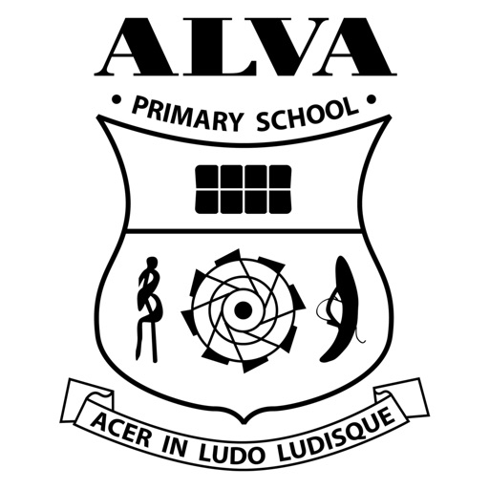

Safe Ready Respectful

School Blog
https://blogs.glowscotland.org.uk/cl/alvaprimaryschool/


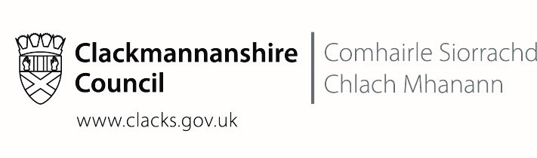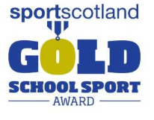
Last Updated December 2025
If you require a printed copy of this leaflet, please contact the school office. We will be happy to provide this.

Contents
Chief Education Officer’s Foreword | 3 |  | Mobile Phones and Recording Devices | 28
Contact Details | 4 |  | Extra-Curricular Activities | 29
Head Teacher’s Welcome | 4 |  | School Clothing Grants | 29
Our Senior Leadership Team | 4 |  | Free School Meals | 29
Our School | 5 |  | Help With Free School Meals Application Form | 30
Our Values, Vision and Aims | 6 |  | Food In School | 30
School and ELC Hours | 7 |  | Breakfast Club | 30
Attendance and Absence | 7 |  | Lunch | 30
Absence From School | 8 |  | Packed Lunches | 31
School Enrolment | 9 |  | Water Bottles | 31
ELC Enrolment | 9 |  | Parent Pay | 32
Meet Our Team | 10 |  | Making a Payment Cash or Cheque | 32
Visiting Music Tutors | 11 |  | Inclement Weather Arrangements | 32
Visiting Professionals | 11 |  | Playground Supervision | 32
Curriculum For Excellence | 11 |  | Secondary School | 32
Curriculum Levels | 11 |  | Education Statistics Privacy Notice | 33
Our Curriculum | 12 |  | Why Do We Need Your Data? | 33
Health and Wellbeing | 12 |  | Data Policy | 33
Sensitive Learning Topics | 13 |  | Your Data Protection Rights | 34
Literacy | 13 |  | Concerns About Data | 34
Numeracy and Maths | 14 |  | Insurance Cover | 35
Sciences | 14 |  | Alva Autism Provision: “Ochil Classes” | 36
STEM | 14 |  | Alva Autism Provision: Curriculum | 36
Social Studies | 15 |  | Alva Autism Provision: Assessment and Recording | 37
Expressive Arts | 15 |  | Alva Autism Provision: Reporting | 38
Religious and Moral Education | 15 |  | Alva Autism Provision: Home Links | 38
Sharing the Learning | 16 |  | Alva Autism Provision: Enrolment | 38
Relationships Policy | 16 |  | Alva Autism Provision: Hours | 39
Assessment and Reporting | 17 |  | Alva Autism Provision: Lunches | 39
Additional Support Needs | 18 |  | Alva Autism Provision: Transport | 39
Creative Therapeutic Interventions for Children | 19 |  | Useful Websites | 39
Other Support Services | 19 |  | School Term Dates | 41
School Health Service | 20 |  | Footnote | 42
Disputes and Resolution in ASN | 21
Safeguarding | 22
Wellbeing | 23
Named Person | 23
Equalities | 23
Racist or Bullying Behaviour | 23
Administration of Medicines | 24
Feedback, Concerns and Complaints Process | 24
Parent Council | 26
Community Links | 26
School Security | 26
School Transport | 27
School Uniform | 27
PE Kit | 28

Chief Education Officer’s Foreword 2026/27

Clackmannanshire Council People Directorate

It is an exciting time in education across Scotland. Within the Clackmannanshire People Directorate, we provide a wide range of services for children, young people, families and communities and we are committed to lifelong learning, giving children the best possible start in life as they progress from nursery to school and beyond.

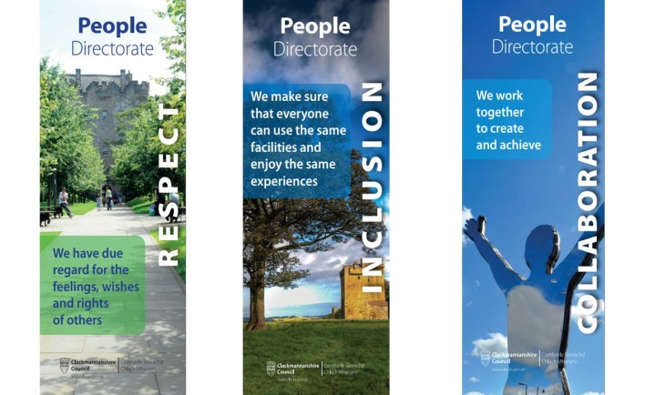
Our mission to educate, protect, support and promote the achievements, health and wellbeing of every child and young person has ensured our children continue to flourish. Much of our work is undertaken in partnership with other services, agencies, communities, children, young people and their families. Improvements and a relentless focus on wellbeing is delivered in collaboration across educational establishments, services and with other regional and national partners.

With the full support of our Headteachers, Elected Members, Chief Executive, our corporate colleagues and partners, we are committed to our values of Respect, Inclusion and Collaboration - raising attainment, tackling inequity and ensuring that high aspirations and positive outcomes are the expected norm for every child in Clackmannanshire. Health and wellbeing, safety of our pupils and staff and educational attainment continue to be at the forefront of our minds.

We are committed to ensuring that the views of our children, families, communities and partners are taken into account when planning and delivering our services. We are committed to UNCRC which has recently been incorporated into Scot’s law. Shared ownership and awareness of the education values is key.

- Respect – we have due regard for the feelings, wishes and rights of others
- Inclusion – we make sure that everyone can enjoy the same experiences
- Collaboration – we work together to create and achieve

Parents and carers, who have always been the most important educators of their own children, supporting their children to continue learning in whatever way possible, whilst keeping them safe and well. I believe we now need to strengthen parental involvement in education and continue to provide flexible systems to enable parental engagement and representation.

I encourage you to get involved in whatever way you can, be that via Social media, Class Dojo or other in school activities to help you support your child’s learning. Read with your child every day! Ask them what they have learned that day and get them to show you! Look out for opportunities to learn together as a family!

We are all ambitious for our children and young people and together we can ensure the best possible future for all in Clackmannanshire.

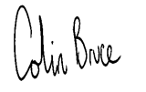

Colin Bruce
Chief Education Officer
Clackmannanshire Council

Contact Details

Alva Primary School
School Address: Brook St
Alva
FK12 5AN
Telephone Number: 01259 452210
E-mail: alvaprimary@edu.clacks.gov.uk
School Blog https://blogs.glowscotland.org.uk/cl/alvaprimaryschool/

Head Teacher’s Welcome to Alva Primary School, ASD Provision and ELC

Welcome to Alva Primary School, ASD provision and ELC. Within our setting, we pride ourselves on being a welcoming, vibrant and nurturing school where pupils, staff and parents work in partnership and together everyone is supported to be all they can be. Our expectations are high, and our overall aim is to ensure a high-quality learning approach is offered to all of our learners. Our staff are approachable, knowledgeable, current, risk-takers and eager to take the learning where our learners want to go. They are dedicated and committed to ensuring that learning is relevant, engaging, and purposeful for a 21st century school.
We want the very best for all our families. We encourage parents/carers to join with our school, at every opportunity to share various events throughout the year.

This handbook is designed to give you an insight into our school. The information was correct at the time of review, December 2025, and may be subject to slight change. If you have any further questions or concerns or would like further information about on any aspect of your child’s education or wellbeing, please do not hesitate to contact me. My door is always open.
We look forward to working in partnership with you and may I take this opportunity to welcome you to our school.

Nicola Ferguson
Head Teacher

Our Senior Leadership Team

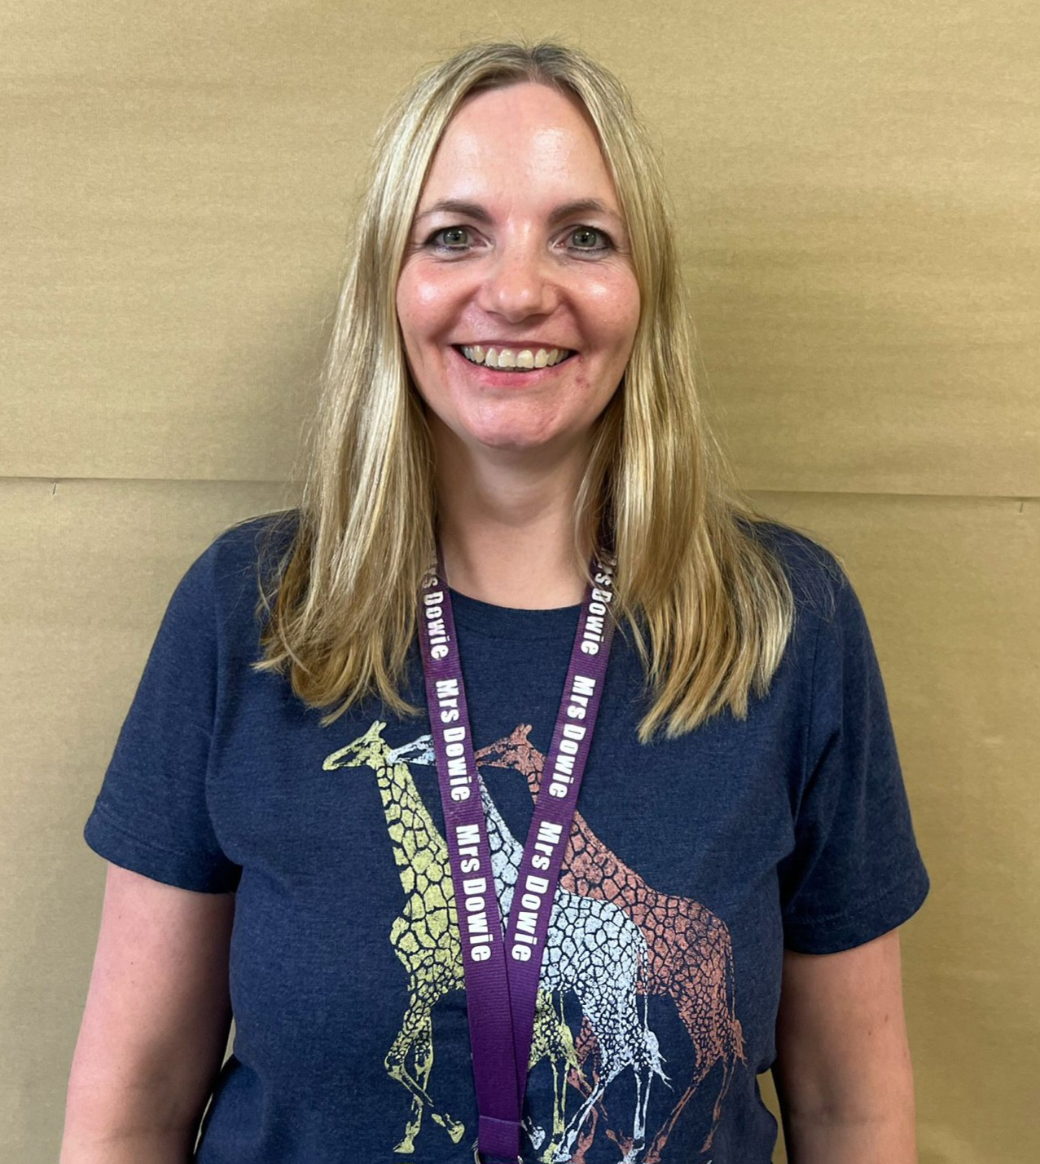
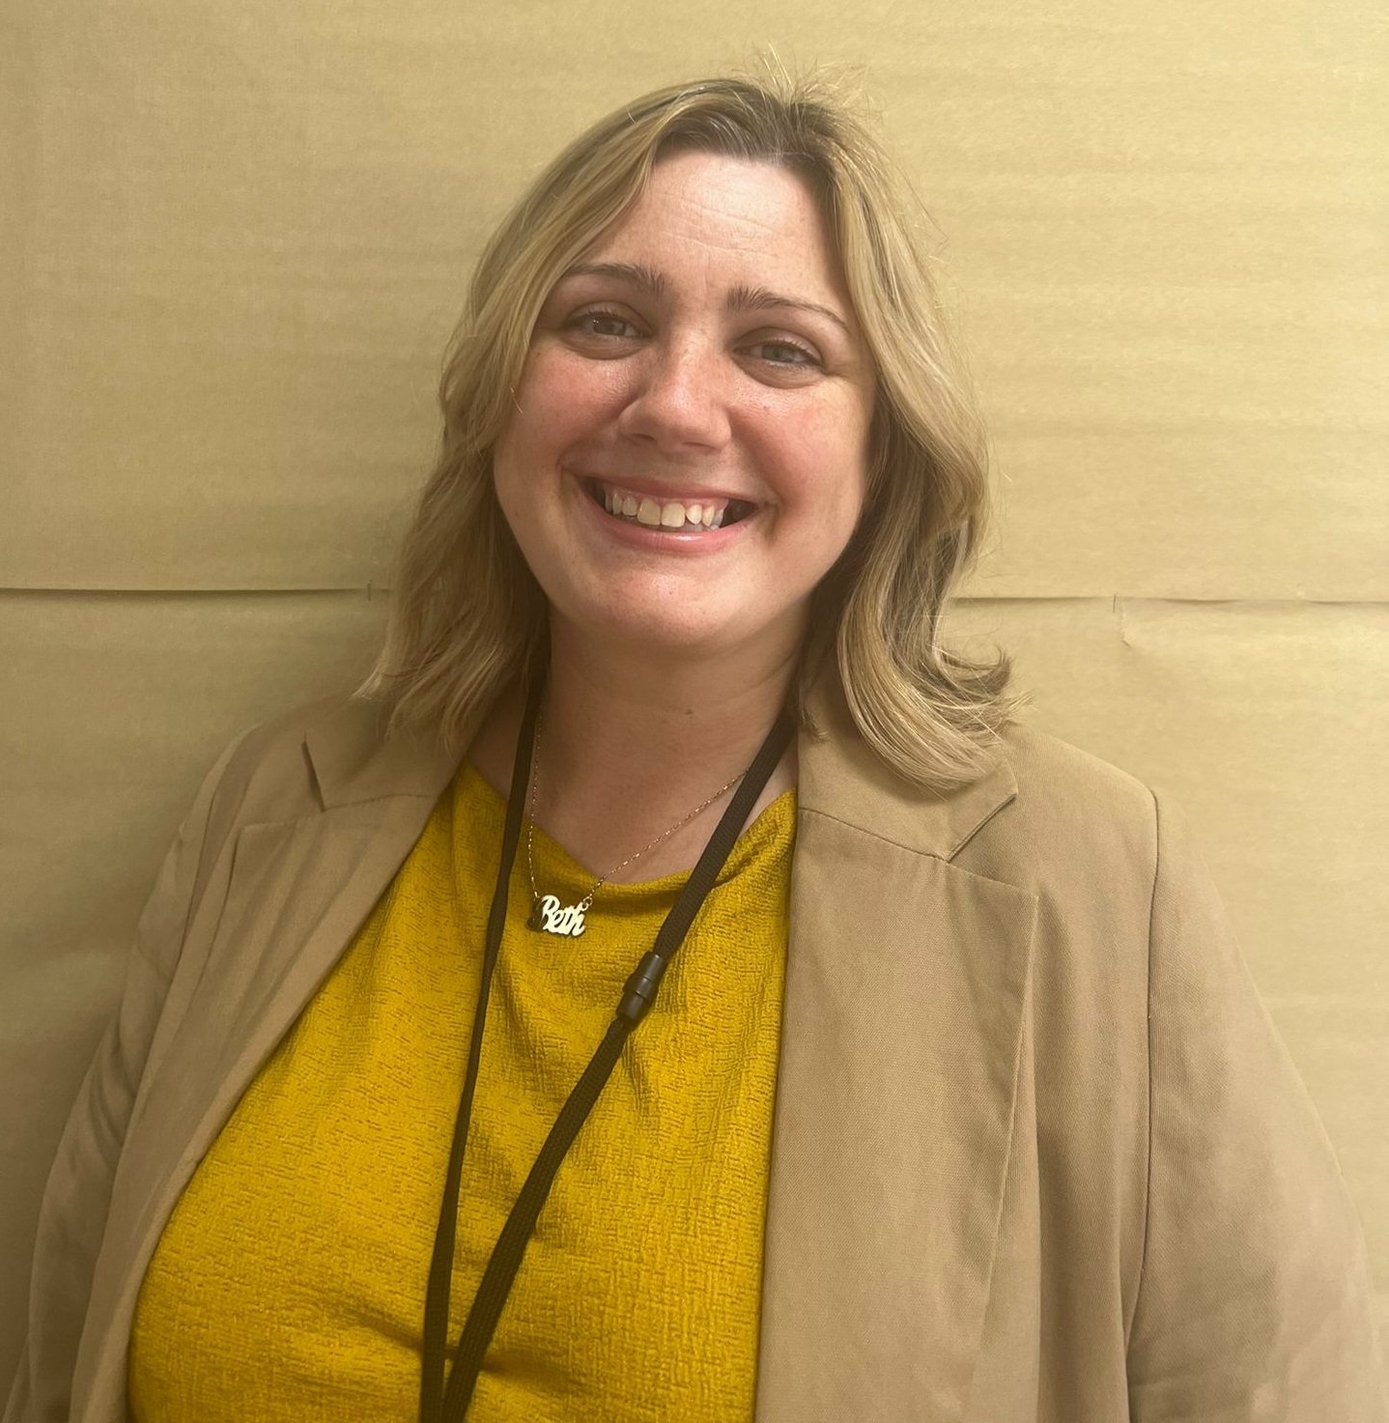
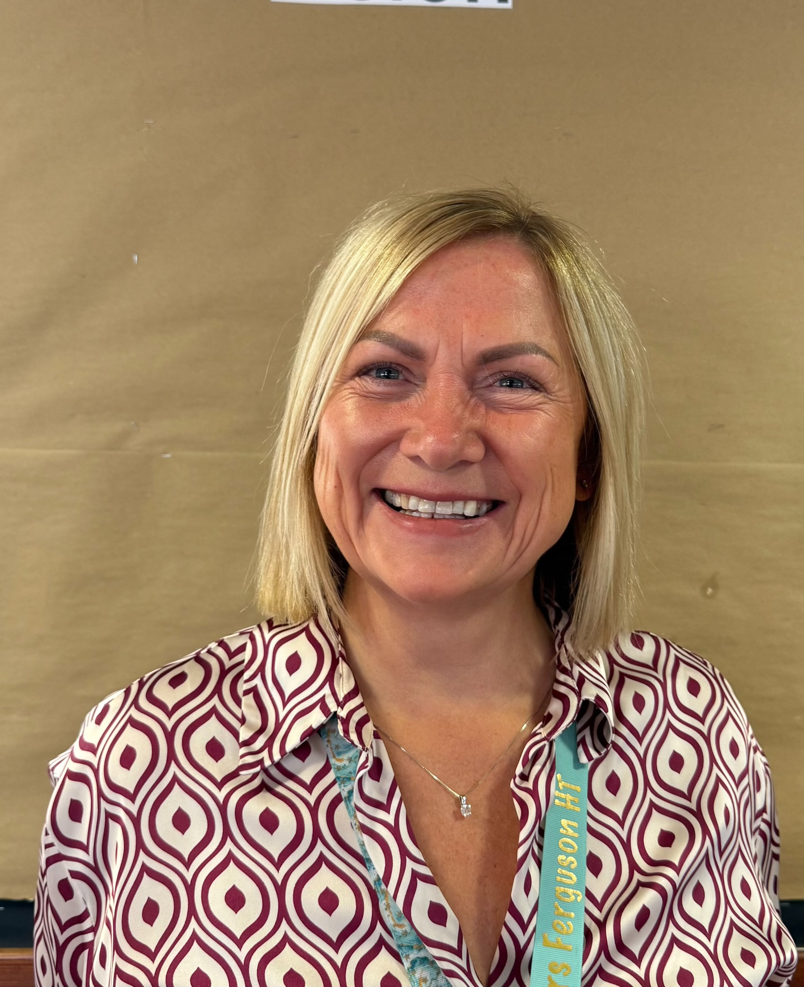
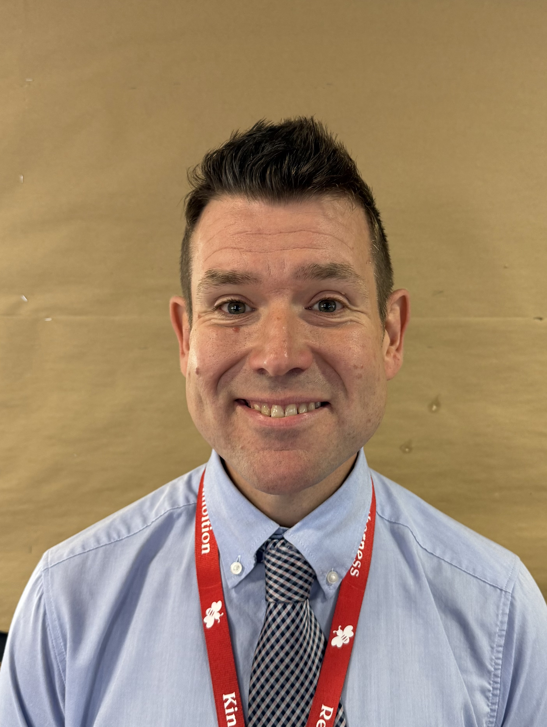
Mrs Nicola Ferguson  Head Teacher |  | Mrs Jacki Dowie  Depute Head Teacher  P4 & P7 |  | Mr David Kerr  Depute Head Teacher  Ochil classes |  | Ms Beth Storf  Senior Early Learning and Childcare Educator
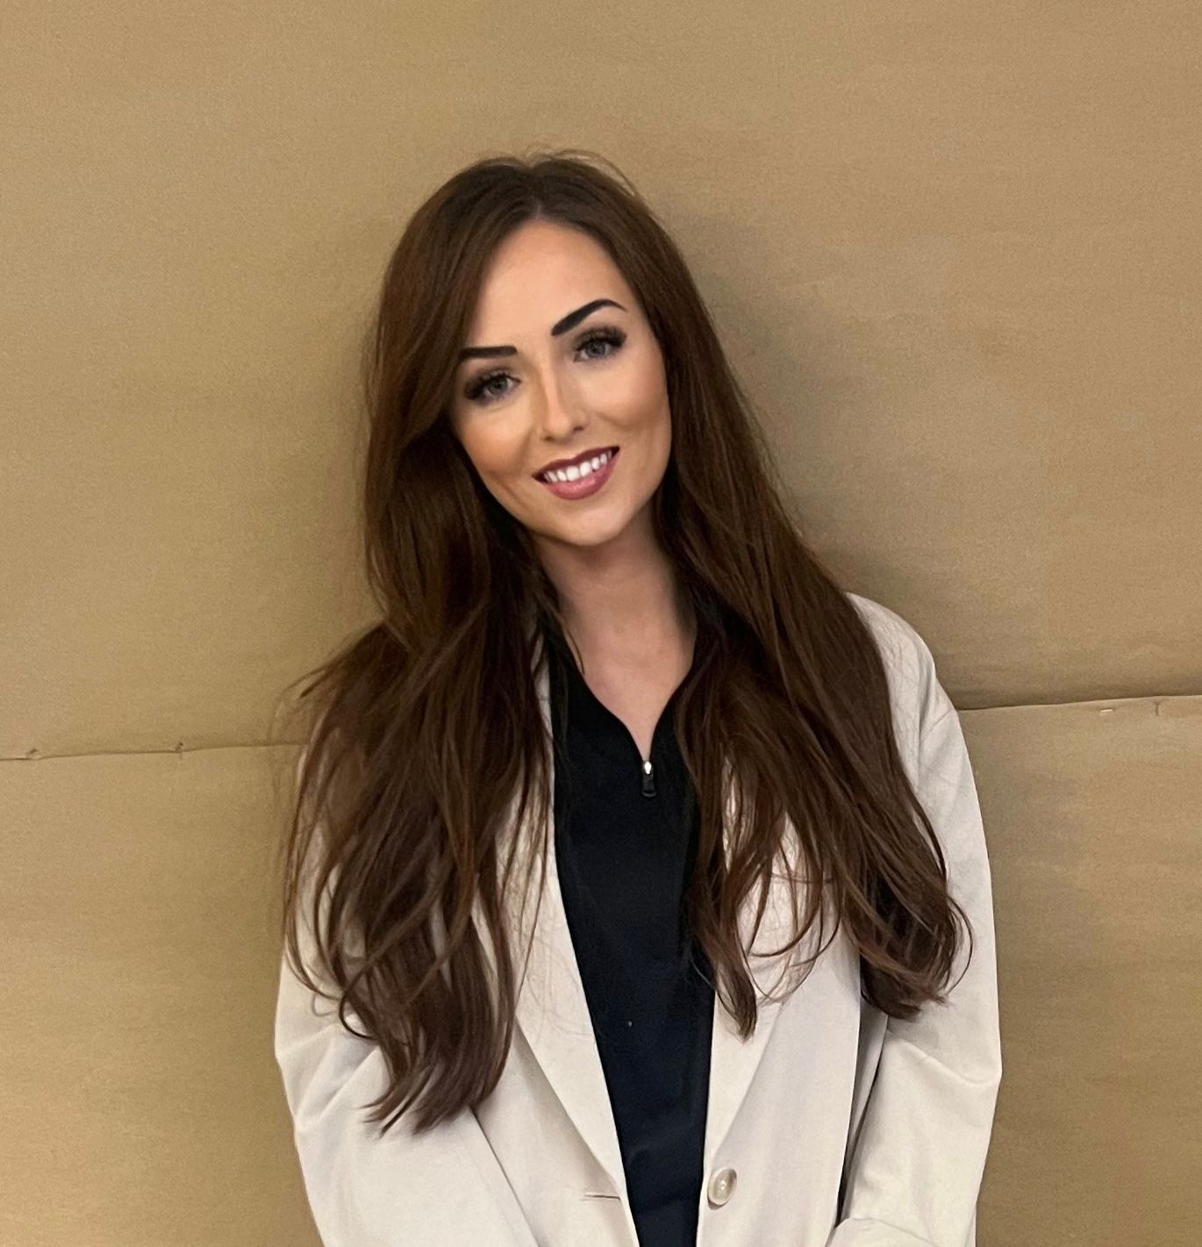  Miss Gillian Crighton  Principal Teacher  The View |  | 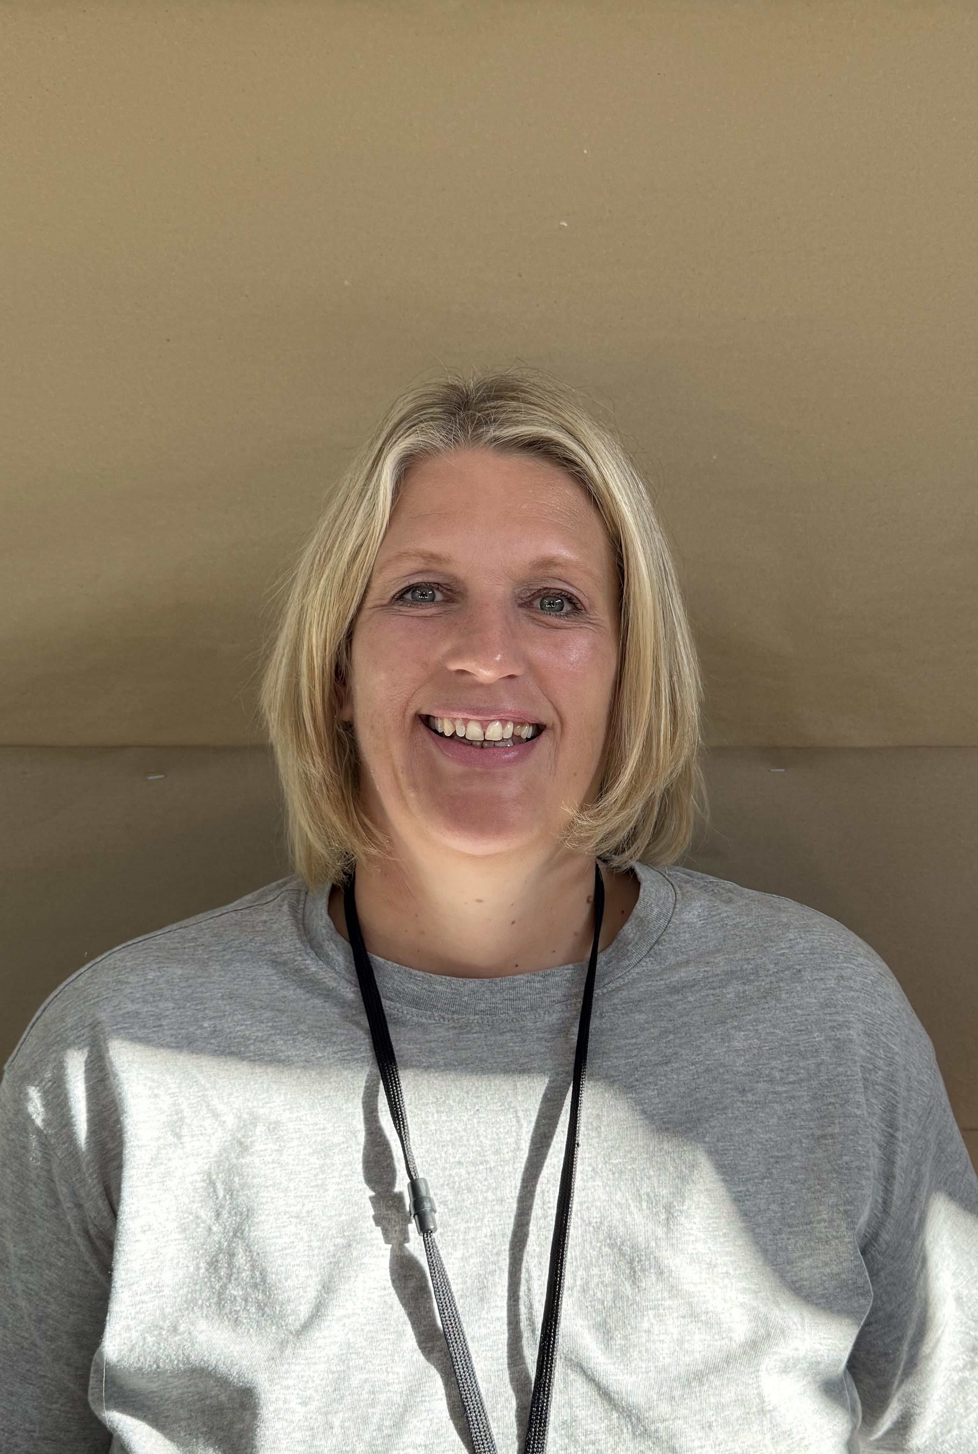  Mrs Ruth McCaskell  Principal Teacher  Ochil Classes |  | 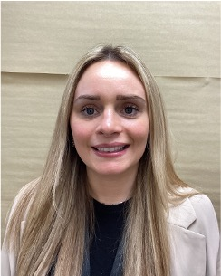  Mrs Sian Hamilton  Early Years Principal Teacher – P2 & P3 |  | 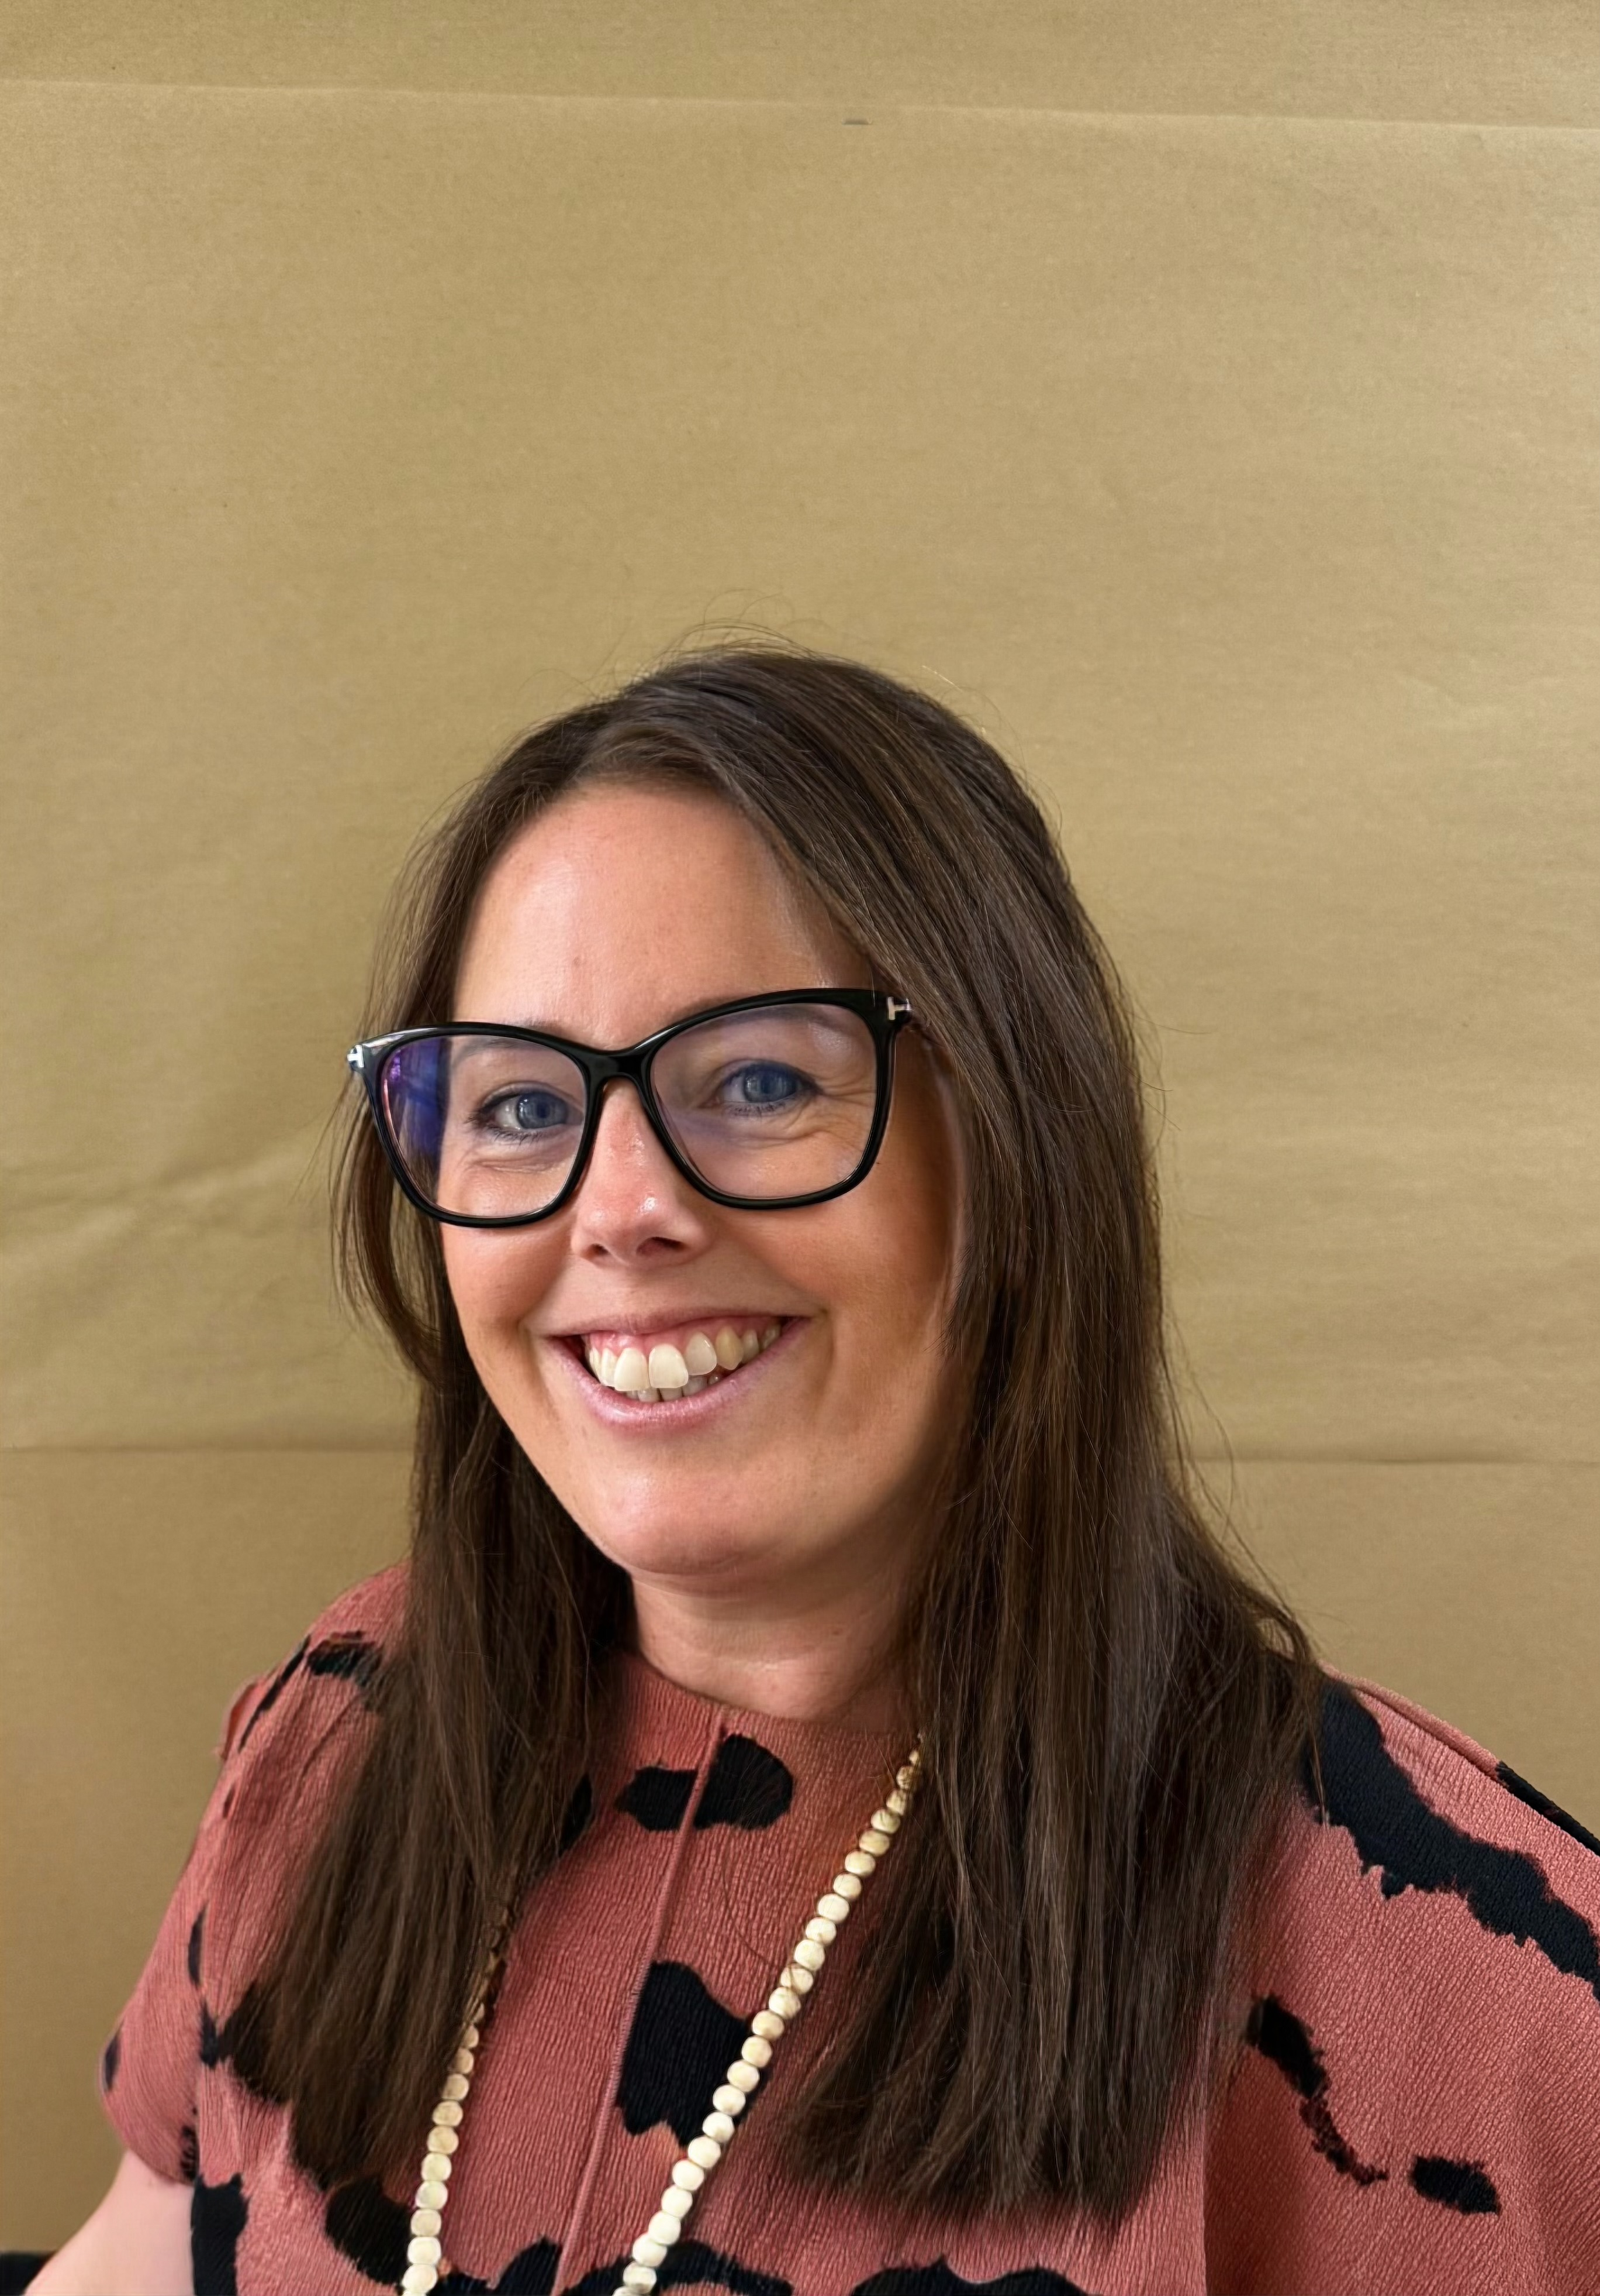  Mrs Samantha Currie  Principal Teacher  Children & Families Support Teacher
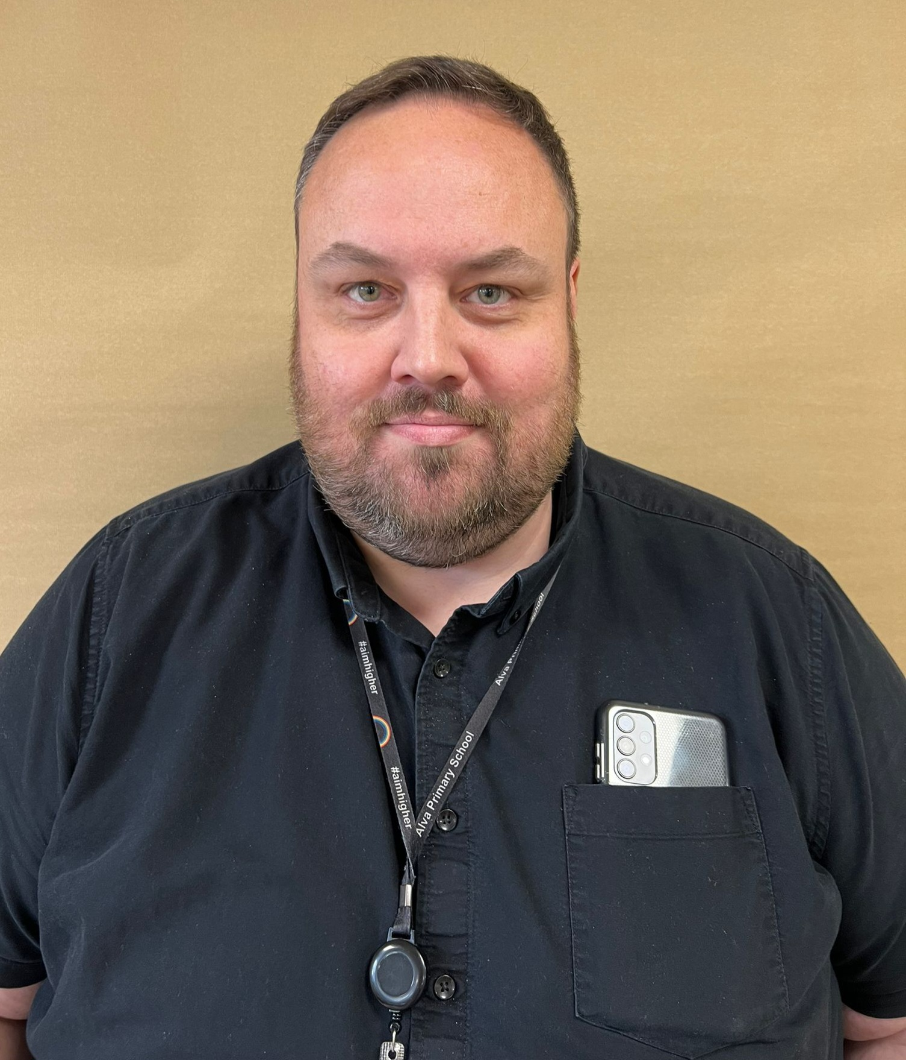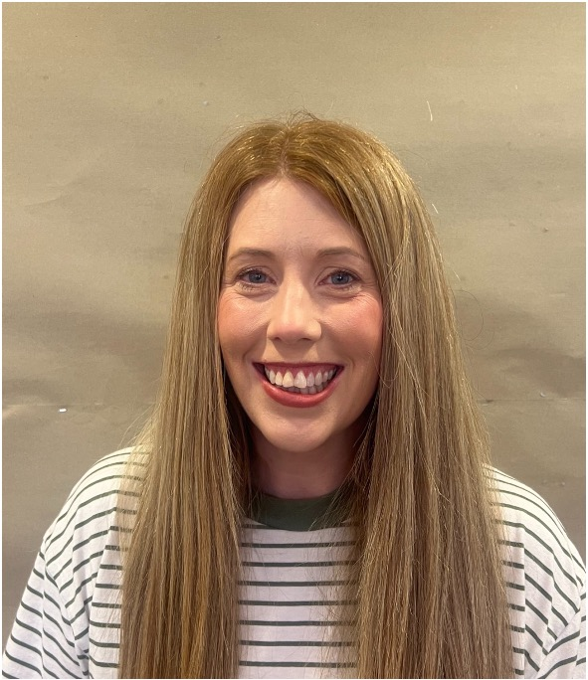
Mr Iain Sneddon Mrs Geraldine Hayes
Principal Teacher Principal Teacher
P5 & P6 P1 & P7

Our School

Alva Primary School is a non-denominational school in the heart of Alva, Clackmannanshire, with a current roll of 314 mainstream primary school children, 41 children in our ASD Provision and 73 children in our ELC for a total of 428 across the entire establishment. The school has 13 mainstream classes, 7 ASD Provision classes (Ochil Classes) and one ELC class offering full day places. We offer 1,140 hours of early learning and childcare. Alva Primary School works with the other schools in the Hillfoot’s Cluster and engages in cross sector improvement work. Our values of Safe Ready Respectful underpin our school policies, processes, routines and curriculum offering. The school works in partnership with children, parents/carers, other agencies and community partners to create an ambitious learning environment, where children develop resilience, value friendships and contribute to our cycle of continuous improvement.

Feel free to visit us and view our breath-taking surroundings, nestling amongst the Hillfoot’s within the town of Alva. Scottish Government guidance on choosing a school for your child can be found by clicking below:
Choosing a School: A Guide for Parents/carers.

Our Values

Safe | Ready | Respectful

Our Vision

As a whole school community, we are inclusive, diverse and supportive of each other. We celebrate individual strengths, where every voice matters; offering rich experiences to equip children with the knowledge and skills to be lifelong learners and caring citizens.

Our Aims

- We support the educational, social, emotional, and physical needs of all our children.

- We ensure that all children develop the attributes, knowledge and skills required to achieve in life, learning and work.

- We attain high standards in all curricular areas; encouraging and expecting all children to work hard.

- Our parents/carers/carers and local community as significant partners.

- We celebrate the wider achievements of our children.

- We regularly reflect on and improve practice, processes and policies; providing an increasing range of high-quality learning experiences.

- We provide an increasing range of high-quality learning experiences.

School, ASD Provision and ELC Hours  ELC | Primary 1 to Primary 7 in Mainstream  and ASD Provision (Ochil classes)
Morning Session: 8.50 am to 11.50 am | Morning Session: 9.00 am to 12.15 pm
 | Break Time: 10.30 am to 10.45 am
Afternoon Session: 11.50 am to 2.50 pm | Lunch Time: 12.15 to 1.00 pm
 | Afternoon Session: 1.00 pm to 3.00 pm

Parents/carers are advised against sending or bringing their child/children to school earlier than necessary. There is limited adult supervision in the playground before 9.00 am. Generally, one adult will be present from 8.50 am until 9.00 am; however, this is only when possible. Whilst care is taken to ensure our playground is as safe as is reasonably practical, the school does not bear responsibility for children’s safety before or after school hours. During particularly inclement weather, children should arrive in the playground just in time for the bell to ring at 9am.

If, on occasion, your child is late for school, please let us know the reason for this. After 9.00am the only entrance to school is via the main entrance. All other school entrance doors are closed at 9.00 am for security purposes. Punctuality, as well as establishing excellent habits for the future, helps all children to become settled and ready to learn as quickly as possible. Your support in this endeavour would be much appreciated. Late arrivals are recorded in the School Late Arrivals Log. The school must report persistent absences and late coming to Clackmannanshire Council’s Welfare and Attendance Officer.

Attendance and Absence

Getting the Best Start: Attendance and Absence at Alva Primary School

Working Together for Our Children and Young People.
At Clackmannanshire Council and Alva Primary School, our biggest focus is on the welfare and success of every child. We know that attending school regularly is one of the most important things that sets them up for a bright future.
We want to work with you, the parents/carers, our children and young people, and other agencies to make sure every learner enrolled with us is in the classroom as often as possible.

Why Does Every Day Matter?
We understand that children will, at times, require absence from school due to illness or scheduled appointments. However, persistent poor attendance can be tough on your child. It's disruptive to their learning, makes it harder for them to keep up with their friends, and can sometimes be a sign that they need a bit more support.
Our procedures are all about making sure every child is safe, well, and getting the education they deserve and have the right to, specifically following the United Nations Convention on the Rights of the Child (UNCRC), particularly Article 28 (the right to education) and Article 3 (best interests of the child).
We ask for your help and cooperation with these procedures to ensure the best for all our learners.
Your Legal Duty: As parents/carers, you have a statutory duty to secure an adequate education for your child. Failing to secure regular attendance is a breach of this duty. Our main goal is always to support the welfare of children, and these procedures help us make sure that happens.
Holidays in Term-Time: Please Think Twice
Clackmannanshire Council actively discourages taking children out of school during term-time for family holidays because of the disruption that it causes to the education of individuals and class groups. Schools cannot give parents/carers’ permission to do this and, except in the most exceptional of circumstances, such absences will be treated as unauthorised.
Attendance Facts That Make a Difference
Attendance Percentage | What it Means in a School Year | What it Means over a School Career (P1-S4)
95% | You've missed two weeks | Nearly half a school year missed
90% | You've missed four weeks | Missing the equivalent of one full school year!
Did you know? Research shows that simply raising a child's attendance by just 1% can raise their overall attainment by a significant 6%! Every day truly counts towards their success.

Getting Support: We're Here to Help
If you notice your child is struggling or becoming reluctant to attend school, please don't hesitate to reach out. We are happy to support you and your family to overcome any barriers to regular attendance.
You can speak confidentially with:
- Your child's class teacher
- A member of the Senior Leadership Team
For more focused help and guidance, or to discuss complex attendance matters, please contact the Principal Teacher of Children and Families Support, Mrs Currie.
Need More Information?
For comprehensive details on attendance and punctuality guidelines set by Clackmannanshire Council, please visit: https://www.clacks.gov.uk/learning/attendanceandpunctuality/

Reporting Absence from School and ELC
If your child is going to be absent from school or ELC, it is vital that you contact us on the first day of absence. Please tell us the reason why your child is absent in all forms of communication, by 9.15am at the latest.
This is crucial for two reasons: it allows us to monitor attendance accurately, and, most importantly, it helps us ensure that every child is safe (this is part of our 'Safe to Learn' procedure).
How to Let Us Know:
- Phone Call: Please call the school office directly on 01259 452210 and leave a message on the absence line
- Written Communication: You can also send a written note prior to your child being absent or an email to the school, clearly explaining the reason for the absence
- new option - by texting the school office. Please save the number 07860 029278 in order to be able to send a text. Please note this number is be used for text messages regarding absence only.
Statutory Duty and Child Welfare:
Please Note: If satisfactory notification (verbal or written) of a child's absence is not provided, the school is obligated to investigate as part of its duty of care and commitment to child safety (often referred to as 'Safe to Learn' or 'Child Missing in Education' procedures). This obligation may necessitate a member of the Senior Leadership Team or designated staff making a home visit to confirm the child's safety and welfare. This action is taken in compliance with the requirement under Scottish Law for schools to know the whereabouts of every enrolled pupil.

School Enrolment

We have one admission date for children starting Primary One, which is in August after the summer holidays. The date for registration of new school entrants is advertised in all local nurseries, the local press, local shops and on the council’s website http://www.clacks.gov.uk/learning/schoolenrolment/ This is normally in January each year. Pupils should be registered in only one school for their catchment area. When enrolling, we will require to see your child’s original birth certificate and a recent utility bill. Parents/carers who wish to send their child to a school, other than the catchment school, must make a placement request. See https://www.clacks.gov.uk/learning/placementrequests/

ELC Enrolment
All children have an entitlement of 1140 hours a year in a local authority ELC, partnership provider or with a childminder. Children become eligible for a free place from the term after their 3rd birthday. This entitlement continues until the child is of the age to start school. You should note, there are no catchment areas for ELC places. This does mean, dependant on availability, you may not get your first choice of ELC. Every effort will be made to accommodate requests. Please arrange a ELC visit by calling the school on 01259 452210. Further information can be found at https://www.clacks.gov.uk/learning/nurseryenrolment/

School Improvement Plan and Pupil Equity Funding

Our School Improvement Plan and Pupil Equity Fund Plan will be published here:
https://blogs.glowscotland.org.uk/cl/alvaprimaryschool/

Standards and Quality Reports

Progress on our School Improvement can be found at:

https://blogs.glowscotland.org.uk/cl/alvaprimaryschool/

Meet Our Team

Our Senior Leadership Team are Mrs Ferguson, Mrs Dowie, Mr Kerr, Mr Sneddon, Mrs Hayes, Mrs Hamilton, Miss Crighton, Mrs Currie, Mrs McCaskell, and Ms Storf, as shown on page 4 of this handbook.

Ms Shona Thomson School Administrator
Mrs Carolyn Grant School Assistant
Mr Stevie Torrance Janitor

Our ELC Staff - Early Learning and Childcare Educators

Mrs Louise Davie Mrs Louise Holdsworth Ms Vikki Taylor
Ms Lisa Craig Miss Jacqueline Dennis Mrs Sally Trzebiatowski
Ms Jillian Stenhouse Miss Ainsley Penn Mr John Bernard
Julie Devonald Susan Lyle Karen Smith

Our School Staff

Class Teachers - Mainstream

Mrs Gwyneth Murchison Miss Sammi Tasker Miss Rachel Whitfield
Miss Laura Gray Mrs Claire Bremner Miss Iona McNeil
Mrs Emma Cairns Mrs Brihony Souness Miss Alison Semple
Ms Sara Black Mr Iain Sneddon Mrs Sarah Seville
Ms Arlene Skelhorn Mrs Sarah Hollywood Miss Leah Lyon
Miss Katie O’Brien Miss Claire Peebles

Mrs Alyson Kenny Support for Learning Teacher

Learning Assistants – Mainstream

Ms Terri Webster Miss Steph McNab Mrs Kim Fleming
Mr Steve Nugent Mrs Louise Walker Mrs Karen Begg

Class Teachers – Ochil Classes (ASD Provision)

Mrs Becca Furby Mr Aidan Miller Mrs Jenn Miller
Mrs Lorraine Gribben Mrs Fiona Dunsmore Mrs Rosa Mulraney
Mrs Fiona Leeson Mrs Sarah Seville Mrs Becca Fleming

Learning Assistants – Ochil Classes (ASD Provision)

Ms Emily Alderson Ms Kayleigh Allan Ms Fallon Bennet
Ms Helen Cairns Ms Shirley Gracie Ms Cheryl Mitchell
Ms Marie Sharp Ms Aimee Stark Mrs Lee Stojanovic
Mrs Keren Wyllie Miss Jenna Bell Ms Lynsey Berry
Miss Carrie MacDonald Ms Julieanne McDade Ms Alexis Pryde

P.E. Specialists

Miss Emma Graham Mon-Fri (Mainstream)
Mrs Fiona Caulfield Thursday (Mainstream)
Mr Ryan Martin Tues, Wed & Fri (Ochil Classes)

Cleaning Team

Sharon McKendrick
Mandy McGrath
Christine Richardson

Visiting Music Tutors

Ms Luci Lamb Brass
Mrs Mairi Hunter Strings
Mr Jamie Rodger Guitar

Visiting Professionals

Debbie Young Clackmannanshire Schools Support Service.
Denise Semwayo NHS - Speech and Language Therapy
Jackie Cramb NHS – Occupational Therapy
Anne Hunter Alva Cluster Active Schools Co-ordinator.

School Minister

Rev. Jim McNeil - Alva Parish Church

Curriculum for Excellence

Curriculum for Excellence aims to raise standards, prepare our children for a future they do not yet know and equip them for jobs of tomorrow in a fast-changing world.

Teachers and practitioners will share information to plan a child’s ‘learning journey’ from 3-18, helping their progression from nursery to primary, primary to secondary and beyond, ensuring each transition is smooth. They’ll ensure children continue to work at a pace they can cope with and with challenge they can thrive on.
Curriculum for Excellence balances the importance of knowledge and skills. Ultimately, Curriculum for Excellence aims to improve our children’s life chances, to nurture successful learners, confident individuals, effective contributors, and responsible citizens, building on Scotland’s reputation for great education.

Curriculum Levels
National levels are used to describe different stages of learning and progress | This is a guideline only, and for some children this can be earlier or later
Early Level | pre-school to the end of P1
First Level | to the end of P4
Second Level | to the end of P7
Third and Fourth Levels | S1 to S3, with the fourth level broadly equivalent to the Scottish Credit and Qualification Framework level 4.

Further details on the Curriculum for Excellence are available at:
https://education.gov.scot/curriculum-for-excellence/
https://education.gov.scot/parentzone/
www.skillsdevelopmentscotland.co.uk

We are working hard to provide Alva’s pupils with an increasingly wide and varied active curriculum. Pupils develop skills for learning, life and work, including literacy, numeracy and health and wellbeing in and out of the classroom. The curriculum is planned across all Curriculum for Excellence levels. Pupil consultation during the planning process is increasing to ensure the contexts for learning are relevant and engaging.
We continue to focus on interdisciplinary learning so that it is more meaningful and relevant for our children. Skills in literacy, numeracy and health and wellbeing will continue to be developed through both independent lessons and across the curriculum.

Our Curriculum
Alva Primary has developed a Curriculum Rationale and our curriculum is tailored to meet the qualities, knowledge, opportunities and skills that pupils, parents/carers and members of our community expect our pupils to have experienced during their time at Alva.

Health and Wellbeing
We are a Health Promoting School in Alva and provide a safe, caring environment for our children. Our school meals’ provision conforms to the Scottish Executive’s nutritional guidelines in ‘Nutritional Requirements for Food and Drink in Schools (Scotland) Amendment Regulations 2021: guidance’: https://www.gov.scot/publications/nutritional-requirements-for-food-and-drink-in-schools-scotland-amendment-regulations-2021-guidance/
Children are encouraged to eat healthy snacks and packed lunches. The health and wellbeing curriculum includes social, emotional, physical and mental health.

Children benefit from two hours of weekly PE with our specialist PE teachers. The lessons cover the areas of games, gymnastics, dance and movement and a variety of sports. Although all children will participate in PE and games lessons, there may be occasions when a child, for health reasons, may be unable to participate in a lesson. Exemption from PE and games lessons will only be permitted if there is an appropriate parental letter.

P7 children receive skiing instruction at Firpark Dry Ski Slope and P5 receive swimming lessons at a local pool, along with Bike Ability for P5 and P6.

Opportunities are taken to provide taster sessions in a wide variety of sports e.g. touch rugby, volleyball, and cricket. External sports coaches are welcomed into school to work with children.

Team games are encouraged as they have a particular role in developing qualities of cooperation, loyalty, leadership and the enjoyment of competition. We encourage children to participate in our extra- curricular activities. A leaflet detailing current clubs on offer is issued termly to pupils.
We have established strong links with the community police and health service. Both of these services help us to deliver an effective and progressive programme to help our children to develop skills to keep themselves safe.

Sensitive Learning Topics

Parents/carers will be informed about sensitive aspects of learning e.g. relationships, sexual health, parenthood, drugs awareness etc. through Group Call, the School App and workshops where appropriate. Any parent/carer who wishes to discuss an area of learning further should contact the Head Teacher.

Literacy

Literacy is at the heart of children’s learning and comprises four main components: reading, writing, listening and talking.

We aim to teach our children to become efficient and effective readers. We also aim to encourage our children to enjoy reading a wide variety of texts fluently and with understanding and to generate interest in the written word both fictional and non-fictional. At the early stages children are engaged in pre-reading activities to develop skills of matching, discrimination, left-to-right eye movement and sequencing. They learn to enjoy books by listening to stories and talking about them. We aim to make reading tasks purposeful, meaningful and within a relevant context. Children are encouraged to use class libraries, and we regularly visit the Alva Community Library in the CAP, attached to the school.

Children are taught handwriting, spelling and grammatical skills. Opportunities are provided for children to write creatively across a range of genres and we encourage learners to use their imagination and present ideas in an appropriate written form.

Children are encouraged to be articulate and express their own ideas coherently and with expression. They are encouraged to discuss experiences, opinions, feelings and texts, showing an awareness of audience and purpose. In so doing they should be able to convey information and accrue knowledge about language. Children have many opportunities to talk to peers and adults in the context of their class work. They are given practical activities which require them to talk together to produce an outcome. Children engage in role-play and drama to develop their confidence and competence and to facilitate talking and listening skills. Progression pathways are used to ensure sufficient pace and progression in literacy for our learners.

READ, WRITE, COUNT

Read, Write, Count with the First Minister is a programme that aims to support parental engagement in literacy and numeracy. Gift bags are distributed annually to all Primary 2 and Primary 3 pupils in Scotland by Scottish Book Trust. The gift bags contain literacy and numeracy materials to support children’s learning, as well as advice and support to parents/carers.

Studies show a direct link between a strong family learning environment and progress in reading, writing and counting. In addition to the activity booklet included in the bag Scottish Book Trust offers a range of hints, tips and advice to help parents/carers engage in their child’s learning on the website.

BOOKBUG

Bookbug is Scotland’s universal early years book gifting programme and aims to inspire a love of stories, songs and rhymes from birth. Bookbug gives every child in Scotland four free bags of books as babies, toddlers, three- and five-year-olds. The bags contain books and other resources for sharing songs and rhymes that are suited to their age. Gaelic Bookbug Bags are also available.

The Bookbug Explorer Bag is gifted to all 3-year-olds at their childcare setting. It includes three lovely books, an activity book, pencils, and postcards to encourage mark making.

‘The Bookbug Primary 1 Family Bag encourages families to share books and activities to inspire a lifelong love of reading, writing and counting. These are gifted during Book Week Scotland in November every year!’

Check out the website for booklists, book sharing videos, activity ideas and much more.

Numeracy and Maths

​​​Learning mathematics gives children and young people access to the wider curriculum and the opportunity to pursue further studies which may lead to careers in fields including science, technology and engineering. It equips us with the skills we need to interpret and analyse information, simplify and solve problems, assess risk and make informed decisions.

Mathematics is rich and stimulating and offers learners of all ages the opportunity to solve problems, develop logical reasoning and think creatively, skills which are not only sought after by employers in today’s global economy, but are also essential life skills.

Numeracy is a skill which permeates and supports all areas of learning, allowing children access to the wider curriculum and develop key skills for life and work. In our everyday lives we will regularly be required to estimate, use number processes, work with fractions and percentages, manage money and time, make measurements and read information from charts and tables.

Being numerate helps us to function responsibly in everyday life and contribute effectively to society. It increases our opportunities within the world of work and establishes foundations which can be built upon through lifelong learning.

Sciences

As part of our whole school science programme, we offer challenging learning experiences in order to develop children’s thinking and encourage children to explore their own ideas about science. Pupils have the opportunity to cover key concepts and ideas from:

• Planet earth
• Forces, electricity and waves.
• Biological systems
• Materials

STEM -Science, Technology, Engineering and Mathematics

We work successfully with our partners and parents/carers to bring these STEM subjects to life and demonstrate the value of them in life and careers. We plan to extend partnerships and further improve these subjects over the coming years.

Additionally, pupils also receive a block of dedicated STEM-focused learning from a member of our senior leadership team, developing skills for life learning and work.

Social Studies

We offer a thematic, creative and enterprising experience to social studies. We aim to have a more flexible approach in future; specifically creating more opportunities for children to choose their own pathways of research. Above all our children should enjoy their context for learning and want to learn and find out more.

Over the course of a school session, pupils will gain skills and knowledge from the following areas:

• People, past events and society.
• People, place and environment.
• People in society, economy and business.

Expressive Arts

Expressive Arts includes experiences and outcomes in art and design, music, dance and drama.

At Alva we have many visiting music tutors for the following instruments: string, brass, guitar, flute, woodwind. The children who learn an instrument are provided with many opportunities to perform publicly throughout the year. As of August 2021, all instrumental tuition is free in Scotland.
Further details of this service can be found at https://www.clacks.gov.uk/learning/musictuition/

Our PE specialists deliver dance lessons, for example social dance lessons are taught prior to Christmas parties. Each class teacher delivers drama lessons to their own class. Pupils are given many opportunities to perform to an audience both within the classroom setting and beyond; this greatly helps to enhance their self-esteem and self-confidence.

Religious and Moral Education

In religious and moral education children learn about and from the beliefs, values, practices and traditions of Christianity and the world religions. The relevant Curriculum for Excellence Experiences and Outcomes can be found here: https://education.gov.scot/Documents/rme-eo.pdf

We have close links with Alva Parish Church and Rev. Jim McNeil and we participate in religious observance.

By establishing a caring atmosphere and placing emphasis on good personal relationships, the ethos of our school is an important element in developing appropriate moral values and a sense of collective and individual responsibility. Our aim for moral education is to increase children’s appreciation of right and wrong.

Whole school assemblies are held every week and these regularly include inputs led by pupils.

1+2 Languages

Children learn English along with 2 other languages – Spanish and French.

Sharing the Learning

Sharing the Learning Curriculum Newsletters are issued at the beginning of each term and provide information regarding the learning that the children are undertaking for the term.

A Sharing the Learning post is added to the School App each Friday to share the learning that has taken place that week.

Parentzone Scotland

Parentzone Scotland is a one-stop shop website for information and advice on education and learning in Scotland. The website continues to be updated and improved and can be accessed here. Why not check out the website for ideas on how you can support your child's learning. https://education.gov.scot/parentzone

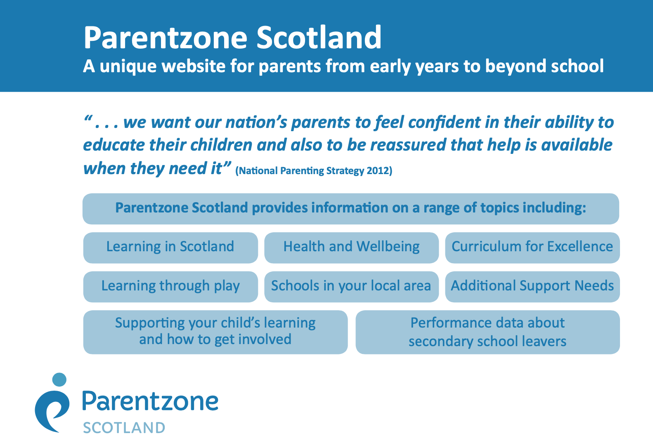. 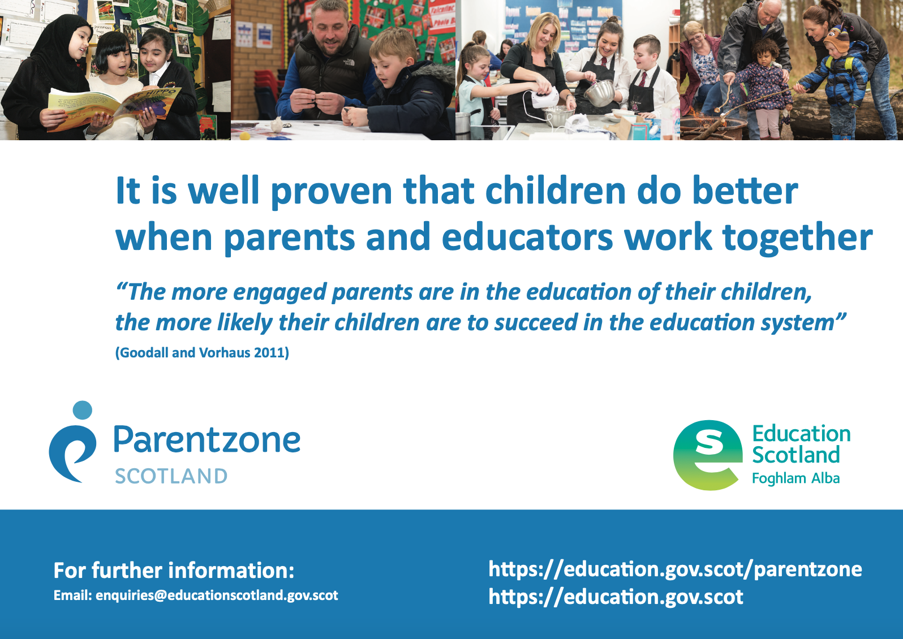

Relationships Policy

Our Relationships Policy is heavily research based and has a high element of restorative and reflective conversations incorporated within it.

At Alva Primary School we understand that positive relationships and behaviour are key to all learning. As a staff, we recognise that children achieve best when they learn in a nurturing and structured environment where high standards are expected, demonstrated and maintained.

“Developing good relationships in the classroom, playground and wider community is essential for creating the right environment for effective learning and teaching. Where children and young people feel included, respected, safe and secure and where their achievements and contributions are valued and celebrated, they are more likely to develop self-confidence, resilience and positive views about themselves. This applies equally to all staff in the learning community.”

(Better Relationships, Better Learning, Better Behaviour, Scottish Government, 2013)

Clackmannanshire Council are at the forefront of brain-based, attachment-led and trauma-informed practice. We have worked with Educational Psychologists to learn more about attachment theory and nurturing principles. Our aim was to work towards a research-based Relationships Policy that would maintain high standards of behaviour and reflect that all behaviour is communication.

This policy has been developed following consultation with pupils, parents/carers, staff and our partners. It is written in conjunction with Clackmannanshire Council’s Building Positive Relationships for Establishment Improvement (2018) guidelines and it is underpinned by the UN Convention on the Rights of the Child (UNCRC), Getting It Right for Every Child (GIRFEC) and the principles of nurture and restorative practice.

At Alva, building positive relationships is at the heart of what we do. In doing so, we recognise that we all have feelings and emotions, but how we behave in response to our feelings is a choice. Making good choices consistently isn’t always easy and often requires help, support and modelling from adults.
This policy sets out the behaviours that we expect of everyone at Alva and are founded upon our core values of being safe, ready and respectful.

To build a positive learning environment, both children and adults need to work together to establish and sustain a culture of responsibility and co-operation. An effective and positive learning environment will include:
- a Class Charter, based on the UNCRC, displayed prominently which has been agreed, referred to and reviewed regularly by staff and pupils.
- simple, clear and predictable routines.
- use of visual cues.
- meaningful positive feedback for all children.

Please refer to our Relationships Policy for full details of how we use restorative approaches to create a restorative culture and ethos where children demonstrate self-regulating behaviour and are ready to learn.

Achievements out with school are very important to us and to a child’s development. We encourage children to tell us about these achievements so that they can be celebrated with us here as well.

Exclusion
Exclusion is a legal process. Exclusion from Alva Primary School will only happen as a last resort, when all other measures and a range of strategies have been unsuccessful, or in extremely serious incidents.

Assessment and Reporting

As pupils progress through school, teachers use a range of assessment strategies, including standardised testing. Learners in P1, P4 and P7 complete online standardised assessments in literacy and numeracy. The assessments help to identify children’s progress, providing diagnostic information to support teachers' professional judgement. Further details can be found at:
https://standardisedassessment.gov.scot/parents/carers-and-carers/

Pupils are also involved in assessing their own progress and identifying their next steps in learning.

We recognise that pupils do not develop and progress at the same rate and adapt teaching approaches for each child accordingly. Please contact the school as soon as possible if you have any concerns about your child’s progress. Parents/carers have the opportunity to find out about their child’s learning through a range of means; such as learner progress meetings, open afternoons, meet the teacher events, Staged Intervention meetings and ongoing discussions with teachers and leaders. Parents/carers are also kept abreast of the learning within the class through regular Curriculum Newsletters and our Google Classrooms. These are issued via email and also available on our school blog.

Pupil Summary Reports are issued to parents/carers, who have an opportunity to comment on these. In addition, of course, parents/carers are welcome to contact the school at any time to ask for information or for an appointment to consult with the Head Teacher or their child’s class teacher.

Additional Support Needs

As with all local authority schools in Scotland, this school operates under the terms of the Education (Additional Support for Learning) Scotland Act (2004) as amended 2009 and its accompanying Code of Practice (Third Edition) 2017 . Further details of the policies and procedures can be found on the Clackmannanshire Council website: https://www.clacks.gov.uk/learning/asl/ These procedures have been strengthened through the Children and Young People (Scotland) Act (2014).

Schools and Early Learning Centres (ELC) work closely with parents/carers/carers and other agencies and professionals such as Social Work Services, Educational Psychology Service, National Health Service to ensure that decisions are made jointly with parents/carers, children and young people with regards to the best possible education to meet the needs of the child within the resources available.

Further information on how support for learning is organised in Clackmannanshire is available by contacting either the school, or the ASN team at Kilncraigs on 01259 452441 or by email asn@clacks.gov.uk

Pupils’ additional support needs will be identified and addressed through the Getting It Right For Every Child processes. This involves close co-operation between the parent or carer, the child and the staff in school – they are the core part of the Team Around the Child. Others involved in your child’s education and well-being will also be part of the Team, and will help to complete a rounded picture of assessment where appropriate. The Team will also draw up and review plans to meet the needs identified. If you believe your child may have unrecognised additional support needs, your first point of contact should be the child’s class teacher.

The school makes provision for pupils with additional support needs throughout their education:
- each teacher differentiates the curriculum within their class to provide educational targets and objectives suited to their age and stage of development.
- the school has an experienced Support for Learning Teacher to co-ordinate and organise support for children.
- the school can call on the time of a Support for Learning Assistant for exceptional cases.

Where there is concern about the progress of individual pupils, parents/carers are informed at an early stage. With parental/carer support, we may also seek further assessment and advice from a variety of other agencies including Speech and Language Therapy, Psychological Services and Primary School Support Services. We implement the Staged Intervention Procedure in Alva and full details are available at
https://www.clacks.gov.uk/site/documents/education/stagedinterventionguidance/

Information and leaflets for parents/carers and young people can be found on the Council’s website http://www.clacksweb.org.uk/learning/asl/ More information on The Education (Additional Support for Learning) (Scotland) Act 2009 is provided by Enquire – the Scottish advice service for additional support for learning. Operated by Children in Scotland, Enquire offers independent, confidential advice and information on additional support for learning. They can be contacted on 0845 1232303, via info@enquire.org.uk. Further information is available at www.enquire.org.uk and www.enquire.org.uk/yp.

The Scottish Government have a duty to provide an advocacy service to parents/carers and young people following a reference being made to the Additional Support Needs Tribunal for Scotland (ASNTS). Ministers have also agreed that the advocacy service should also provide support for parents/carers and young people from the time they have grounds to make a reference to the ASNTS. It will be a national service and available to parents/carers and young people on request and free of charge.

The Additional Support Needs Tribunal for Scotland also places a duty on Clackmannanshire Council to provide access to mediation and dispute resolution services free of charge to parents/carers who have made a successful placing request from another Authority.

This service will be provided through a partnership between Kindred Advocacy Service and the Scottish Child Law Centre, known as “Let’s Talk”. The two organisations will work together to deliver lay and legal advocacy for parents/carers and young people. The service will focus on non-legal representation, but where appropriate in complex cases, legal representation will be available. For further information on this National Advocacy service please contact the Scottish Child Law Centre on 0131 667 6333, via enquiries@sclc.org.uk or visit www.sclc.org.uk

Creative Therapeutic Interventions for Children

Clackmannanshire Education Service is working in partnership with Inscape Therapies and Reachout with Arts in Mind to provide support to children and young people who are experiencing mental health and wellbeing issues.

Creative Therapeutic Interventions for Children (CTIfC) is a targeted service available to 5 – 9-year-old children across Clackmannanshire’s primary schools. It offers developmentally appropriate resources which include:
Music Therapy – Inscape Therapies

Music therapists are fully qualified and registered. They deliver a longer term one to one service in school or remotely to children who are experiencing issues such as trauma, bereavement, loss and anxiety.
Referrals are made through the GIRFEC forum.

Therapeutic Art – Reachout with Arts in Mind
The qualified artists from Reachout offer a 6-session group work programme to children in an identified school. The group focuses on building resilience, self-esteem and confidence through art and is delivered in school supported by school staff.
The school is offered this service and refers children through the Counselling in Schools Coordinator.

Other Support Services

Several support services are readily available to the school. Clackmannanshire Education Service provides advice and support regarding overall issues of quality and effectiveness. Other services provide advice and/or assistance about how best to meet the needs of an individual child or group of children. Staff from the Primary and Secondary Schools Support Service offer experience in working with children with social, emotional or behavioural difficulties; staff from Psychological Services provide assessments of and support for a range of needs and the school can link with social services over matters of family and child welfare.
Educational Psychology Service

Educational Psychologists (EPs) work together with families, schools and ELCs and other professionals, to help meet children and young people’s educational needs.
Educational establishments can make referrals to the Educational Psychology Service as part of the Staged Intervention process, once they have obtained the agreement of parents/carers and, where appropriate, the pupil.

Parents/carers can also contact the service directly through the Telephone Consultation Line which operates Monday - Friday, 9.30-12pm in term time.

Counselling in Schools Services

Clackmannanshire Education Service and Wellbeing Scotland are working in partnership to provide support for children and young people who are experiencing mental health and wellbeing issues.

Counselling in Schools is a universal service available to all 10 – 18-year-old pupils in Clackmannanshire and each Secondary School has the equivalent of one, full time counsellor on site. Counsellors are also available to support Primary Schools and ASN Settings.

Counsellors are professionally qualified and registered offering focused, longer- term support for issues such as trauma, depression, anxiety, bereavement, loss and separation. They offer a confidential, one-to-one service in school or remotely, with the service being available during the school holidays. Referrals for counselling are made directly to Wellbeing Scotland by the school.

School Health Service

Forth Valley NHS Board fulfils a statutory obligation to provide a health service for all school age children in Clackmannanshire. The aim of the service is to make sure that all children are in the best possible health to benefit from their education and to provide the Education Authority with advice about the spread of infections and the promotion of good health. This service is provided by staff from Forth Valley Primary Care NHS Trust.

Vision Screening is carried out at pre-school by a specialist service. Hearing is no longer screened in school but any concerns about your child’s hearing should be discussed with the school nurse who can arrange a fast-track referral to the audiology department. During their time at school, children are offered various immunisations and parents/carers are asked for written consent for these.

Parents/carers, and school staff with parental/carer consent, can request a consultation with the school nurse at any time.

The NHS in Scotland runs a programme of dental inspections of children in Primary 1 and Primary 7. The aims of the National Dental Inspection Programme are:

- To inform individual parents/carers of the dental health/oral health status of their children.
- To provide Scottish Government and NHS Boards with information on trends in dental disease in children in order to monitor oral health and plan dental services.
- To support dental attendance in those children who are found to have need of dental care

For more information, please visit https://ndip.scottishdental.org/

The children in our school participate in the Childsmile Programme in the Nursery only. Childsmile is a national programme designed to improve the oral health of children in Scotland, and reduce inequalities, both in dental health and access to dental services. For further information on Childsmile visit https://www.childsmile.nhs.scot/

From time-to-time children may have clinic appointments (eye clinics, dentist, doctor, etc.) during school hours. Please let the school know about these visits and arrange for your child to be collected. For personal safety reasons, children are not allowed out of school during school hours unless accompanied by a responsible adult or unless written permission to do so has been given by the parent or carer. When you, or another authorised adult, take a child out of school, you will be asked to sign a register.

Colds, flu and gastro-enteritis are the most common infections affecting children of school age. Please keep your child off school in the early stages of flu. Following episodes of sickness and/or diarrhoea, pupils are required to stay at home for 48 hours. For advice about early detection and treatment for other infectious diseases e.g. chickenpox and mumps, consult your GP or Health Visitor.

Our community and school nurse is Zsanett Kanyo. She works closely with the school and can be contacted through https://nhsforthvalley.com/health-services/az-of-services/school-nursing-team/

Head lice are spread through head-to-head contact at home, while playing or in school. Regular combing of your child’s hair using a head lice detection comb is the best way to catch this possible problem at an early stage. The only way to be sure that your child has head lice is to find a live louse. If you find live lice, appropriate treatment can be sought from your doctor or pharmacist free of charge. Ordinary shampoos and other treatments are not effective. One treatment requires two applications of treatment lotion seven days apart. If this is not followed correctly then re-infection is likely.

We are not permitted to notify parents/carers of outbreaks of head lice within the class/school. Advise all family members and close friends of your child to check and treat only if live lice are found. Don’t be shy about advising others of this possible problem as you would tell family and friends about other infections which might affect them. Regular combing of your child’s hair with the head lice detector comb is the best protection as it allows you to detect and then treat speedily. Further advice can be obtained from the Health Board head lice leaflet which is available in all schools and health centres.

Disputes and Resolution in Additional Support Needs

Schools and Early Years facilities do their best to support pupils and are responsive to the needs of parents/carers, and pupils. Nevertheless, problems may arise, and it is important to deal with these as soon as possible.

In the first instance it is most appropriate to contact the school or ELC directly, and if the matter cannot be satisfactorily resolved, you may wish to discuss with the Quality Improvement Officer ASN or the Senior Manger Inclusion and Partnerships. If this cannot be resolved at this level, Children’s Services also commission independent mediation through Children in Scotland. Their services, called Resolve, may be arranged by the Additional Support for Learning Adviser, or accessed directly by parents/carers at https://resolvemediation.org.uk/

Parents/carers and children with additional support needs can also seek independent advice and support through:

Enquire – the Scottish advice and information Service for additional support for learning: www.enquire.org.uk
Scottish Independent Advocacy Alliance; https://www.siaa.org.uk/
Take Note: National Advocacy Service for Additional Support Needs (Barnardo’s in association with the Scottish Child Law Centre) www.sclc.org.uk
Let’s Talk ASN https://www.barnardos.org.uk/get-support/services/lets-talk-asn-scotland

Safeguarding

Our safeguarding policy applies to all staff, students, volunteers (including parents/carers) and any other adult working with or supporting the school.

The policy aims to:

- protect and ensure the safety and wellbeing of all children in Alva Primary School
and Nursery Class.
- provide all staff and adults with the necessary information that guides our approach to
safeguarding and child protection.

Alva staff do this by:

- Creating and maintaining a positive, inclusive and nurturing ethos.
- Developing health and personal safety programmes.
- Being observant of children’s needs, views and concerns.
- Reporting and recording concerns about the welfare or safety of children.
- Monitoring and supporting children in co-operation with relevant professionals, parents/carers and
carers.

The school actively supports children and young people to develop their knowledge and skills about personal safety and to be confident in expressing any anxieties about their own wellbeing. This is encouraged through our Health and Wellbeing programme.

The safety of children is everyone’s responsibility. If staff have any concerns for a child or young person’s wellbeing, they have a duty to pass on information that will help keep that child safe. All school staff receive Child Protection training at the beginning of a new academic year and complete training modules.

Getting it Right for Every Children (GIRFEC) is the Scottish Government’s approach to improve children’s services. The wellbeing of all children and young people is at the heart of GIRFEC. Services must work together with children, young people and their families to provide quick and effective support when it is needed. The children and Young People Act (Scotland) 2014 will mean key parts of GIRFEC become law in 2016.

Wellbeing
The Getting it Right approach looks at eight areas of 'well-being'. These are recognized as areas in which children and young people need to progress in order to do well now and in the future. They allow those responsible for the care and support of children - including members of their own families - to look at a situation in a structured way that will help them identify any needs and concerns and plan with the child and family any action they need to take. The eight well-being indicators are:

Safe, Healthy, Achieving, Nurtured, Active, Responsible, Respected and Included

The approach gives a common language and a way to gather information about a child's world, making sure the child is growing and developing, and has everything they need from the people who look after them both at home and in the wider community. It also encourages practitioners to think about who else might need to be involved (for example a teacher might need to contact other professionals to make sure that an education improvement plan with the child and family was meeting all the child's needs).

Named Person

Every child and young person will have a Named Person to make sure their wellbeing is promoted
The role of the Named Person in health or education, depending on the age of the child, is to act as the first point of contact for children and families. Through children and families knowing who to contact, their access to help is made easier

Who is my named person?

Stage of child/young person | Named Person
From pre-birth – until starting school or 5 years old | Health Visitor
Primary-aged children | Mrs Nicola Ferguson, Head Teacher

Equalities

Clackmannanshire Council has developed Council-wide policies for diversity, race, disability and gender equality, which aim to ensure that all Council employees are aware of their responsibilities to ensure that no child or young person will receive a less effective service on grounds of ethnicity, disability or sexual orientation.

Racist or Bullying Behaviour
Any incident of racist or bullying behaviour is unacceptable and must be recorded through SEEMIS, our Education Management Information System, in line with Clackmannanshire Council’s policies and procedures. These incidents are reported annually to the local authority.

A working party across Clackmannanshire have created an Anti-Bullying Strategy, in consultation with national bodies, parents/carers, pupils and educators. This can be found here: https://www.clacks.gov.uk/site/documents/education/antibullyingpolicy/
Alva’s Anti-Bullying Policy has been created to sit alongside our Relationships Policy.

Administration of Medicines

Whenever possible prescribed medication should be administered at home. Parents/carers are most welcome to come to school to personally administer medication if required during the school day. If this is not possible a consent form must be signed and the medication brought to school by the parent or carer. Pupils should not carry medication to school. The school will not administer non-prescribed medication or prescribed medication without the above conditions being met.

If your child is asthmatic and requires medication, an appropriate medication consent form should be signed. Parents/carers are required to provide two named inhalers for their child, which will be stored in the first aid room and/or by the Class Teacher. Any bespoke arrangement; for example, where children are old enough to carry their own inhalers should be documented in the accompanying paperwork and signed by the Head Teacher or Depute Head Teacher. In this case, the spare inhaler kept by the class/school teacher is an emergency, back-up supply in the event that the child’s personal supply is depleted.

Please contact the Head Teacher if you require any further clarification.

Feedback, Concerns and Complaints Process

We welcome feedback from parents and carers regarding all aspects of the service we provide, helping us to recognise areas of strengths and areas for improvement. Please feel free to contact us if you have any ideas for improvement or any concerns. We regard a concern as an expression or dissatisfaction about our action or lack of action, or about the standard of service provided by us or on our behalf. Should you remain unsatisfied after raising a concern with the Head Teacher, you have the right to raise a complaint.

Who can complain? The parent or legal guardian of a child or a person authorised to complain on his/her behalf. For example, a child’s grandparent who is not the legal guardian needs authority from the child’s parent or guardian. This would normally mean a note to show that the person responsible for the child had agreed.

What can’t I complain about?

Here are some things we cannot deal with through our complaint’s procedure:

• A routine first time request for a service or action – e.g. informing the school that your child told you she is being bullied and asking them to resolve this.
• Requests for compensation from the Council.
• Things that are covered by a right of appeal, e.g. Exclusion from school which has its own statutory process.

In these cases, we will give you information and advice to help you.

We have a two stage Complaints Procedure.

Stage One - Frontline resolution

In the first instance please complain to your child’s school or nursery, telling them as much as you can about the complaint, what has gone wrong and what you want them to do to resolve the matter. A senior member of staff, either the Head Teacher or Depute Head, will be responsible for looking into complaints. Heads are senior managers with a high level of responsibility for your child’s learning and welfare and able to look into most matters. However, the Head Teacher may refer the Stage One complaint to Education Services centrally, e.g. if it is about the conduct of the Head Teacher or too complex to be dealt with at front-line service level. The school or nursery will give you our decision at Stage One within five working days or fewer unless there are exceptional circumstances. If we need further time, we will ask you to agree an extension of up to five further days. If the Stage One complaint has been referred to Education centrally your response will come from there.

Stage Two – Investigation

If you are dissatisfied with your Stage One response you can move to Stage Two. Stage Two deals with 2 types of complaints: those not resolved at Stage One and those not appropriate for Stage One, for example the conduct of a Head Teacher or those which are too complex for a Head Teacher to deal with.

To move to Stage Two, you should contact the Head of Education and ask for a formal investigation under Stage Two. You can do this by contacting the education service at Kilncraigs 4th floor, Alloa

When using Stage Two:

• We will acknowledge your complaint within 3 workings days.
• You will be contacted by the Investigating Officer for your complaint, who will usually meet you to confirm: the detail of your complaint, what you want to achieve, and if your expectations are achievable. In some cases, e.g. your complaint has been made in writing and is clear, there may be no need to meet. It is helpful if you present any evidence that you can offer in support of your complaint, e.g. contact details for witnesses, reports from other professionals etc. if appropriate.
• We will write to you confirming the details of your complaint, what you want to achieve, and what the investigation can cover.
• We will give you a full, written response to the complaint as soon as possible and within 20 working days.

If our investigation takes longer than 20 working days, we will agree revised time limits with you and keep you updated on progress.

After we have fully investigated your Stage Two complaint, if you are still dissatisfied with our decision or the way we dealt with your complaint you can ask the Scottish Public Services Ombudsman (SPSO) to look at it. The SPSO cannot normally look at:

• A complaint that has not completed our complaints procedure.
• Events that happened or you became aware of, more than a year ago.

Parent Council

Alva Parent Council’s vision is to be an inclusive, friendly and open group that helps to help support communication, to aid curriculum development, to raise funds, provide a voice for parents/carers and support the school to deliver the very best possible education for all our children.

All parents and carers are very welcome to attend Parent Council meetings; dates can be found on the Parent Council Facebook page. Alva Primary School P.T.A & Parent Council | Facebook

Alva is fortunate to have an active and supportive Parent Council. Our Parent Forum consists of all parents/carers in our school community. Parent Council information can be found on the outside notice board, and on the school website.

Community Links

The school provides an invaluable focus for the community and is used by clubs and groups for their activities. We believe we have a responsibility to ensure that the life and work of the school is appropriately shared by the community and endeavour to assist and support local groups. Wherever possible we utilise the resources of our community to support our social studies programme.

School Security

Clackmannanshire Council aims to provide a safe and healthy environment for all pupils, staff and other school users. Safety and school security have been a key focus since 1997 when the Council involved all schools and school communities in the preparation of safety and security action plans. Since then, these plans have been implemented in a systematic way. Work undertaken in schools has included:

- Creation of a one door entry system during normal school hours.
- Installation of electronic doors locking mechanisms.
- Erection of signs directing visitors to the single door entry point.
- Introduction of an entry procedure for visitors including the issue of security visitor pass.
- Introduction of staff identification passes.
- Use of mobile radios for staff working alone such as playground supervision.

All schools have had their door entry construction work completed and all schools are using the visitor pass system.

Your co-operation and assistance in complying with school access arrangements is greatly appreciated as the safety of children and staff is at the heart of this programme.

The provision of additional security measures in Alva Primary has ensured that all entrances to the school are locked whilst the children are inside. These locks also operate as emergency exits internally. The only entry point for visitors and parents/carers is via our front main entrance. Only parents/carers visiting the nursery should use the nursery entrance door, which has its own separate secure entry system. All other parents/carers and visitors to the school are requested to report to the main front entrance for security clearance.

We have a clearly delineated fenced perimeter around the school grounds. Pupils are able to access the playground either from Brook Street or Greenhead. The access road to the school, at Greenhead, is only to be used by cars for those who require access to houses. In all other cases, cars should not use this access road. Pupils are welcome to cycle or scoot to school. Bikes and scooters should be dismounted before entering the playground, at which point they can be pushed through the grounds. Bikes and scooters should be locked up and are done so at personal liability to the owner.

Parents/carers are requested not to bring cars into the staff car parking areas because of the limited space and for safety reasons. Additionally, parking in the CAP car park is restricted between 8.30 to 9.15 and 2.30 to 3.15 in order to allow access for our ASN provision taxis and buses. This is signposted in the car park area.

For those children living in outlying areas that are transported by the authority the pick-up point for their transportation is at the main entrance door. In the event of late coming, pupils may also use the front entrance.

We appreciate your help and co-operation.

School Transport

Clackmannanshire Council has a Home to School Transport Policy, which can be found using the following link - http://www.clacks.gov.uk/learning/hometoschooltransport/

School Uniform

At Alva Primary all children are encouraged to wear school uniform so that we can continue to grow our positive identity as a school community. School uniform helps to promote our positive school image and creates a feeling of equality and inclusion. We appreciate the considerable efforts and support that you, as parents/carers, make to ensure the smart appearance of our children. We gathered views of families on uniform through a consultation process. The overwhelming majority (93%) were in favour of school uniform.

To ensure that the cost of living is not a barrier, we request the following:
• Black trousers, skirt, pinafore, shorts, leggings or joggers
• Black trainers or shoes
• White/black polo shirt (with or without Logo), shirt or blouse
• Black jumper, sweatshirt, or cardigan (all with or without logo)
*Please note hoodies are not school uniform

We also consulted families on their views about changing for PE. The feedback was mixed and given our lack of high-quality changing spaces; we request that children come to school on PE days in their kit. All classes will be advised of PE days in the first week back after summer and any changes communicated through the School App and/or Group Call.
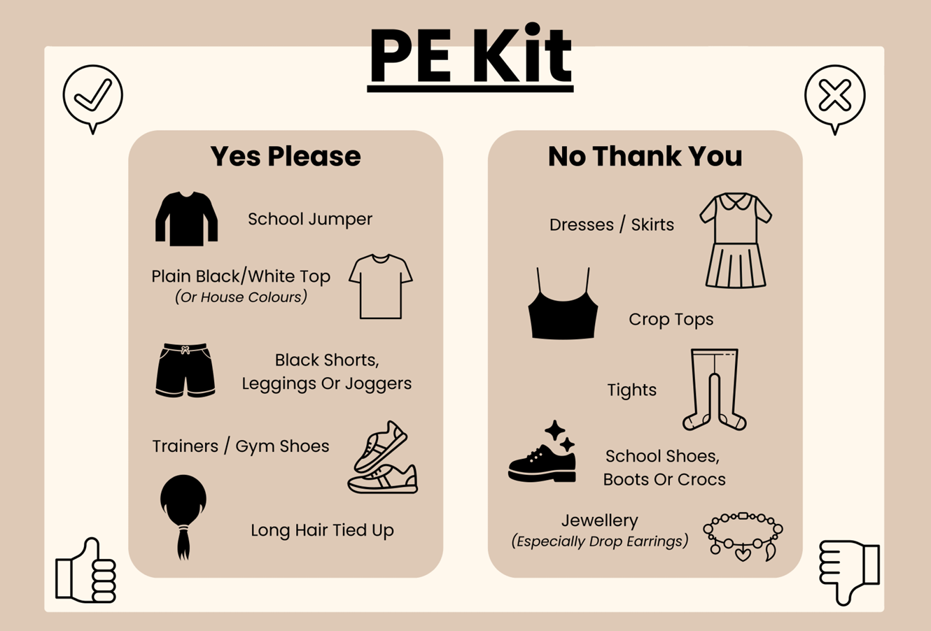

PE kit:
• Black joggers, leggings, shorts (these may be worn underneath)
• White polo shirt or t-shirt in house colours - all children will be
reminded of their houses
• Change of footwear is essential to maintain cleanliness of the gym hall.

*Please note that unbranded items are preferred and no hoodies of any colour. Please ensure all jewellery is left at home on P.E. days and long hair is tied back for safety reasons.

Please ensure that all uniform and other items are labelled with your child's name so that any lost property can be found by your child.

There is a selection of school uniforms available for free in the school foyer. Please feel free to take what you need and give what you can. Pre-owned uniform is also available from Gate uniform project. The school uniform can also be purchased from Scotcrest in Alva.

The nursery uniform is a green sweatshirt and a yellow polo shirt. There is a selection of nursery uniforms available for free in the nursery. Please feel free to take what you need and give what you can. The school uniform can also be purchased from Scotcrest in Alva.

Mobile Phone and Recording Devices

Camera mobile phones are now the norm and a built-in digital camera enables users to take high resolution pictures. These can be sent instantly to other mobile phone users or email addresses. They can also be posted on the internet or in chat rooms. There is a potential for camera mobile phones to be misused in schools. They can become an instrument of bullying or harassment directed against pupils or/and staff. We strongly discourage pupils bringing mobile phones to school.

Pupil Policy

While we fully acknowledge a parent’s right to allow their child to bring a mobile phone to school if they walk to and from school without adult supervision, Alva discourages pupils bringing mobile phones to school due to the potential issues raised above.

When a child needs to bring a phone into school, the phone must be left with the school office at the start of the day and collected at the end of the day. Phones should be clearly marked so that each pupil knows their own phone. Parents/carers are advised that Alva accepts no liability for the loss or damage to mobile phones which are brought into school or school grounds, whether handed to the class teacher or not.

During the school day, on excursions and at after school/lunch clubs pupils are not permitted to use their phones or similar recording devices.

Our Mobile Phone Policy can be obtained from the school office.

Extra-Curricular Activities

There are many activities for children after 3.00 pm and, occasionally, before 9.00 am or at lunchtime. Some are organised by the school; others are run by separate clubs or by parents/carers and children. A brochure displaying all available clubs is issued to pupils.

School Clothing Grants

If your child/ren attends one of our primary, special or secondary schools, you may qualify for a school clothing grant. This is currently £120 per child. School clothing grants will not be paid to children attending nursery schools, nursery classes or other pre 5 centres.

To qualify for a school clothing grant you must be in receipt of Child Benefit and one of the following benefits:

• Income Support.
• Income-based Job Seekers Allowance.
• Income-related Employment and Support Allowance.
• Maximum Working Tax Credit and Maximum Child Tax Credit with an income below £6,420.
• Child Tax Credit where NO Working Tax Credit is payable and income is less than £16,105 (as assessed by Inland Revenue).
• An asylum seeker in receipt of support under part VI of the Immigration and Asylum Act 1999.
• You may also be eligible if you are in receipt of Universal Credit.

If you think you qualify, please contact the Business Support Team on 01259 450000 for further information. Application forms can be obtained from schools, CAP offices and the Council Offices at Kilncraigs; also, by accessing https://www.clacks.gov.uk/learning/schoolclothinggrants/ Applications may be made at any time during the session.
School Meals
Primary and Secondary Menus offer healthy and tasty meal options whilst reflecting the Scottish Government food and drink legal requirements for School Lunches. Special diets and allergies are usually accommodated subject to consultation with the parent and the regional dietician. Meal prices are reviewed annually. Please contact the school to be advised of the current price.

Free School Meals

All P1-P5 pupils are entitled to a free school meal. In the case of P6-P7 and secondary aged pupils, some families may be eligible to apply to Clackmannanshire Council for provision of free school meals. Where a pupil is in P1 to P5 and parents/carers meet the eligibility criteria, you can apply for free school meals in order to receive free breakfast club and holiday food payments. Further details can be obtained from your child’s school or on the Clackmannanshire Council website - https://www.clacks.gov.uk/learning/freeschoolmeals/

If you think you qualify, please contact the Business Support Team on 01259 450000 for further information. Application forms can be obtained from schools, CAP offices and the Council Offices at Kilncraigs; also, by accessing: https://www.clacks.gov.uk/learning/freeschoolmeals/
Applications may be made at any time during the session.

Pupils registered for free school meals are also eligible for free milk and for free breakfast, whether or not they take a school lunch.

Help with Free School Meals Application Form

The school staff would be happy to support anyone completing this form on a one-to-one basis.

Food in Schools

Schools in Clackmannanshire are taking a whole school approach to food, through Health Promoting Schools and in implementing the recommendations of The Schools (Health Promotion and Nutrition) (Scotland) Act 2007. If your child has a food allergy or needs a special diet, please discuss this with the Head Teacher and the Catering Department. You can also find more information by accessing: https://www.clacks.gov.uk/learning/allergyintdiets/

Breakfast Club

The primary school breakfast comprises:

- Tea, fresh semi-skimmed milk or water.
- A piece of fresh fruit or a glass of fresh, unsweetened apple or orange juice.
- A selection of cereals with milk.
- Toast or crusty bread with butter or jam.

The service is available free of charge to children entitled to free school meals. All other children can purchase a breakfast. Please contact the school to be advised of the current price. Payment can be made via ParentPay. Children are supervised when in the dining hall and remain there with activities to do until the bell rings at 9am when they go to their classroom.

Lunch

School Menu Selector is displayed in classes and at reception. All pupils are issued with a menu at the start of the school year or can view the selections here: https://www.clacks.gov.uk/learning/schoolmenus/

The schools (Health Promotion and Nutrition) (Scotland) Act 2007 has had a significant effect on school lunches. Our hot plated menu meets the https://www.gov.scot/publications/healthy-eating-schools-guidance-2020/documents/
In primary schools, a two-course lunch is available where the pupils can freely choose from the bread basket and also have the option of milk and water with their meal. These choices are included with all meals. Please contact the school to be advised of the current price.
Each lunch is guaranteed to contain a healthy balance of nutrients and is low in fat and salt.

A three-weekly menu cycle is in operation in Clackmannanshire Primary Schools. Pupils order their lunches each morning and are the prepared to order. Pupils are given a coloured band which matches their lunch choice that day. This band is shown to the catering staff who give the meal that has been selected. This saves food waste and ensures all pupils can have their selected meal. Therefore, it is important that your child is aware that they cannot change their lunch option at lunch time. Please support younger pupils in their decisions to avoid disappointment.

All school lunches are produced centrally by a cook freeze system. In this production system, food is produced in batches, rapidly cooled and frozen to preserve flavour and vitamin content, then transported to each primary school to be finished and served. Food is served from multi-portion dishes in much the same way as it has always been. Salads and fruit are still freshly prepared in every school.

By investing in the cook freeze production method, in raw ingredients and in new recipes, we have improved the quality of food provided. The cook freeze system is extremely good in terms of food safety, portion and cost control. Efficient management of the production system means more funding can go into the food.

Special menu days are held throughout the year and will be advertised e.g. Christmas, International Week.

The service constantly reviews raw ingredients and recipes and where possible, try to source produce locally.
Clackmannanshire Council is committed to promoting the uptake of school lunches; we believe that this is consistent with our efforts to have all our schools health promoting and delivering a Curriculum for Excellence.

Packed Lunches

At Alva many children choose to bring a packed lunch to school each day. Provision is made in the school gym hall for those children to eat lunch at the packed lunch tables. Children bringing a packed lunch to school should bring it in a container clearly labelled with their name. Lunch boxes are stored in labelled class tubs. These tubs are taken to the packed lunch hall prior to lunchtime. Pupils then put their empty packed lunch box back in the tub and it is collected after lunchtime and returned to class. Unless particularly messy, packed lunch waste is sent home with children to allow parents/carers to monitor what has been eaten at lunch times. We encourage diluted juice or water to be brought with a packed lunch in a carton or bottle; no cans or bottles of fizzy juice are allowed in school.

Children staying for lunches are supervised at all times and are not allowed to leave the school grounds.

Water Bottles

We encourage all of our pupils to drink water regularly in school. Research states that keeping the brain hydrated helps children to learn more effectively. We recommend that your child brings a filled water bottle to school, which can be refilled during the school day, from the classroom tap. Please ensure that your child’s water bottle has their name on it. The responsibility for cleaning the water bottle and ensuring appropriate hygiene levels rests with you as parents/carers. We do not have appropriate water bottle washing facilities in school. We recommend that your child takes their water bottle home daily for cleaning and refilling. The bottle should be filled at home and brought back to school in the morning. It is important the bottle is returned full. The congestion caused by multiple children refilling bottles each morning would be considerable.

Parent Pay

At Alva we are a cash-free environment. Most parents/carers use a secure online service called ParentPay to pay for lunches, breakfast club etc. ParentPay offers you the freedom to make payments whenever and wherever you like, 24 hours a day, 7 days a week - safe in the knowledge that the technology used is of the highest internet security available.

You will have a secure online account, activated using a unique username and password; you will be prompted to change these, and to keep them safe and secure. If you have more than one child at our school or children at another ParentPay school, you can create one single account login for all your children regardless of which school they attend.

Making a payment is straightforward and ParentPay holds a payment history for you to view at a later date; no card details are stored in any part of the system. Once you have activated your account you can make online payments straight away.

For further information on ParentPay please visit www.parentpay.com

Inclement Weather Arrangements

There are rare occasions when the children may be dismissed early without warning (e.g. power cuts or inclement weather). In the event of this happening, every effort will be made to contact you or your child's emergency contact directly. It is important that you notify the school immediately of any changes to your child’s emergency contact. During extremely wet or inclement weather (e.g. snow and frost), children may remain in school at morning interval or after school lunch. There will always be a cleared, gritted walkway to entrances and children, parents/carers and visitors are advised to use this. Stevie Torrance, our janitor ensures that all fire exits remain clear of snow and ice.

Playground Supervision

Children are supervised in the playground during intervals and lunchtimes by our learning assistants and members of the school management team in accordance with the Authority's policy. The primary school day begins at 9.00 am. Children should arrive at school in time to enter classes punctually.

In cases where children are sent or brought to school so early as to cause concern about their welfare, Head Teachers will draw this to the attention of parents/carers. If such early arrival persists and if the child is regarded as being at risk, in accordance with Local Authority guidelines, the Head Teacher will refer the child to social services.

Secondary School

At the end of P7 pupils normally transfer to:
Alva Academy
Academy Avenue
Alva
FK12 5FE
Tel. No. 01259 452322
https://sites.google.com/cl.glow.scot/alvaacademy/home

Alva Academy provide a programme of transition events. If your child is transitioning to a different Secondary School, then the onus will lie with the parents/carers to contact the receiving school to make transition arrangements and transport your child to and from these events.

Please also refer to https://www.clacks.gov.uk/learning/placementrequests/

Education Statistics Privacy Notice

The Scottish Government and its partners collect and use information about pupils in schools (e.g. the number and characteristics of pupils, their attendance, absence and exclusions, their attainment and their destination when leaving school) to help to improve education across Scotland. This note explains why we need this information, how we use it and what we do to protect the information supplied to us.

Why do we need your data?

In order to make the best decisions about how to improve our education service, Scottish Government, education authorities and other partners such as the SQA and Skills Development Scotland need accurate, up-to-date data about our pupils. We are keen to help all our pupils do well in all aspects of school life and achieve better examination results. Accurate and up-to-date data allows us to:

- plan and deliver better policies for the benefit of all pupils
- plan and deliver better policies for the benefit of specific groups of pupils
- better understand some of the factors which influence pupil attained and achievement
- share good practice
- target resources better
- enhance the quality of research to improve the lives of young people in Scotland

Data Policy

Information about pupils’ education is collected through our statistical surveys in partnership between the Scottish Government and Local Authorities through the ScotXed Programme which aims to help schools and Local Authorities by supporting efficient collection, processing and dissemination of statistical information. The Scottish Government then provides analysis of the data to support research, planning, management and monitoring of education services as well as to produce National Statistics publications.

Education data within Scottish Government is managed effectively by secure systems and is exploited as a valuable corporate resource, subject to confidentiality restraints. As part of its data policy, Scottish Government will not publish or make publicly available any information that allows individual pupils to be identified, nor will data be used by Scottish Government to take any actions in respect of individuals. Data is held securely and no information on individual pupils can or would be made publicly available by Scottish Government.

The individual data about pupils in schools collected by Scottish Government through statistical surveys is used only for the statistical and research purposes for which it is collected.

Your data protection rights

The collection, transfer, processing and sharing of ScotXed data is done in accordance with the Data Protection Act (1998). We also comply with the National Statistics Code of Practice requirements and other legislation related to safeguarding the confidentiality of data. The Data Protection Act gives you the right to know how we will use your data. This note can give only a brief description of how we use data. Fuller details of each individual ScotXed survey, including the purpose of each and the published data, can be found on the ScotXed website (http://www.gov.scot/Topics/Statistics/ScotXed). Pupil names and addresses (other than postcode) are never collected in any ScotXed statistical survey.

Scottish Government works with a range of partners including Education Scotland, Skills Development Scotland and the SQA. On occasion, in order to help meet our aim of improving the life of young people in Scotland, we may make individual data available to partners such as the National Registers of Scotland to carry out research relating to the national population census and also to academic institutions and organisations to carry out additional research and statistical analysis which helps inform policy development and contributes to improving outcomes for Scotland’s people. In order to carry out this research to support better decisions, policy making and practice, data may be linked to information from other sources.

Any sharing or linkage of data will be done under the strict control of Scottish Government, and will be consistent with our data policy and the National Data Linkage Guiding Principles. This will ensure that no individual level data will be made public as a result of the data sharing and that these data will not be used to take any actions in respect of an individual. Decisions on the sharing or linkage of data will be taken in consultation with relevant colleagues and individuals within and outwit Scottish Government. At all times pupils’ rights under the Data Protection Act and other relevant legislation will be ensured.

Concerns about Data

If you have any concerns about the ScotXed data collections you can find information here https://www.gov.scot/collections/scottish-exchange-of-data-scotxed/ or write to Education Analytical Services, Area 2D, Victoria Quay, Leith, EH6 6QQ

Insurance Cover

Public Liability
There is in force a Public Liability Cover in the name of Clackmannanshire Council, which would operate in respect of any third-party claim for injury or damage to property arising out of the operation of the Council. This is a Liability Cover and, as a result, negligence on the part of the Local Authority or their employees resulting in loss or injury must be established.

Pupils’ Property
Each session, unfortunately but inevitably, pupils’ property is lost, damaged or stolen in school. As a parent you should be aware of the following points:-

- Clackmannanshire Council’s Liability policy does not automatically provide cover for personal property left within the school or other Council premises.
- Most Home Insurance policies give some measure of cover for personal effects of the policy holder and his family but pupils are strongly discouraged against bringing expensive personal items to school.
- It is suggested that you should ensure that personal possessions cover is in place to provide additional individual personal cover.

Insured Persons: Organisers, participants, members, employees and others travelling on authorised excursions or trips organised by or under the auspices of all employees of the Insured.

Insured Risk(s) and Benefits Adult Under 18 years
1.
a) Death (Excursion) £20,000 £20,000

b) Permanent Total Disablement £20,000 £20,000

c) Permanent Partial Disablement Proportionate based on ‘Continental Scale’

Aggregate Limit - £15m with £25m re: aircraft accidents.

2. Medical Expenses (outwith UK only) unlimited unlimited

3. Baggage and Personal Effects £5,000 £5,000

Excursion/Trip Insurance
(Schools, Services to People and other Services of the Council)
Insurer – Chartis

4. Money £5,000 £5,000

5. Cancellation £10,000 £10,000

6. Personal Liability £5,000,000 £5,000,000

Territorial Limits – Worldwide

For full details, please consult the Council’s Policy for Educational Excursions.

Local Authority Autism Provision in Alva: ‘Ochil Classes’

Our aim is to give children access to the highest standards of learning and teaching delivered through a curricular approach flexibly aligned to the Curriculum for Excellence, with an emphasis on Communication and Life skills, which will:

- Provide a happy and secure environment conducive to learning.
- Aim to develop confident individuals, responsible citizens, successful learners and effective contributors
- Through autism relevant strategies, address the barriers autism presents to the child’s learning.
- Enable children to achieve their full potential through access to a broad and relevant curriculum which has educational and therapeutic elements and is suited to their individual needs.
- Enable children to achieve success and feel valued.
- Promote independence and enrichment in preparation for adult life.
- Promote educational inclusion and social partnership with educational establishments and the local community.
- Foster partnership with families and others and work towards common aims.

Curriculum - Alva Autism Provision

In Alva Autism Provision we have a focus on Literacy, Numeracy and Health and Wellbeing with communication and life skills underpinning all of the work we do. We believe we should do our utmost to give the pupils skills for life, learning and work.

Life skills
Communication
Personal Hygiene
Self-regulation
Social Skills
Transitions
Coping out on the community
Keeping Healthy
Personal Safety
This list is not exhaustive!

We believe it is important for pupils to achieve at all levels. We deliver a rich, stimulating curriculum which is individually tailored to suit the individual learning styles and needs. The provision offers a holistic approach with a range of sensory and therapeutic interventions.

We aim to enable all of our children here in the Provision to become:

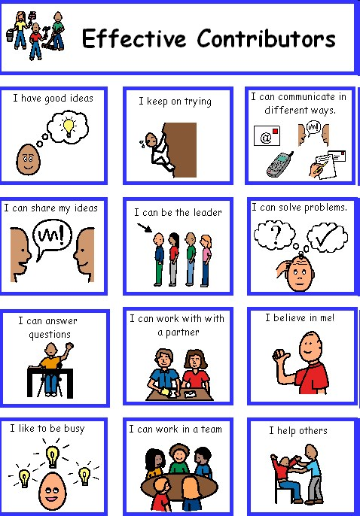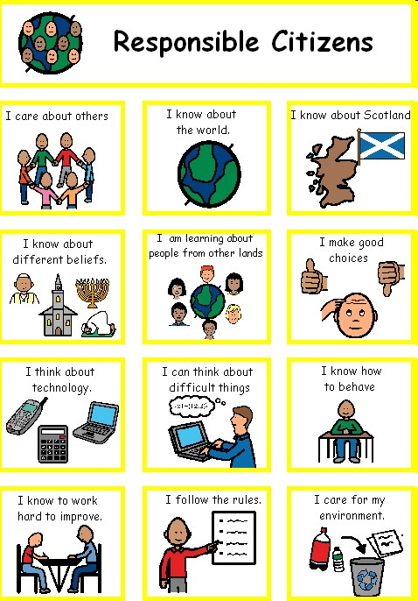

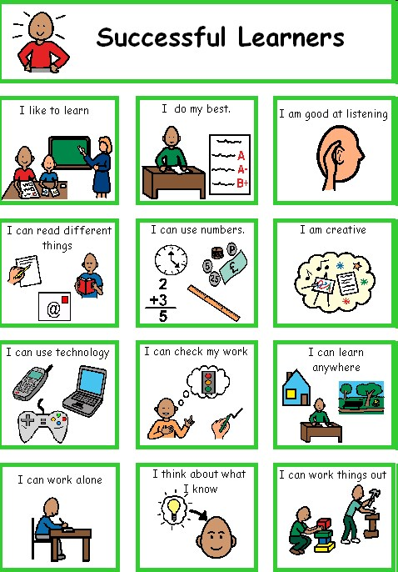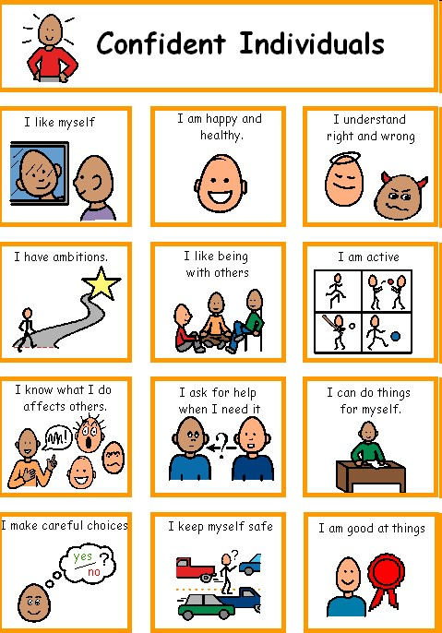

Assessment and Recording - Alva Autism Provision

There is assessment of the children’s needs in all areas of their development. A range of assessment tools are used and form the basis of formal assessment which helps support ongoing and continuous informal assessment.

From this assessment each pupil has an individual programme of learning activities which ensures that all aspects of their developmental needs are addressed within the curriculum. Assessment is an integral part of learning and teaching.

Through daily planning and individualized curriculum, teachers are continually assessing children’s progress. Pupil achievement is recorded. A Child’s Plan will be developed for specific Health and Wellbeing targets for which reviews are held for all children and these are attended by parents/carers and staff working with pupils. At these meetings open discussions lead to decisions on appropriate targets for each individual pupil.

Reporting - Alva Autism Provision

Families will meet with staff three times a year to discuss and agree the Child’s Plan. These targets are evaluated in June and a report outlining your child’s progress in all areas of the curriculum is produced for the end of the school year.
During the school year there will be many opportunities for families to come into school. There is the opportunity to attend two learner progress meetings when families can view their child’s work and have informal discussions with their teacher.
Families are welcome to come into school at any time. We would hope that they will be actively involved in the identification of their child’s needs and the implementation of the Child’s Plan.

Home Links - Alva Autism Provision

A school consists of children, families, staff and the community. A high degree of co-operation between families and staff ensures that children gain maximum benefit from their school experience. Families are therefore always welcome to visit the school and to take an active part in the life of the school.
The Provision strives to keep daily informal contact with the families through home/school communication, and parents/carers are encouraged to respond with comments from home. If an issue is considered to be urgent, please telephone the school reception.
The Ochil Classes Subgroup runs alongside the School Parent Council and PTA. Please contact the school office for contact details.

Enrolment - Alva Autism Provision

The Provision is an authority-wide provision and can be accessed by children from all areas within Clackmannanshire Council. Children are usually referred to the Provision, through the Internal Resource Group, by the Team Around the Child (TAC). Once the decision has been reached that a child would benefit from having their needs met within the Provision, an enrolment with the school should take place. For Primary 1 this takes place in January of the year the child will start school. You will be notified as part of the IRG process of the dates for this.

We have close links with Alva Academy ASD provision and have an extended transition process for those children who will transition there.

Hours - Alva Autism Provision

Children attend the Provision Monday to Friday from 9 am to 3:00 pm.

Lunches - Alva Autism Provision

All children are encouraged to take a school lunch as this is viewed as an opportunity for Personal and Social Development. All children within the provision are eligible for free school meals. They may of course bring a packed lunch if they prefer.

Transport - Alva Autism Provision

All children are eligible for free transport to and from the Provision. This transport uses the car park at the front of the school on Brook Street. Please observe the information, on the signs on the fencing, regarding parking times for other vehicles to ensure our school transport can park safely.

The car park to the side of the school is for staff only to ensure children’s safety.

Useful Websites

https://blogs.glowscotland.org.uk/cl/alvaprimaryschool/
Alva Primary’s website

Alva Play Pals Logo
Privately run before and after school club based in Alva Primary School and other locations.

https://education.gov.scot/parentzone/
Parents/carers can find out about everything from school term dates to exam results. This site also offers information for pre-5 and post school. It also lists relevant publications for parents/carers and provides hyper-links to other useful organisations.

http://www.childline.org.uk/Explore/Bullying/Pages/Bullyinginfo.aspx
Contains information for parents/carers and children on varying forms of bullying and provides help for parents/carers and children who are affected by bullying.

http://www.respectme.org.uk/
Scotland’s anti-bullying service. Contains information for parents/carers and children on varying forms of bullying and provides help for parents/carers and children who are affected by bullying.

http://www.equalityhumanrights.com
Contains information for everyone on equality laws within the government and local authorities.

https://education.gov.scot/

www.hmie.gov.uk
Parents/carers can access school and local authority inspection reports and find out more about the work of
Education Scotland.

http://www.careinspectorate.com/index.php/member-of-the-public
The governing body for our nursery provision.

http://www.ltscotland.org.uk/scottishschoolsonline-index-asp/
Parents/carers can find out about individual schools. They can choose a school and select what type of information they need such as Education Scotland reports, exam results, stay on rates and free school meal entitlement.

- School Term Dates 2026/27 
- We operate a set pattern of school holidays.
- Autumn term: Starts on the Monday of the second full week in August. (as the first 2 days are normally staff development days pupils will start on the Wednesday)
- October holiday: Two weeks starting on the Monday of the second full week in October.
- Christmas holiday: Two full weeks to include two public holidays on 1st and 2nd January.
- Easter holiday: The first Monday in April, for two weeks, regardless of when Easter weekend falls.

- Event | - Date
- Autumn term begins (Staff only - staff development days): | - Monday & Tuesday 10 & 11 August 2026
- Autumn term begins (Pupils): | - Wednesday 12 August 2026
- Autumn term ends: | - Friday 9 October 2026
- October holiday begins: | - Monday 12 October 2026
- October holiday ends: | - Friday 23 October 2026
- Winter term begins: | - Monday 26 October 2026
- Staff development day (pupils off) | - Friday 27 November 2026
- Winter term ends | - Tuesday 22 December 2026
- Christmas holiday begins: | - Wednesday 23 December 2026
- Christmas holiday ends: | - Monday 4 January 2027
- Spring term begins: | - Tuesday 5 January 2027
- Staff development days (pupils off) | - Monday & Tuesday 8 & 9 February 2027
- Spring half-term holiday begins: | - Wednesday 10 February 2027
- Spring half-term holiday ends: | - Friday 12 February 2027
- Public holiday - Good Friday | - Friday 26 March 2027
- Public holiday - Easter Monday | - Monday 29 March 2027
- Spring term ends: | - Friday 2 April 2027
- Spring holidays begin: | - Monday 5 April 2027
- Spring holidays end: | - Friday 16 April 2027
- Summer term begins: | - Monday 19 April 2027
- May public holiday: | - Monday 3 May 2027
- Summer term ends: | - Friday 25 June 2027
- Summer holidays begin: | - Monday 28 June 2027
- Summer holidays end (provisional): | - Friday 6 August 2027

- Staff Development Days
- Monday 10 August 2026
- Tuesday 11 August 2026
- Friday 27 November 2026
- Monday 8 February 2027
- Tuesday 9 February 2027

Footnote

Although every effort has been made to ensure that the information provided is correct at the time of issue. We will endeavour to keep the online version up to date. This is available at https://blogs.glowscotland.org.uk/cl/alvaprimaryschool/

