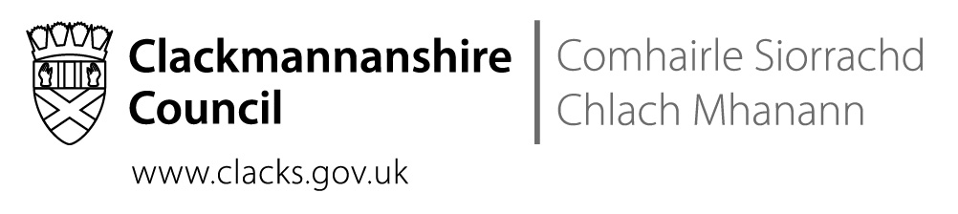

Clackmannanshire Educational Psychology Service

A Guide to the Educational Psychology Service

Information for Education Staff and other Partners
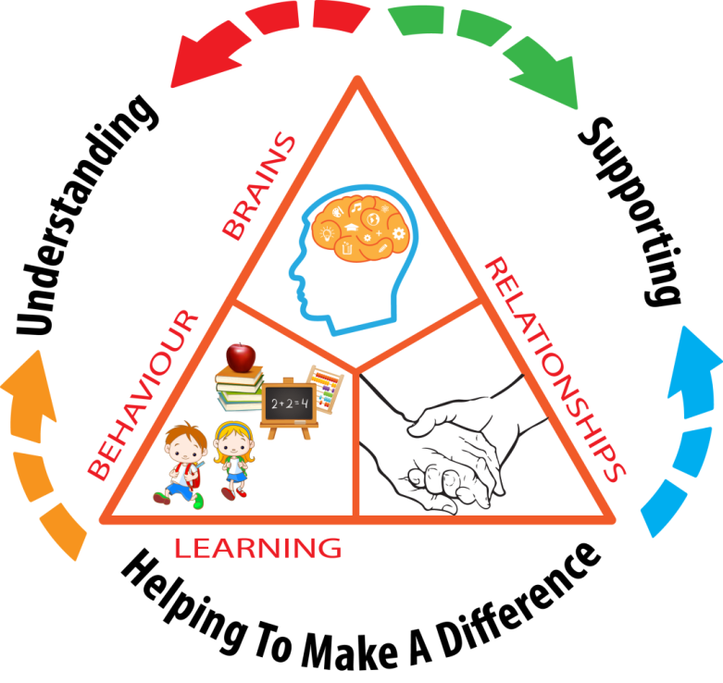

CONTENTS |  | 2
OUR SERVICE |  | 3
HOW TO INVOLVE US |  | 3
SERVICES WE CAN PROVIDE | Core functions  Service provision types  Our expectations | 3  4  5
DIAGRAM | How to involve the Educational Psychology Service | 6
APPENDIX | Our Vision, Values, and Aims  Professional registration requirements | 7  8
FURTHER INFORMATION | EPS contact information | 8

Our Service
Using psychological theory and knowledge to deliver excellence in and equity of Educational Psychology Services, when and where required.
We are a team of 5.1 FTE core staff consisting of:
- a 0.8 FTE Principal / Senior Educational Psychologist (EP)
- 4.3 FTE maingrade EPs, of which 0.9 FTE is a permanent post funded by the Scottish Attainment Challenge (SAC).
Our wider team includes 0.7 FTE temporary maingrade SAC-funded EPs, and from September, 2018, we hope to have appointed a 1.0 FTE assistant EP. We have collaborated with university students on projects that relate directly to Clackmannanshire priorities, and hope to continue this in future. We also have access to 1.0 FTE business support assistant.
We serve children and young people in the 0-24 age range. Our stakeholders include the Education Service, all educational establishments within the local authority, and children, young people and parents. We also work with Health, Social Work, the Children’s Reporter and the voluntary sector.
Please refer to the appendix section to learn more about our Vision, Values, and Aims, and professional requirements.

How to Involve Us
Everything starts with consultation.
In most cases, the appropriate pathway for engaging with our Service will be through the Team Around the Child (TAC) arranging an initial consultation with their link EP, usually involving both the parent/ carer and a school representative, as well as other professionals who may be involved, and in some cases the pupil in question.
Each learning community and educational establishment in Clackmannanshire has access to a link EP for consultation, as the first point of contact for queries about individual pupils or families, general concerns, or requests for development work. Please refer to Figure 1, “How to involve the Educational Psychology Service”.
- For some schools, the link EP will have a schedule of regular visits dedicated to addressing new queries (follow-up meetings and assessments are not limited to those visit dates).
- Other schools’ direct link is the twice-weekly telephone consultation service (although this service is also available to all Clackmannanshire stakeholders, link schools will be encouraged to have routine access to this service).
- There are also dedicated time slots each month for other partners (such as social workers and health visitors) to access consultation.
Consent must always be obtained from the parent/ carer, and/ or young person when appropriate, before seeking EPS advice or ongoing work regarding a specific individual or family. However, we understand that there can be times when a school or other partner is unsure of whether a query is appropriate for the EPS: we encourage that colleague to contact us for general guidance.

Services We Can Provide
Core functions, delivered at the levels of individual/ family, establishment/ cluster, and Local Authority.
Our five core functions: | Service provision types:
- Consultation  - Assessment  - Intervention  - Research  - Training | - Universal: e.g., all pupils in a school, council-wide, etc.  - Enhanced: e.g., an identified classroom or other specific group  - Targeted: e.g., strategies created for an individual child, but delivered by the teacher, parents, and/or other existing sources of support  - Intensive: e.g., direct work via our Intensive Therapeutic Service (ITS)
We primarily support children and young people through the process of consultation and Staged Intervention, to help facilitate those who know the pupil best to intervene directly.
Depending on the nature of a query, it may be addressed in a single consultation, or ongoing EP involvement may be indicated. In this case, an action point from the initial consultation would be that a request would be brought back to our team’s Service Delivery Group for consideration, in order to ensure equity of these targeted services across the Council.
As mentioned previously, ongoing work may come under categories including input regarding a specific pupil/ family, general concerns (e.g., “challenging behaviour in a group of P5 pupils”), and/ or development work (e.g., “design of a nurture base”, training, research, etc.). We prioritise our Service response according to equity of service delivery, level of need, statutory role (e.g., in the assessment for a placement in specialist or out-of-authority provision), and appropriateness of the query (e.g., if another agency would be better able to meet the need).

We appreciate that situations such as unanticipated support needs, critical events, etc. can occur unexpectedly. However, for routine consultation about individual children and young people, we would generally expect that:
- before education staff approach us for an initial consultation
  - a child or young person would be on Stage 2 of Staged Intervention
  - with all supports having been exhausted at this stage

- for ongoing work of a more direct nature
  - a child or young person would be at least on Stage 3 of Staged Intervention
  - their difficulties must be having a significant impact on their ability to access education
  - despite significant modification to the environment, timetable and/or curriculum already having been made.

Figure 1 (overleaf) provides a summary of this pathway.

Figure 1: How to involve the Educational Psychology Service
Initial consultation, via
- school consult visit
- telephone, or
- service consultation time slot (e.g., social work)

If re. a pupil, s/he should usually be on Stage 2 or above.

Service Delivery Group discusses, prioritises, and allocates cases
No further action

Development
(e.g. training, research, strategic planning)
Direct Intervention
(Intensive Therapeutic Service)
Direct Assessment
(e.g. , a placement query)
Ongoing Consultation
(e.g., to support current placement)

If re. a pupil, s/he should usually be on Stage 3 or above.

Our Vision
Our vision is that all children and young people in Clackmannanshire have the opportunity to achieve excellence and to meet their potential in terms of their well-being and academic attainment by being regulated and ready to learn.
Our Service provides five core functions of consultation, assessment, intervention, training and research. We also have a statutory role under Education and Social Work legislation.
We will work to ensure that all children and young people, their parents/ carers and our partners will have equal access to psychological knowledge through our universal consultation service. We will ensure equity of service delivery by providing a targeted service response to assessment, intervention and research when and where it is most needed.

Our Values
We are committed to providing an efficient, targeted and equitable service.
We believe that social and emotional well-being is at the heart of excellence – for our children, families and partners and also of our team.

Our Aims
Our aims are closely aligned to National Priorities such as the National Improvement Framework (NIF) and the Scottish Attainment Challenge as well as to Clackmannanshire Education Service’s 6 Big Goals:
1) | Children First – They enjoy learning and they strive: We aim to provide equality and equity by offering a service response to prioritising requests.
2) | Learning and teaching is consistently excellent: We aim to provide educators with the tools to support regulation and readiness to learn.
3) | We work as a family: We aim to work collaboratively with educational establishments and partner agencies to support the needs of children and young people.  (continued overleaf)
4) | Families are engaged and supported: We aim to listen and engage with the views of a child, young person, and parent/carer in order to contribute to the assessment and planning process.
5) | Educators are inspired and motivated: We aim to support those who know the child best through a joint process of problem identification and solution-finding.
6) | Decisions are based on evidence and ongoing improvement is the norm: We aim to use research evidence, undertake research and, in conjunction with partners, support educational practitioners to engage in collaborative action research - where appropriate - in order to inform best practice. We also aim to continue to develop our use of Implementation Science and Improvement Methodology in the evaluation of our impact and outcomes.

Professional Registration Requirements
Educational Psychologists also work to an agreed Code of Conduct, Ethical Principles and Guidelines laid down by the British Psychological Society and we all require to be registered with the Health Care Professions Council.

Further Information

If you would like further information about our Service, please contact the Principal Educational Psychologist or your link Educational Psychologist at:

Educational Psychology Service
Clackmannanshire Council
Kilncraigs
Greenside Street
Alloa , FK10 1EB
Tel: 01259 226000

