Primary 4
In Primary 4, the children will:
- Learn about the need for rules about keeping safe when exchanging information online, particularly when social networking.
- Recognise that some websites may be biased and unreliable.
- Learn to distinguish between fact, fiction and opinion when looking at information online.
- Identify protective behaviours and strategies for keeping safe when communicating online.
- Develop an awareness of the fact that cyber bullying is a form of bullying.

New key words:
social networking, bias, manipulation, cyber bulling, instant messaging, chat rooms, forums, Trojan (uninvited software that will bypass computer security), virus


Primary 5
In primary 5, children will:
- Learn that cyber bullying takes many forms and understand the effects of cyber bullying.
- They will explore how to respond to unacceptable communications via mobile phone, text, IM or email chat rooms.
- Find out how to respond if asked for personal details.
- Identify strategies for keeping themselves safe.

New key words:
cyber bullying, bystander, chat rooms, IM, netiquette


Primary 6
In Primary 6, children will:
- Learn about social networks and how these can be used safely and responsibly.
- Access approved, safe, social network sites.
- Learn how to use instant messaging, mobile technology and online gaming responsibly.
- Understand the dangers of speaking to and playing games with strangers online.
- Learn how to report people online if they make you feel uncomfortable.
- Understand the importance of telling adults if you feel unsafe online.
- Learn about the importance of keeping personal information private, especially online.
- Create an alias or avatar online using www.voki.com

New key words:
online gaming, mobile technology, avatar, alias, grooming, paedophile, upload, phishing



Primary 3
In Primary 3, children will:
- Recognise the need for politeness and courtesy with online and offline communications
- Know what to do if something makes them feel uncomfortable online
- Know that not everything they see and read is true
- Know what copyright means and know not to take work without permission
- Know never to share personal information online
- Know that popups and links may take them to unsafe websites
- Develop skills for safe online searching

New key words:
copyright, popup, websearch, search engine, bookmark/favourites



Primary 2
In Primary 2, children will:
- be made aware that anything saved online can be viewed by others
- learn to share work on the school network
- use websites suggested by an adult to find a range of information
- learn what to do if something they see online makes them feel uncomfortable
- learn that it is possible to communicate with other people online
- understand that they should respect the work of others stored electronically

New key words:
e-mail, cyberhunt, GLOW


Primary 7
In Primary 7, children will:
- Learn that material they upload will be available for others to see immediately and permanently
- Explore personal safety and assess risks of sharing digital images and videos
- Know the laws regulating misuse and abuse of internet
- Understand the emotional, health and social issues involved in excessive gaming use
- Have first hand experience in using social networking sites e.g. Glow

New key words:
addiction, repetitive strain injury (RSI), griefing (deliberately disrupting multiplayer games or online communities with bad behaviour), social mapping (cell phone GPS technology), IP address and digital footprint


Primary 1
In Primary 1, the children will:
- Learn that anything saved online can be viewed by others.
- Find a range of information online.
- Navigate websites suggested by an adult.
- Learn what to do if something they see online makes them feel uncomfortable.
- Learn it is possible to communicate with other people online.
- Learn to respect the work of others stored or presented electronically.

New key words:
User, Login, uncomfortable – “butterflies in your tummy”


Nursery
In Nursery, children will:
- Become aware of how to use the internet safely.
- Become aware of using the internet to play games.
- Become aware that information can be found on the internet and will use websites supported by an adult.
- Become aware that people can communicate online and will have experiences doing this.
- Know what to do if something online makes them feel uncomfortable.
New key words:
Mouse, click/press, hold, drag, arrow, keyboard/keypad, computer, online, Internet, website, research, minimize, maximize, safe, red thoughts and green thoughts
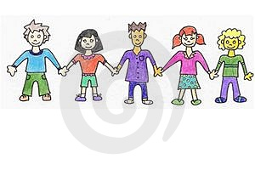
Pointers for Parents and Carers
Discuss with your child:
- Sites which are acceptable and those which are unacceptable.
- How much money you are willing to pay towards your child’s mobile phone each month.
- Where the computer will be located in the house. This should be in a main area of the house (where you can monitor their use of the computer).
- Online games consoles will be located in a main area of the house.
- How long they should spend on line.
- Agree the passwords will only be shared with parents or carers.
- What will happen if your child approaches you with an issue.

Important Points to Remind Children About

- Online relationships are no different from relationships off-line.
- Be mindful of the fact that you are communicating differently.
- Be respectful of other people’s privacy.
- NEVER give away personal information.
- If you wouldn’t say it, don’t send it.
- There’s a history on a computer so it can be traced, even if you delete the history.
- Be polite.
- What will happen if you are being cyberbullied?

Contents

Page 1 – Nursery
Page 2 – Primary 1
Page 3 – Primary 2
Page 4 – Primary 3
Page 5 – Primary 4
Page 6 – Primary 5
Page 7 – Primary 6
Page 8 – Primary 7
Page 9 – Pointers for Parents and Carers
Page 10 – Points to Remind Children About
Page 11 – Useful Information and Resources

Useful Information & Resources:
Websites:
www.thinkuknow.co.uk - information about how to stay safe online and where to go for help
www.kidsmart.org.uk - information about how to stay safe online with Captain Kara and Winston
www.childnet.com - Contains a source of leaflets and resources for schools, teachers, parents and carers.
www.kidscape.org.uk - A range of information for both children and adults, with some interactive sections for young people on responding to bullying.
www.stoptextbully.com - Information on text bullying specific to children and young people.
www.ceop.gov.uk - The Child Exploitation and Online Protection Centre website provides information and advice for online safety.



Menstrie Primary School

E-Safety
Education

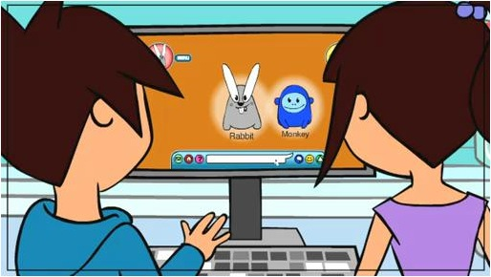

A Parents’ Guide

