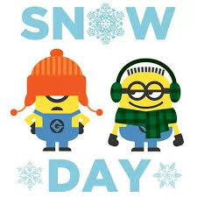
Snow Day Activities
Primary One

Share a book with an adult. | Use a stick to write the alphabet in the snow. | Play a board game with someone. | Copy a sentence from your reading book. Try again without copying.
Build a snowman and then draw a set of pictures to show someone else what you did. | How many ‘at’ words can you write on a piece of paper. Repeat with ‘an’. | Use buttons or pennies.  How many stories of 7 can you write? 7+0=7 | Mark out a short distance in the snow. Estimate how many footprints it will take to walk the short distance with your wellies. Now count. Try the same distance with someone else’s wellies on.
Go on a winter walk and collect things to make a winter picture. Make a picture. | Collect five objects to recycle. | Count how many step ups you can do on your stairs in one minute? | Listen to a favourite song. Make up a dance and perform it to your family and friends.
Set the table for tea. | Take a cup of snow into the house. What happens? | Write your full name in three different colours of pencil. | Print some pictures and bring to school to share.

