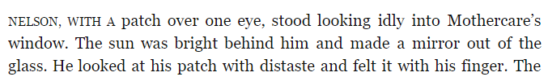1

2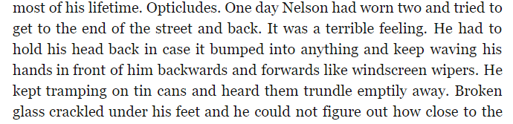

3
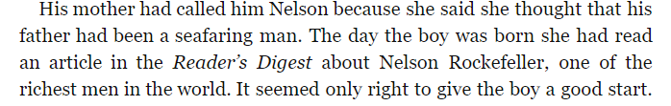4
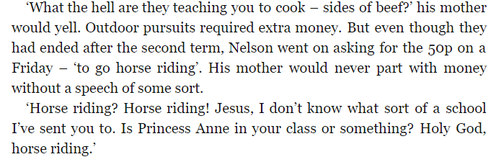5

6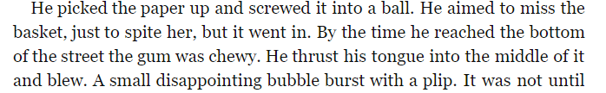

… 9
7

8

10

11

12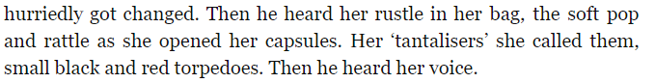

13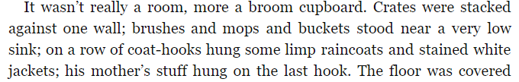

14
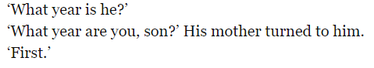20
17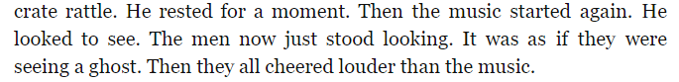
15

21
19
18
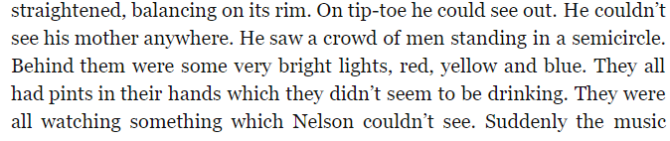16

22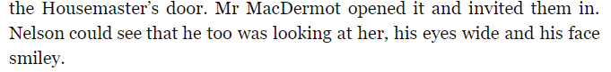
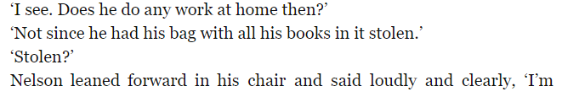
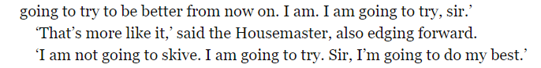23

24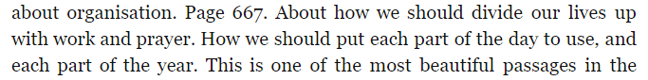

25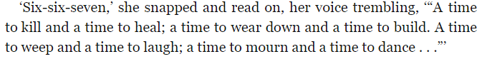

26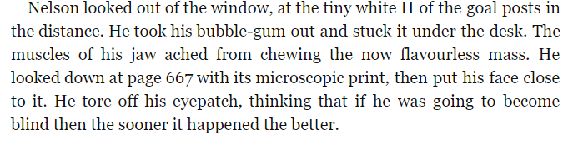

Motif of society’s blindness to the unpleasant realities of poverty / vulnerable people | Exploitation and dehumanisation of impoverished women and children | Key incident – metaphor for society’s unwillingness to see the unpleasant realities of poverty / vulnerable people | Characterisation - Metaphor for Nelson’s isolation  -Nelson’s poverty  -Nelson as comical / sympathetic  -Nelson as a victim of ironic circumstances | Characterisation  -Mrs Skelly’s ignorance / poor parenting  -Mrs Skelly as an exploited, poor woman who performs for a male audience in order to survive | Motif of ironic religious references | Irony of the ending | Symbolism at the end of the story.
NUMBERS | NUMBERS | NUMBERS | NUMBERS | NUMBERS | NUMBERS | NUM | NUMBERS

