Roy Batty prepares to jump
- Low angle shot with blue back-lighting – mirrors scene in which Batty kills Chew
- Re-establishes him in the audience’s mind as an emotionless killer
- He is holding a white dove in one hand (important later!)
- His semi-naked body makes him look very human (superhuman?)
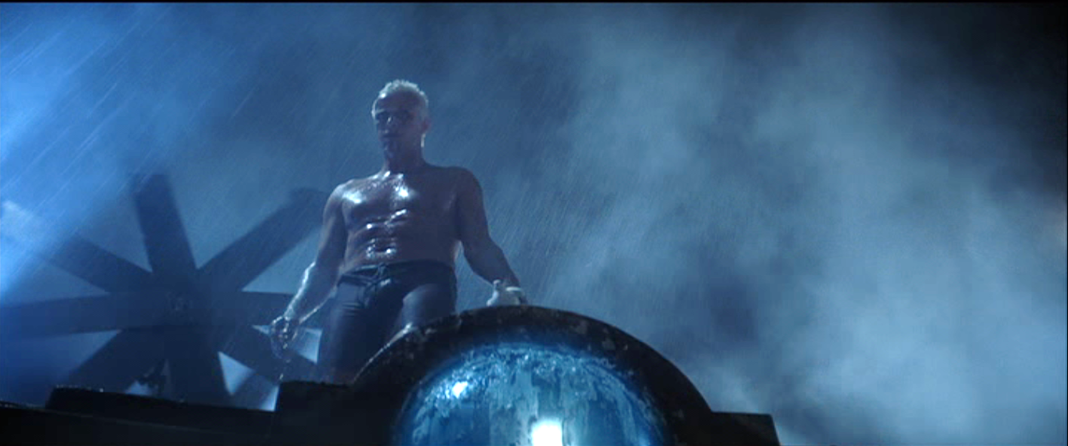

- Roy Batty saves Deckard, lifting him up with superhuman strength
- A low angle shot heightens the sense of danger
- Roy Batty lifts Deckard with the hand with the nail in it (religious allusion to Christ’s crucifixion – suggests Roy Batty may be capable of forgiveness / good actions)
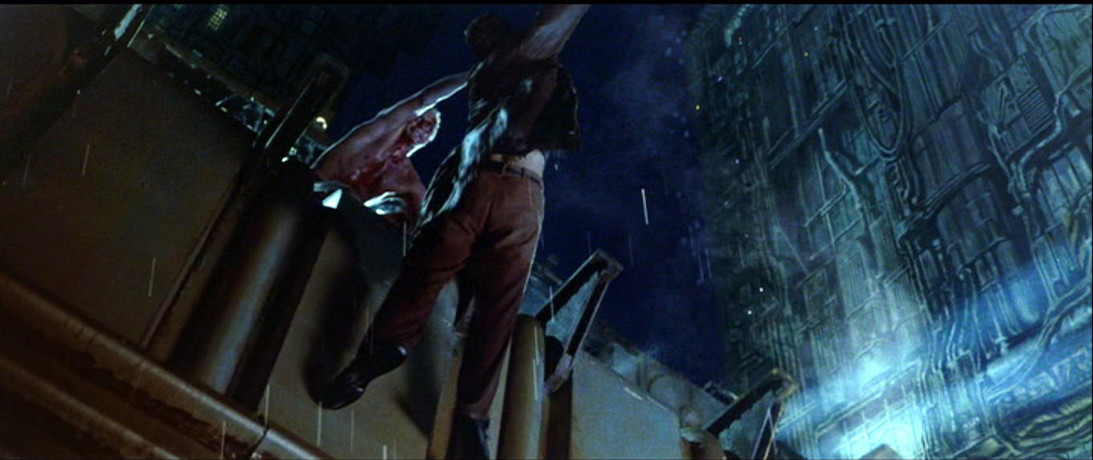

- Roy Batty sits down and talks sadly to Deckard, then dies
- Dialogue:
  - “I've seen things you people wouldn't believe. Attack ships on fire off the shoulder of Orion. I watched C-beams glitter in the dark near the Tanhauser Gate. All those moments will be lost in time...like tears in rain. Time to die.”
  - poetic – human quality
- Water running down face = water motif – suggests sadness at mortality (dying) – human emotion
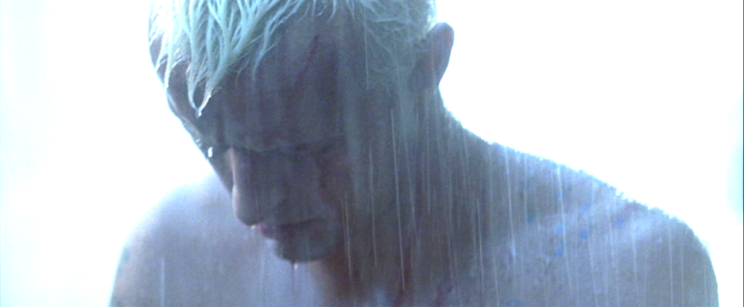

As Roy Batty Dies – cut to frame of blue sky / low angle shot of dove flying upwards
- Symbolism – Roy Batty has a soul (human quality)
- Hopeful ending to an otherwise bleak dystopian film
- Roy Batty is transformed from the villain into the hero – better than Deckard (a murderer)
