Batty enters slowly – low tension
- Long shot – over Tyrell’s shoulder (emphasises his fear)
- Tension-building music (non-diegetic) – harp arpeggios
- Mise en scene: costumes all black and white
  - Tyrell – in white (black hair) = angel
  - Roy Batty – in black (white hair) = demon

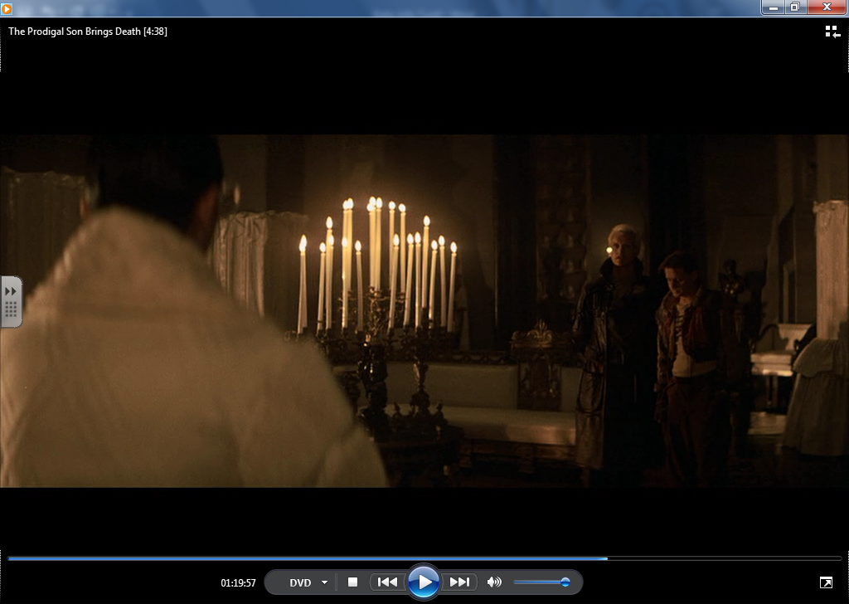
Close-up on Roy Batty’s face
Dialogue – only swearing in film ‘I want more life f*cker’
- Betrays Roy Batty’s emotions

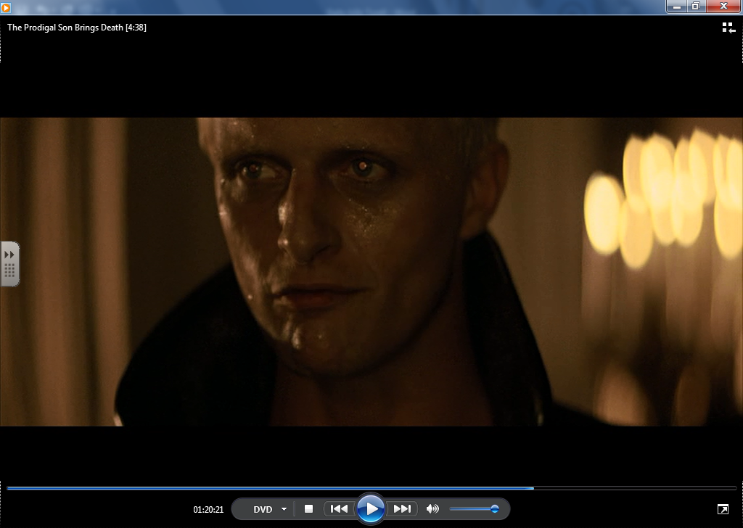

Close up: father/ son or priest/confessor
- Human roles – suggests Roy Batty has a human side
- “I’ve done questionable things” – Roy Batty is able to make moral judgements (a human quality)

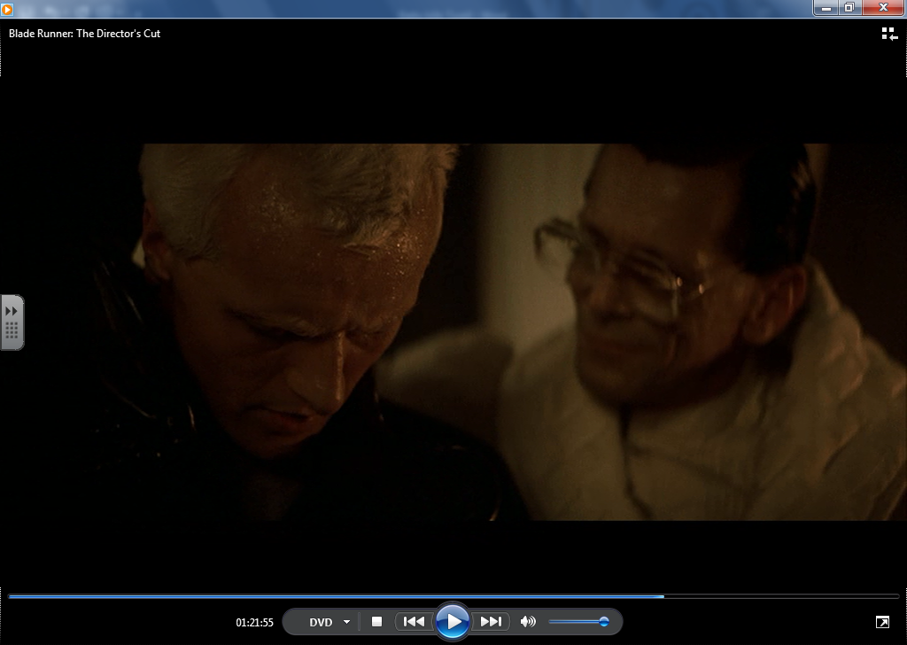
- Extreme close up – Roy Batty kisses Tyrell
  - Unsettling incestuous overtones
  - Emotion
  - Religious allusion – Judas kissing Christ
  - Makes it all the more surprising when Roy Batty kills him
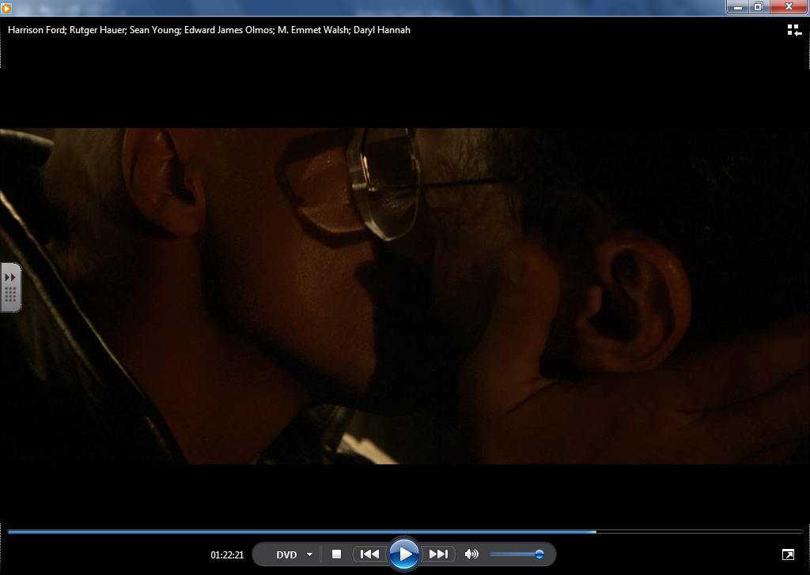

- Roy kills Tyrell by crushing his eyes
- Extreme close up on Roy’s hands / Tyrell’s face
- Sound: Tyrell’s screams / Crunching of bone being crushed / minor chords on synth
- Fast cuts between Roy’s tortured face and Tyrell’s head – suggests he is feeling intense emotions: frustration / anger / regret

