Motif of an eye [motif = repeated image]
- Close up shot – reminds us of important quality of humanity – beauty / function of the eye
- We know Roy Batty has artificial eyes – he is not human

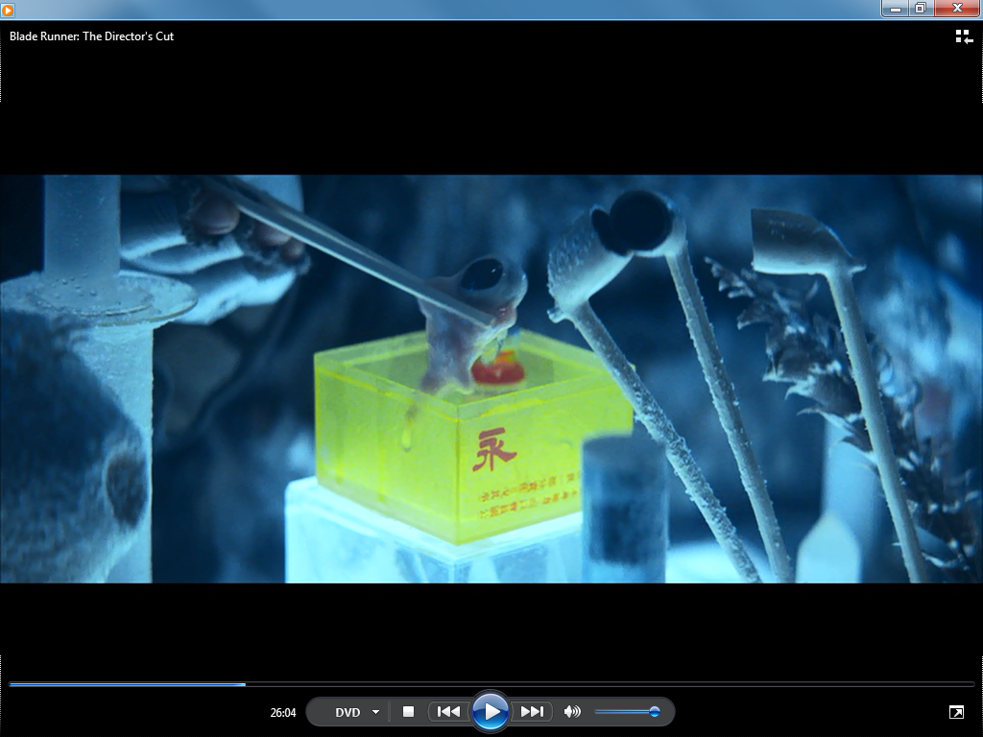

Roy Batty – medium shot
- Lighting: dark and shadowy (mise en scene)
- Colour: blue filter – makes mood sad / threatening (mise en scene)
- Roy’s figure is backlit – we only see his silhouette – makes him appear frightening – like a monster / vampire (not very human)
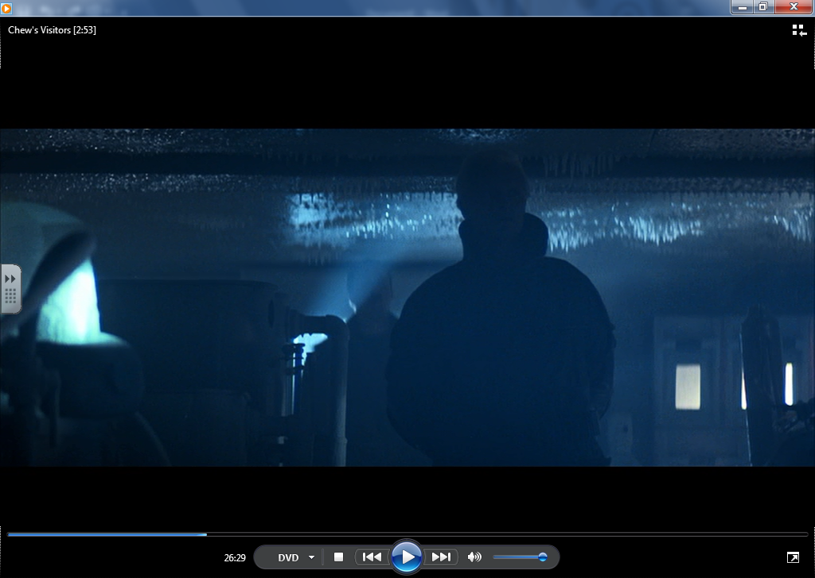

Dialogue: “fiery the angels fell, deep thunder rolled around their shores, burning with the fires of orc” – Roy Batty
- Taken from a poem by William Blake – sounds Biblical / threatening but also poetic (human quality)

Close up shot
- Roy Batty moves slowly back under a blue light – lighting used for same effect as earlier in scene – to present Roy as a terrifying monster (i.e. – not very human)
- Expression on Roy’s face – smile – seems to be enjoying torturing/killing Chew – sadistic/unpleasant in this scene

