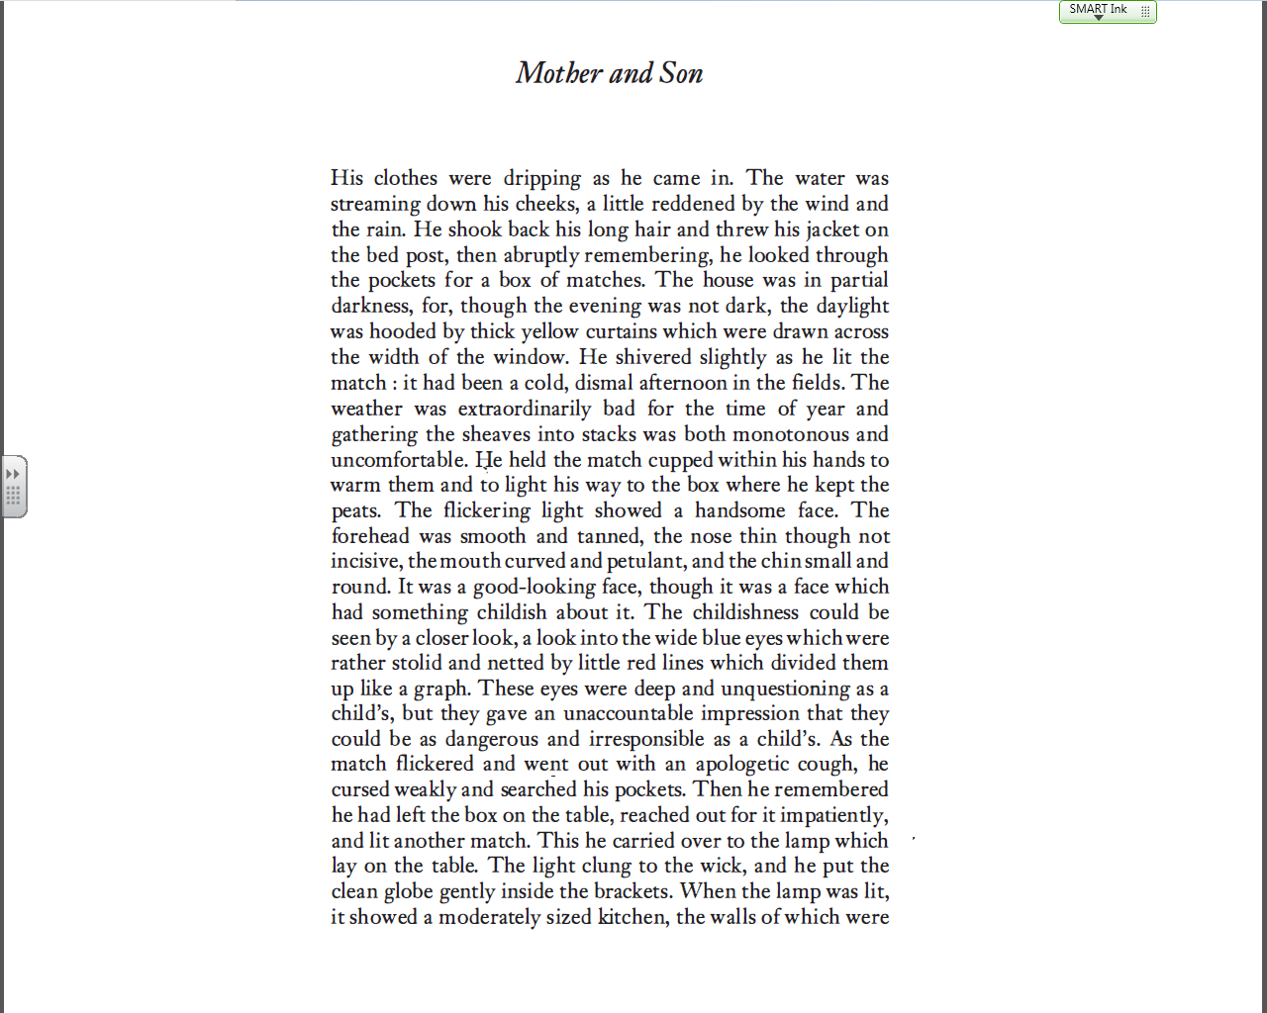

Suggests unpleasant and repetitive work



Metaphor: interior or house is dull and dark, like the son’s life



Pathetic fallacy – the setting mirrors the character’s emotions





Simile. Red = colour of rage

Dangerous: not completely responsible for actions. Violence?

Handsome but child-like: suggests something impulsive / not quite normal about the character



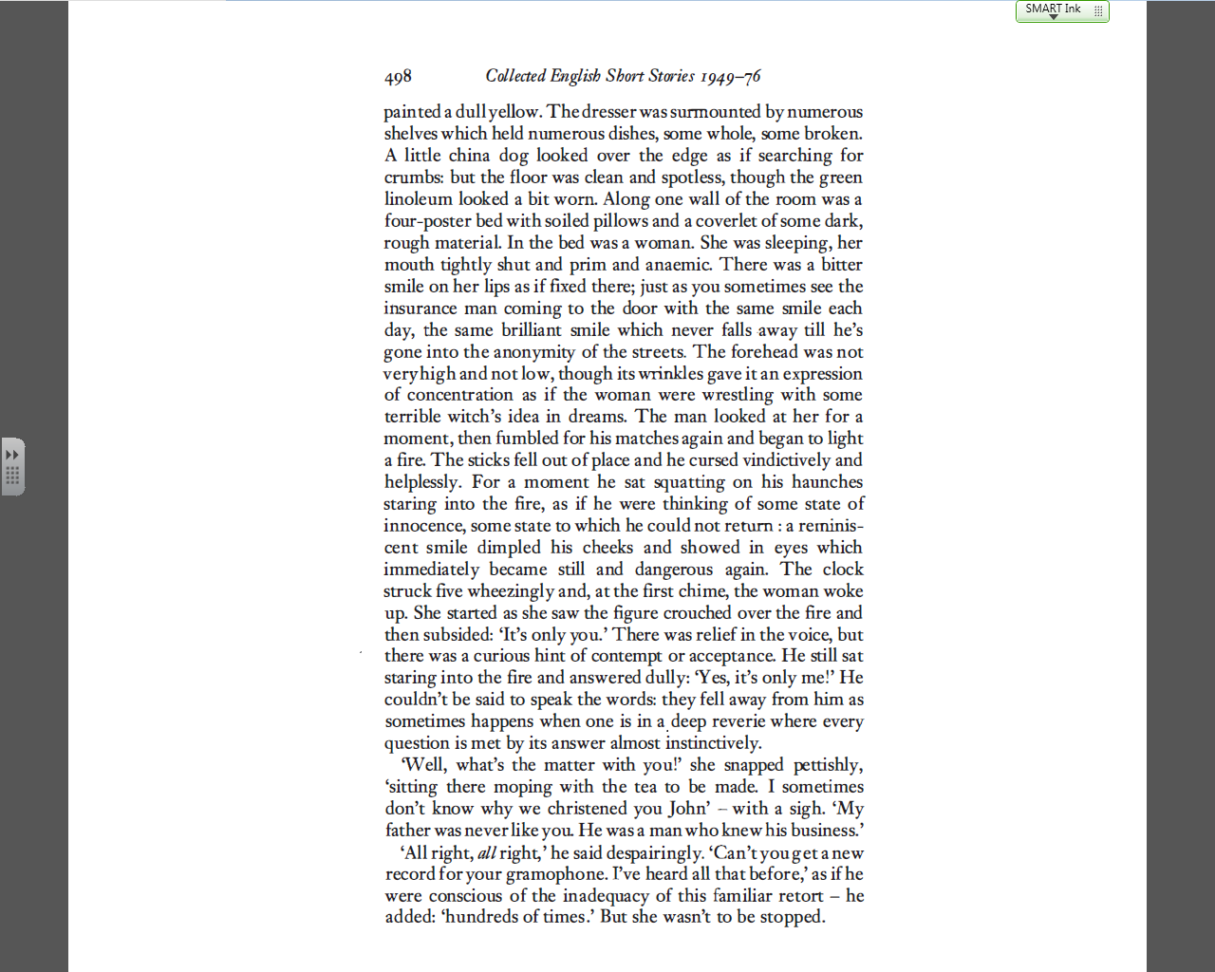



Contrast: innocent yet dangerous

‘witch’ suggests mother is evil and tormented



‘Bitter’ is repeated often to describe the mother.

Comparison to ‘insurance man’ is disturbing – there is something false and selfish about the smile



Setting: a croft – poor and uncared for





He has no defence against her cruelty

Mother insults her son



Fears an attacker – is relieved it’s only her son, but **not** pleased to see him



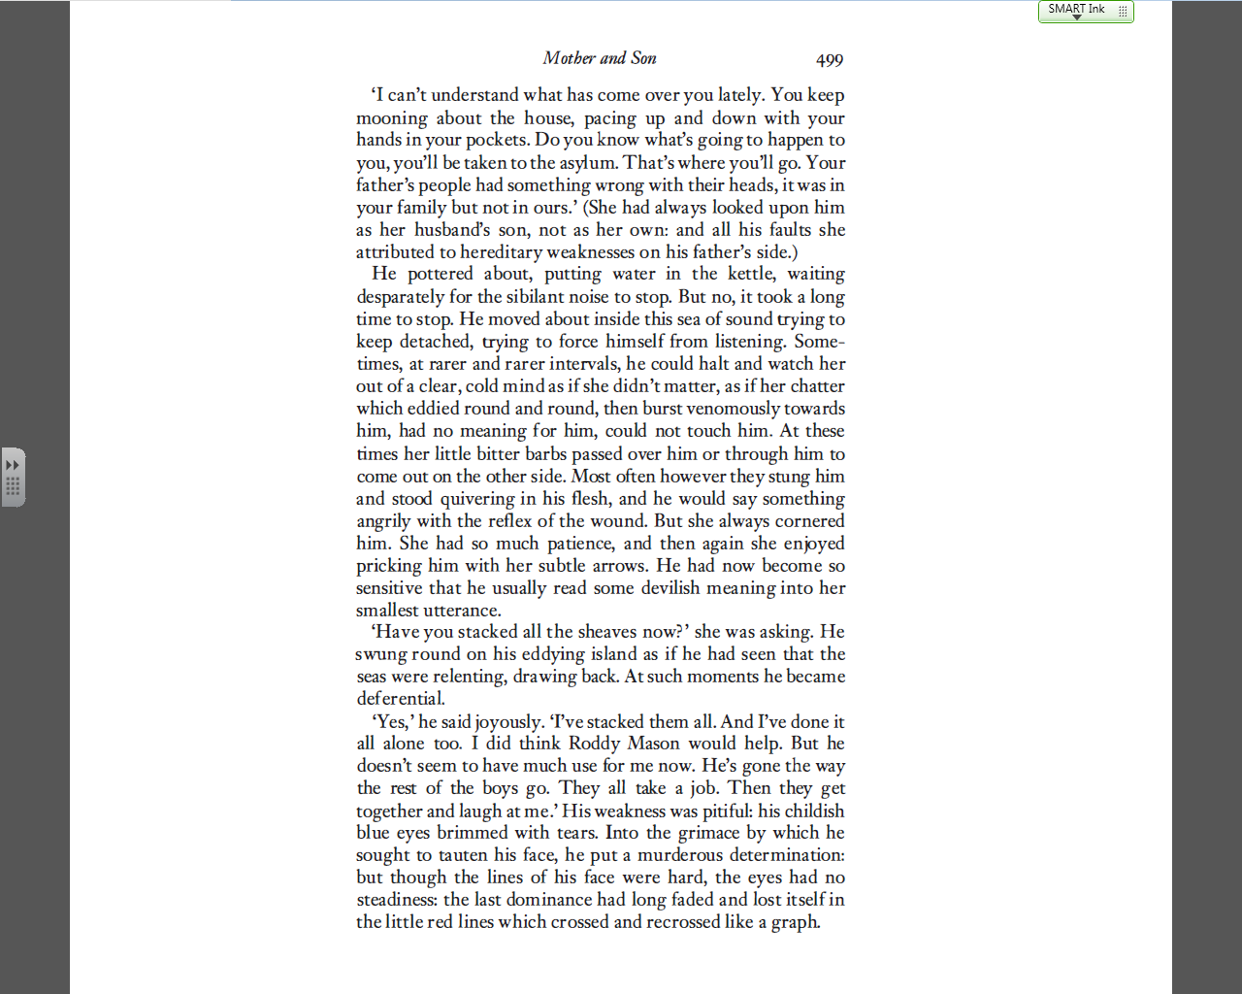

Imagery connected to arrows – suggests her words cause him pain and literally wound him

Makes mother sound like snake



Suggests that even making tea is difficult for him

Narrator tells us she accepts no responsibility for him



More cruelty: destroying her son’s confidence





Graph image is repeated

Reminds us that he is not a child, but a grown man who is being driven into a fury by the mother

Reinforces idea of him as a child

Still wants to please her

Comparison suggests sea-sickness and confusion



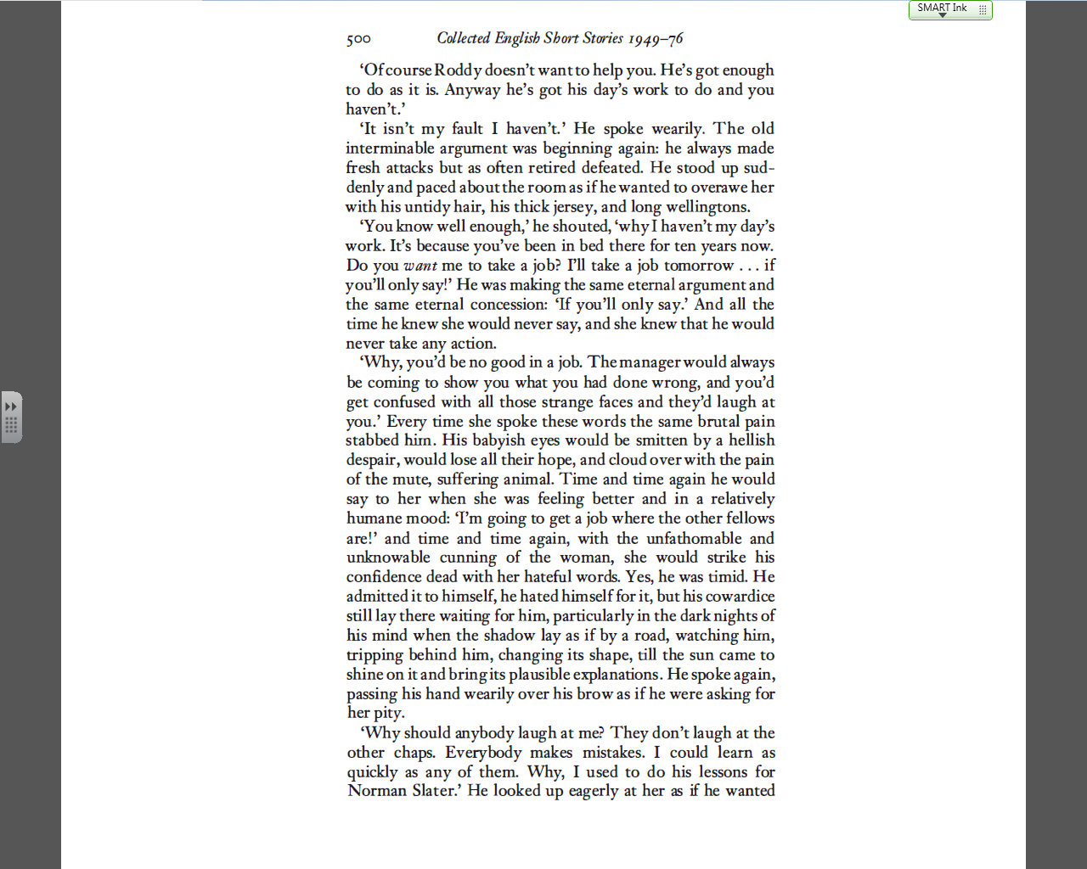

The son finally takes action, but contained within it is the idea that things will never change



Suggests that the same argument is played out every day of their lives





Lengthy comparison of cowardice to a dangerous animal or monster: personification. Contains an idea of the fear of the dark – linked to childhood (son is child-like)



Narrator explains son’s inner thoughts

‘animal’ suggests he lacks understanding / intelligence

Contrast: the son is not strong enough to put up with the mother’s attacks



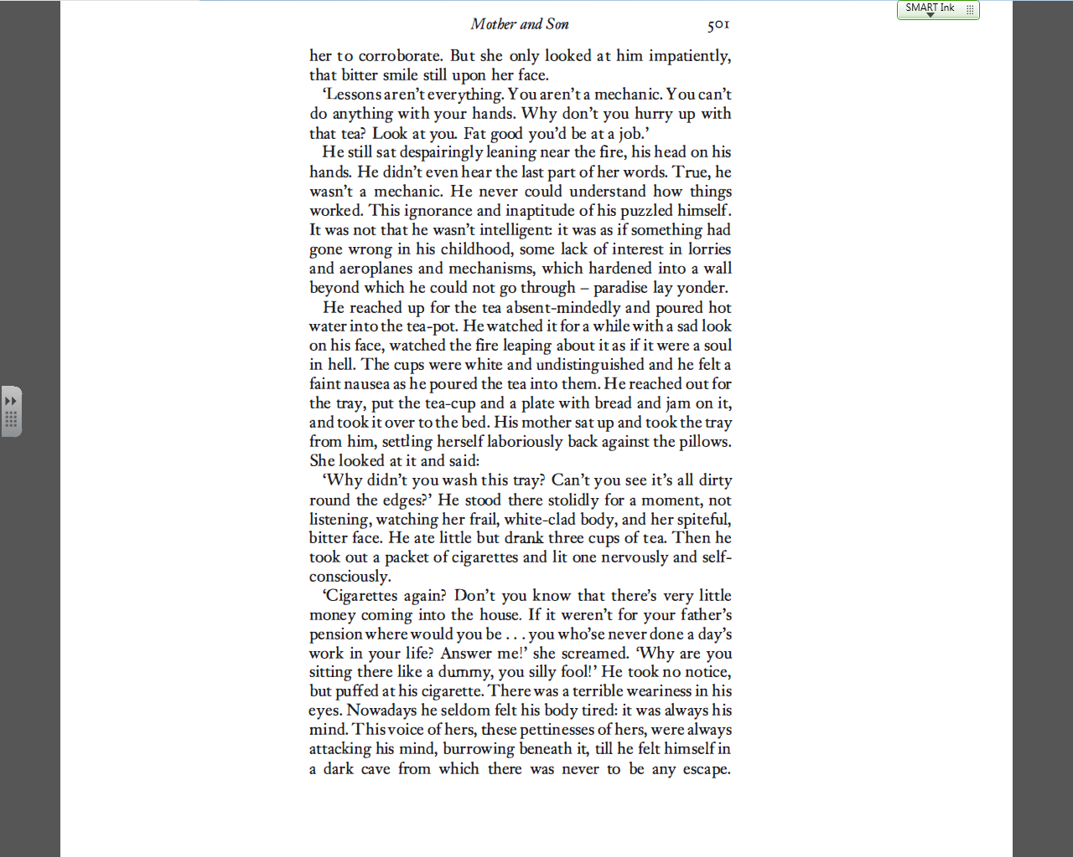

The son looks after his mother attentively, even though she does not admit it

Everyday thing (fire) linked to idea of damnation: son’s life is a torture



Constant cruel negativity about her son

Repeated motif of bitterness





Mother insults son – screams at him – dramatic climax

Son does not react. Metaphor of ‘dark cave’ explains his mental state: detached from reality



Repetition of ‘bitter’

Extreme ungratefulness makes reader dislike mother intensely



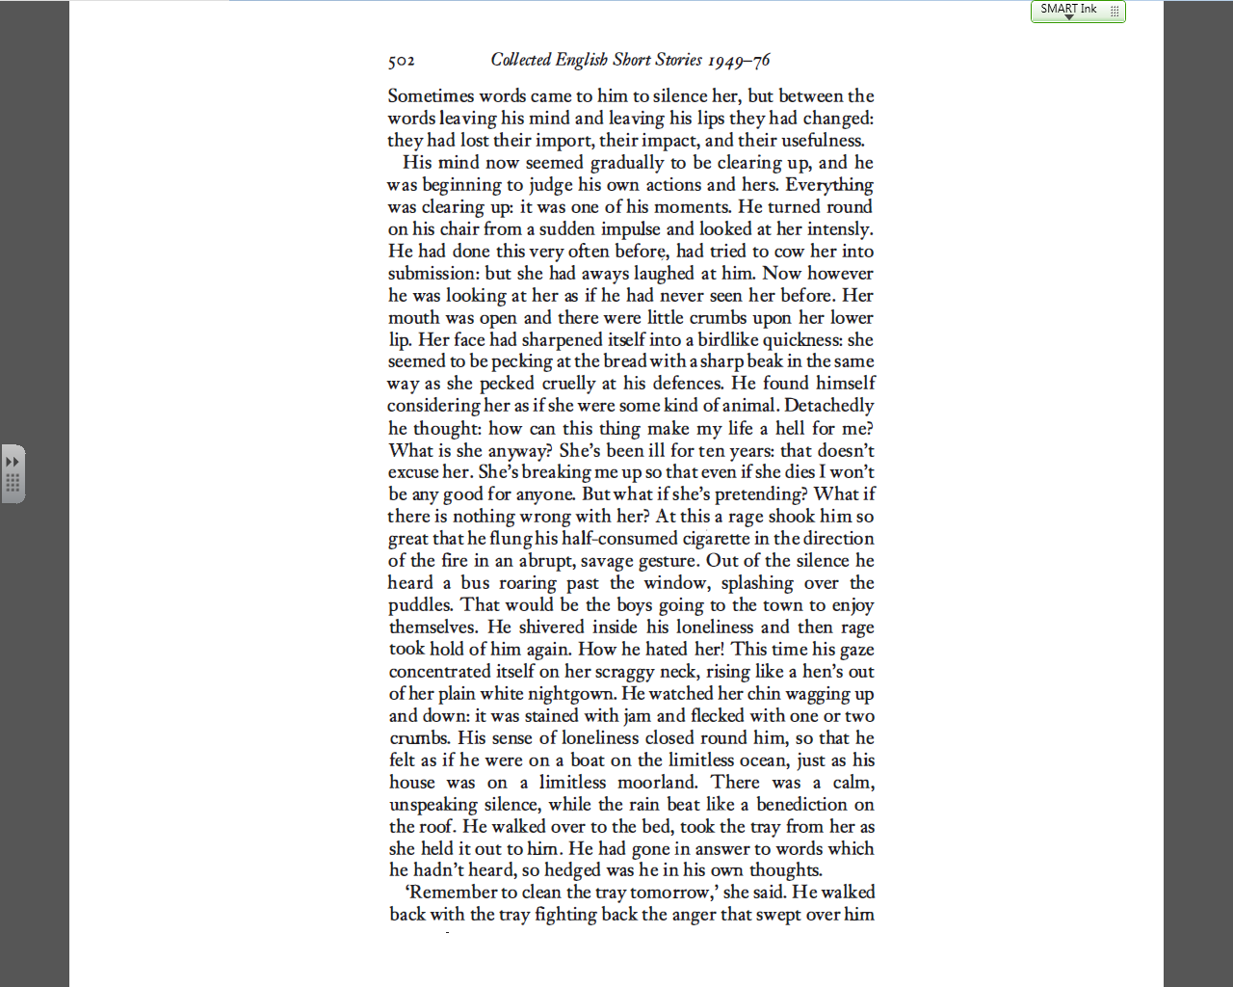



Son now sees mother as animal or thing, not person – suggests he will attack her



… but now his perception of her has changed

Glaring at the mother usually achieves nothing…



List of three things his words cannot achieve – the son is unable to break out of his situation

Repetition of ‘hell’



Pathetic fallacy



Mental state will not allow him to act. ‘Ocean’ imagery linked to landscape (‘moorland’) – no one can help him



Ugliness of mother

Animal image combined with fragility of neck (‘scraggy’) – raises tension



Action, but not the action we expect – anti-climax?

Series of rhetorical questions: indicates son’s internal turmoil



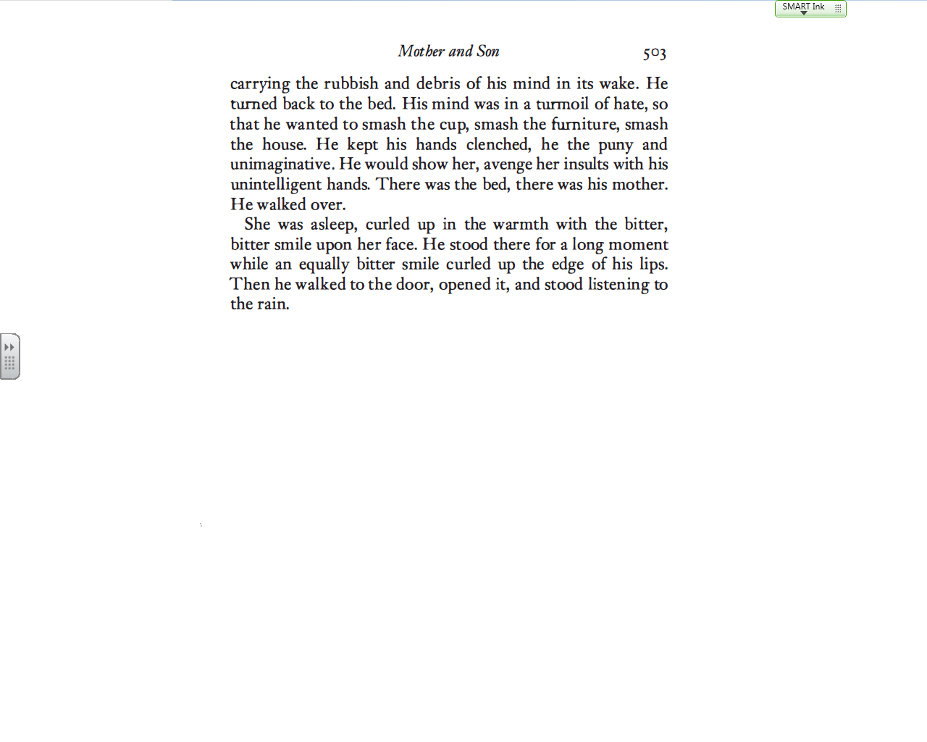

The mother does not find out how close she came to death



Bitterness: defining characteristic of the Mother and Son’s relationship. Similarity between them (fault of the mother)



Story closes with reference to weather – rain = ambiguous. Sadness? Solace in nature?

Dramatic climax: internal. Son does not act – frustrating for reader

