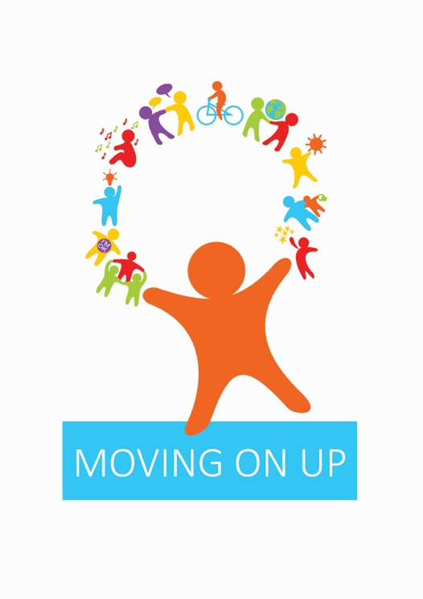
MOVING ON UP DAY THREE
Building Resilience Competition

Design a new avatar or image for ONE of the ten Building Resilience tools that has most meaning for you. You can draw it by hand or use technology, but it must be your own work. Do not use other people’s images and make sure there are no words in the picture.

Complete the form below and email it to lucy.gallagher@sciennes.edin.sch.uk by Thursday 25th June. We will hand over all the images to your city secondary schools who will then select their favourites to go forward to the next round of the competition.

The first ten images will be selected in October from entries to secondary schools across the city and the winners will receive a £50 Blackwell’s or Waterstones voucher!

Full Name
Primary school
Secondary school
Which of the Ten Builidng Resilience tools have you drawn?
Why is this so important to your mental health?
How will you use this to help you starting secondary school?

