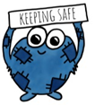
Keeping Safe
Key Messages
Keeping Myself Safe has been subsumed into the Health and Wellbeing curriculum mainly through the organisers Relationships, Sexual Health and Parenthood and Substance Misuse. The Health and Wellbeing progression frameworks from early to second level have been adapted to include sign posting as to how the topics from Keeping Myself Safe can be covered through this aspect of the curriculum. The Building Resilience programme also supports much of this work, particularly in relation to skills development.
Within the frameworks we have inserted the new Keeping Safe logo to indicate where this now fits into the HWB curriculum.
Skills
In addition to the taught curriculum, there are a number of core skills which need to be developed to enable the children and young people deal with situations and keep themselves safe. These core skills are;
- Communication
- Self-regulation
- Risk assessment
- Self-awareness

These have been linked to the old Keeping Myself Safe toolkit to help practitioners understand how they can develop these skills when teaching HWB.
Link to this;

High quality learning and teaching
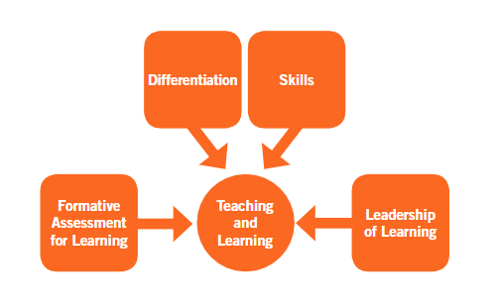
As with all aspects of the curriculum, our children and young people deserve HWB to match their needs and interests. Learner voice should be taken into account when planning learning as different contexts within the city may require different emphasis on particular topics. When planning the learning it is vital that the Edinburgh Learns Learning and Teaching Framework messages are foremost in teachers minds. The key aspects of;

Links to the framework document here;
https://cityofedinburgheducation.sharepoint.com/sites/EdinburghLearns/teachingandlearning/Framework%20Documents/Forms/AllItems.aspx
Moderation
In addition, planning and moderation should work hand in hand and the Education Scotland model should be used to facilitate this;
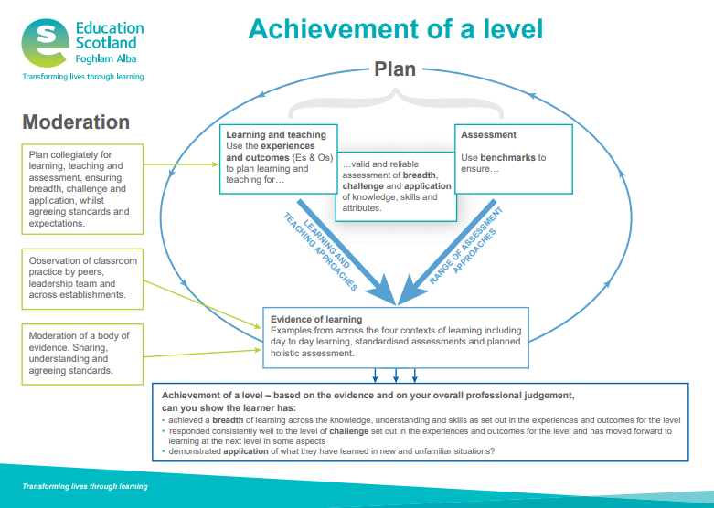

Link to this document here;
https://education.gov.scot/improvement/documents/achievement-of-a-level-poster.pdf
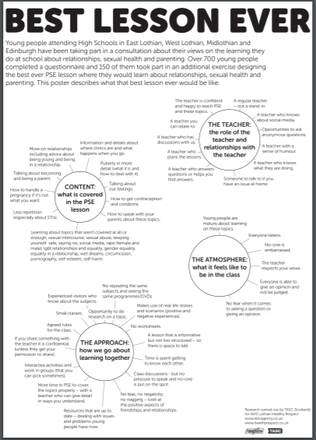
Best Lesson Ever
Healthy Respect commissioned research to identify what young people were looking for in relation to RSHP education in schools. Part of this included what children and young people thought ‘The Best Lesson Ever’ would look like. Teachers may find this helpful when planning for this aspect of the curriculum.
Link to this document here; http://www.tascagency.co.uk/assets/pdfs/Lothian-RSHP-Education-for-Healthy-Respect-FULL-REPORT.pdf
Supporting staff
Online safety; The Learning and Development team have developed a number of digital ‘games’; these are resources for teaching staff to use with children and young people, in order to help them to think about online safety. These resources are available to staff who have attended the ‘Keeping Children Safe Online’ workshop; the workshop shows staff how to use the resources as well as providing up to date knowledge on the issues facing children and young people. Staff can book on this course via MyHR, using course code CF2261
RSHP Resource; We are committed to supporting staff to feel more confident about teaching this aspect of the curriculum. Healthy Respect is planning training for our RSHP Champions (1 per school) so they can provide support for staff in their own schools. This support will b on going and shaped by the needs of our schools.

