Language, learning and living go hand in hand and being able to communicate influences everything we do. BtA p. 54

The importance of developing communication skills is central to our lives. Children start developing as communicators from the moment they are born. The way children move, relate to others, play and explore all have an impact on the language and literacy skills they develop
‘We need to understand what is involved in the subject knowledge of literacy. What are the essentials of texts and how do they work? What are the mechanics of reading and writing? Some of the most important things in developing literacy are not always that obvious. The way the brain works to co-ordinate vision, hearing and movement is crucial here, and so is the way each child develops as a symbol maker and symbol user. Talking, understanding what each other says, and engaging in conversation are also part of the process.’ Essentials of literacy
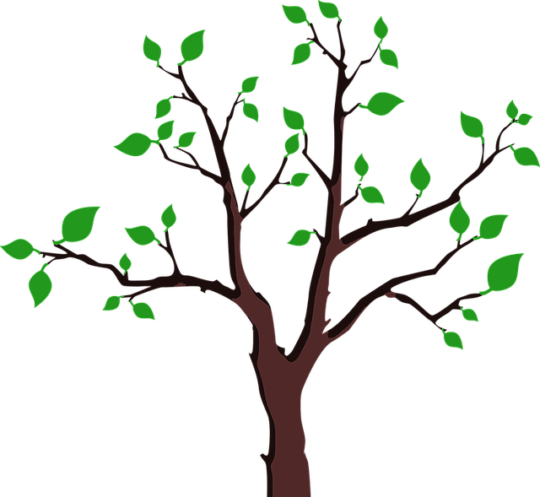
Print awareness and reading
Importance of sound rhythm and rhyme
Mark-making

Relating to others
Motor development
Play and creativity, becoming a
symbol maker and user
Early oral language
Curriculum for Excellence
Listening and Talking, Reading, Writing

- enjoying choosing stories, exploring characters and events and sharing thoughts
- retelling and role-playing stories
- using different materials for mark-making to communicate
- exploring and playing with the patterns and sounds of language
- exploring words, letters and sounds
- learning new words
- finding out new things, and asking questions
These are key elements of our curriculum.
How we put these in place depends on the uniqueness of our setting.
This is the process of developing our literacy curriculum.

‘Literacy is one of the cornerstones to success in life. Being able to read and write and communicate successfully is essential for engaging in education and in other areas of life [for example, in employment and personal relationships]. Up Up and Away p3
Core documents:
Building the Ambition
- Communication
Up Up and Away
- literacy rich environment tool
- Home literacy environment tool
- Reflective tool for enriching communication
Planning with Children
- continuous provision tools focusing on book corner, mark-making and gather time
Developmental Milestones and Learning Overview
Some resources to support
- ‘Essentials of Literacy’ Tina Bruce and Jenny Spratt
- ‘Interacting or Interfering?’ Julie Fisher
- Hanen training

