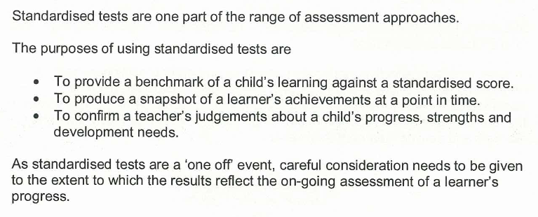
Analysis and Evaluation using Standardised Assessments
CEC Assessment / Moderation Framework (2012)

YARC (York assessment of Reading Comprehension) Early Reading
Notes
For comparison purposes use Standardised Assessment Score (SAS) and Group Ranking (GR). SAS is the raw score adjusted for age. The GR column heading will indicate the number of pupils
The Ability score is produced from the raw score and the level of difficulty of the question being asked.
Phoneme Awareness Composite is a standardised score based on the combined raw scores for sound isolation and sound deletion.
According to YARC developers
“Phoneme awareness is the skill which most strongly predicts reading ability”

Scores for the group (by surname)
Look at individual pupil scores and group ranking across the 4 category areas (Letter Sound Knowledge, Early Word Recognition, Sound Isolation and Sound Deletion). Use this diagnostically to identify individual strengths and areas for development.
The most useful data here is Standardised Assessment Score (SAS) and Group Ranking (GR).
  - Which category has the individual pupil performed best / least well in?
  - Is the pupil performing at a similar level across all category areas?
  - Are any individual SAS 88% or below (below average) 112% or above (above average)
    - Who are these pupils?
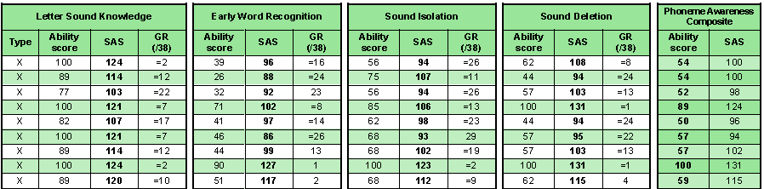
    - Does this reflect other evidence of achievement in learning?
Example
The pupil above (blue arrow) is performing very well in sound deletion (SAS,GR) and Letter sound knowledge (SAS). In relation to other learners in the school they are however performing less well in letter sound knowledge (GR). They are above average in Early Word Recognition and Sound isolation (SAS) but again doing less well in relation to the other learners in the schools.
The pupil (orange arrow) is performing consistently highly across all categories (SAS, GR).

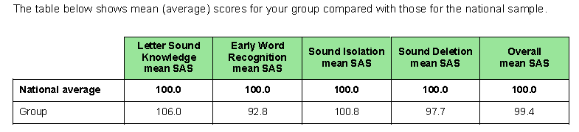
Analysis of group scores (by test)
Notes
The national mean average will always be 100.
Care needs to be taken in using percentages with small cohort sizes eg 3% of a cohort of 38 is 1 pupil; 24% is 8 pupils.

The red line indicates the National distribution of standardised scores.
A positive attainment picture would have the bars in the very low / below average to be lower than the red line.
A positive attainment picture would have the bars in the above average / very high area to be higher than the red line.

Notes

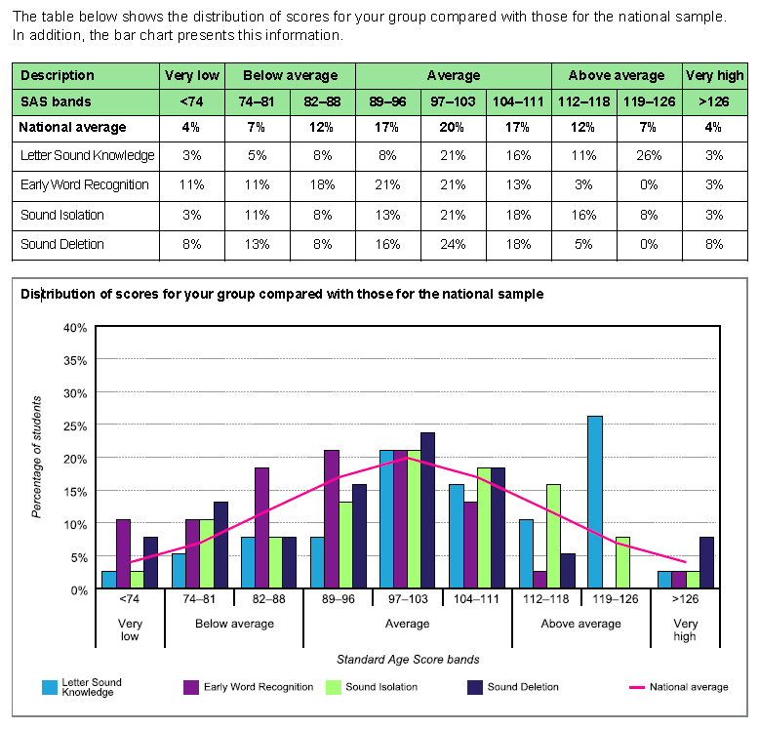
In which categories is your school cohort doing better / similar to / better than the UK average?
Investigate further from the detailed table and chart.
Why might this be the case?
Is there a learning and teaching, CPD, Resource issue?
Examples
From mean average score table -Children in this school are performing well in letter sound knowledge. Sound isolation and deletion are close to the mean. Early word recognition is the aspect which is of least good performance. This is true across most standard age bands. (Distribution) Conversely letter sound knowledge is strong across most score bands compared to the other categories. (Distribution)

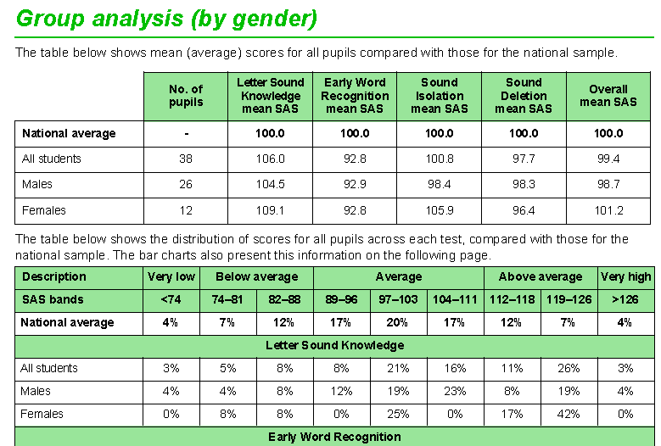
Group analysis (by Gender, by Ethnicity)
Notes
Care needs to be taken in using percentages with small group sizes eg in this example 8% represents 1 female pupil.

The charts for each categorycan be used

Similar analysis can be done as above for different ‘groups’. However see Notes.

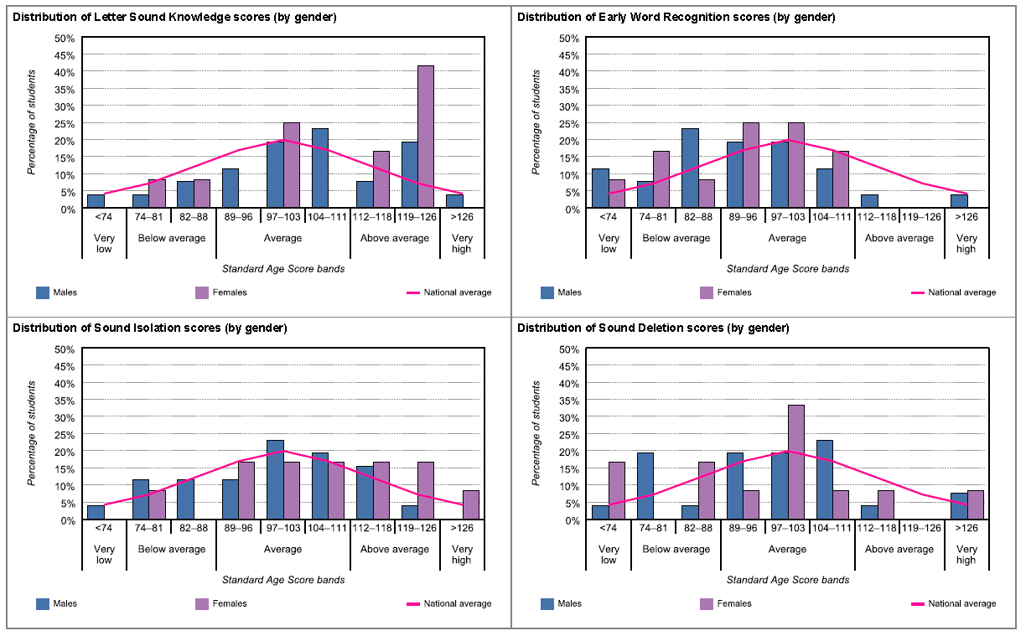
EXAMPLE
These charts confirm the previous analysis.
Sound isolation scores for male and female are similar to that of National distribution. Letter sound knowledge is strong, females generally do better at this than males (though compare 104-11 band and 119-126 band).
Early word recognition and sound deletion are areas for development / investigation.

NGRT (New Group Reading Test) P4 / P7
Group Scores for Sentence Completion and Passage Comprehension (by SAS)
Notes
These notes should be read in conjunction with page 2 of the report produced by GL. This gives further explanation of the data and terminology.
Pupils with the same raw score will have a different standardised score this is related to pupil age at test.
For comparison purposes use Standardised Assessment Score (SAS) and Group Ranking (GR). SAS is the raw score adjusted for age. The GR column heading will indicate the number of pupils who completed the assessment.
Ignore the NC Reading level column.

Pupils are ranked (GR) by standardised score. Is this broadly the order you would have expected for your pupils? Are there individuals that stand out (positively or negatively) from expectation and on-going classwork / Assessment evidence?
Which pupils are performing above average (to the right of yellow banding), in average band (in yellow area), below average (to the left of yellow banding)? Overall Stanine and NPR (National Percentile Rank) give a further comparison information of individual performance relative to the National Sample.
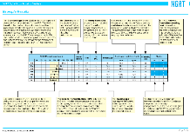
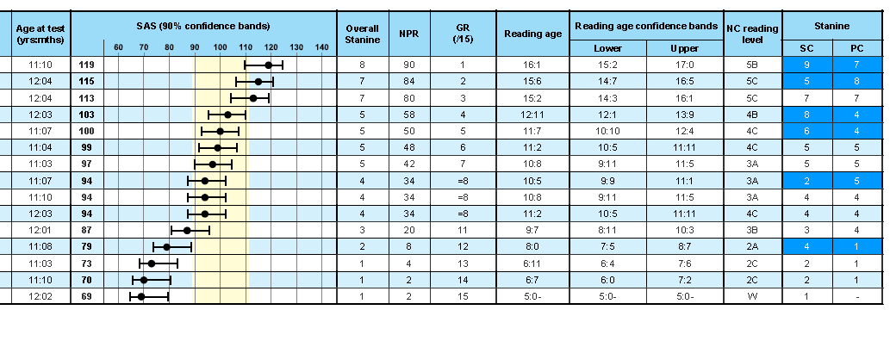
Be wary of too much interpretation and use of reading age.eg the pupil starred is aged 11 and 4 months, they have a reading age of 11yrs 2 months which could actually be anything from 10yrs 5 months to 11yrs 11 months.
Are there pupils who have performed significantly different between sentence completion and passage completion? (This will be highlighted in the final stanine column)
Are there any pupils who has no value appearing in the PC column - the Passage Comprehension section was therefore omitted and the Phonics section administered to the learner in its place. A later section will detail these results.

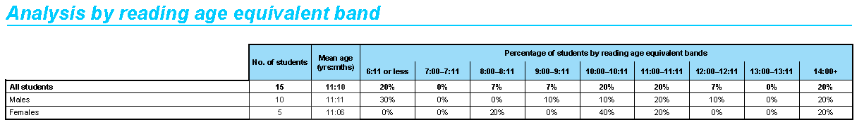
This table gives a broad indication of reading ages (See previous guidance re reading ages). It does however give an indication of the distribution of reading ability across the pupils who sat the assessment. As with all percentages care needs to be taken in interpretation eg in the above 20% of females is one child!
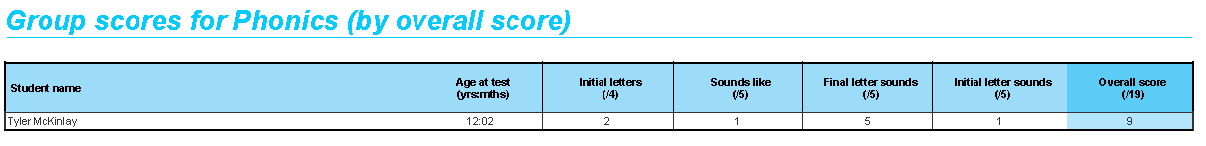

This details the score for any pupils who undertook the phonics assessment. Which categories did the learner perform well in? Less well in? Where should focussed areas of intervention therefore be?

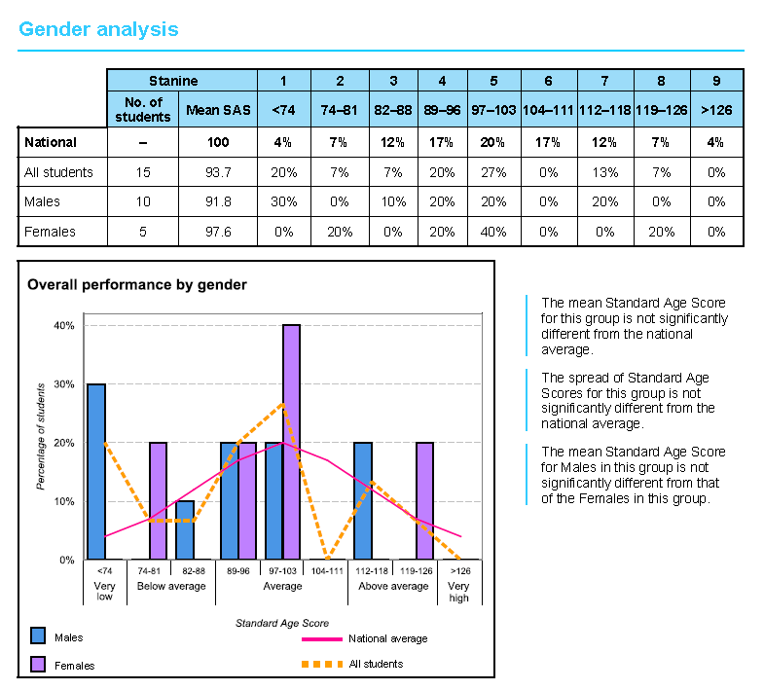
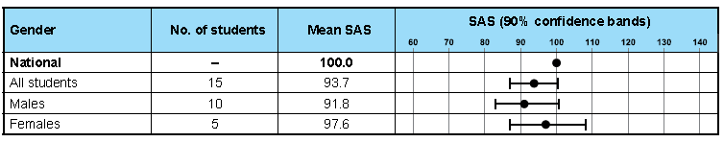
Whilst this section of the report is headed Gender analysis it can equally well be used for overall analysis, comparisons between year groups and progression where the assessment is carried out in future years with the same cohort of pupils.

The GL report will give some written statements about the data.
Some questions to think about would be …
Does our distribution (orange dotted line) match that of the National distribution (pink solid line)?

The mean SAS has a confidence band. Statistically this means that in a typical 90 per cent confidence band for the mean score of 100 there would be a 9 out of 10 (90%) chance that the test-taker's true score lies within the SAS band 83 to 101. Therefore in this example 1 out of 10 (10%) males statistically is likely to actually fall outwith this band.

