City Of Edinburgh Council

Children and Families Department

Profiling and Profiles: Position Paper January 2013

What is a Profile?

A profile is a snapshot of a young person’s best achievements at a given point in time. It is produced by the young person with support from an identified lead teacher. Profiles are primarily aimed at young people and their parents, and draw together a range of information about a young person’s learning. It is one of the ways in which a learner’s achievements can be recognized (See Appendix 1),

By completing their profile the young person will increase their self-esteem, improve their motivation, and thereby improve learning. This is integral to the overall Curriculum for Excellence aims of raising attainment, reducing the achievement gap and preparing for the future.

Within the city of Edinburgh schools are expected to work with learners to produce a profile at the end of nursery, end of P7 and end of S3. However profiles need not be restricted to these transition points.

Profiles should support and inform transition, but it is not expected that they will replace effective transition procedures that are already in place.

What are the purposes of Profiling and the Profiles?

Profiling is the process that gets you to the end product.
A profile is the end product.

The purposes of profiling are to:
- build learners’ skills & capabilities to reflect on their learning.
- enable learners with a summary of achievements to help them plan their learning & development.
- challenge, motivate and support all children & young people to achieve their best.
The purposes of profiles are to:
- provide learners with a reflective summary statement of achievement from S3 into the senior phase.
- publicly recognise progress in learning
- support & inform transition

The Process of Profiling and how it is managed.

Research indicates that a powerful tool in learning is the ownership of learning and the process of profiling provides such ownership (See Appendix 2)

To meet the principles of Curriculum for Excellence schools and learners will undertake a range of activities and processes to support recognising achievement, profiling and reporting. Many of these practices will already be well established in schools and other education establishments.
Learners' achievement relates to all aspects of their learning both in and out of school. It includes their achievement in relation to national standards and expectations in the broad general education and in the senior phase, including their progress in becoming successful learners, confident individuals, responsible citizens and effective contributors.
Gaining recognition for their achievements benefits all young people. The process of planning, assessing, recording and recognising achievements can help learners to understand the skills and attributes they have developed through their planned learning and enable them to build on these (See Appendix 7).
Young people’s engagement in the process of profiling needs to be carefully planned.
In planning the process of profiling schools should aim:
- to ensure young people acquire the skills to reflect on their learning and to develop the skills for life and the skills for work
- to enable them to develop positive attitudes about themselves, and
- to provide opportunities for dialogue between pupil and peer; teacher and pupil; teacher, pupil and parent/guardian.

The teacher’s primary role is to provide these opportunities for reflection and dialogue and to ensure that the information is valid.

Profiles are primarily aimed at learners and their parents and will provide a clear statement of progress and achievement at a particular point in time.

The Nursery – P1 Profile.

Most early years centres and schools already have effective systems in place for profiling as part of the personal learning planning process. The child’s profile will contribute to this process by allowing children the opportunity to reflect on their best achievements and engage in dialogue about their next steps before moving on to Primary school. An example

It is envisaged that staff will support children in completing their profile at transition time. A copy should be given to the child who may wish to share this with staff on their first visit to the primary school. You should also attach a copy of their profile to the transition report for the receiving school.
An example of a Nursery – P1 Profile can be found in Appendix 4

The profile includes:
1. An opportunity to reflect on achievements and identify next steps.
2. An example of drawing and writing skills.
The P7 Profile.

All P7 pupils should complete their profile by the end of May each school session to allow their profile to be included with the other transition information passed on to the relevant high school.

As last session all primary schools can use the authority exemplar or devise their own cluster format.
An updated copy of the authority exemplar can be found in Appendix 5.
Please note that a significant change from last session removes the requirement to include a level for each of the nine curriculum areas.

Essential components of the profile include:
- a learner’s statement: the learner, with appropriate support, will produce a statement outlining his or her best achievements in and out of school.
- as appropriate a record of qualifications and awards:
- information on progress and achievement in literacy and numeracy, and in health and wellbeing.
- information on progress and achievement across all curricular areas.

The S3 Profile.
S3 marks the end of young people's broad general education phase and is a time when they are choosing their future learning paths for the senior phase. It is a unique point both to reflect on learning that has taken place to date and to plan for future learning and development. At the end of S3, young people should have their progress and achievements recognised by the school or educational establishment.
The final format of a profile will be decided by individual schools and the local authority and should not exceed 3 sides of A4 paper. Different formats may emerge which may vary according to the age or circumstances of learners (e.g. the P7 profile will be different in appearance from the S3 profile) However all profiles must meet the national criteria provided by Education Scotland (See Appendix 3).

Essential components include:
- a learner’s statement: the learner, with appropriate support. will produce a statement outlining his or her best achievements in and out of school.
- as appropriate a record of qualifications and awards: this may include SQA qualifications and any other qualifications and awards.
- information on progress and achievement in literacy and numeracy, and in health and wellbeing.
- information on progress and achievement across all curricular areas.

An example of an S3 Profile produced by St Augustine’s RC HS as part of their participation in the national pilot (May – November 2012) can be found in Appendix 6.

Schools and local authorities must ensure that the production of profiles is manageable for all involved, whatever profile format is adopted.
In Edinburgh a number of different arrangements have been put in place in schools to provide the time for developing the process of profiling. These have included timetabled PSE classes, mentoring time and the allocation of a period each week for work on wider achievement. At the same time it must be remembered that all staff have a role to play here, as opportunities for dialogue about a young person’s learning should be taking place across all curriculum areas.

S3 profiles will also be used to validate achievements in their broad general education and better prepare young people for the senior phase and working towards a positive and sustained destination after school. Profiles, alongside the S3 report, should help inform the Senior Phase pathways.

What are the main differences between a profile and a report to parents?

Profile | Written and ongoing reporting to parents
Written by the young person in partnership with the school. | Written by teacher(s)/staff.
At P7 and S3, which are significant points of transition in a learner’s education. | At least once per year.
Provides information on successes in learning and a reflective summary statement of achievements, including achievements beyond school and other awards. | Provides clear information and feedback on a learner’s progress and how well she/he is doing against agree expectations.
Provides a way for young people to explain and share their achievements with a range of people, including parents, teachers and, at future dates, ongoing education staff and prospective employers. | Provides an agenda for discussion between learners and those teaching and supporting them.
The learner has ownership of the profile and it contains the information that they choose to share with others. | Informs parents of what their child needs to do to improve and suggests how parents might help.
Contributes directly to the learning process by giving each learner an important context for applying their skills, including literacy. | Young people do not usually provide content directly for the report.

Appendix 1 - Education Scotland Materials & Resources
This guidance is based on materials currently available on the Education Scotland website:
http://www.ltscotland.org.uk/learningteachingandassessment/assessment/achievement/profiling/index.asp
and also on the National Assessment Resource
https://www.narscotland.org.uk/_search.jsp?search_phrase=S3%20Profiles

Particular Resources from Education Scotland.Briefing
Briefing Paper 3
Curriculum for Excellence: Profiling and the S3 profile

Appendix 2 – Research Literature

Val Klenowski
Assessment in Education: Principles, Policy and Practice: Volume 19 Issue 1

Assessment Reform Group University of Cambridge Faculty of Education
Testing, Motivation and Learning

Pauline Clarke, Thompson Owens, Ruth Sutton
Creating Independent Student Learners: A Practical Guide to …. (2006) 86 pages.

Sue Swaffield, Pete Dudley; Association of Teachers and Lecturers
Assessment Literacy for wise decisions

Appendix 3 - Criteria for Developing Profiles

- to be appropriate to the learner’s age, stage, individual needs and interests, and support further learning (recognize that children and young people learn and progress in different ways and at different rates).

- focus on the progress which the child or young person has made and take account of the breadth, challenge and application of learning.

- contain robust information on progress and achievement in all curriculum areas (information which is based on a range of assessment approaches and evidence which is valid and reliable and is underpinned by moderation and quality assurance).

- contain robust information on progress and achievement in literacy and numeracy and health and wellbeing (information which is based on a range of assessment approaches and evidence which is valid and reliable and is underpinned by moderation and quality assurance)

- include a learner’s statement (for the learner, by the learner) outlining their latest and best achievements, and aspirations in and out of school.

- promote learner ownership through reflection by learners and dialogue with learners as central features

- relate to the full range of achievement in learning in and out of school, outlining their latest and best achievements

- include a record of awards (as appropriate)

- be useful to learners (increases self esteem and motivation and thereby improves learning) and to those within and out with the school system

- be a positive statement reflecting the range of achievement of the broad general education to date

Appendix 4 – An example of a Nursery Profile.



Nursery Profile
2011-2012

This is me
Name …………………………………………………………………

Child’s Comments:
My name is
At Nursery I liked learning to


Now I would like to learn

Appendix 5 - P7 Exemplar Profile.

__________Primary School
2012-13
Name: DOB:




Me as a learner
My personal achievements and awards (in and out of school)

My hopes for Secondary School

Me in the future
Photo
My Magic Moments in Primary School
⬆

⬆

⬆

Parent/Carer Comment:

Signatures:
Pupil

Parent/Carer

Class Teacher

Date










Literacy and English

Health and Wellbeing

Numeracy and Mathematics
Modern Languages
RME
Expressive Arts
Technologies
Science

Social Studies

My Personal Statement My Personal Achievements

Appendix 6 - Example of S3 Pupil Profile – St Augustine’s RC HS Personal Achievements

Skills I Have Gained For The Future Me In The Future

Learner 1

Skills I Have Gained for the Future

Me in the Future

Signed: Pupil
Signed: Parent/Carer Signed: Teacher Date:

Languages Mathematics

Health and Wellbeing Social Studies

Religious Studies Sciences

Expressive Arts Technologies

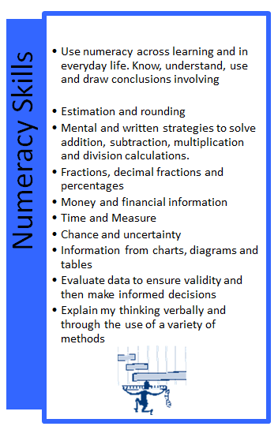
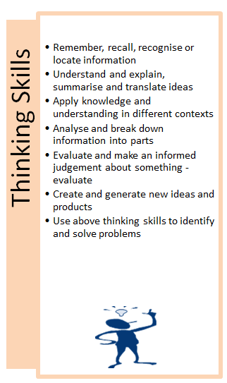
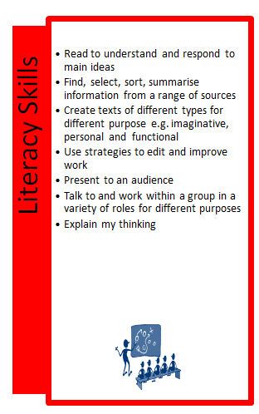
Appendix 7 - Skills for learning, life and work

Work effectively with others
Show initiative
Be assertive
Communicate effectively
Learn from mistakes and accept responsibility
Persuade and influence
Set high standards
Agree objectives and check they are completed
Make decisions
Be a good role model

Value myself and respect others
Make and keep positive friendships
Demonstrate resilience and confidence
Communicate well
Make good choices and promote a healthy lifestyle
Recognise and make links between rights and responsibilities
Seek and accept help positively
Assess and manage risk including use of ICT
Recognise and reflect on my strengths and those of others
Demonstrate an awareness of other people’s differences
Challenge myself and approach new challenges with confidence
Display a positive attitude
Develop physical coordination and movement skills

Take responsibility for my contribution
Accept responsibility for and carry out a role
Contribute to discussion and justify suggestions
Listen to the views of others and compromise when appropriate
Encourage and support others.
Give and receive feedback
Self evaluate my contribution
Identify and discuss my own learning
Be reflective
Set realistic next steps for myself
Use appropriate language to evaluate my learning
Recognise my achievements
Take responsibility for my actions
Know and use other peoples strengths
Identify strengths and areas for improvement
Take on board suggestions for improvement
Have a positive attitude to my learning
Be motivated to do well

Take initiative,working with and leading others
Being creative, flexible and resourceful with a positive attitude to change
Manage resources and time
Work effectively with others
Demonstrate good leadership skills
Be motivated
Determination to succeed

Health and Wellbeing Skills
Leadership Skills
Working with Others Skills
Personal learning planning skills

Enterprise and employability skills

