**Analysing Attainment data**

**Insight**

The fundamental difference between Local and National measures is that all four National Measures are based on data about learner performance at point of exit from school, so they graph the performance of the leavers as one big cohort - some coming from S4, some from S5 and some from S6 but all together making up the leavers' cohort. National measure data will be live in February of the year immediately after the examination diet year.  
The Local Measures look at the performance of cohorts of pupils in your school, whether they have left school or not. Thus we can consider the pupils' performance in Literacy and Numeracy by the end of S5, or the performance of the highest-attaining 20% of S5 as a year group. Local measures will be available on the 31st August of the same year as the exam diet.

**Fyfe**

S4/5/6 data will be available from 14th – 31st August 2015. In 2015 22 out of 32 LAs have engaged in this data analysis exercise.

Incomplete awards not included in subsequent analysis

Green type = strong +ve patterns, red = strong negative patterns

**Number/Percentage**

Number of learners entered for this course. Then as a percentage of the whole year cohort.

**CCD – Consortia Comparison Decile**

All Scotland secondary schools from 22 Local Authorities ranked in order for a variable. After ranking the schools in order; schools placed in the top decile will be CCD 1 (first 10th), schools placed in the 2nd decile will be CCD2 (2nd 10th) etc. High percentage is ranked first (1), Low percentage is ranked last (10). This is why it’s good to be CCD 1 or 2 for most categories but better to be CCD 9 or 10 for No Awards and Mean Average Band, Average Grade etc.

CCD 5 or 6 – performance is in line with National Average

**Mean S4 Points**

Used in S5/6 analysis to measure the attainment level of cohort incoming from S4.

**UPS Points**

Unified Points Score. Every grade awarded for each qualification is represented by a number of points. Adding these points tariffs together for an individual learner would give them their UPS points score for this diet of exams. (Credit 1 = 38 points, Credit 2 = 28 Points, Credit 3 = 22 points. For full rundown see - <https://pubxed.scotxed.net/stacshelp/reference/ups.htm> ) Average UPS points value per pupil is used rather than total.

**RV – Relative Value**

Describes pupil attainment in your subject against attainment in their other subjects. You should be looking for the coloured spots to be as far above and left of the line as possible. The x-axis is average award band for all other subjects excluding yours and y axis represents attainment in your subject.

**\* and P ratings in tables**

The asterisks indicate how significantly different from zero a value is (0 means neutral – in line with expectations)

* equivalent to 90%

** equivalent to 95%

*** equivalent to 99%

The number represents the duration of the pattern and the letter **P**ositive or **N**egative for a strong pattern or + or – for a less strong pattern. **U** and **D** sometimes used to show upward and downward trend.

|  |  |  |  |  |  |  |  |  |  |  |  |  |  |  |  |  |  |
| --- | --- | --- | --- | --- | --- | --- | --- | --- | --- | --- | --- | --- | --- | --- | --- | --- | --- |
|  | Relative Value | | | | | | | | | | |  | Ave Award (Low is better) | | | | |
|  | 2008 |  | 2009 |  | 2010 |  | 2011 |  | **2012** |  | Patt |  | 2008 | 2009 | 2010 | 2011 | **2012** |
| All | 0.19 | ** | 0.12 | * | -0.23 | *** | 0.00 |  | **-0.16** | **\*\*** | D |  | 2.46 | 2.42 | 3.11 | 2.80 | **3.03** |
| Male | 0.15 |  | 0.21 | ** | -0.32 | *** | -0.08 |  | **-0.21** | **\*** | D |  | 2.81 | 2.70 | 3.63 | 3.25 | **3.46** |
| Female | 0.27 | *** | 0.10 |  | -0.11 |  | 0.17 |  | **-0.01** |  |  |  | 2.08 | 2.00 | 2.58 | 2.23 | **2.45** |
| Upper | 0.26 | * | 0.06 |  | -0.11 |  | -0.01 |  | **-0.16** |  |  |  |  |  |  |  |  |
| Lower | -0.13 |  | 0.23 |  | -0.40 | * | -0.04 |  | **-0.19** |  |  |  |  |  |  |  |  |

Regression line



The regression line is determined by the pattern of awards achieved nationally. In reality there should be a female regression line and a male regression line but this would make the graph difficult to interpret. For this reason the regression line shown is for all pupils.

**PV – Progression Value (Used for S5/6 analysis)**

Describes progression from previous qualifications in this subject. PV scatterplot – S4 UPS points average on the x axis and award band for this subject on the y axis. Learners, represented by either a red (female) or blue (male) dot are displayed as either above or below the regression line (black). The further above the regression line the better. You should be able to identify the learners using their award band for your subject along with their UPS points from S4. You obtain a regression value per subject by calculating the amount by which the dots are above or below the line. (This is shown in numbers in the PV and RV tables)

|  |  |  |  |  |  |  |  |  |  |  |  |  |  |  |  |  |  |
| --- | --- | --- | --- | --- | --- | --- | --- | --- | --- | --- | --- | --- | --- | --- | --- | --- | --- |
|  | Progression Value | | | | | | | | | | |  | Ave Band (Low is better) | | | | |
|  | 2008 |  | 2009 |  | 2010 |  | 2011 |  | **2012** |  | Patt |  | 2008 | 2009 | 2010 | 2011 | **2012** |
| All | -2.05 | ** |  |  | -0.39 |  | 0.44 |  | **-1.08** | **\*\*** |  |  | 5.75 |  | 4.56 | 3.67 | **5.63** |
| Male | -3.04 | * |  |  | -0.64 |  | 0.22 |  | **-0.86** |  |  |  | 7.67 |  | 5.00 | 3.63 | **5.40** |
| Female | -1.32 | Regression line | Residual (-) |  | 0.36 |  | 1.83 |  | **-1.40** | Average of summed residuals |  |  | 4.60 |  | 3.00 | 4.00 | **6.00** |



**S5/6 Course Comparisons**

|  |  |  |  |  |  |  |  |  |  |  |  |  |  |  |  |  |  |  |  |
| --- | --- | --- | --- | --- | --- | --- | --- | --- | --- | --- | --- | --- | --- | --- | --- | --- | --- | --- | --- |
|  |  |  | Ave Band | |  | Prog Value | |  | Entries | | |  | Grades A-C | | |  | Incomplete | | |
|  | Pts |  | Band | CCD |  | PV | Ast |  | No | % | CCD |  | No | % | CCD |  | No | % | CCD |
| Falkirk High (Fal) | 29.4 |  | 3.33 | 9 |  | 1.21 | *** |  | 27 | 10 | 2 |  | 26 | 96 | 2 |  | 0 | 0 | 0 |
| Dunfermline High (Fif) | 29.5 |  | 3.42 | 9 |  | 1.09 | *** |  | 12 | 3 | 9 |  | 11 | 92 | 3 |  | 0 | 0 | 0 |
| Perth Grammar (P&K) | 29.4 |  | 3.85 | 8 |  | 0.65 |  |  | 13 | 6 | 5 |  | 12 | 92 | 3 |  | 0 | 0 | 0 |
| Trinity High School (Ren) | 29.4 |  | 4.11 | 7 |  | 0.40 |  |  | 19 | 7 | 3 |  | 16 | 84 | 4 |  | 0 | 0 | 0 |
| Vale of Leven Academy (WD) | 29.4 |  | 4.46 | 6 |  | 0.04 |  |  | 13 | 5 | 6 |  | 11 | 85 | 4 |  | 0 | 0 | 0 |
| Auchenharvie Academy (NA) | 29.5 |  | 4.58 | 5 |  | -0.07 |  |  | 12 | 8 | 3 |  | 8 | 67 | 8 |  | 0 | 0 | 0 |
| Mackie Academy (Abs) | 29.4 |  | 4.81 | 4 |  | -0.29 |  |  | 32 | 11 | 1 |  | 25 | 78 | 6 |  | 1 | 3 | 1 |
| Milne's High (Mor) | 29.4 |  | 4.84 | 4 |  | -0.33 |  |  | 19 | 15 | 1 |  | 15 | 79 | 6 |  | 0 | 0 | 0 |
| Girvan Academy (SA) | 29.3 |  | 4.90 | 4 |  | -0.37 |  |  | 10 | 6 | 5 |  | 8 | 80 | 5 |  | 0 | 0 | 0 |
| Blue Sky School (Edi) | 29.4 |  | 5.63 | 2 |  | -1.08 | ** |  | 16 | 5 | 7 |  | 10 | 62 | 8 |  | 0 | 0 | 0 |
| St Margaret's Academy (WL) | 29.4 |  | 5.92 | 2 |  | -1.40 | ** |  | 13 | 5 | 7 |  | 7 | 54 | 9 |  | 0 | 0 | 0 |

Table is then ranked based on their S5/6 band in this subject

These schools are grouped together for this table based on S4 UPS points average

The same table for S4 will have schools grouped on UPS points average for all subjects apart from the one being analysed.

**CL/HT attainment review meeting**

Open ‘City of Edinburgh’ Folder then ‘ClassAnalysisTool’

Click on the ‘Add Ins’ menu

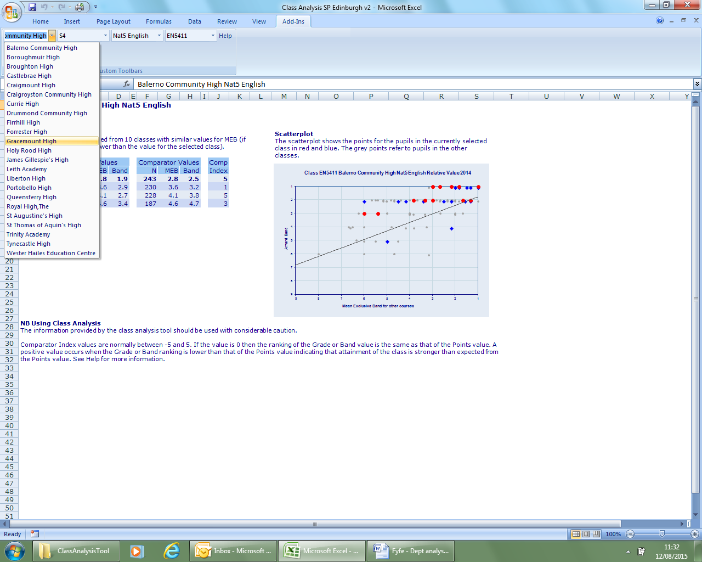

Select the school, year, course and class. This allows you to look at performance on a class by class basis.

**Sample return for:**

**S5/6 Higher English**

54 learners entered for 2012 Higher English. This is 24% of the S5/6 cohort.

Slight increase in entries on last year.

Reasons for low uptake into higher English:



Actions to increase uptake into Higher English:



For entry into Higher English prior attainment of learners is below national average.

Discuss running Intermediate 2 English next session.

2 classes

5H1 had Mr X. This class contained 24 learners who had slightly lower attainment in S4.

5H2 had Mr Y. This class contained 30 learners who had slightly higher S4 attainment in English.

Higher class tracking information.

This course is tracked monthly. Our courses and programmes are designed to have milestone assessments at appropriate points in the year to match this. In addition to this - learners have the opportunity to self select pieces of work to supplement this information. This can be done at a time appropriate to the learner. If the young person feels that the piece of work used for assessment purposes does not fully reflect their ability they are allowed the opportunity to replace this work with a different assignment/task. Tracking information will be amended accordingly.

Learners have learning conversations with their teacher at least once a term (at appropriate stages in their learning) During these discussions, areas of strength and next steps are agreed. These are based on their portfolio of evidence and resulting tracking information

Discussion of actual tracking data

* Targeted groups. Names of learners in the following groups - LAC, ASN, gender, EAL, lowest attaining 20%, SIMD 1+2, highly able.
* What are these groups being provided in terms of opportunities to achieve equity of provision?
* Interventions
* Improvements
* Learners who were struggling to achieve even after identification and interventions
* Early warnings to Support for Pupils
* Homework/Attendance

Final SQA Attainment :

A1:2

A2:5

B3:5

B4:9

C5:9

C6:6

D7:4

D8:4

F9:3

Progression value is positive. We are doing well to progress the learners we get in the door. 4+ pattern.

The following learners did not progress well from their S4 attainment:

3 girls at band 9 – names

3 girls and one boy at band 8 – names

3 boys and 3 girls at band 7 – names

1 girl and 2 boys at band 6 – names (may have to use other subject exam results to work out exactly who this is – 28 UPS points average)

These learners were tracked from S4 data then throughout the Higher English course. Reasons for poor progression shown next to each learner’s name. (evidence of tracking and interventions)

**Relative value**

The following learners did not do as well in English as they did on average across the rest of their subjects:

3 girls at band 9 – names

3 girls and one boy at band 8 – names

3 boys and 3 girls at band 7 – names

1 girl and 2 boys at band 6 – name (may have to use other subject exam results to work out exactly who this is – 28 UPS points average)

These learners were tracked from S4 throughout the Higher English course. Reasons for poor relative value shown next to each learners name. (may be different from pv reason)

All in all – last year this year group did not achieve particularly great S4 results. They have managed to ‘catch up’ by higher level though. Look into local reasons re why S4 was so poor?

Because S4 attainment was so poor and average UPS points were low progression showed up as strong. For this reason – in amongst the schools with learners of similar S4 UPS points average This school was high in the course comparison table obtaining an average band of 5.11 (High C) for Higher English.

**ACTION PLAN – I plan to make the following improvements to address the issues highlighted ....**

**(This is the important section of this analysis. This section should inform dept and school IPs)**

