**SHE – Health & Safety Software**

The Council is changing the way accidents/incidents are reported to an online reporting and recording system which will:

* make it easier to report accidents
* be more efficient at maintaining records
* produce accurate and meaningful management information
* produce better statistical information which will identify any accident 'trends' and help improve safety.

Please note that the guidance on what needs to be reported remains unchanged. It is only the method of reporting that is changing.

The new reporting system "[SHE Portal](https://www.sheassure.net/EdinburghCC/portal/portal/index)" allows everyone with access to the internet to report an accident at any time of the day. If you don't have internet access please contact the [Corporate Health and Safety Section (CHSS)](mailto:hr.healthandsafety@edinburgh.gov.uk) so that an alternative reporting arrangement can be made.

To help you complete the form we have developed the instructions below.

To report an accident you should now [fill out our new online form](https://www.sheassure.net/EdinburghCC/Portal/Create/Portal/04224edf-8d75-4c56-a489-4ff79184258b) on the SHE portal. Please remember to add your email address so that you can receive a copy of your report for your records.

**Contacts**

Your contacts for general SHE advice and support for example user guidance, Information Technology support are:

John Enock, Management Information Systems Officer[John.Enock@edinburgh.gov.uk](mailto:John.Enock@edinburgh.gov.uk) tel 0131 529 6531

Derran Beer, Project Manager, [Derran.Beer@edinburgh.gov.uk](mailto:Derran.Beer@edinburgh.gov.uk) tel 0131 529 6621

**Posters**

Alongside the roll out of the SHE database you will receive over the forthcoming weeks Health & Safety “Report It” accident posters. Can you please ensure that these posters are displayed on staff notices and throughout your establishment where appropriate.

**Licenses**

You will see from the attached instructions that the SHE database is capable of providing high quality statistics. In order to do this user licences will be provided in the near future to School Business Managers and Establishment Managers. A series of planned demonstrations will be held at Waverley Court and neighbourhoods. This training will be advertised and colleagues will be able to book on through the normal CPD process.

**What is coming next?**

The next module of SHE to be rolled out is a Risk Management portal that will enable staff to undertake risk assessments online using the portal as a tool to do this, you will receive further information on this as soon as the portal is ready to go live.

**Instructions**

# Running Reports on the SHE database

1. Open and login to the SHE database portal:

<https://www.sheassure.net/EdinburghCC/Login>

1. Click on either the ‘incident report’ quick link (see below how to set this up) or choose ‘Incident’ and ‘Incident Record’ from the ‘Modules’ drop down menu:

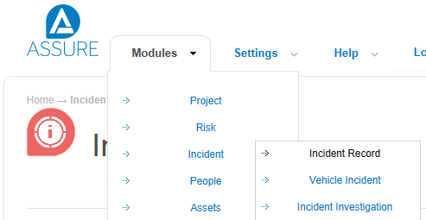

1. On this screen you can see what incidents have been recorded at your establishment. To run a report click ‘Reports’ button and then the quick report button :

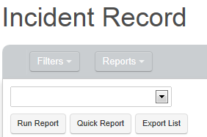

1. Click the cog wheel button at the end of the C&F Establishment report:

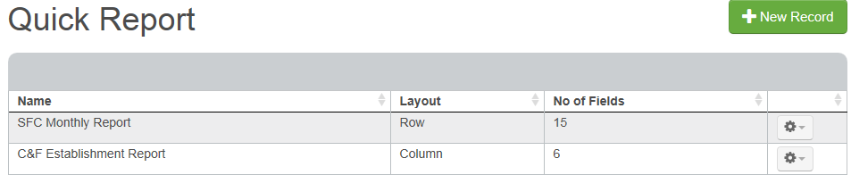

1. Click View from the drop down:

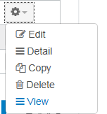

1. This presents you with a report which you can copy and paste into an excel spreadsheet (press and hold the keyboard button ctrl and press the keyboard button ‘a’, then press and hold the keyboard button ctrl and press the keyboard button ‘c’, open your spreadsheet and press and hold the keyboard button ctrl and press the keyboard button ‘v’).

# Setting up your SHE Dashboard

1. Open and login to the SHE database portal:

<https://www.sheassure.net/EdinburghCC/Login>

1. Click the configure button:



1. Click the new record button:

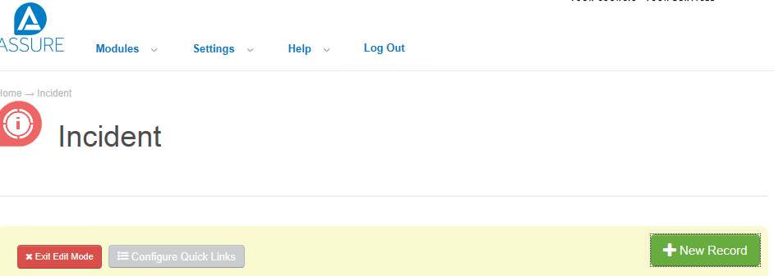

1. Select the criteria for your report. For example to find out how many and what type of accidents have happened at your establishment in the past 6 months you would choose the following parameters:

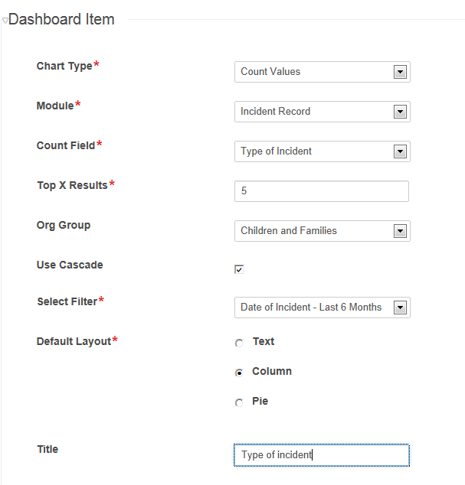

1. Click Save and close.
2. The chart can be edited by clicking the button with a cog wheel icon to the top right of the chart and selecting edit: 
3. To set up quick links on your dashboard click 
4. Click 
5. Click Add when it appears 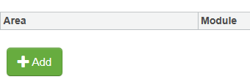
6. Click the check box beside the area ‘incident’ and the module ‘incident record’ then click select: 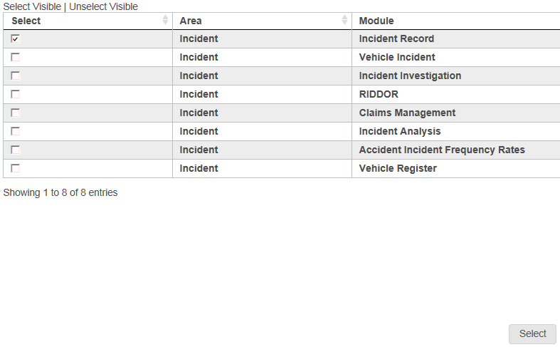
7. Click 
8. Click 
9. You can further adjust the layout of your dashboard using the buttons  at the right hand side of the screen. You can choose for everything to be displayed in one, two or three columns. This can be changed depending on your own preference e.g. if the graph you have created contains a lot of detail you may wish to keep your display to one column or if you are in a hurry you may wish to view all of your graphs at once without scrolling down the page.