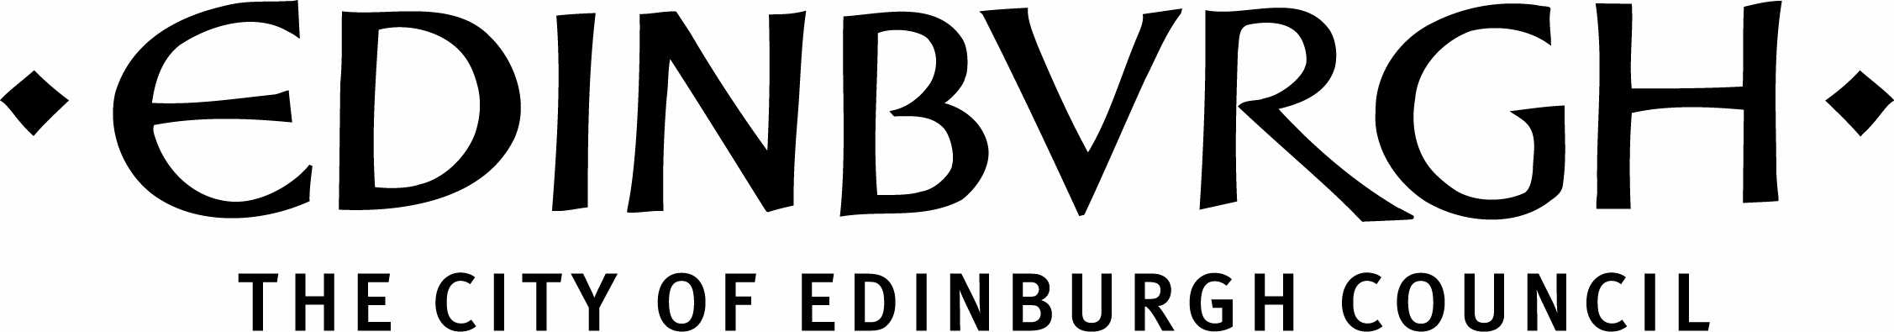
Quality Improvement team STEM Strategy * September 2014
( *The strategy outlined here forms part of a much wider range of council , partnership and national actions . )
- Vision
Our vision is to work in partnership to educate, equip, enthuse and encourage a generation of learners who have opportunities to:
- learn in context
- experience a range of learning journeys
- engage in challenges, and
- achieve a positive destination in STEM further education , employment and training .
- Aims
Our aims are to:
- appropriately prepare and provide opportunities for our young people for their future training and academic studies to allow them to continue on into positive destinations in the field of the sciences, technologies, engineering and mathematics
- bridge the gap between the future workforce and economic demand
- encourage aspirations of young people to develop the skills and knowledge of science, technology,
engineering and maths (STEM) will be increasingly important in the years ahead.
- Rationale
- Science, Technologies and Engineering and Maths (STEM) are vital for Scotland’s future. STEM is a keystone in delivering Government Economic Strategy of creating a more successful Scotland with opportunities to flourish through increasing sustainable economic growth. This makes a major contribution to the Scottish Government’s 5 strategic objectives smarter, safer and stronger, wealthier and fairer, greener and healthier.
- “Education, working for all! “ recommends that “A focus on STEM should sit at the heart of the development of Scotland’s Young Workforce.”
http://www.scotland.gov.uk/Resource/0045/00451746.pdf

- STEM experiences are central to achieving the priorities set out in the Skills investment plans http://www.skillsdevelopmentscotland.co.uk/resources/skills-investment-plans/

- STEM is a priority in the Curriculum implementation (CfE) plan 2014/2015
http://www.educationscotland.gov.uk/Images/CfEImplementation%20Plan2014to15_tcm4-829949.pdf

- STEM supports the established wider goals of successful learners, confident individuals, effective contributors and responsible citizens.

- Priorities for Edinburgh Council Children and Families

- Improve learners’ STEM experiences
- Ensure our learners are informed about STEM education employment and training opportunities that exist in Edinburgh and beyond
- Improve positive destinations in STEM education, employment and training.

- Priorities for Edinburgh schools and establishments
- Work towards implementing entitlement of STEM experiences and the development of skills * for all learners throughout their broad general education (*See STEM learning experiences Appendix 1)
- ensure that schools and learning centres provide flexible learning pathways, which allow learners to gain appropriate qualifications to allow them to respond effectively to economic demand
- ensure that primary, secondary and special schools have a strong understanding of the place of computing science in CfE, and teachers deliver learning in the subject which is up-to-date and relevant
- increase capacity further to work collaboratively with businesses to develop science, technological, engineering and maths skills and knowledge programmes which enhance personal effectiveness, technical ability, productivity and support sustainable business growth
- nurture a culture in which creative, enterprising people are empowered and rewarded within establishments
- develop and support networks which facilitate creative interaction with and between subject areas and relevant partners
- enhance the range of work- based vocational learning, assessment and accreditation opportunities, working in partnership with employers and Skills Development Scotland.

Conclusion

Achieving the vision and aims outlined in this paper depends on a collaborative approach between all of the individuals and organisations which make up the STEM base in Edinburgh – in the public, private and voluntary sectors

The priorities are not exhaustive or prescriptive, but aspirational in meeting the needs of young people in an economy where 40% of the Scotland’s GDP is generated from science and technology.

Alison Kidd QIO Technologies
Jill Pringle QIO Numeracy, Maths and Science

September 2014

Appendix 1 - STEM learning experiences
Sciences Learners can:
- ask questions or hypothesise
- plan and design procedures and experiments
- select appropriate samples, equipment and other resources
- carry out experiments
- use practical analytical techniques.
- observe, collect, measure and record evidence, taking account of safety and controlling risks and hazards
- present, analyse and interpret data to draw conclusions
- review and evaluate results to identify limitations and improvements
- present and report on findings
- report (hypothesis, activity, results, evaluate)
Technologies Learners can:
- analyse products, systems, environments and services
- identify design issues
- search and retrieve information to inform thinking
- develop a range of ideas / possible solutions
- select and manage appropriate resources
- develop skills and dexterity in manipulating materials and components
- develop and use sketching techniques
- use a specification as a measure to evaluate performance
- be creative and innovative
- use tools, equipment, software and materials safely and effectively
Engineering Learners can:
- formulate questions
- make use of problem-solving skills: clarifying objectives, assembling and evaluating information, planning a solution, implementing the solution, checking results and rethinking the problem and steps towards solution, if necessary
- think creatively
- think critically
- design and build models and prototypes
- use tools, equipment, software and materials
- evaluate products, systems and services
- make connections and apply learning in new contexts
- collaborate, lead, show initiative and interact with others
- prepare and deliver presentations – oral, written, multimedia
Mathematics Learners can:
- observe
- explore
- investigate
- experiment
- discuss, communicate and explain their thinking
- develop problem-solving capabilities
- develop critical thinking skills
- see patterns and relationships
- evaluate to make informed decisions.

http://www.educationscotland.gov.uk/stemcentral/about/skills/index.asp

