Using TEAMS

How To Use The Class Notebook 1

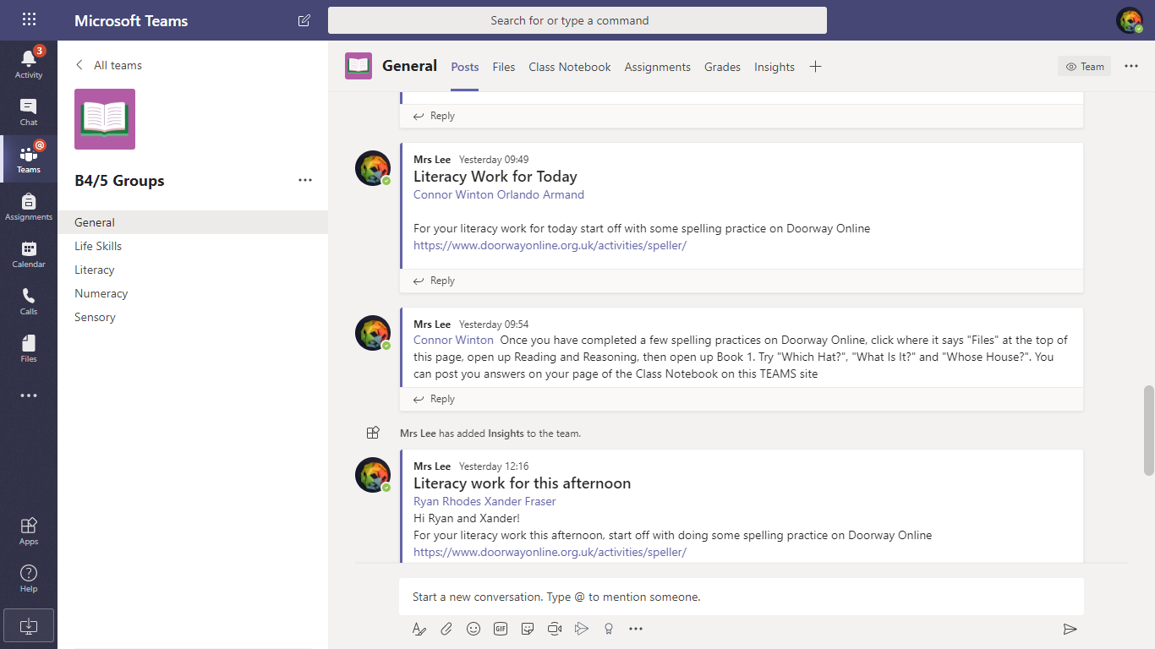



Click where it says Class Notebook

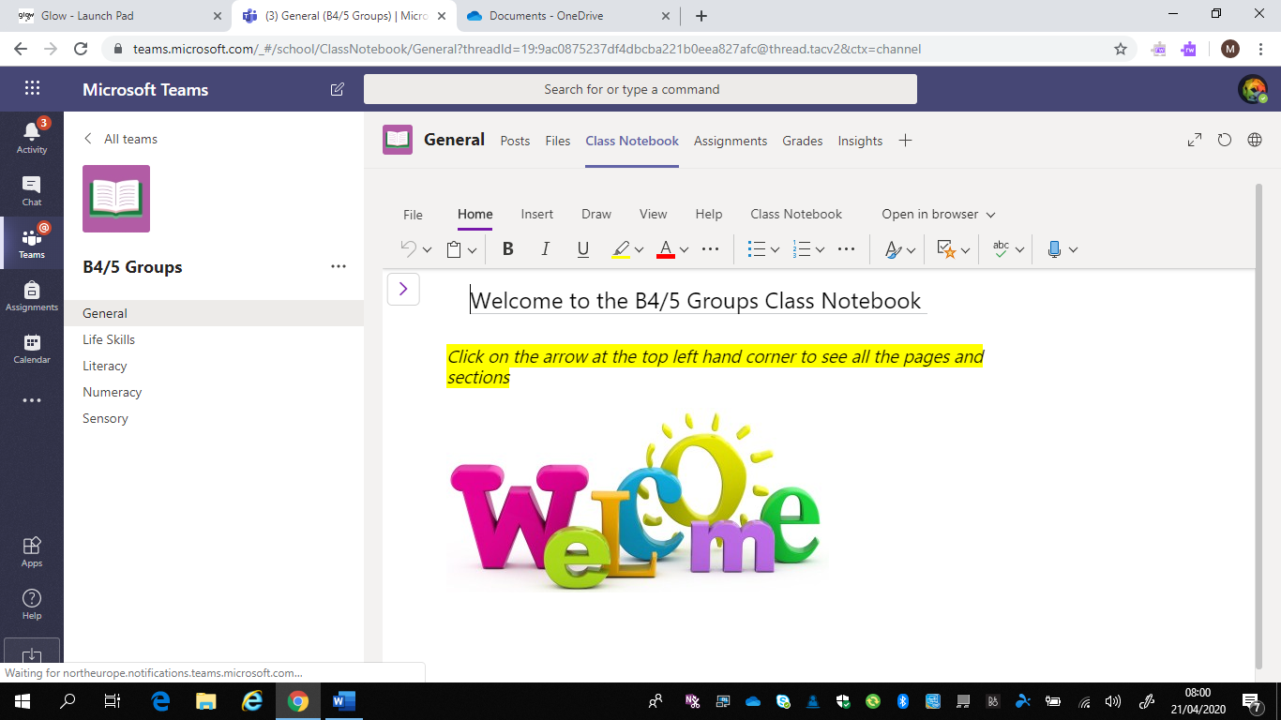

Click on the arrow at the top left



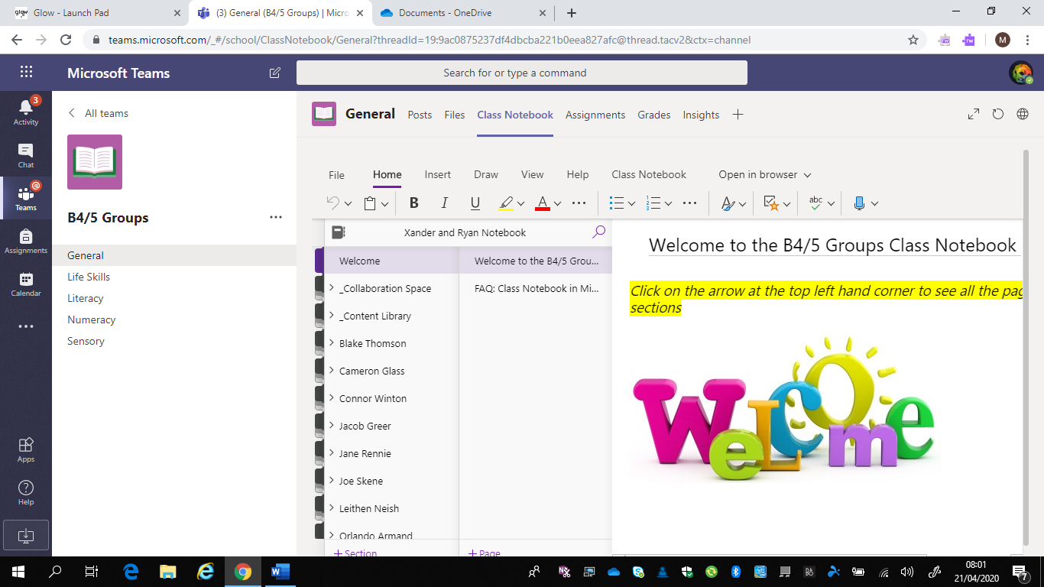



Over here you will see the Collaboration Space tab, the Content Library tab and your name (I can see lots of names because I am the teacher of the class – you should only see your own name)

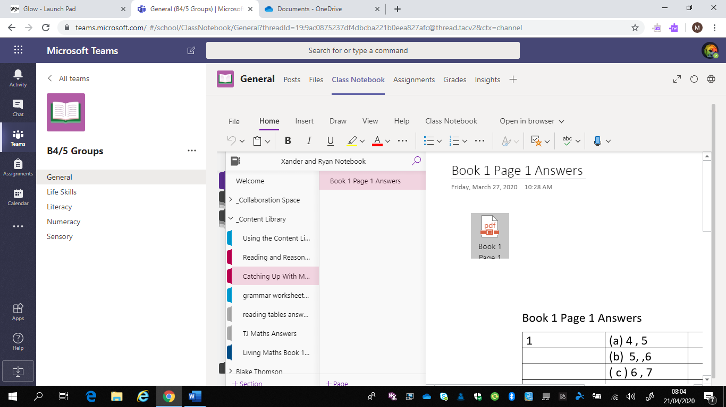



If you click where it says Content Library it will open up lots of tabs below it

Once you click on one of the tabs in the Content Library you will see a list of pages to the right of it, and when you click on the page the contents of it will display in the right hand box

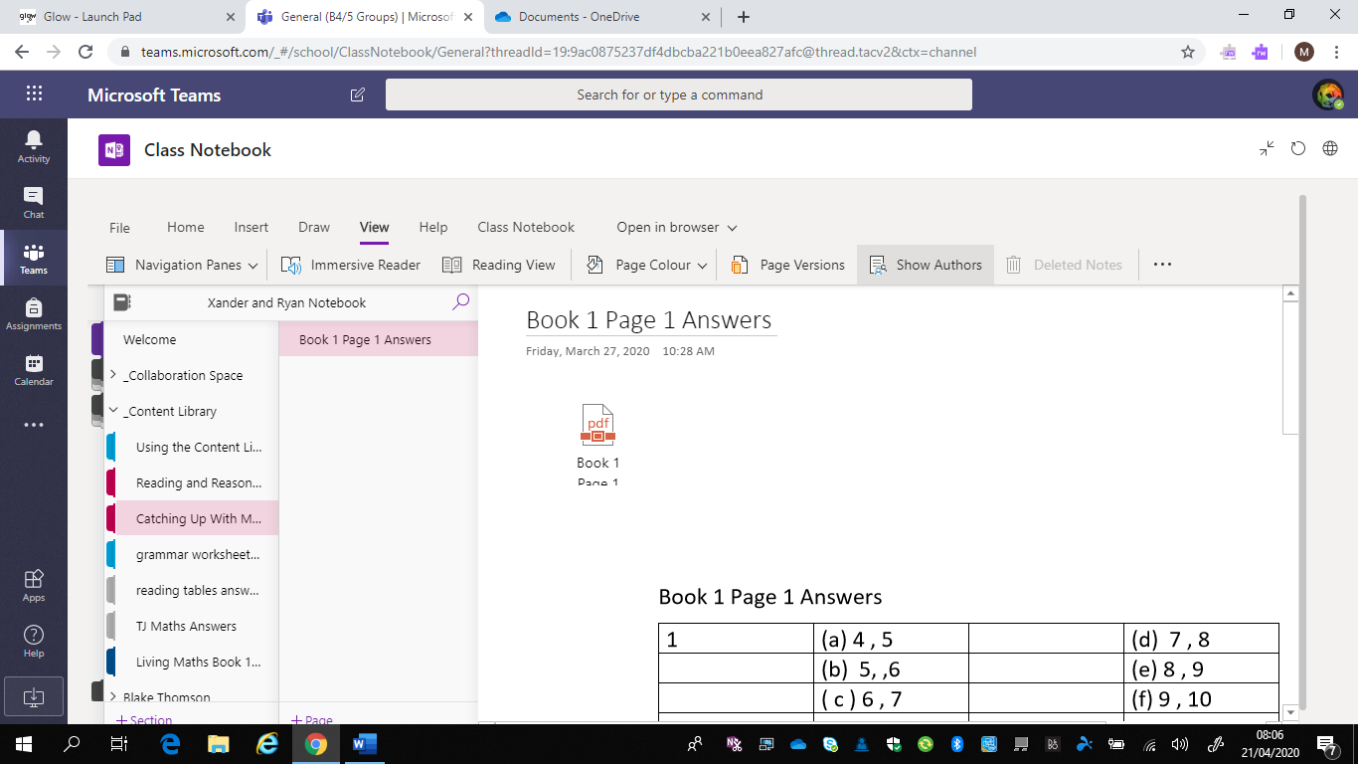



Click on the double arrow at the top right corner to display the page at a larger size

