I am learning to
Sort food into Healthy and Unhealthy, develop my understanding of how different foods help my body and give me energy and help me grow.
HWB 30a – Together we enjoy handling, tasting, talking and learning about different food groups, discovering new ways in which eating and drinking may help us grow and keep healthy.

How you can help me:
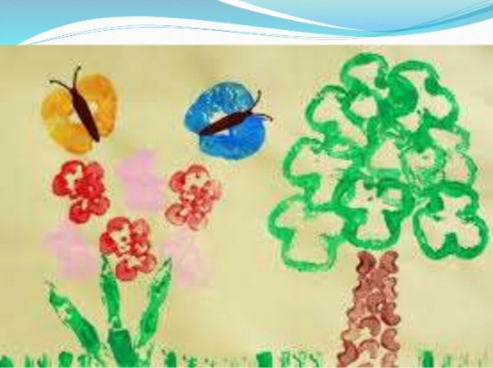
- Unpack the shopping together, try to sort the food into different groups. It could be by colour, by type (fruit, veg, diary, sugary, etc) or what they think is healthy and what is less healthy, for treats.
- Vegetable printing – try cutting different vegetables in half and see what prints they make, or use potatoes to make different shape pictures.
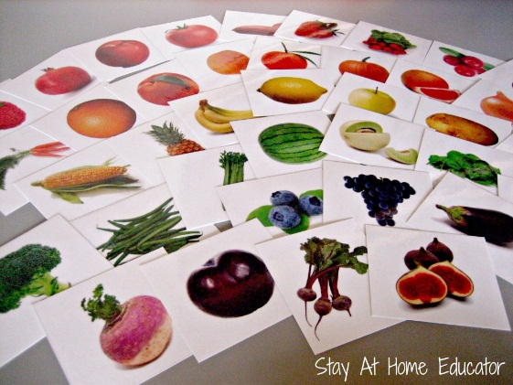
- Try the eat the rainbow challenge – can you eat something from each colour of the rainbow every day?

- Healthy Food collage – cut pictures of healthy food out of magazines or papers.
- Make food faces or other cooking together.
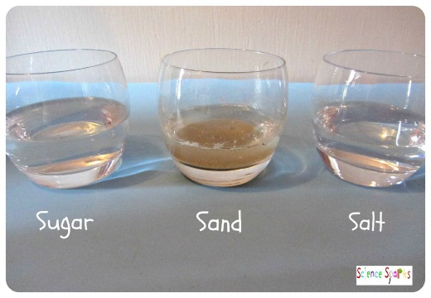
- Make Solutions! – some drinks have sugar hiding in them but why can’t we see it? Try mixing sugar and water, salt and water and sand/soil/flour and water and see which ones disappear. This explains why sometimes we don’t see the sugar in drinks and we have to check the labels.
- Look for games or apps online
http://www.foodafactoflife.org.uk/Activity.aspx?contentId=56&sectionId=61&siteId=14
http://www.foodafactoflife.org.uk/Activity.aspx?contentId=57&sectionId=37&siteId=3
When you have tried some of these different learning opportunities, please can you use the space below or over the page to tell the nursery staff what we have been doing and what I have learnt?
Please sign and date the bottom of the form and return it to nursery, Thank You.

