I am learning to
use the words heavy and light, heavier and lighter and compare different things and talk about and order them by weight.
How you can help me:
- Unpack the shopping together, talk about what the heaviest thing in the shopping is and what the lightest thing might be. You could even build your own balance scales, to see if you guessed right!
- Make a balance scale: http://www.wikihow.com/Make-a-Balance-Scale-for-Kids
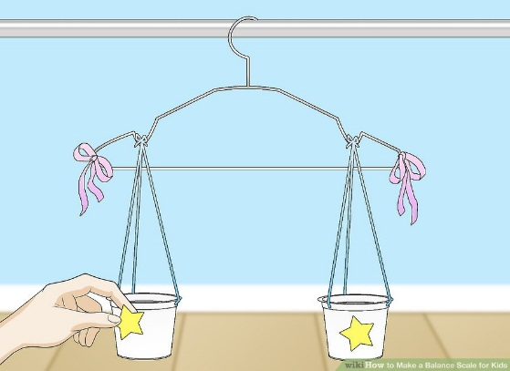
- Use the scales in your kitchen or bathroom and talk about what happens.
- Try to put some toys in order heaviest to lightest.
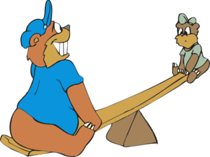
- Try to find something that weighs the same as another thing or adding lots of little things to be the same as one big thing (e.g. pasta, marbles)
- Look at how changing the shape of something doesn’t change the weight. (play dough)
- Play on the see saw at the park and see who is heavier!
- When reading stories talk about the different sizes and compare possible weights of the characters in the stories.
- Look for games or apps online
  - https://www.topmarks.co.uk/maths-games/3-5-years/measures
When you have tried some of these different learning opportunities, please can you use the space below to tell the nursery staff what we have been doing and what I have learnt?
Please sign and date the bottom of the form and return it to nursery, Thank You.

