**Miss Minto’s Musical Moment – Number 54 – The Final Countdown**

**The Final Countdown was a very popular song in the 1980s. It was sung by Joey Tempest, the lead singer in the pop group Europe.**



**Les Fo’Plafonds are a group of musicians from France who perform with items you would not normally expect to see used as musical instruments…they make a great sound though. This is their version of The Final Countdown.**

**See if you can make a list of the instruments they use.**

**Hint: there are a lot to spot!**

<https://youtu.be/B4PSvN3VSyI>

**Final Countdown - Les Fo’Plafonds**

<https://youtu.be/9jK-NcRmVcw>

**Europe - Final Countdown**

**This is the original version of The Final Countdown.**

**Can you compare the two performances and say what you like or dislike about each one?**

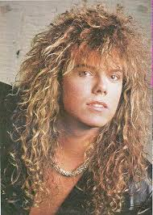

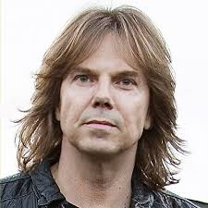

**Joey Tempest 1986 Joey Tempest 2019**