**Miss Minto’s Musical Moment – Number 52 – Marble Machine by Wintergatan**

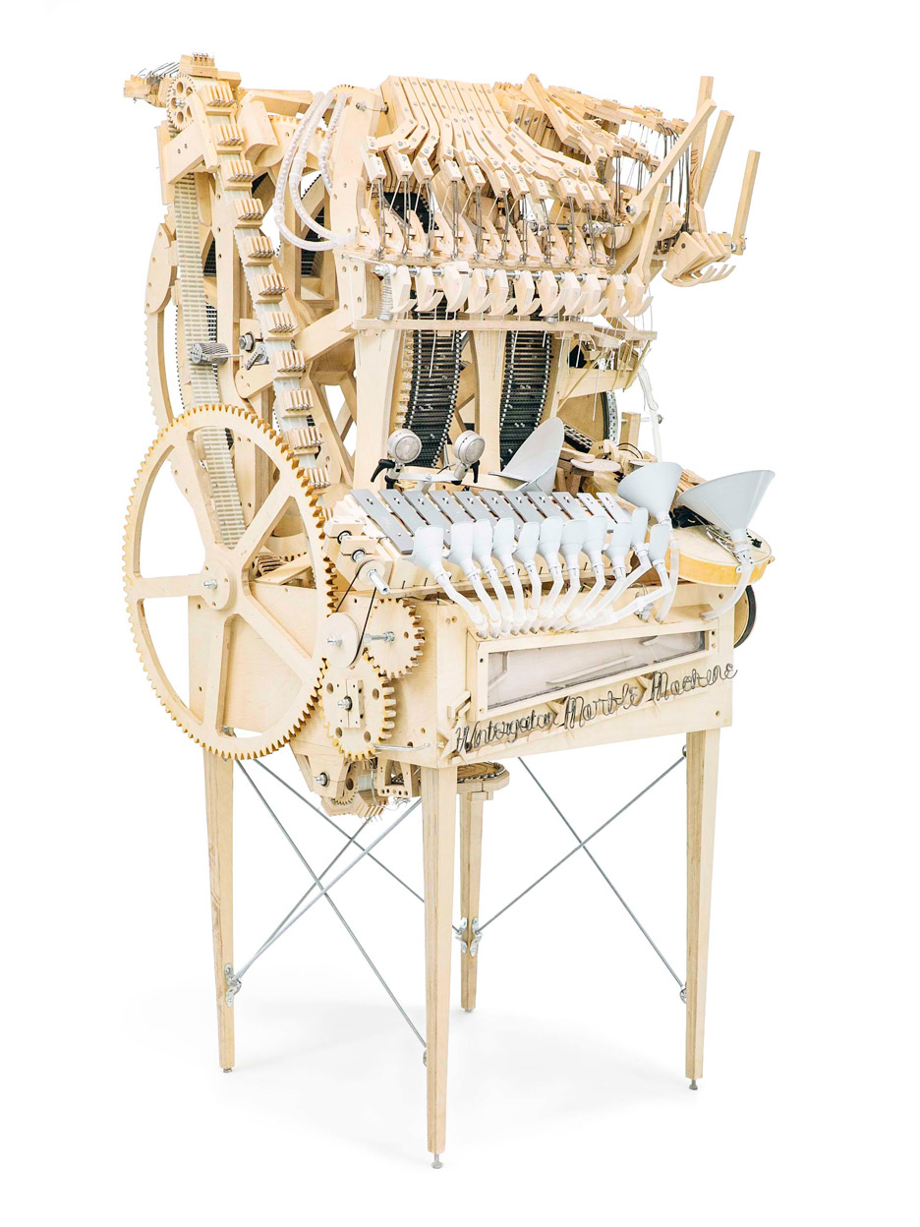

**Wintergatan is a Swedish folktronica band from Gothenburg.**

**Between December 2014 and March 2016, Martin Molin constructed a music box that uses marbles to play the instruments. The instruments played by marbles striking them include a vibraphone, bass guitar, cymbal and produced kick drum, high hat and snare drum sounds using contact microphones. This video showing the machine in use was released in 2016 and has been viewed over 141 million times.**

[**https://youtu.be/IvUU8joBb1Q**](https://youtu.be/IvUU8joBb1Q)

**Folktronica is a genre of music using folk music and electronica – often featuring acoustic instruments, especially strings – and incorporating hip hop, electronic or dance rhythms.**

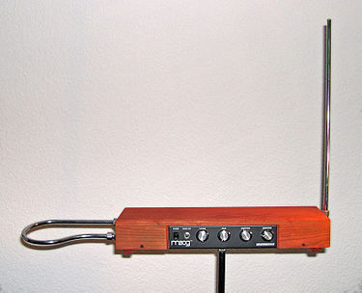**Wintergatan use a variety of unconventional instruments including:**

**A digital theremin – the loop antenna on the left controls the volume while the upright antenna controls the pitch.**

[**https://youtu.be/K6KbEnGnymk**](https://youtu.be/K6KbEnGnymk)

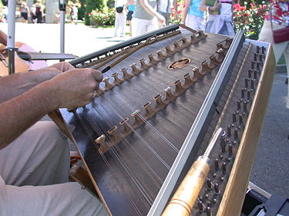**A hammered dulcimer which is a percussion stringed instrument.**

[**https://youtu.be/pzyGyObsD_I**](https://youtu.be/pzyGyObsD_I)

**A musical saw, also called a singing saw.**

**This is a standard saw which is played with either a cello or violin bow.**

[**https://youtu.be/7E_U1xyK7Gw**](https://youtu.be/7E_U1xyK7Gw)