**Miss Minto’s Musical Moment – Number 51 – Landfill harmonic**

[**https://youtu.be/UJrSUHK9Luw**](https://youtu.be/UJrSUHK9Luw)

**The Landfill Harmonic Orchestra**

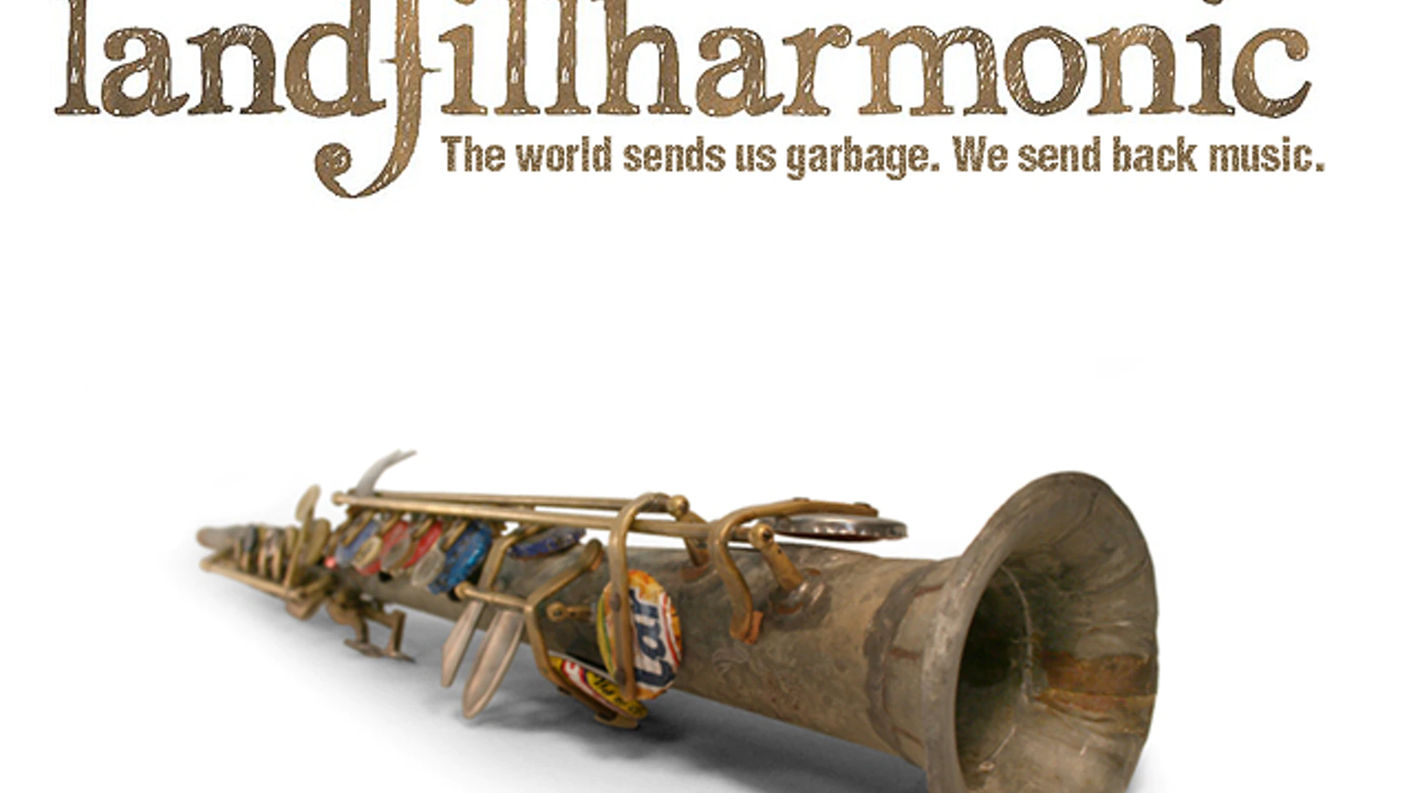

**My saxophone is made of spoons and buttons: tin water pipe, metal bottle caps, plastic buttons, metal spoon and fork handles.**

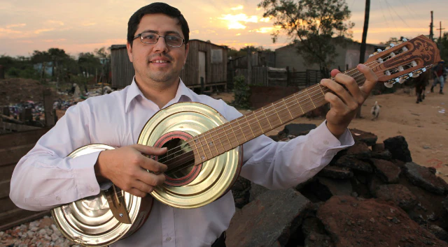

**Favio Chavez – Director of Los Reciclados Orchestra**

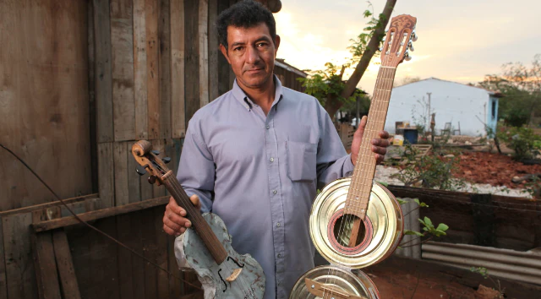

**Nicolas Gomez (Cola) – together with Favio, Nicolas started the construction of recycled instruments.**

[**https://youtu.be/F3blz60t57Q**](https://youtu.be/F3blz60t57Q)

**Cateura – Vamos a Sonar Cateura – We Will Dream**

**Performed by Mariana Barreto Music by Michael A Levine**

***El alma de mis canciones The soul of my songs***

***Al mundo quiero cantar I want to sing to the world***

***Es lo unico que tengo Even though it’s all I have***

***Te lo voy a regular I give it to you***

***El ritmo de la guitarra The rhythm of my guitar***

***Me llega al Corazon Touches my heart***

***Me hacen seguir luchando What gives me life***

***Sus notas de inspiracion Are it s notes of inspiration***

***La Fuente de nuestra passion The fount of our passion***

**Cateura. Ven conmigo Cateura. Come with me**

**Cateura. Vamos a sonar Cateura. We will dream**

**Cateura. Oh! Pueblo mio Cateura. Oh! My town**

**Te vamos a cantar We will sing to you**

**In the heart of our music Cateura. Come with me now**

**There are echoes each of us brings Cateura. Oh how we will sing**

**And the soul of the world Cateura. You gave us music**

**Runs through us all when we sing We give back the dream**

**Gives life to everything**

***El llanto de mis violins The cry of my violins***

***Me abre el corazon Opens my heart***

***Lo que llevo conmigo What I bring with me***

***Son notas de inspiracion Are notes of inspiration***

***La Fuente de nuestra passion The fount of our passion***

**Cateura. Ven conmigo Cateura. Come with me**

**Cateura. Vamos a lograr Cateura. We will succeed**

**Cateura. Aqui vivimos Cateura. Here we live**

**Vamos a volar We will fly**

**Vamos a sonar We will dream**

***“I think this is our mission: Build the bridge between two different worlds. We can then tell that the two worlds aren’t that different. We are ultimately part of a whole. Music is the bridge.” Favio Chavez***

***---***---***---***---***---***---***---***---***---***---***---***---***---***---\*\*\****

***“We believe that people shouldn’t strive for material things, they should strive for knowledge. We need to make intelligence hip instead of clothes and cell phones.”***

***Luis Szaran (Director of Sounds of the Earth who had the inspiration to start giving poor children instrumental lessons)***

***###___###___###___###___###___###___###___###___###___###___###___###___***

***We want to convey the message that in a society where what seems to be the most important thing are material things, for us, the most important things are people. The hands of people which transform garbage into these instruments and the hands of these kids which transform these instruments made of garbage into a beautiful thing – music.***

***Without the people, this is just garbage.***