Miss Minto’s Musical Moment Number 36 – Balalaika Player aged 7
https://youtu.be/QJjSEGOOOcc
Anastasia Tyurina (aged 7) playing Balalaika.
The tune is a Russian Folk Song called ‘Valenki’.
Valenki are very warm, traditional Russian boots made of felt.
Not only is Anastasia amazingly talented at playing the balalaika,
she is clearly loving every moment of her playing.
BALALAIKA
The balalaika is a string instrument from Russia.
The Balalaika family includes the piccolo balalaika, prima balalaika, sekunda balalaika, alto balalaika, bass balalaika and contrabass balalaika.
They all have three strings.
There are many ways to tune balalaika; the most common tuning is E-E-A.
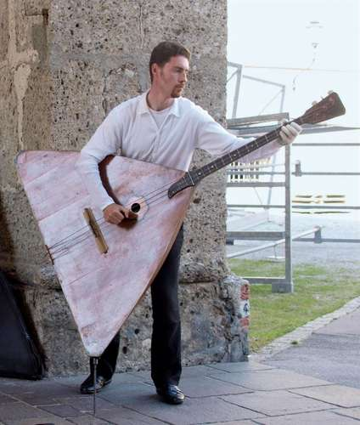

Contrabass Balalaika
Notice the little spike that the balalaika is resting on – too big and bulky for the player to hold up.

https://youtu.be/PFq-6A3lEsY
The Balalaika Osipov Russian Folk Orchestra playing the same piece as Anastasia played.

