Kodaly Worksheet Week 6 – P5-7

Did you manage to identify the song from last week’s Name That Tune exercise? Here is the answer –
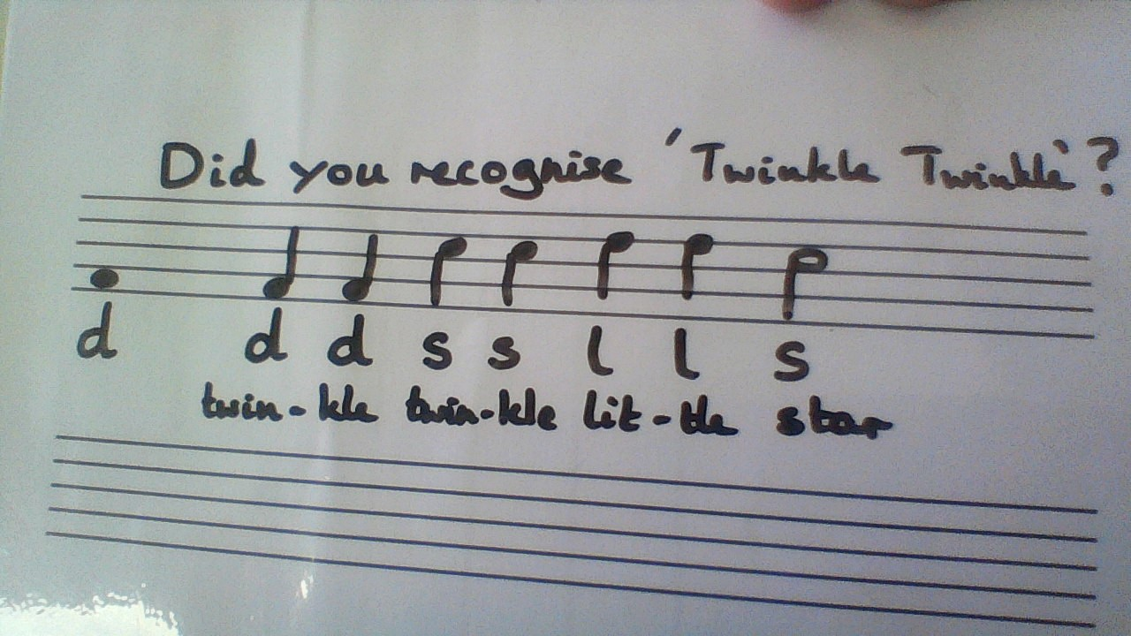

This week we looked at the new rhythms te-ti-ri and ti-ri-te
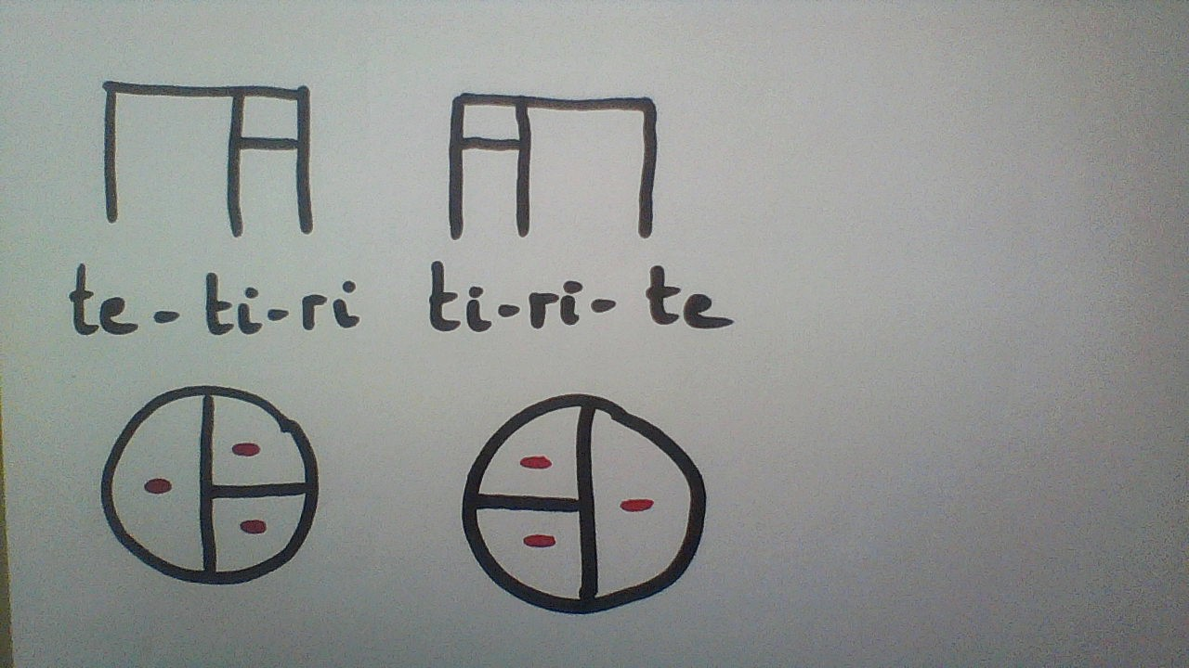

These rhythms consist of three sounds on a beat – the sounds are not even, the beat is divided like this – te-ti-ri is a half beat sound followed by two quarter beat sounds; ti-ri-te is the other way round -two quarter beat sounds followed by one half beat sound.

In “Bom Makalele” we found that the second half of the song was exactly the same as the first. When this happens, instead of having to write the same thing out twice, we can write it once only and use a repeat sign ˸II which tells us to go back and repeat what we have just done.

We also looked at the new pitch fa. It is found in between mi and so.
On the stave, if mi and so are on lines, fa is in the space between them. If mi and so are in spaces, fa is on the line between them.

Please transfer the rhythm and pitch for “Once a Man Fell in a Well” to the stave (d is in the first space). We started doing this in this week’s video and you can refer back to the video to help you if you need to –
πππ I π π I I π π π I π π I I
d r m f s s s d r m f s s d r m f s s s s f m r d d

_____________________________________________________________________________________________________________________________________________________________________________________________________________________________________________________________________________________________________________________________________________________________________________________________________________________________________________________________________________________________________________________________________________________________________________________
(Answer next week)

Please have a go at the following cup rhythms for “Dance Monkey” and “Havana”
https://www.youtube.com/watch?v=R1k_l7PT7Sw
https://www.youtube.com/watch?v=i5gBl4S3ur4

