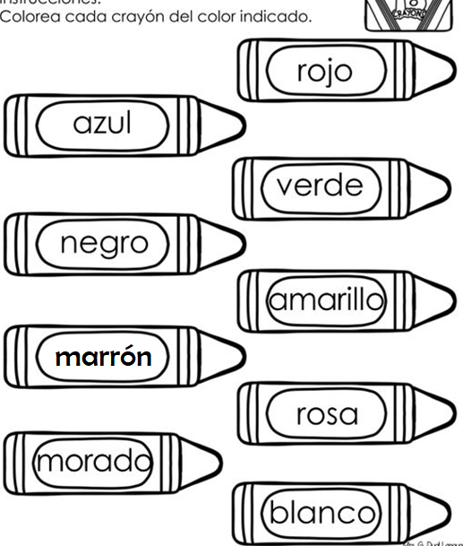

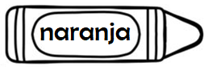
Look, read and colour.

You might find colour rosa as rosado, marrón as café or morado as violeta and it is fine! These are different versions depending on the country.

