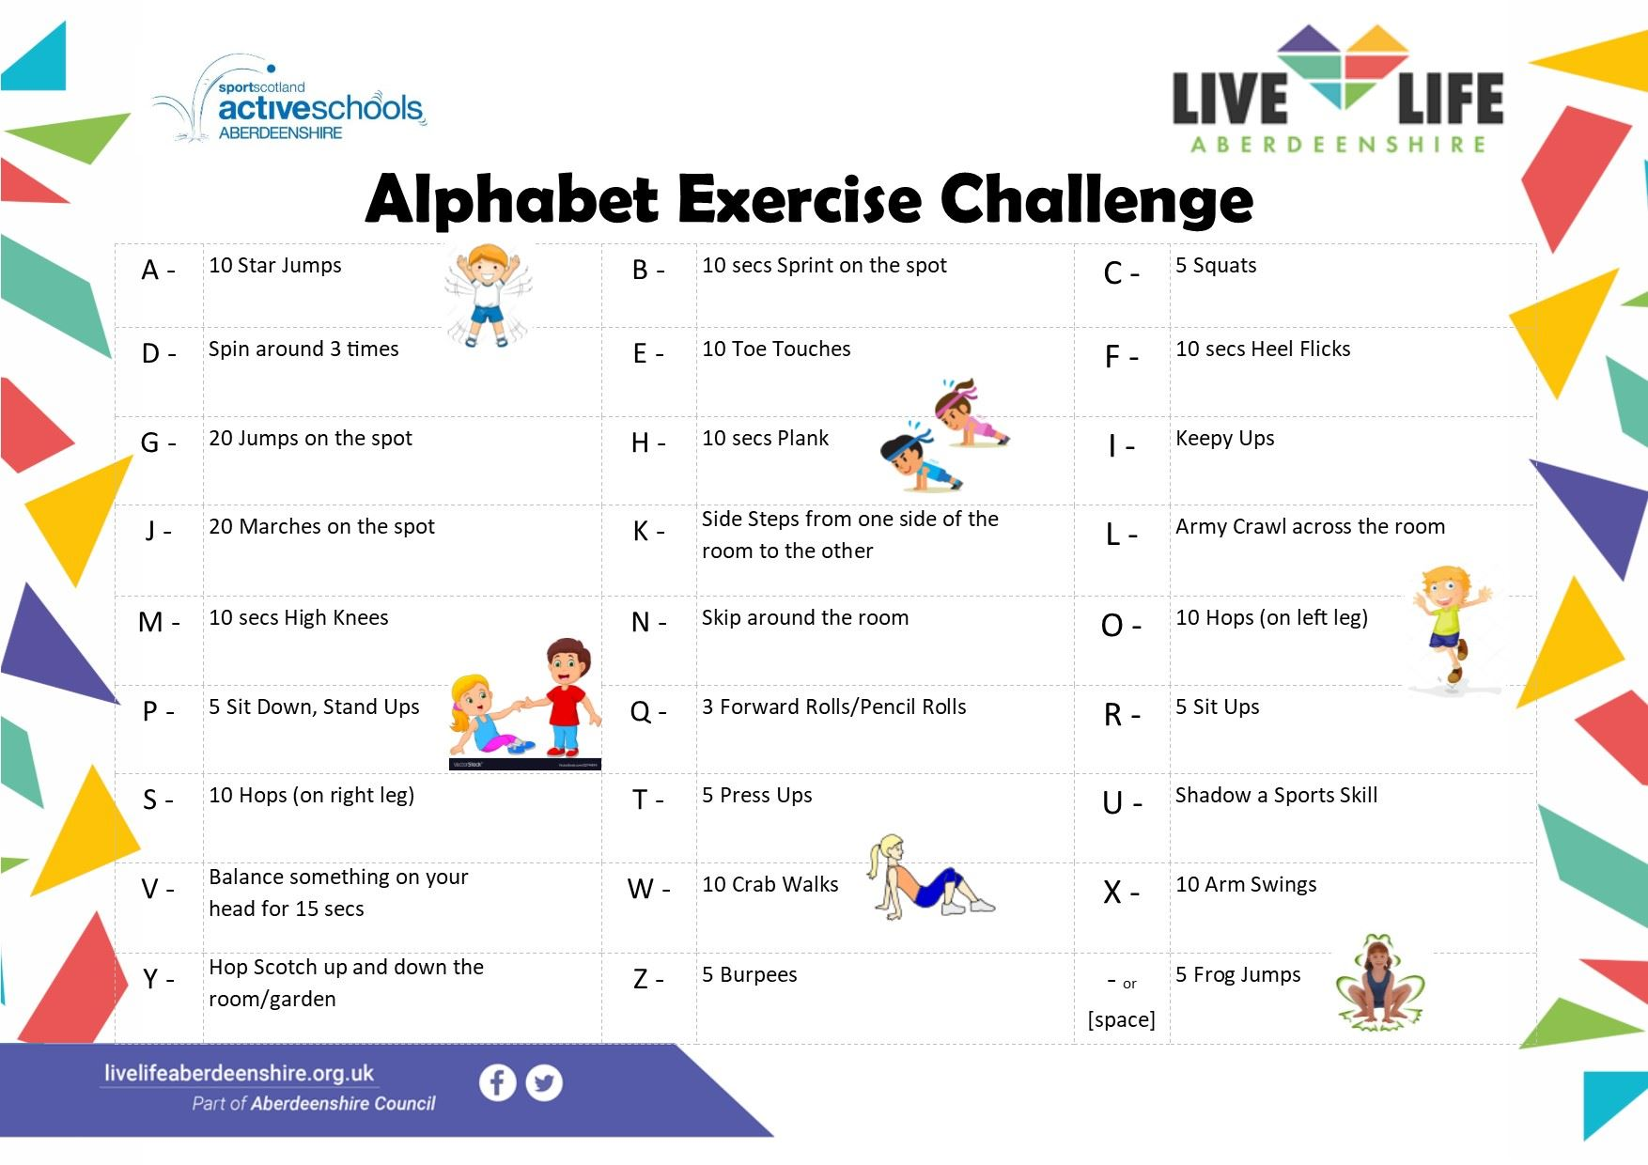

https://www.facebook.com/ActiveSchoolsAberdeenshireCentral/videos/234070137962743/

