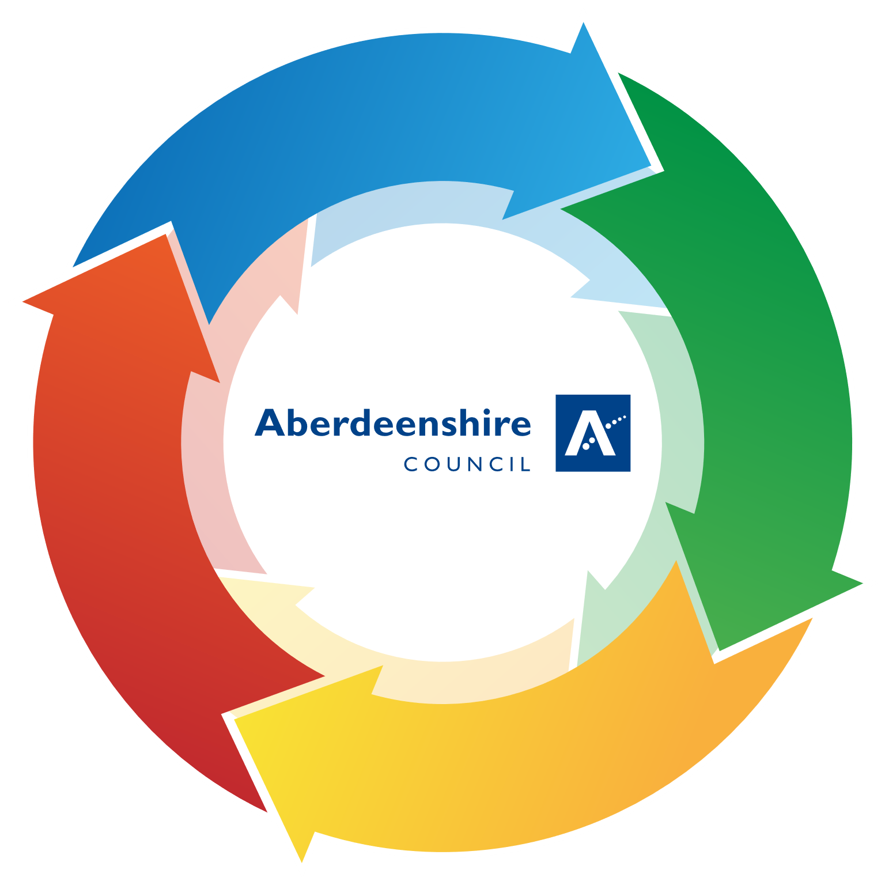

**QUALITY OF TEACHING**

|  |  |
| --- | --- |
| * Positive relationships in place between staff and learners. An ethos of mutual respect exists which is conducive to learning and teaching. * Ongoing learning experiences are underpinned by school vision, values and aims. * Learners have an understanding of their rights and respect for the rights of others. * Learners’ wellbeing is a consistently high priority across all classes. * Learners are motivated and engage effectively with their learning. Opportunities to exercise choice and make use of real-world contexts ensures personalisation, meaning and relevance. * Learners are supported by a variety of high-quality, innovative and creative teaching approaches, including the use of digital technologies. * Learning activities meet the developmental needs of all.   **Consider disclaimer re. statements being interlinked** | * Learners are increasingly responsible for and actively involved in planning and leading learning. Their views are sought, valued and acted upon across the school and wider community. * Learners are supported in the development of skills for the 21st century (critical thinking, communication, collaboration and creativity) and attributes within the 4 capacities. * Learners have an increasingly accurate understanding of their own and others’ learning and are encouraged to talk about strengths and identify next steps. * Learners are able to articulate their developing skills and value these in terms of future learning and career pathways. |

**LEARNING AND ENGAGEMENT**

|  |  |
| --- | --- |
| * Planning is proportionate and manageable and clearly identifies what is to be learned and assessed in all areas of the curriculum. Learners are involved in the planning process. * Effective tracking and monitoring of attainment across all areas of the curriculum provides reliable, accurate and up to date data regarding the progress of all learners. * Analysis of such data leads to appropriate interventions to address gaps in attainment and achievement. Interventions are regularly reviewed for impact. | * Tracking and monitoring processes include analysis of data linked to any barriers to learning. This may include SIMD profiles or any identified additional support need. As a result, pupils’ needs are well identified across the school. * Analysis of data including comparator data informs improvement priorities, planning and practice. * Identified areas for improvement are monitored and measured for impact. |

**PLANNING, TRACKING AND MONITORING**

|  |  |
| --- | --- |
| * Learning, teaching and assessment are planned in an integrated manner identifying what is to be learned and assessed at the planning stage. * Assessment approaches are matched to the needs of the individual learners to allow them to demonstrate their knowledge, understanding, skills, attributes and capabilities. * There is effective use of a wide range of assessment information, including formative (ongoing), summative and standardised (periodic), to inform teacher/practitioner judgements. * National benchmarks are used to improve the validity and reliability of professional | * A quality body of evidence is used to support assessment judgements/decisions about progress and next steps. * Outcomes from assessment are shared with learners to engage them in reflection and identification of strengths and areas for development. * Moderation processes and approaches are applied to all aspects of learning, teaching and assessment to improve the validity and reliability of judgements of progress and attainment within and beyond the school terms of future learning and career pathways. |

**EFFECTIVE USE OF ASSESSMENT**

|  |  |
| --- | --- |
| * Staff treat pupils with respect and develop positive relationships, thus creating an ethos which is conducive to learning and teaching. * Our teaching is underpinned by school vision, values and aims which reflect UNCRC. These are evident in our daily practice. * Staff know learners well. They make very good use of learning profiles and data to support the learning and wellbeing of all children and young people. * Staff have high expectations of all learners. * Staff give clear explanations and instructions to learners, building on prior knowledge and understanding. * Staff plan and differentiate effectively to meet the needs of all learners, making use of all resources (including staff) ensuring appropriate support and challenge. | * Staff make use of different learning environments and a wide range of innovative, creative teaching approaches, to meet the needs and interests of their learners. * Staff integrate technology into the delivery of learning and teaching experiences and provide ongoing opportunities for learners to develop and enhance their digital skills. * Staff develop links between ongoing learning, skills, and their relevance to learners’ economic futures * Staff provide effectively organised and well managed learning experiences, clearly identifying the purpose of the learning and what learners need to do to be successful. * Staff ensure that their learners understand the purpose of their learning and are provided with ongoing opportunities to plan and lead. * Skilled questioning is used by staff to challenge and extend higher order thinking skills * Staff provide quality feedback that helps learners be clear about strengths and next steps in learning. * All staff use assessment data effectively to plan and secure improved outcomes for each of their learners * Through their ongoing commitment to professional enquiry, staff are accessing and |