W/C 08.02.21 Fettercairn Nursery Activities

Dear Parents and Carers,

We hope you enjoyed last weeks activities and had fun recording the weather, going on a sensory walk and making the delicious chocolate mousse for greedy goose recipe. If you took part in the RSPB Garden Birdwatch on the weekend of 29th January, we would love to see photos of any birds you saw in your garden and the data you collected. We love seeing all the activities and learning you are getting up to at home, so keep sending in your photos!

Children’s Mental Health Week was 1st-7th February
The theme of this year's Children’s Mental Health Week was Express Yourself. Expressing yourself is about finding ways to share feelings, thoughts, or ideas, through creativity. This could be through art, music, writing and poetry, dance and drama, photography and film, and doing activities that make you feel good. The website has lots of free resources to help children and young people explore what it means to Express Yourself. Click on the link where you will find lots of activities on the site.
Time to Talk Website for parents to explore about Mental Health
https://www.time-to-change.org.uk/get-involved/time-talk-day

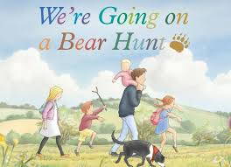
This week we are going on a Bear Hunt!!!!
Click here to listen to the story

Ideas to act out your own Going on a Bear Hunt Story

Watch Emma and Liam as they go for a walk in the forest and act out the story of the Bear Hunt click here

Have fun retelling the story. You could draw or printout the characters in the story, then find other props to retell the story around your house and garden. (Mud, Grass Water, Trees, Tissue paper for snow, make your own Cave)
*Remember to send photos to your teachers*

Other fun activities
1.Cosmic Yoga Going on a Bear Hunt click here

2. Design your own Bear Cave
Some bears sleep in caves during the winter. Do you think you could build a cave? Ask a grown-up if you can use some chairs and cover them with sheets and blankets to create your own little cave. Now you can pretend to be a bear. Pretend to sleep in your cave and then, when you get hungry you need to go and find some food. Brown bears like to catch fish to eat. Can you draw a picture of a bear that has caught 5 fish? When you have

drawn the fish, try counting them carefully, by pointing to each one as you count. (Use your Bear Cave to read more stories.)
3. Have a Teddy Bears’ Picnic (Small World Play)
- Lay out a tablecloth arrange the bears randomly around the tablecloth.
- Set out the right number of cups and plates. (1:1 correspondence)
- Cut the toast in half and each half into 3 pieces or soldiers. (Support your child to cut)
- Spoon the jam into small bowls.
- Invite the children to play. Some children may create imaginative storylines, whilst playing with the bears, whilst others will enjoy the physical actions of making jam sandwiches for the bears.
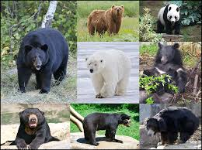
- Remember to wash the dishes!
4.Learn some facts about Bears use information books and the internet

Which is the largest Bear? What do Bears like to eat?
5.Read some more bear stories with your child
Listen to Bedtime stories on CBeebies Click here for the story Big Little Hippo
Read by Eddie Redmayne

6. Maths - Teddy Number Game click here
Bud’s Number Garden click here

7. Teddy Bear Hide and Seek (Draw/printout and hide numbered bears around the house or in the garden. Tell your child how many there is to find. Your child counts to check they have found all the bears.
Extension activity - put bears in order and play ‘What number is missing game?’ Child closes their eyes and you take one of the numbered bears away.)

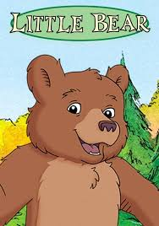
8. Sing Little Bear
(tune: Frere Jacques)
Are you sleepy, Are you sleepy
Little bear, little bear?
Wintertime is coming,
Wintertime is coming,
Very soon, very soon.
Find a cave, Find a cave,
Little bear, little bear
Wintertime is here,
Wintertime is here,
Go to sleep, go to sleep.
Are you sleepy, Are you sleepy
Little bear, little bear?
You will wake in springtime
In the warm, warm springtime
Little bear, little bear
Time to wake up,
Time to wake up
Little bear, little bear
Springtime is here,
Springtime is here
Wake up now, wake up now!

Five Little Bears: Counting up
One little bear
Wondering what to do
Along came another
Then there were two! Two little bears
Climbing up a tree
Along came another
Then there were three!
Three little bears
Ate an apple core
Along came another
Then there were four!
Four little honey bears
Found honey in a hive
Along came another
Then there were five!

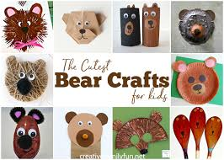
8 Art Ideas

Click on link to make a Bear

Story and Song time link for this week - Wednesday 10th February at 1:30 -2 p.m
It was really lovely to see all the children last week

https://teams.microsoft.com/l/meetup-join/19%3ameeting_Yzk1OTNiOTItZjAxNi00YWU0LTgyNDUtNTc0NzRkMGY4NDQ4%40thread.v2/0?context=%7b%22Tid%22%3a%22fed99306-4d2d-4409-959d-d0edb7304a0b%22%2c%22Oid%22%3a%225ebb7ddf-1292-4714-879a-52fee93197aa%22%7d

Our next home learning email will be sent out on Monday 22nd February (if required), we will be sending out activities to learn about the customs and traditions around the celebration of the Chinese New Year. There are lots of activities this week to keep your child going, as there will be no activities sent out next week due to holiday and in-service days.

We hope you have a great week and enjoy doing all the fun learning activities.
Mrs Keal, Mrs Rae and all the Nursery Staff
