Life skills linked to learning.
Try to make learning fun. Have a clear daily routine and give breaks between activities. Choose 1 or 2 per day.
Daily Reading is very important, please continue to read with your child every day, in English or your own language, and to share books.
Listening to stories  Visit https://www.storylineonline.net/ to stream videos featuring actors reading children’s books in English. See if you can find a translated version on the internet.  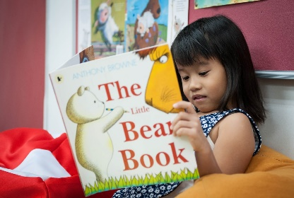 | Balls skills.  Make a ball from some socks.  Write numbers 1 to 5 on scraps of paper.  Put them in a pile, number side down.  Turn over the first number.  Throw the ball and catch it for the number of times shown.  If you complete this without dropping the ball you keep the number.  Play with someone else in your family or by facetime with your friends.  (Extend this to 1 to 10 when 1 to 5 are learned.)  You can play this using your own language(s). | Active Literacy Activities  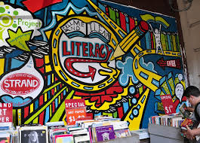  Learn the letter sounds – use plastic letters.  Think of words that begin with each letter; a for apple etc.  Draw pictures to go with words.  Write the letters on the carpet with your finger.  Make letters with string.  Write out the letters with different colours.  The words can be in English or your own language(s).
Memory  The Tray Game  Place 6 items on a tray and ask your child to look at it for 20 seconds.  Cover the tray with a cloth and give your child 30 seconds to name everything they can remember. Remove one or several items from the tray and ask them to guess what is missing.  You can play this in your own language(s). | Listening  Dice and Movement Game.  This game supports listening, attention and taking turns. Assign each number of the dice to a different movement e.g. number 1 can be shake your arms, 2 can be spin around etc. Take turns to roll the dice and make the movement.  You can do this in your own language(s)  This Photo by Unknown Author is licensed under CC BY-NC | Talking and Listening.  Before bedtime sit together and talk about the day.  Encourage your child to speak about what has happened and ask them questions.  Then talk about your day while your child listens carefully.  Explain that they must listen to what you say and then ask questions at the end.  Encourage them to speak clearly and to listen without interrupting.  You can do this in your own language(s)
P.E  Follow the Joe Wicks workout at least twice a week.  This can be done live or whenever is convenient.  On you tube search for thebodycoach.  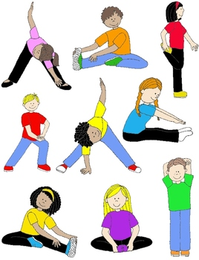 | Health and Wellbeing  Encourage the children to grow food. This can be done in pots or in the garden. Seeds can be bought at supermarkets or online. Lettuce or rocket are good as they grow quickly. The children can eat the leaves in salads and sandwiches.  Tomatoes grow well on windowsills, but they take longer.  You can do this in your own language(s).  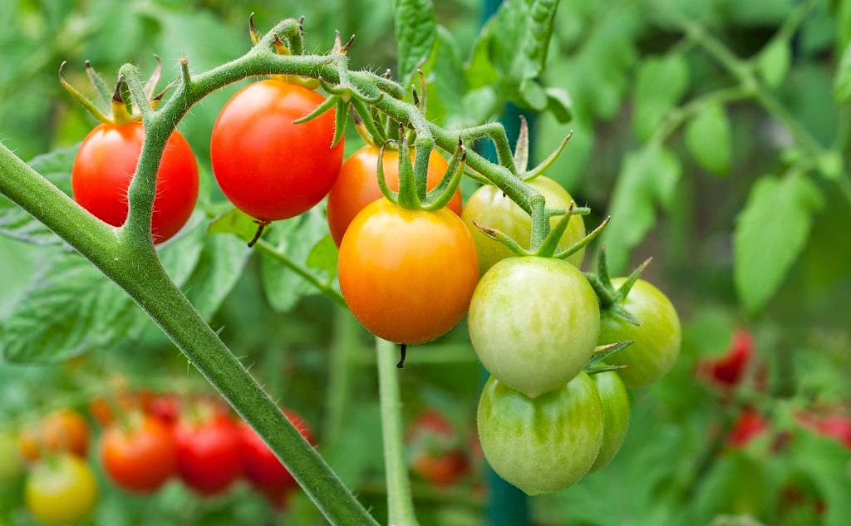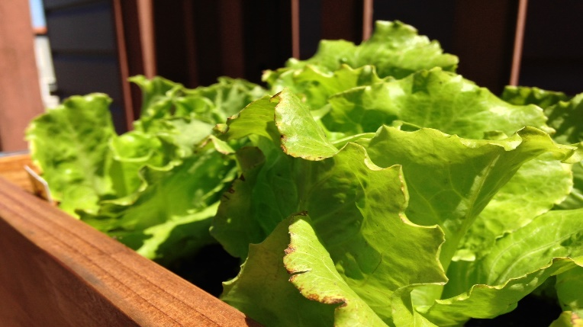 | Health and Wellbeing and Maths.  Make some cup cakes together. Allow your child to measure out the ingredients. You should put the cakes in the oven and lift them out. Your child can time the baking.  This is a simple recipe found on line.  INGREDIENTS  - 125g butter softened/margarine  - 125g caster sugar  - 125g self-raising flour  - 2 large eggs, beaten  - 1teaspoon of vanilla extract  INSTRUCTIONS  - Preheat oven to 180C/gas mark 4.  - Cream the butter and sugar together in a bowl.  - Stir in the beaten eggs.  - Sift in the self-raising flour and mix. Take care not to overmix.  - Transfer the mixture into cupcake cases, filling half way.  - Bake in oven for 20 minutes.  - When the cupcakes are ready they will have risen and be a golden brown colour.  You can do this in your own language(s) with any easy recipe. ​
Reading.  This is a great website to encourage children to engage with books. They could listen to stories, draw characters or engage with many other activities https://www.booktrust.org.uk/hometime  You can find books in your own language at  www.worldbookonline.com which has translated information on a variety of subjects.  Click on the kids section and search for a topic. You can then select to read in a different language - this uses electronic translation. It will not be perfect but a useful resource for supporting learning in the first language.  www.overdrive.com has lots of ebooks (in many languages) available to read – you need a library card to access this.  This Photo by Unknown Author is licensed under CC BY | Skills.  Use your time to teach yourself and your child a new skill.  Practise a little every day and you will soon be amazing.  You could learn to juggle with balls made from socks.  You could learn how to draw cartoons.  You could learn how to sew or knit or even crochet!  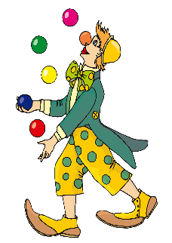 | Literacy  Ask your child to make a sandwich for him/herself and think very carefully about what he/she is doing.  They could record themselves for a TV cookery programme explaining clearly how to make a sandwich.  You can do this in your own language(s)  