Report on the plant species in our school playground
Introduction
At Catterline school the playground is nearly 3,000 square metres. It has a little wood with some bushes, grass and tarmac.
Our survey findings
The school grounds were surveyed to see how much trees and plants and bushes grow there and to see how much species we have in our playground.
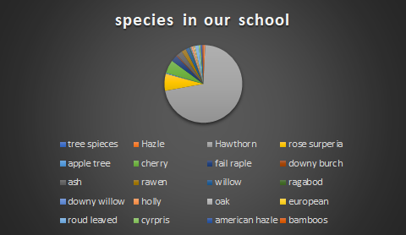

Our aims
For the insects we want more pollinating bushes and trees like crocus, honeysuckle, foxglove, viper bugloss, lavender, blue bells, forget me not, buddleia, snap dragon, allium, cornflowers, lemonthyme.
For mammals sunflowers, snowdrops, dandelions, roses.
For birds more cherry plum tree, adambaburnum, acer palmatum, prunus virginiana, silver birch, beech, alder, holly, elder, hazel, crack willow, bird cherry.
Looking ahead
By doing these actions we will see a difference in seeing more pollinators (bees, wasps, Butterfly) and more nesting birds in our school. In conclusion by next year, we will have a healthy place for all animals.

Nico, Ben, Lathan, and Ellie

