Catterline Bird Survey
Introduction
The school grounds are half grass, half gravel with a garden where we have a bird bath and bird feeders. Our report is about the birds in our playground.
Our Results
The birds seen in the playground were recorded over 2 mornings. The results are in the chart below.
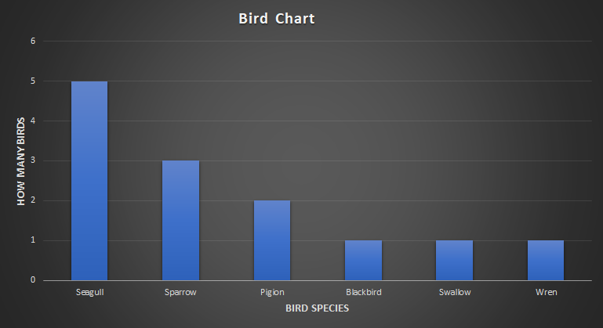
More seagulls were seen than any other birds. This is not surprising because the school is right next to a cliff where sea gulls nest.

Our aims
What we want to achieve is a bigger bird population and encourage birds to nest in the school grounds. We want them to eat, nest and stay clean.
Our planned actions

- Bird boxes
- Bird feeders
- Dense hedges
- Clean out the bird bath regularly

What we hope the impact will be
When we get bird feed bird and boxes. we hope that birds will come and nest in our playground.
Looking Ahead
We will be getting things for the birds and will help them nest in the future at Catterline school. We will survey them again to see if there are more.
- Sophia, Oscar, Oliver

