STEM OUTDOOR BOX – These are just ideas and useful as a starting point
Blanket or tarpaulin to sit on
Clipboards White boards
Pencils and /or pens Outdoor chalk
Plastic Folders Poly pockets
Antibacterial gel Scissors

Identifying and naming
Identifying sheets, cards, booklets (ranging from easy and pictorial to top trump style cards and keys)

Joining
Rope (use for going across trees to mark out boundary or close off areas)
String Sticker dots
Elastic bands Wooden pegs

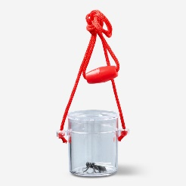
Looking Closely
Microscopes Magnifying glasses
Binoculars and monoculars Insect viewers

Sample collecting
Test tubes Measuring pots, beakers, tubs
Petri dishes and sample trays Tweezers
Spoons Pipettes and syringes
Small plastic bags

MEASURING
Tape measures rulers

Growing
Selection of seeds for: Plant pots
- Growing to eat
- For butterflies
- For scent

Additional unusual resources
Balloons Labels
Filter paper Water holder
Sticks Kebab skewers and cocktail sticks

