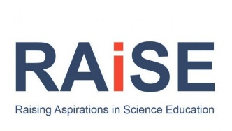
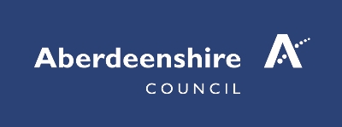

NOVEMBER 2022
Aberdeenshire CLPL Outside Partners CLPL

Monday | Tuesday | Wednesday | Thursday | Friday
31 | 1 | 2 | 3  STEM Through Stories  Online: contact kim.aplin@aberdeenshire.gov.uk  Deep Space Discovery  SSERC (Teams) | 4
7  Modelling the Solar System  SSERC (Teams) | 8  Learning through Play using LEGO  Learning through Play using LEGO® Tickets, Tue 8 Nov 2022 at 16:00 | Eventbrite | 9 | 10 | 11
14  DYW Live COP27 Week – 14th -17th November  Digital learning from Comhairle Nan Eilean Siar | e-Sgoil | 15 | 16  Discover the Deep Online Teacher CLPL  Career Long Professional Learning | Dynamic Earth | 17 | 18
21  Christmas SSERC Meet  Christmas STEM SSERC Meet - SSERC | 22 | 23  KAPLA and Makedo  Face to face: Newtonhill Primary School: contact caroline.nicol2@aberdeenshire.gov.uk  Science Storytelling CLPL  Diving Deep - Earth's Ocean  Career Long Professional Learning | Dynamic Earth | 24  Christmas SSERC Meet  Christmas STEM SSERC Meet - 24th Nov 2022 - SSERC | 25
28 | 29 | 30 | 1 | 2

