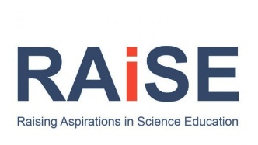

SEPTEMBER 2022
Aberdeenshire CLPL Outside Partners CLPL

Monday | Tuesday | Wednesday | Thursday | Friday
29 | 30 | 31 | 1 | 2
5  Coding for Early Years  Barefoot Computing | 6 | 7  Zoom In Zoom Out Meet SSERC  Computational Thinking Barefoot Computing  Young STEM Leader Tutor Assessor Training  YSL  Learning for Sustainability Scotland  Webinar for Primary  This is Primary Computing Science part 1  Digilearnscot | 8 | 9
12 | 13 | 14  Scratch Workshop  Barefoot Computing  This is Primary Computing Science part 2  Digilearnscot | 15  Zoom In Zoom Out Meet SSERC  Biodiversity: Classification and Adaptation at Early Level (SCN 0-01a)  Online: contact kim.aplin@aberdeenshire.gov.uk | 16
19 | 20  Learning for Sustainability Scotland  Webinar for Early Years | 21  Early Years Coding  Barefoot Computing  Young STEM Leader Tutor Assessor Training  YSLP  This is Primary Computing Science part 3  Digilearnscot | 22  STEM Through Stories  Online: contact kim.aplin@aberdeenshire.gov.uk | 23
26  Maths through Stories webinar  Webinar: Linking maths and picture books in early years settings with Lynda Keith - Scottish Book Trust | 27  Getting started with Micro;bits  Micro:Bit Education | 28  Early Level STEM Day SSERC  Scratch Workshop Barefoot Computing | 29  KAPLA and Makedo  Face to face: contact kim.aplin@aberdeenshire.gov.uk | 30

