

ELLON PRIMARY SCHOOL

Newsletter
June 14

Staffing
Next session our Depute Head Teacher, Mrs Sinead Lindsay will be taking up a secondment as Acting Head Teacher at Newburgh Mathers Primary School. This is a fantastic professional opportunity for Sinead as she continues with her Flexible Route to Headship studies. While we will miss Sinead’s positive presence and hard working professional approach, we all wish her well in her in this new venture.
Ms Anna Rossvoll, Depute Head Teacher with responsibility for early years, has been appointed as Head Teacher at Udny Green and will be leaving the team at Ellon Primary this week. Anna has a special interest in early years and during her time at the school has made a valuable contributed to the development of planning & assessment approaches at early level. She was also instrumental in setting up our school blog. Her creative, innovative flair will be missed.
Mr Paul Fyfe, who has been with us for one day a week as Depute Head Teacher has been appointed as Acting Head Teacher at Longhaven Primary and will be talking up his post in August. Paul has been an energetic, enthusiastic member of the team this year and I would like to thank him for his contributions to the school this session.
I am sure that you will join me in congratulating Sinead, Anna and Paul as we wish them all the very best in their new Head Teacher roles.
Our Depute Head Teacher entitlement will reduce to one next session due to a drop in our school role.
Mrs Leigh Anna Whalley has been appointed to the post of Depute Head Teacher in the absence of Mrs Lindsay. Mrs Whalley currently teachers at Muirfield Primary in Aberdeen City and will take up her post when we return to school for the new session.
We welcome two newly qualified teachers to our team in August; they are Ms Stephanie Davidson who will be teaching in P5 and Ms Kim Briskham who will be teaching in P6/7.
Miss Eleanor Blaney, support teacher, will be leaving us to teach in other schools within the Ellon network. Next session Ms Christine McBay will be joining the support team. We thank Miss Blaney for her work here and wish her all the best.
Visiting specialist teachers of art and drama, Mrs Jan Connell & Ms Julie Collins will not be with us next session and we thank them for their valuable input.
Ellon Primary Has Talent 2014
On Monday, pupils who reached the final of the talent show performed to judges, Mrs Kirsty Wotherspoon & Mrs Debbie Canning from the Parent Council, janitor Mr Martin Mathieson, music teacher Mrs Doreen Astley and Kids Council representative pupil Rory Brown.
Our compares Gene Leslie and Robbie Urquhart did an absolutely fabulous job of introducing the acts and building excitement in the audience.
As ever it was tough for the judges to reach a final decision as to who should win the trophies.
The P1-P3 talent show trophy went to Samantha Parker for a fantastic dance performance. 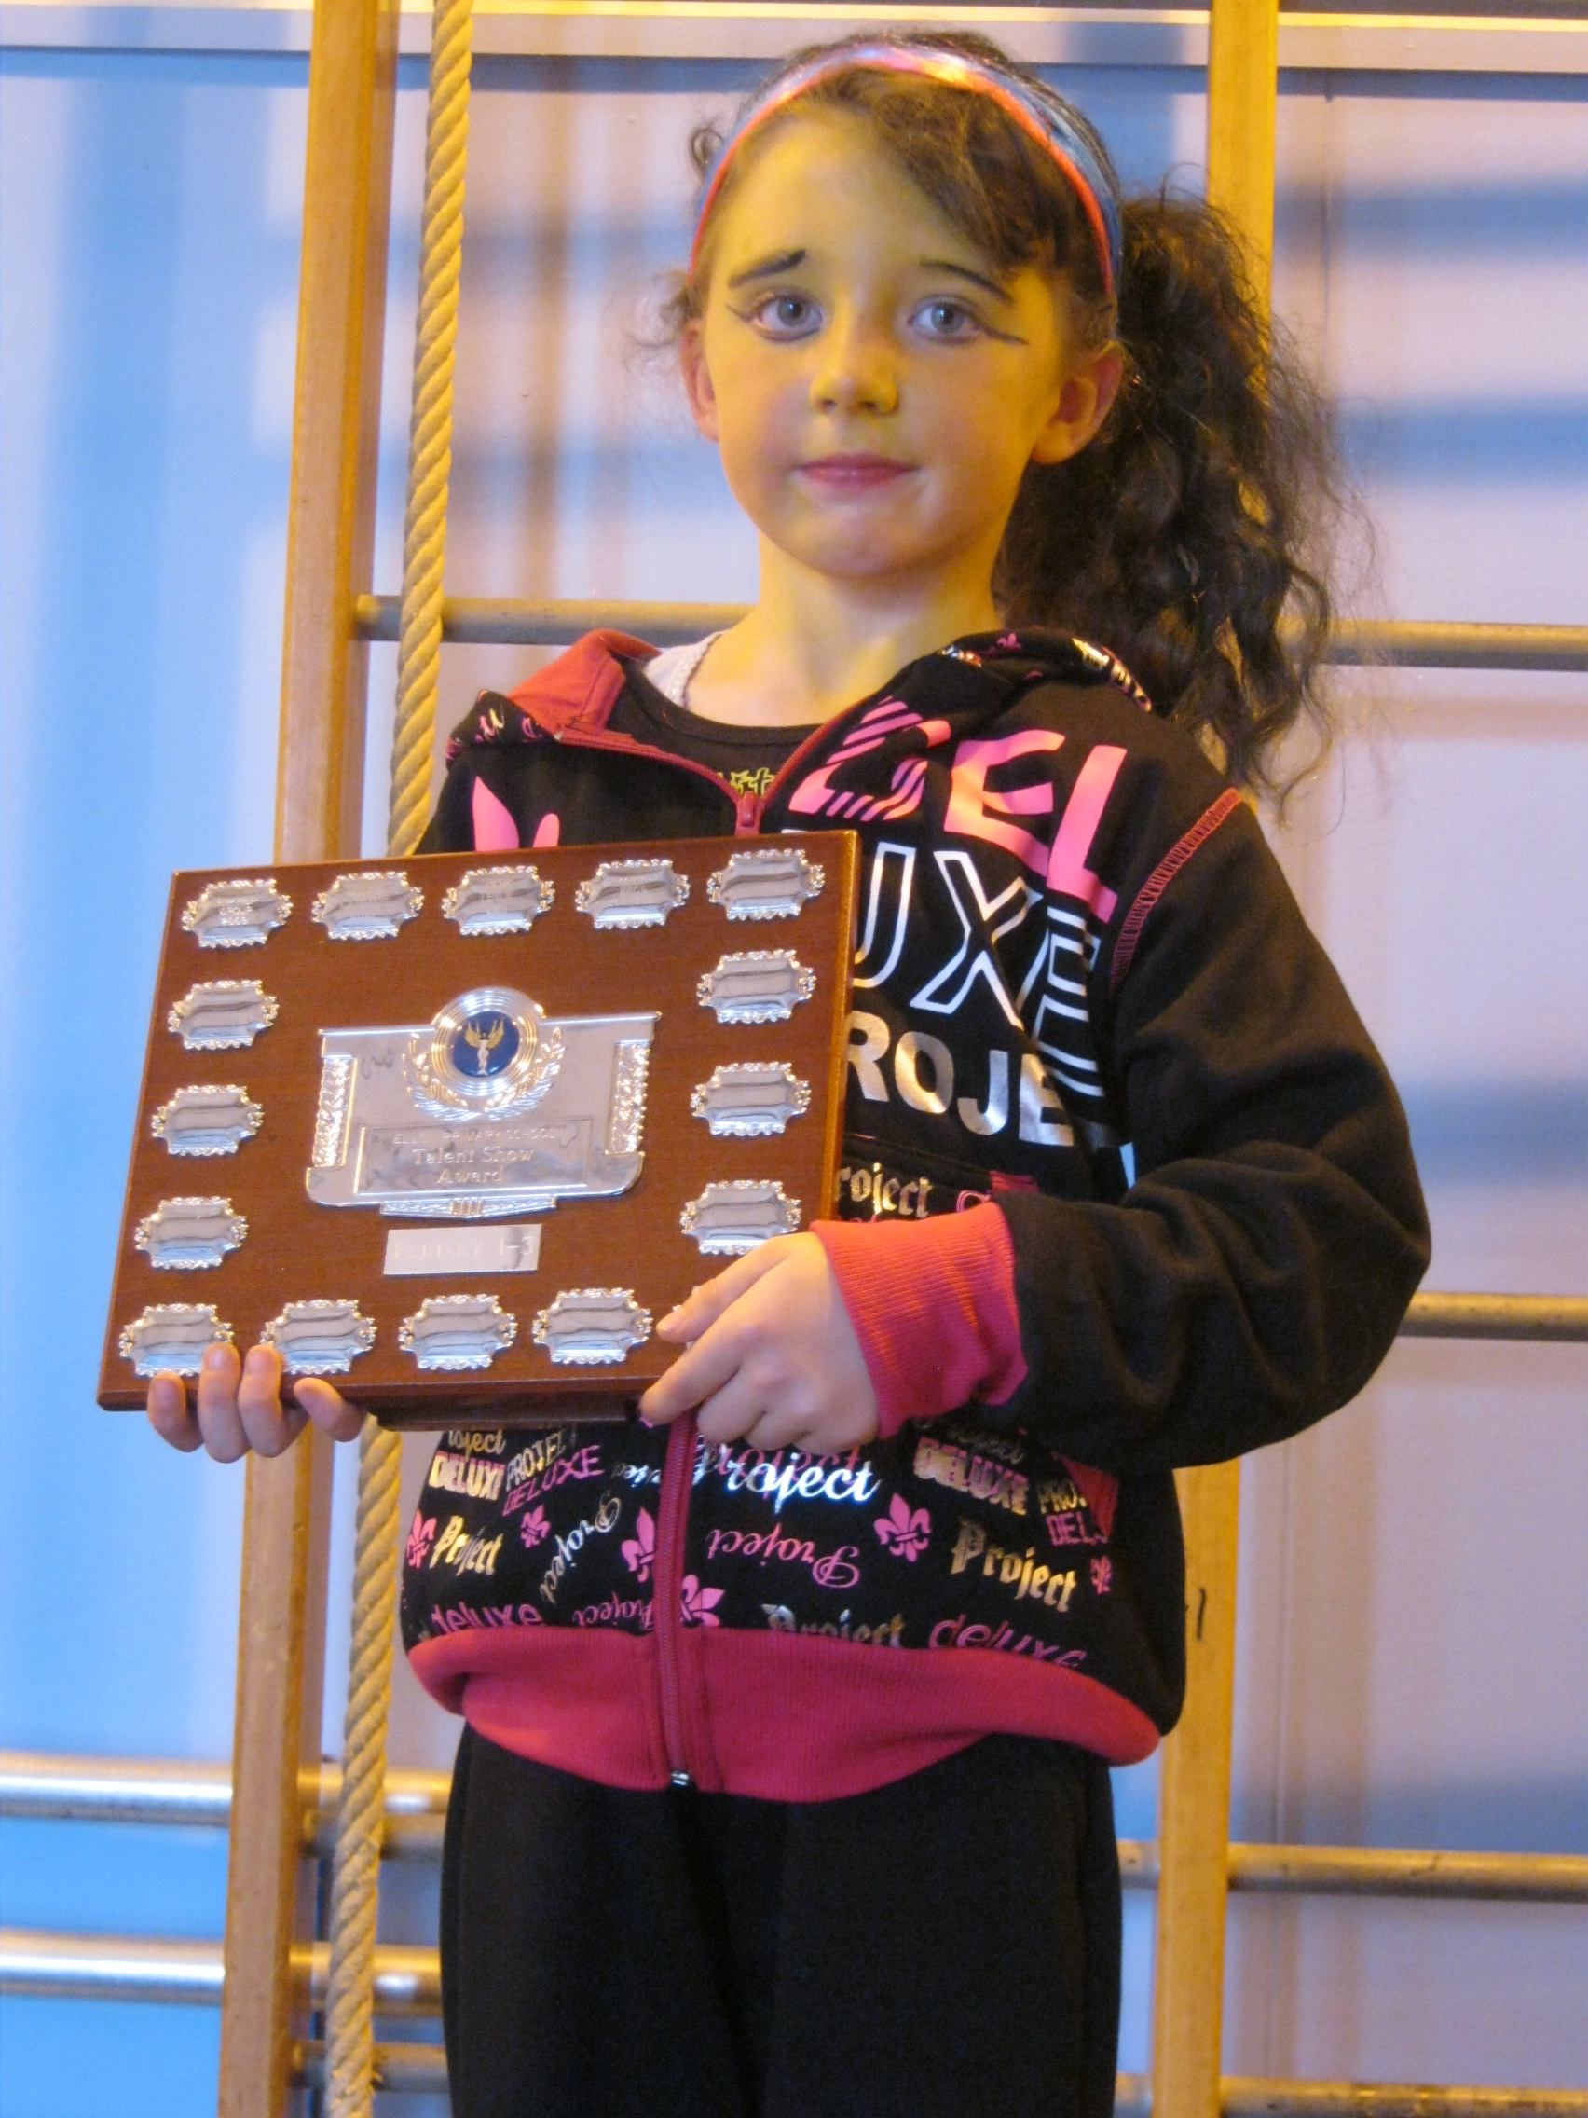
The P4-7 trophy went to a duo singing and dance act performed by Zoe Mitchell and Tilly Ripley. They sang ‘Do you want to Build a Snowman’ from the film Frozen.
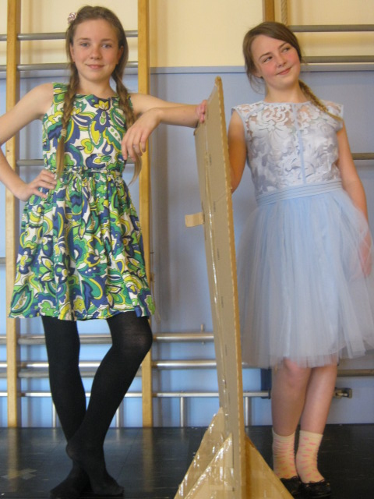
Well done to all the children who put themselves forward for the show and especially to those who reached the final.
I would like to say thank you once again to Miss Sarah Stout, for organising the auditions and making all the arrangements for the show.
Barnardos Boxes
We would like to say a huge thank you to the children and families who collected for Barnardos over the course of the year in the ‘wee house’ collection boxes. A total of £644.36 was raised for the charity. Kerena Hobbs was awarded the Barnardos Bear for collecting the most. Well done Kerena!
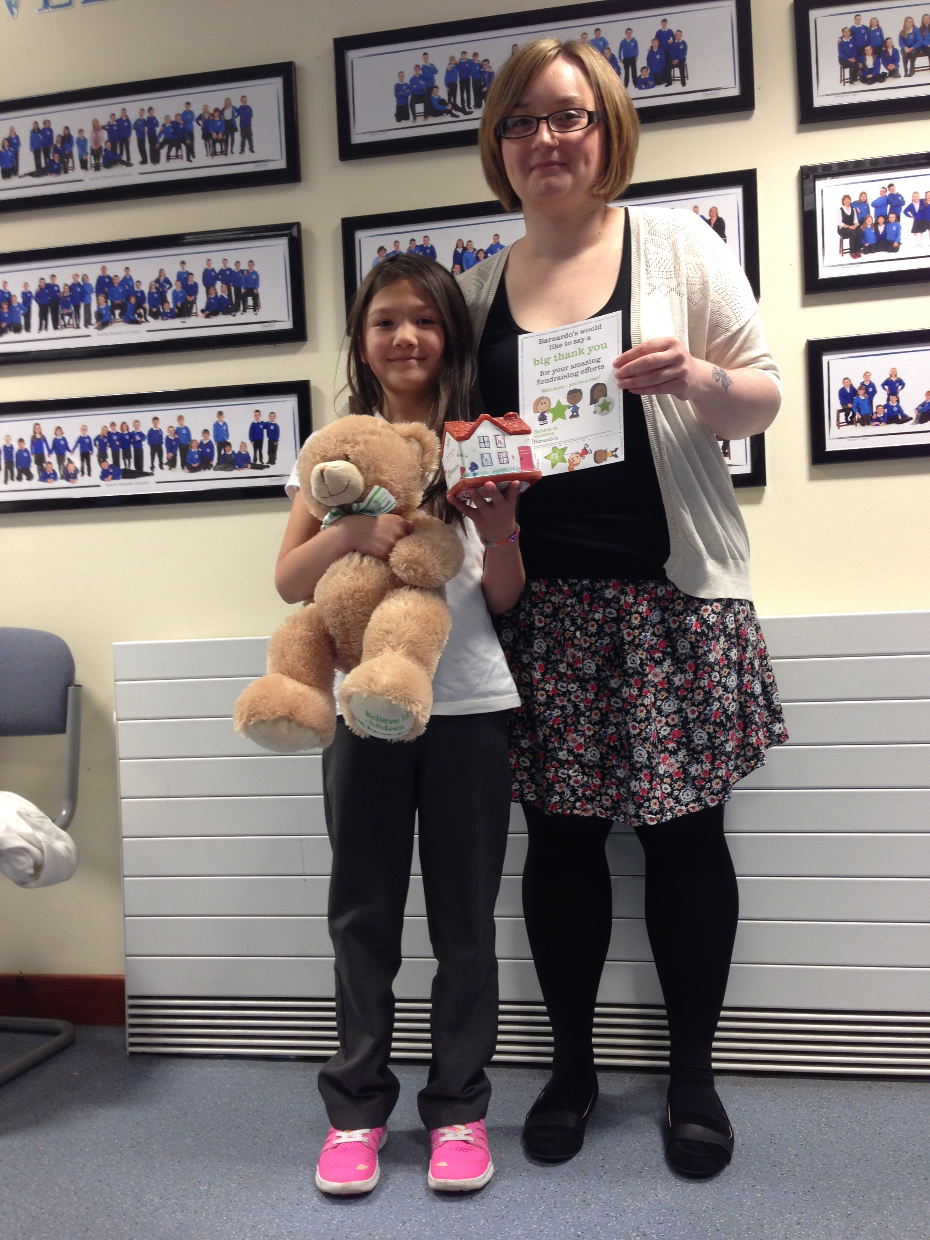
Thank you to Miss Blaney for organising the distribution of the boxes and the money count.
Sunshine on Sports Day
Children and families enjoyed a glorious day of sporting events on Tuesday as children competed in their house teams for the Sports Day House Cup.
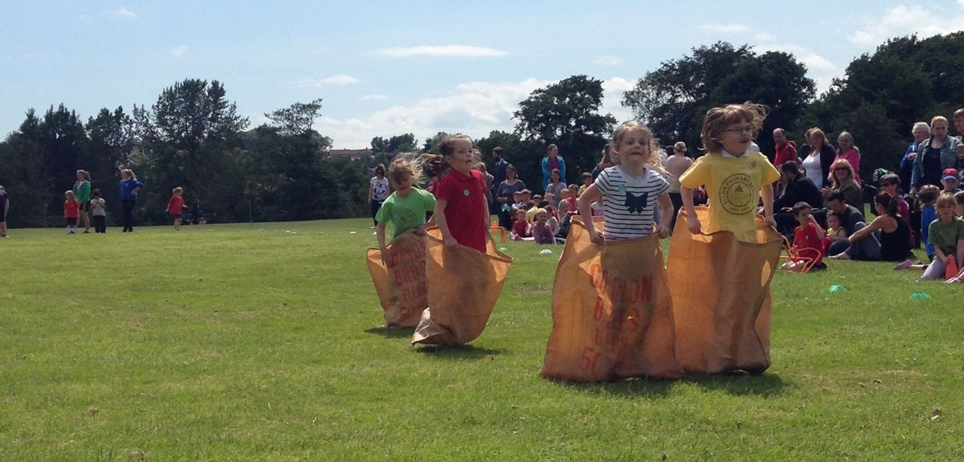
P1 girls participate in school sports for the first time having lots of fun with the sack race.
We thank Miss Mair for organising a range of exciting and challenging races for the children. We appreciate all the work that goes into the organisation of the sports day.
We would like to say a special thank you also to Mrs Vicky McBride and Mrs Debbie Canning for their bright idea of dying t -shirts in house colours. It certainly brightened up the day & helped to create house team identity and made for a very colourful event.
The Sports Day House Trophy went to Forvie.
School Grounds Development
Over the summer holiday period there will be work done to upgrade the school playground. The work will begin mid July and be completed mid September.
Work on the playground will continue on our return to school after the summer holiday .We will therefore not be able to use the main gates at the front of the school.
When we return to school in August all parents and children should enter the school grounds through the side gate on the path from Station Road to Gordon Park. The gate will be widened for ease of access.
P1 parents and children can enter through the back gate leading to the nursery while the work is being done in the playground. Do not walk through the school car park.
A fenced off compound for the contractors will be created in the back playground and the work areas fenced off from the children.
Class teachers will talk to the children about keeping safe while the work is going on and we would ask you to reinforce this message prior to the children returning to school.
Promoting Positive Behaviour Policy
Over the year a group of teachers have been reviewing our current rewards and sanctions system.
The consultation and review will be completed next session over the course of the first term. There will be further consultation with pupils and parents and all views will be gathered and analysed.
It has been decided along with the Parent Council that we will operate a class based reward system when we return to school in August until views have been considered.
This means that the current sticker system, praise notes and the Diamond Tea will not be in operation during term 1 next session. Golden time will still operate along with the individual praise and reward systems operated by individual class teachers.
Safe Summer in Scotland
Attached to this newsletter you will find information and guidance available on the NHS website to help people to have a safe summer. You will receive the information letter as an additional attachment.

Netball Success
Our netball teams had a successful time at the Ellon Gala. The P7 team won and P7/6 team came 4th out of 5 teams. At Balmedie the P7’s came first and they were 2nd at the Auchnagatt Gala. They have had great success this summer. Well Done!
The P5 team had a very successful competition coming joint 2nd in their tournament.
This was fantastic and we have a lot a talent going forward to take part in the Garioch league next session.
Next session the netball with continue for P6 and P7 only with Zoe Webster a senior pupil from Ellon Academy, Kirsty Wotherspoon, Tracy Kelly and Lori Jaffrey as the coaches. We currently have no coaches for our P5’s for next year.
Sheena Blakey has stepped down as netball coach at Ellon Primary after 12 years. Sheena has been a fantastic coach and supporter to our netballers over the years taking them to galas and Garioch league matches. She has helped to coach children who are now playing at district level and one player has a trial for the under 17’s Scotland team. Our thanks go to Sheena for dedicating her time to the development of netball in our school and across the Formartine area.

Volunteers Needed for P5 Netball
If any parent(s) wishes to form a P5 team Miss Jack will be happy to talk to volunteers about what would be involved and to point the coaches in the right direction. If you are interested in becoming a netball coach please contact Miss Jack through the office or talk to the parents who are already coaching.
Thank You
And finally we would like to say a huge thank to all our VIP’s, Volunteers in Primary. We really appreciate parents giving their time to assist the school with various tasks, photocopying, counting vouchers, helping out with sports events. The list is endless and we couldn’t do it without you.
Thanks also to our hard working Parent Council who have supported the school tirelessly over the course of the year. Through working together to improve the school we can look forward to an upgraded playground environment for our children next session.
We would like to wish our pupils, staff, families and school supporters a very, happy, healthy and safe summer holiday.
Thanks to everybody for your hard work this year! We look forward to seeing everyone back at school on….
Tuesday 19th August 2014

Happy Holiday Everyone! ☺☺☺☺☺☺☺☺☺☺☺☺☺☺☺☺☺☺☺☺

Holiday Dates for Session 2014 – 2015
These are attached to this newsletter.

