

ELLON PRIMARY SCHOOL

Newsletter
December 14

Santa Fun Run
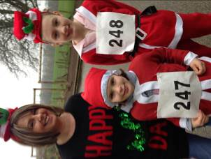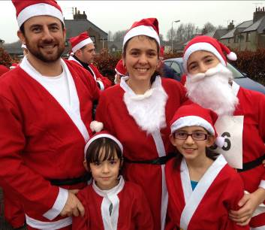

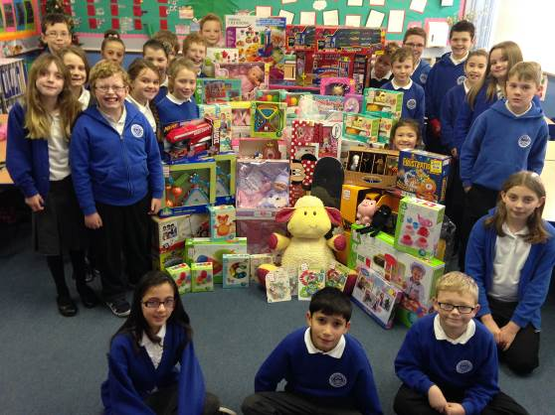
The Santa Fun Run on the 29th of November was organised by Tracy Kelly and Wendy Stewart who put a lot of effort into making sure the event ran smoothly. An amazing 248 people signed up to put on their Santa costume and run two kilometres around Gordon Park.

The event saw both young and old waiting with anticipation and excitement at the starting line.
However, not only did they receive an applause and a medal to keep for life, they were then greeted by the extravagant Christmas fair which was organised by our very hardworking Parent Council. This included a number of stalls, spectacular food and even a glorious Santa’s Grotto (once we managed to tempt Santa away from the home baking!)
Thank you to everyone who helped with the Santa Fun Run and Christmas Fair. We really appreciate it.
Written by the P4-7 Skills for Life, Learning and Work Newspaper Group.

Mission Christmas
For the first few weeks of this term, Primary 5 pupils were on a ‘Christmas Mission’ to raise as much money as they could for Cash for Kids. They took part in a sponsored read and organised guess the teddy’s birthday. They managed to raise an amazing £530! They then spent time researching toys, finding out the best places to buy the toys and working out what they could afford with the money. The classroom was filled with toys that will go to children who may not have received a present this Christmas. Well done to everyone in Primary 5.

Congratulations to Mrs Lindsay
Sinead Lindsay, DHT was appointed to the post of Head Teacher at Newburgh Mathers Primary School this week. We are delighted for Sinead and wish her every success in her new post.
We will of course miss Mrs Lindsay who contributed hugely to school improvements over the years at Ellon Primary. In particular she worked to promote inclusive practice across the school, encourage reflective practise and co-operative approaches to teaching and learning. Her thoroughly hard working, professional approach will be missed by all her colleagues here. She will return to an assembly in January to say farewell to staff and pupils.
Christmas Lunch
On Friday the 5th of December we had our Christmas lunch. There were about 178 people and 13 teachers. The dinner ladies wore Christmas aprons and Mrs. Whalley had a funny hairband on. There were a lot of Christmas crackers and everyone got to pull one.
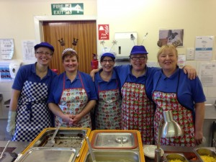
Everyone liked the Christmas music and had a really nice time. Erin’s mum helped to make sure we all had crackers.
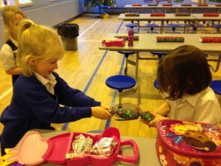


Dean, Sophie, Alisha and Jessica all had fun pulling their crackers.
Written by Alex and Rhianna in the P2-4 S4L Newspaper Group

More Success for Ellon Primary School Netball Club
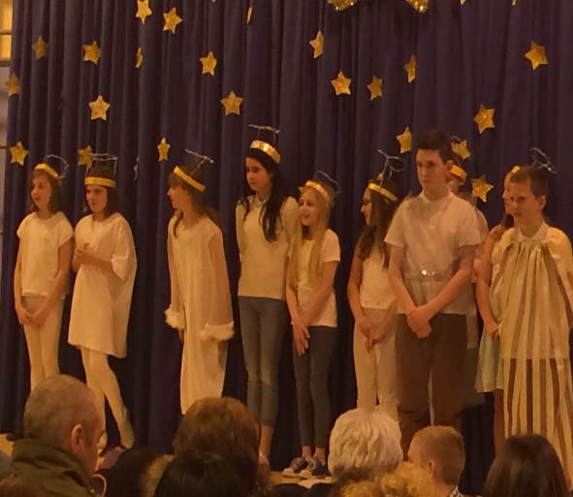
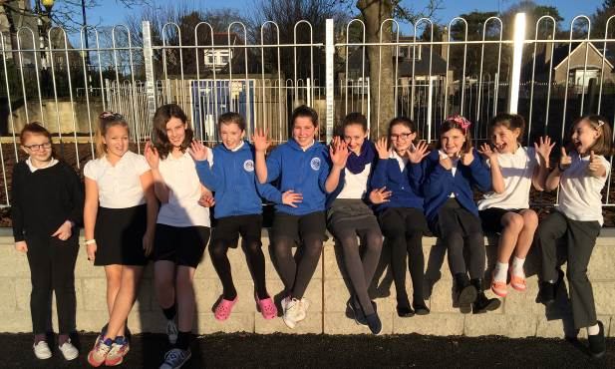

Ellon Primary School’s P6-7 Netball team played against Auchterellon Primary at Old Meldrum Academy on the 11th of December. They played extremely well and showed off their team working skills and creativity. As a result, they won the game 12-0. Lois-Jay Muir was given the prestigious title of “Player of the Match” so an extra well done to her too! This is an amazing achievement for our netball team and we are absolutely delighted with how hard they are working. Thank you to their coaches who work with them every week to help them achieve their goals
Christmas Concerts
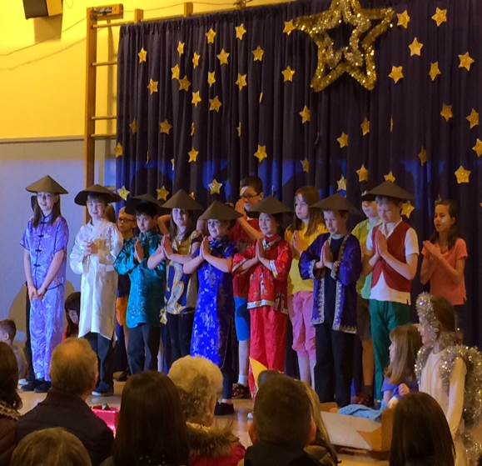
Our Janitor Martin and his wife, Maureen, helped to set the scene for the Christmas concerts by making our wonderful curtain backdrop. The P4-P5 pupils performed ‘Christmas Around the World’ with dedication and happy smiles. They worked very hard and had lots of fun learning how to say ‘Merry Christmas’ in different languages. Our P6-7 pupils performed “The Xmas Factor”. The singing was beautiful and the acting was very well presented. We were absolutely delighted with how hard all of the pupils worked and the positive feedback received from parents & grandparents. ‘
School Blog
After some changes to the ICT system at Aberdeenshire Council our Ellon Primary School blog is back up and running again. Please have a look and perhaps leave some comments. Also let us know if there is any news or anything else you'd like to see added to the blog.
This link will take you to the blog:
http://blogs.glowscotland.org.uk/as/Ellon/
School Lunches
Free School Meals for All P1 to P3 Pupils

From Monday 5 January 2015 all primary 1 to primary 3 pupils will be entitled to free school meals in all of Aberdeenshire’s Primary Schools.

Lunch tickets will no longer be required for these pupils in primary 1 to primary 3.

For parents or guardians of pupils that have not previously taken lunch in school the current primary school menu cycle and information on primary school meals can be viewed on the school catering web pages at:
http://www.aberdeenshire.gov.uk/schools/school_meals/primary.asp

Lunch tickets will still require to be purchased for pupils in primary 4 to primary 7 unless pupils are entitled to free school meals.

Playground
Thank you to all parents who have made a
detour while the building work has been going on. We appreciate that it is a longer walk but much safer by far.
The building works are almost complete and we expect the play equipment to be installed on our return to school.

Please remember that no one should be entering/exiting the staff car park at any time.

Kids’ Council
The P3-P7 members of the Kid’s Council were on hand to welcome many parents, grandparents and family friends in to school to see the P4-5 and the P6-7 performances.
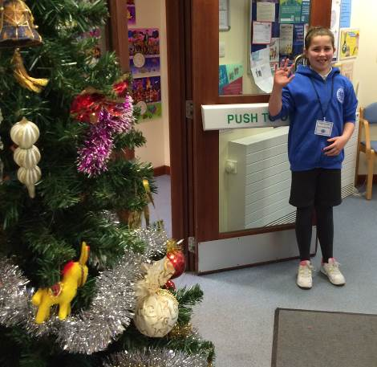
Here are Cameron, Austin and Erin also helping by handing out programmes for the Christmas concerts and selling calendars for the Parent Council.
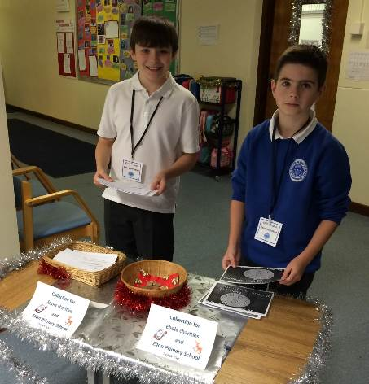

Christmas Holidays
May we wish you a very restful and
peaceful Christmas.




Thank you to everyone for your hard work this year! We look forward to seeing everyone back at school on….
Monday 5th January 2015
From Everyone at Ellon Primary School

