Southesk Primary School
SIP 2019 2020
Outcome | Primary Drivers | Secondary Drivers | Actions | NIF | HGIOS 4 |  | Timescale and Responsibility
  85% of all Southesk Learners will show a year’s growth for a year’s input  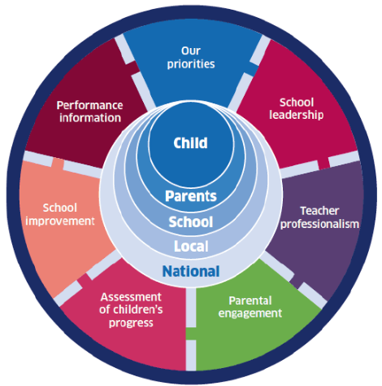  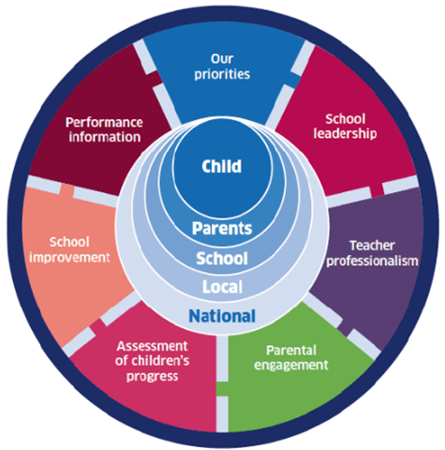 | The culture and ethos of Southesk promotes a positive learning climate, good relationships, collaborative practice and a shared language of learning | Arrangements are in place to facilitate collaboration between school staff across the school, cluster and beyond | A whole school audit to take place of reading experiences and stakeholder views to inform decision making and allow for improvements to be tracked. To what extent do our learning pathways support the provision of a literacy rich curriculum? (Benchmark Audit Point RR P5, P6 Whole School Approach Teaching and Learning Weekly Overview p65, p125)  A whole school audit of the environment will take place to identify areas of improvement linked to promoting a reading culture (RR and POLAAR Resources) A focus will also be on identifying and closing the vocabulary gap (Word Aware) Do we understand our vocabulary gap?  Pupil Voice to be fully integrated in to decision making and resourcing. How Good is OUR school to be used to effectively gather views linked to reading  CFE Level Planning Meetings will take place termly with a focus on Reading and Literacy learning and teaching and providing teachers with opportunities for professional dialogue  Planned opportunities for teachers to collaborate, discuss and share good practice and network will be facilitated within and out with the cluster and authority and with partner agencies (Cluster, Authority Family Groups, TRIC, SALT,OT,EPS)  The school will provide family learning events to promote and support reading at home and gather parent views for further improvements (Homework Club, Family Book Club, Parent Information Sessions RR p132, p134, p135) To what extent are we working with parents, carers and partners to provide children with literacy rich learning opportunities in a range of meaningful contexts?  The school will share ‘This is how we do it here.. ‘ reading learning videos via the school website and refresh the school’s reading policy (Jolly Phonics, Modelling Reading, Bed Time Stories. RR p35-36)  All teaching staff will have high quality CLPL through Book Club ‘Reflective Reading by Anne Glennie’ to inform agreements to ensure consistency and a whole school culture of reading alongside embedding Southesk’s Learning Dispositions To what extent is the learning environment literacy rich?  The school will work with the community to promote a positive reading culture. Links with businesses and the local library will be strengthened (All pupils to have a library membership) | TP  PE  SL | 1.1  1.2  2.2  2.3  2.5  2.7 |  | By Oct 19: All staff and pupils  On-going: Junior SLT  On-going: Teaching Staff  By Jan 2020: Teaching Staff  By June 2020: PT Family Learning  By Jan 2020: PT Familiy Learning  On-going: Teaching Staff  On-going: PT Family Learning
 |  | A range of appropriate and relevant networking and professional learning opportunities involving a number of partners is planned and implemented
 |  | Learning environments support the literacy development of all learners and are literacy rich
 |  | Pupils are engaged and motivated readers and demonstrate Southesk’s Learning Dispositions
 | I am an evaluator I collaborate I see assessment as feedback to me I develop positive relationships I talk about learning, not about teaching
 | High quality learning and teaching in reading with increased pace and progression resulting in raised attainment and improved pupil engagement | Planning is thorough, builds on prior learning and supports pace, challenge and depth of learning in reading | Staff, pupils and families will be engaged in activities to discuss reading progression and teaching and learning experiences within the 7 Principles of Curriculum Design (Imagine if ….. TRIC Principles of Design Evaluation Rubric Activity)  Flexible learning pathways will be explored fully to support identified learners and allow for learning experiences to be facilitated out with school if beneficial  The school will invest in sufficient and appropriate reading, comprehension and technology resources for each CFE level to support reading  All teachers and SPSA’s will be refreshed in the teaching of phonics and early reading skills using the school’s core resources and Early Years Reading Toolkit and effective reading instructions (RR p29 Checklist Audit RR Identifying Reading Problems p24)  SPSA’s will be refreshed in delivering high quality interventions such as Precision Teaching, Toe by Toe, Fresh Start to support learners and will be allocated to classes to support learners  All teachers will engage in focussed discussions linked to effective feedback (‘Visible Learning Feedback by John Hattie and Shirley Clark’) Are there daily planned opportunities, targeted at the appropriate level, for children to engage in literacy across the curriculum?  Teachers to self-reflect on their own practice regularly to ensure breadth of reading experiences and ensure that there are a wide variety of pedagogical approaches in place Paired Reading, Reciprocal Reading etc (RR p43-49 VL Inspired and Passionate Teachers p24 VL into Action for Teachers Two VL Mindframes SurveyVL into Action for Teachers Two p14) | OP  ACP  SL | 1.2  1.3  2.2  2.4 | By Jan 2020: SLT/Teaching Staff/Pupils  On-going  By Oct 2020  By Dec 2020: By DHT  By Dec 2020: By DHT  On-going: Teaching Staff
 |  | Across the school teachers deliver consistent high quality learning experiences in reading which focus on developing reading fluency, key reading skills and strategies
 |  | Teachers give high quality feedback to all pupils which incorporates Southesk’s Learning Dispositions
 |  | Teachers develop the skill of evaluating the effect they have on their learners
 |  | Whole school approaches to planning, assessing and using targeted interventions within reading are used consistently across the school and embedded within a literacy rich curriculum
 | I inform all about the language of learning I engage in monologue, not dialogue I enjoy challenge
 | Data and evidence is used effectively to measure the impact on learning and to improve individual and school reading outcomes  There is a relentless focus on ‘Know thy Impact’ | Consistent whole school assessment data alongside Standardised testing is used effectively to support, measure and monitor individual, class and school progression | Teachers and SLT to attend Osiris In-Service Day Training focussing on SOLO Taxonomy. (November 2019 In-Set Day)  Visible Learning SOLO Taxonomy strategies will be used to support teachers in designing Learning Intentions and Success Criteria and the creation of robust assessments to measure progress. (Osiris: VL The Inside Series: Creating Effective Assessments for Teaching and Learning Using the Solo Taxonomy)  Visible Learning will be used to support teachers in developing skills linked to deep and surface level questioning  Visible Learning Impact Cycles with a focus on reading will be used to ensure teachers are evaluating the impact of their own teaching (Agreed improvement focus of Attitudes to Reading, Learning and Teaching Approaches, Parental Engagement)  Staff and pupils to be involved in the creation of child friendly assessment booklets (RR p52-54)  The school’s approach to recording assessment data will be refreshed and will move to spread sheets for teachers to track core baselines and measure progress effectively. Staff will explore the use of (Oxford Reading Criterion Scale as a whole school approach: See Oxford Primary Reading Assessment) (VL Into Action for Teachers 1 p11 Dashboard for Success)  To what extent do we use evidence based practice to support the development of a literacy rich environment to address the gap? | TP  ACP  SL  PI | 1.1  1.2  1.3  2.3  3.2 | By Dec 2020: SLT/Teaching Staff  By June 2020: SLT/Teaching Staff  By June 2020: SLT/Teaching Staff  On-going: Teaching Staff/Pupils  By April 2020: SLT/Teaching Staff
 |  | Teachers confidently assess progress in reading through CFE levels using teacher judgement based on reliable evidence
 |  | A whole school approach to data gathering and progress tracking is used to evidence progress
 |  | All teachers, working in pairs, will carry out Impact Cycles to measure the impact of planned tests of change linked to reading
 |  | All teachers and pupils to feel empowered to lead developments and inform decision making across the school
 | I am an evaluator I am a change agent I see learning as hard work

