
Southesk Primary School
January 2018
Parent/Carer Newsletter 3
Staffing
Ms Main has moved on from Southesk this term and we wished her goodbye last week. Primary 7 will now have Miss Parker as their teacher. I will keep you informed of any staffing updates as and when I know.
Should you have any queries or concerns regarding this then please do not hesitate to contact me to discuss them.

Happy New Year
On behalf of all the staff at Southesk I would like to wish you all a happy and healthy 2018.
It has been lovely to welcome the children back after the holidays and we are now well and truly back in to the work of this term. Another busy term ahead filled with many new and exciting learning opportunities for your children.

Burns Competition
We held our annual Burns Poetry competition this term on Thursday 25th of January with the children all doing so well learning to recite their chosen poem.
Miss Campbell and Mrs Cooper kindly agreed judge for us. Winners were chosen from each class and were fantastic. The winning children will receive a certificate and prize which has kindly been donated by Montrose Burns Society.
In-Service & Holidays
Pupils will be off school from the 15th of February and returning on Tuesday the 20th February. Thursday 15th is an In-Service day where staff will be focusing on Visible Learning. Friday 16th and Monday 19th will be holidays.

P7 Transition
P7 have started their transition activities with Montrose Academy and have visits planned. On Tuesday the 23rd January and Wednesday 21st February the P7 children will visit Montrose Academy and spend time familiarising themselves with the building and the school library.

J is for January, J is for Jacket …
It’s that time of year to come to school all wrapped up and cosy, as whenever possible children will be playing outside and completing the Daily Mile.


Southesk Primary School

January 2018
<meta http-equiv="refresh" content="0; URL=https://mobile.twitter.com/i/nojs_router?path=%2F">
<meta http-equiv="refresh" content="0; URL=https://mobile.twitter.com/i/nojs_router?path=%2F">
<meta http-equiv="refresh" content="0; URL=https://mobile.twitter.com/i/nojs_router?path=%2F">
<meta http-equiv="refresh" content="0; URL=https://mobile.twitter.com/i/nojs_router?path=%2F">
<meta http-equiv="refresh" content="0; URL=https://mobile.twitter.com/i/nojs_router?path=%2F">
<meta http-equiv="refresh" content="0; URL=https://mobile.twitter.com/i/nojs_router?path=%2F">
<meta http-equiv="refresh" content="0; URL=https://mobile.twitter.com/i/nojs_router?path=%2F">
Rag Bag
The next Rag Bag date will be 9.2.18. Please put any donations in the Rag Bag bin or into the school office. All donations will be welcomed.
Lighting up Learning at Southesk Primary School:
This term your children will be learning about:
P1 Katie Morag
P2 Scottish Castles
P3 Chinese New Year & Plants and Food chains
P4 Scotland
P5 Rainforest
P6 Natural Disasters
P7 Rainforest
Please contact your child’s teacher should you feel you would be able to offer any expertise or contribute to the learning within these topics.

Enrolment Dates for 2018
P1
Please note the dates for enrolling your child for P1 in August 2018 were between 15.1.18 and 19.1.18. If you have not enrolled your child please hand in your forms ASAP.
Nursery
The deadline for enrolling nursery pupils wishing to start in April 2018 was Friday 26th January 2018.
Please collect all enrolment forms from the school office.

Games and Jigsaw Donations
We are keen to increase the number of games and puzzles we have in school and would be very grateful for any donations of board games and jigsaw puzzles which are in good condition for our children to use.

Home School Link Diaries
Your children have all again been issued with their Home/School Diary which travels back and forth between home and school every day. This diary details school events and class events alongside a daily update on your child’s behaviour alongside any information that the teacher may wish to share with you.
This is a two way communication diary so please feel free to use this to also inform the class teacher of any information you feel she may need to know.

P3 Tennis Tasters
Graeme Walker and Ona Ramsay have been doing tennis taster sessions with our Primary 3’s. The session is running from 16.1.18 – 6.2.18. They have been thoroughly enjoying the fun games so far.
Southesk Primary School
January 2018
Lunches

If your child has an appointment or you are running late please phone the school office on 01674 662655 to order their lunch as we have to give the kitchen our numbers no later than 10.15am.
S Factor

Once again we are holding our annual S. Factor talent contest with the emphasis on “FUN”.
Rehearsals will take place on 30thJan, 6th, 13th, 20th, 27th Feb, 5pm to 6pm in school dinner hall.
The finalist will perform on Finals night Tue 6th March.
Tickets can be purchased from the school office from 8:30 to 9:30am. Firstly, only for finalists on Mon 26th February, and then they will be on sale for everyone else on 27th, 28th February. Please try to bring the correct money as we are a cashless school.

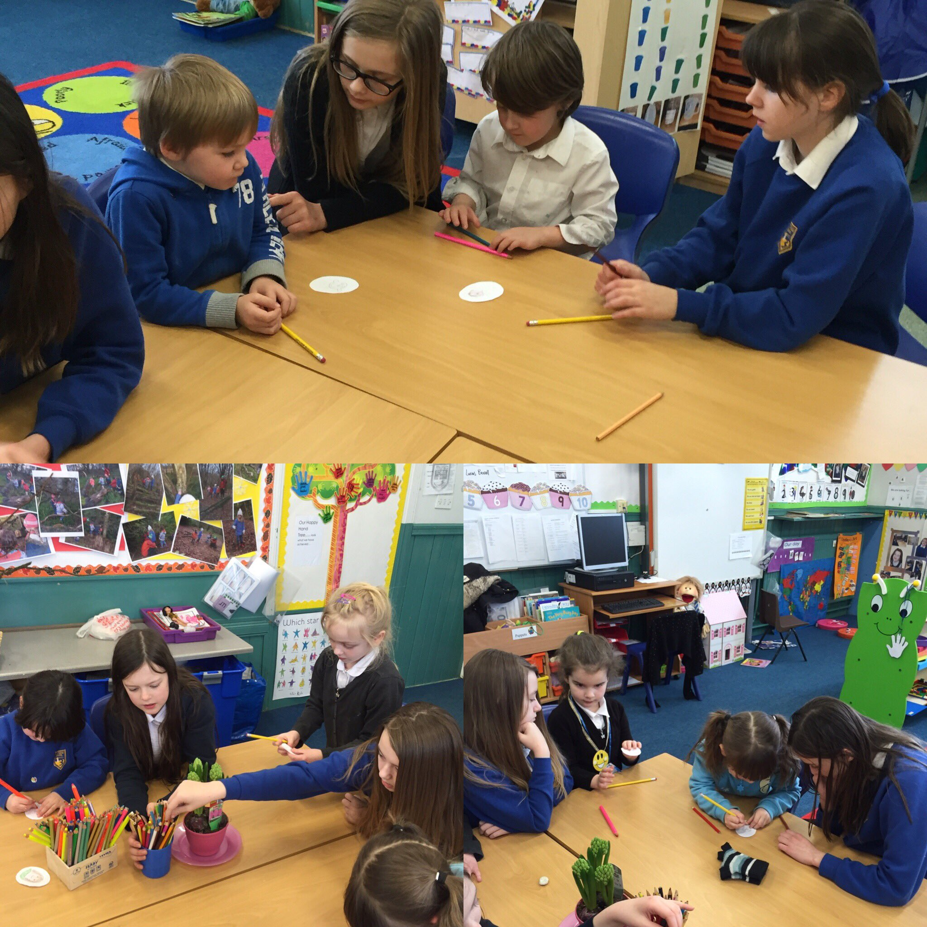

Upcoming Events
Bingo: Tuesday 6th February
Our next school fundraiser will be our Bingo Night on the 6th February. This is always a great night so we look forward to welcoming you for a night of fun.
Doors open at 6.00pm with the first game starting at 6.30pm.
Tempest Photographer: Friday 2nd February
This year we will be having individual photographs and class photographs. We also created a poll on Twitter for you to vote for your preferred school background. The school will use this in inform their decision as to the background to be used this year. Thank you to those who voted.
Rotary Quiz
The annual Rotary Quiz will take place on the evening of Tuesday 13th March. We will be entering a team of pupils again this year.
World Book Day
We will be celebrating World Book Day on Thursday 1st March within school. All children will come to school dressed as normal in uniform but are asked to wear their favourite quote from a book of their choice.

Tesco Bags for Help Funding
Our Wildlife Garden improvements are now nearing completion with the Log Cabin fully installed and a seating area completed. Outdoor Learning resources have now also been purchased and we are hoping to have an official opening ceremony in the better weather.
Book Fayre
Many thanks for your support in buying books from the Scholastic Book Fayre at Parents’ Evening. We now have £509.08 to spend on their books for the benefit of the school.
Donations to Charity
We received a lovely thank you letter for the £100 donation made to Muscular Dystrophy UK. Many thanks for this.
We also raised £174.56 for Children in Need with our Dress as You Please Day.

Southesk Primary School
January 2018
Calendar Dates for this Term
JANUARY
Monday 8th – New Term
Tuesday 23rd – Nursery Parent Forum 2
Thursday 25th – Burns Poetry Competition Final in School
Friday 26th – Nursery Burns Scottish Party Parents Invited
Tuesday 30th – P3 Class Assembly Parents Invited
FEBRUARY
Tuesday 6th – School Fundraiser – Bingo Night
Friday 9^{th –} Ragbag Collection, Please bring any donations to school
Friday 9th – Home/School Link Books Issued – to be returned on Monday
Thursday 15th – In-Service - No Pupils
Friday 16th – Holiday - No Staff/Pupils
Monday 19th – Holiday – No Staff/Pupils
Friday 23rd – 9.45am – 2.00pm LPCT P5 Literacy Trail
Tuesday 27th – P6 Class Assembly Parents Invited
Wednesday 28th – 9.45am – 2.00pm LPCT P6 Environmental Trail
MARCH
Thursday 1st – World Book Day Celebrations in School
Tuesday 6th – 6.30pm S Factor Final
Friday 16th – 9.45am – 2.00pm LPCT P7 Science Trail
Wednesday 21st & Thursday 22nd – 4.00pm – 6.00pm Parents Evening
Friday 23rd – Home/School Link Books Issued – to be returned on Monday
Friday 23rd – Nursery Folio Sharing (both sessions)
Tuesday 27th – P4 Class Assembly Parents Invited
Friday 30th – Last day of Term
School Fund 2017 2018 Updates
This term in discussion with the pupils we have purchased a wide variety of outdoor play equipment for our children to use at playtime and lunchtime. We have also purchased an outside storage container for ease of access.
School Funds are donations, fund raising activities, contributions from pupils towards school trips, voluntary activities etc. These funds are then administered and spent for the benefit of the school and pupils and do not come within the budget of, or under the direct administration of Schools & Learning.

Monies received for specific purposes must only be spent as specified (for example monies received for a school trip must only be spent on that school trip). Where the funds are not received/raised for a specific purpose, they must be used to benefit and enhance the learning experience of the pupils.

School Fund  Income  December  School Christmas Fayre Stall £223.20  Christmas Concert £1548.06  Christmas Concert Raffle £752.70  Carol Singing £464.99 | School Fund  Expenditure  December:  Paddington Bear 2 Film Day £792  January:  Outside play equipment for the playground £2,2034
Current Total: £4991.91
Our upcoming Bingo Night will contribute towards paying for buses for upcoming school trips

As always please do not hesitate to get in touch with myself or Mrs Denyer should you have any concerns, queries or ideas for improving our school.
Kind regards
Ms Sara Morgan
Head Teacher
Southesk Primary School

Sara Morgan, Head Teacher, Southesk Primary School, Hill Place,
Montrose DD10 8BP
Tel: 01674 662655
Email: s.morgan@angusschools.org.uk

Dear Parents/Carers
Family learning is an approach which encourages family members to learn and work together across generations. Recent research suggests that family learning improves attainment and encourages children to learn, leading to more positive outcomes for both adults and children by improving the life chances for families involved.
Over the past couple of months at Southesk, we have been working to create a family learning environment within the school, a room where families will feel welcome, relaxed and encouraged to be involved in learning. Our aim is to use this room for a wide range of family learning activities. Below are some activities that we are currently exploring but we would like to know what you think will work for you? Some of the ideas we have come up with are:
- To create learning breakfasts where your children will invite you into school so they can share aspects of their learning with you. Allowing them to share what they have been learning and how they have learned it.
- To invite parents/carers/grandparents who have a skill or talent to come and share this with our children, to teach them new skills such as knitting, sewing, cross stitch, music, wood work, baking etc.
- To create family learning school clubs such as a reading club where children attend with their parents/carers/grandparents to share a reading book and carry out a range of art and craft activities relating to the book
- To create a club for ICT where children can teach parents/carers/grandparents to carry out a range of tasks on a computer or tablet.
- To create daytime sessions such as Learn, Laugh Play, Adult Learning, Learn English for free sessions and more…
We would like to know your views on the above ideas and also any other suggestions that you might have to help your child’s learning. Please help us by completing the short survey on the next page as we really value your views. We will use your ideas and opinions to drive forward activities for ‘Southesk’s Family Learning Lounge’.

We currently have two activities up and running for parents/carers of the school with the help of Angus Council’s Communities Team these are:
- Learn, Laugh Play Sessions currently running on a Tuesday Morning from 9.15-10.45. This session is aimed at families with pre-school children. Parents/ Carers attend with their children for a friendly fun-filled morning.

- Adult Learning Drop-in – this session is held on a Thursday morning from 9.15- 10.45 and is a session for parents/carers to enhance skills in reading, writing, numeracy and ICT. Within this session you can also gain qualifications or get help and advice for creating a CV. This is a fantastic opportunity that we are very lucky to have going on within our school.
If you are interested in any of the above or have any questions or require any more information about any of these sessions, please contact the school office or Kathryn or Elaine from Angus Council’s Communities Team on (01356) 627460.
Please complete and detach the below questionnaire and hand back into the school office

Family Learning Questionnaire

- What family learning activities would you like to see at our school?

- Do you feel confident enough to help your child’s learning? Yes/No

If you answered no, please provide any suggestions of how the school can help to increase your confidence to support your child with their learning?

- Do you think we as a school do enough to encourage you to be involved in school activities? Yes/ No
If you answered no, please provide any suggestions of how the school help involve parents and carers with school activities.

- Would you be interested in coming into the school to share a skill or talent?
Yes/No
If you answered yes, what learning would you like to come and share with our pupils at Southesk?

