SEAVIEW PRIMARY SCHOOL

Home and School: Seaview United

School Partnership with Parents Policy

August 2018 (Updated)

‘What is it we want for our children?’
In Seaview, we want our children to be treated fairly, to be happy and enjoy learning. We want our pupils to feel valued, confident and included in all aspects of learning and where everyone will achieve success through effort, commitment and resilience.

‘What are we going to do to achieve it?’
To achieve this, we will provide our pupils with relevant, meaningful and rich learning opportunities. We will celebrate their achievements and successes, engage with parents and the wider school community and continually enhance our knowledge and skills through career-long learning.
Our shared values are:
- Excellence - Happiness
- Fairness - Teamwork

Our shared aims are:
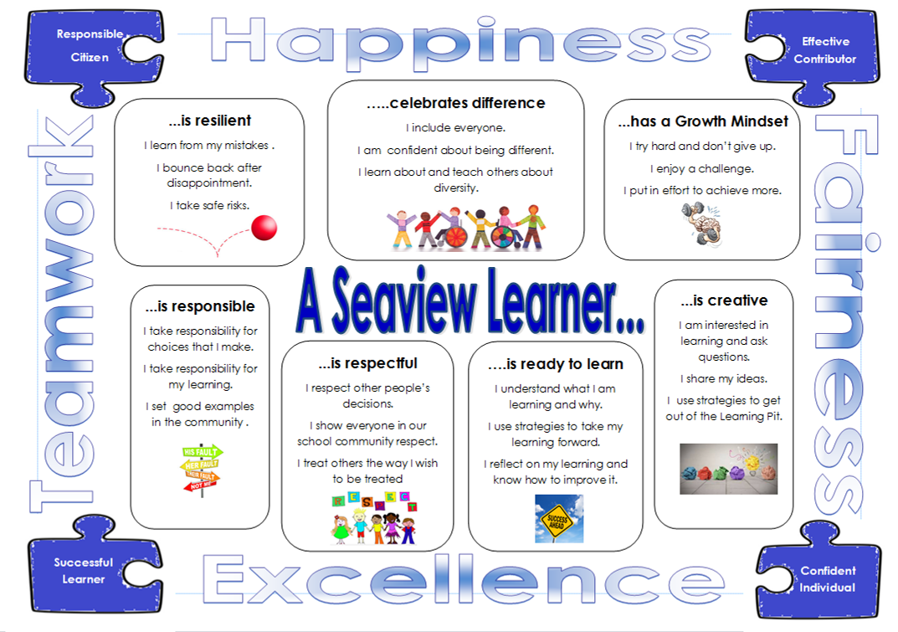

We work together to be the best we can be!

Seaview Primary School Partnership with Parents Policy

Rationale
Seaview Primary School acknowledges that parents and carers play a central part in their children’s education. As a school community we are confident that the strength of the partnership between home and school will enhance school achievements and promote a continuing positive ethos and effective two way communication.

Aims
Our overall aim is to enable home and school to work together to support children in everything they do and we believe that numerous benefits will be derived from this partnership.

We aim to:
1. Provide a warm and welcoming environment to all parents and carers who come into school in order to help their child settle in successfully.
2. Provide regular opportunities for parents and carers to become involved in their children’s learning to create a genuine partnership.
3. Share parents’ and carers’ expertise and provide training, where necessary, for specific tasks, to find out as much as possible about the child’s interests and needs.
4. Communicate with parents and carers regularly and share information whenever appropriate about their child.
5. Make provision for constructive consultation and decision making with regard to all aspects of school life to inform the parents about the setting.
6. Maintain an open-door approach where parents and carers feel comfortable and confident in approaching school with any concerns or specific requests to ensure safe practice.

How do I go about becoming a helper?
If you are unsure
If you think you would like to become a helper but are still a little unsure you should contact the Head Teacher who will arrange for you to come in for a ‘one off’ taster session. For this one session you would not be required to complete any application forms.

If you are sure: making an application
Complete both parts of Appendix 1 and return them to school.
If you have not already undergone a PVG check for being a volunteer in Seaview, you will then be sent the necessary forms to complete (See Appendix 3 for details).
Once this check has been completed with the relevant documents taken to school, the forms will be sent to Angus Council headquarters and you will receive another set asking for similar details.
Once this process has been completed and the check approved then arrangements will be made for you to start helping. This will include a brief induction when fire drill procedures and child protection issues will be discussed along with the Code of Practice for School Helpers and Volunteers (Appendix 3)

How Can We Achieve These Aims?
1. Provide a warm and welcoming environment to all parents and carers who
come into school informing them of what we do:
• attractive foyer area and bright displays throughout the school
• friendly and encouraging staff
• invitations to Sports Day, Book Fair, Fair Trade cafes, concerts, open
days and stay and play days
• fundraising events – e.g. School Fairs, Bingo night or sponsored
events
• annual awards ceremony.

2. Provide regular opportunities for parents and carers to become involved in their children’s learning.
• helpers in school, pre-school rota and helpers on trips (who are PVG checked)
• regular home/school links via diaries, homework tasks, Class Dojo,
nursery folios etc.
• invitations to Stay and Play Days in nursery
• parent rota in nursery
• invitations to Open events
• invitations to church services
• invitations to pre-entry visits during transition events
• communication/ liaison with parents of the child’s interests, learning and achievements
• record and use individual pupil’s information to inform curriculum planning
• encourage parents to organise social events and raise funds for special projects
• make information leaflets available, discuss their contents
• make translation services available where necessary
• evaluate our practices to help maintain and improve our standards.

3. Share parents’ and carers’ expertise and provide training, where necessary, for specific tasks.
• helping with a wide range of classroom and school tasks or special projects
• as members of the Parent Council, Eco committee, Reading Council, S.T.E.M weeks
• to assist in staffing the Extra Curricular Programme of activities
• bikeability and walkwise training
• opportunities to share specific skills and expertise
• follow Angus Council’s Guidelines regarding PVG.

4. Communicate with parents and carers regularly and share information whenever appropriate.
• provide regular newsletters
• offer drop-ins, open afternoons and workshops to heighten parents’ and carers’ awareness of school activities
• provide written reports and formal interviews at set times in the year and be available to discuss any concerns outwith these set times
• ensure a range of written correspondence between school and home – e.g. details of forthcoming class trips or events.
• home-school diaries
• Class Dojo App to share the learning journey of each child

5. Maintain an open-door approach where parents and carers feel comfortable and confident in approaching school with any concerns or specific requests.
• prompt responses to enquiries and appropriate feedback given.
• being available at the earliest mutually agreed time when a request for a meeting is made
• ensuring that the first newsletter of each session explains clearly the
procedures for making contact with the school
• open class events such as Fair Trade Cafe
• ensure that all parents and carers are aware of the Complaints Procedure.

Advantages of having a strong partnership between home and school

For children
• visible signs of co-operation and communication between home and school.
• wider learning opportunities.
• extra assistance with certain tasks.
• greater opportunity to work in small groups.
• closer supervision and assistance with practical tasks.
• opportunity to invite family members to volunteer in school.
• opportunity to celebrate success.

For families
• deeper understanding of school aims and objectives.
• sharing of skills and expertise.
• becoming more aware of children’s learning needs.
• developing an awareness of the curriculum and teaching methods.
• building positive relationships with staff.

For school
• additional help.
• communication and understanding between home and school improved.
• learning environment enriched.
• more time being available for specific groups of children e.g. practical
activities.
• the aims and ethos of the school can be communicated by example rather than written.
• building positive relationships with families and carers.

Opportunities for family involvement in classrooms and other areas of the school
• art/craft activities.
• outdoor learning.
• practical life skills (Walkwise, cooking, gardening, Bikeability).
• reading activities – eg reading stories to children, listening to stories being
read, paired reading, phonic games.
• pre-school rota
• supervising board games
• library work.
• Golden Time activities.

Other possible opportunities for parental involvement
We often require help with these activities:
• educational visits.
• sports days.
• fund raising events.
• school concerts – making costumes, props, supervising children.
• extra-curricular activities – coaching, supervising, sports, country dancing.
• sharing experience – e.g. playing musical instruments, giving talks on various subjects, demonstrating first aid.
• promoting road safety, Bikeability training.
• supporting play in the pre-school setting.

On-going school and parent/carer liaison
We liaise with parents and carers through the following activities:
• Homework diaries and Class Dojo App.
• Policy Reviews and Questionnaires.
• Feedback from Reviews and Questionnaires.
• Up-dated School Handbook.
• Distribution of policy statements.
• Information meetings – regarding issues highlighted in the School Improvement
• Plan – teaching and learning issues, drugs awareness etc.
• Volunteer helpers on school trips.
• Volunteer helpers in classrooms and pre-school.
• Individual enquiries and concern (action recorded and feedback given)
• Social events and fundraisers (Parent Council)
• Parent Council meetings
• Termly newsletters

Appendix 1
School Helper/Volunteer Request form

Name:

Telephone Number:

Child’s class/classes:

How often do you wish to help? (Please tick as appropriate)

Weekly Basis
More than once a week e.g. 2 x 1 hour or less
Fortnightly
Once a month
On special occasions e.g. trips, parties
What day/days suit you best? (Please circle all possibilities)
Monday | Tuesday | Wednesday | Thursday | Friday
AM | AM | AM | AM | AM
PM | PM | PM | PM | PM
What times suit you best? (Please tick as appropriate)
9.30-12.15
12.30-1.30 (lunch time club)
1.45-3.00
Any time slot
3.20-4.20 (Extra Curricular activity)
Activities you would be able to help with.
Please tick any areas in which you would like to help. If there is something which you are keen to help with, please mark with a P for preference.

Art/craft activities
Practical maths/science/problem solving games
Reading activities e.g. reading stories to children, listening to stories, phonic games, paired reading
Supervising board games
Library work
Golden Time activities
Helping with resource organisation in class
Assisting with school trips
Sharing expertise (please tick)
- Gardening
- Baking
- Art
- Sport- please state which sport(s)
- Music
- Business/work related experience
- Eco-school activities
Other

Appendix 2
Staff helper/volunteer request forms

Teacher’s name and class:

Are you interested in having a helper/volunteer?
Yes or No (please delete as appropriate)

If so, how many and how often:

Times are usually as set out below but can vary
9.30 – 10.30
11.00 – 12.15
1.45 – 3.00

Which times and days would you welcome a helper/volunteer?
(List all possibilities, in order of preference)

Are there any particular activities you would like the volunteer to be involved in? (Suggestions overleaf if you wish)

Did you have a helper last year? Yes/ No

Name of helper/s:

Would you like the same helper/s in your class this year? Yes/ No/ No preference

Is this helper’s child in your class this year? Yes /No

Activities you would like help with.
Please tick any areas in which you would like help in. If there is something which you are keen to help with, please mark with a P for preference.

Art/craft activities
Practical maths/science/problem solving games
Reading activities e.g. reading stories to children, listening to stories, phonic games, paired reading
Supervising board games
Library work
Golden Time activities
Helping with resource organisation in class
Assisting with school trips
Sharing expertise (please tick)
- Gardening
- Baking
- Art
- Sport- please state which sport(s)
- Music
- Business/work related experience
- Eco-school activities
Other

Appendix 3
Code of practice for school helpers/volunteers

On arrival please sign the visitors’ book at the school office and collect your visitor sticker.

On departure please sign out.

If you are unable to come for any reason, please telephone the school or let the relevant member of staff know (in advance, if possible) rather than sending a message via a child.

When working with children in school be supportive and approachable, but not ‘over friendly’. If you do experience any problems or feel at all uneasy, inform the class teacher. He/she will be in overall charge of discipline at all times.

It is essential that anything you see or hear during your school visits is treated with the utmost confidentiality. Anything that happens within the school must not be talked about outside the school.

Be aware of fire drill procedures.

Training will be made available on topics such as health and safety and child protection. Do your best to take the opportunity to attend these sessions.

Finally, remember to enjoy yourself! There is the option of a one–off taster session for those unsure about becoming a regular helper. There would be no need to complete the PVG form for a one-off session.

