
Rosemount Primary School
Anti-Bullying Policy
October 2023

Aim
Our aim at Rosemount Primary School is to prevent bullying from occurring in the first place and for our children to foster positive relationships with others. Our Positive Relationships Policy is a key part of achieving this aim. Our restorative approaches support children to reflect on actions and incidents and how they and others felt. This Anti-Bullying policy is in place to support us when allegations of bullying occur.

Background
When creating this policy, we have considered the following:

- Angus Council’s Anti-Bullying Policy
- Scotland’s Anti-Bullying Service: Respect Me
- Pupil Voice (as expressed through the relationships surveys of November 2022
- Parent Voice (as expressed from Parent Focus Group in September 2022)
- Approaches to recording and monitoring incidents of bullying in schools (Education Scotland, February 2023)

This policy should be read alongside the Positive Relationships Policy (August 2020).

Our school ethos encourages all children to be kind, respectful and inclusive and reflect on the impact of their actions on others and their learning. We want all children to be happy at Rosemount




At Rosemount Primary School, we aim to promote fairness, equality, respect and inclusion. The wellbeing indicators underpin everything we do to ensure we are getting it right for all of our children (GIRFEC).

We aim to embed the rights of the child as articulated in the United Nations Convention on the Rights of the Child into all our work. Article 3 asserts that all decisions made must consider children’s best interests and Article 19 asserts that all children must be kept safe from harm. These principles are at the heart of our anti-bullying policy.
We all work together (as a school community – staff, parents and pupils) to prevent all forms of bullying, including online bullying and prejudiced- based bullying. We firmly believe that working with pupils and families to prevent all forms of bullying, harassment and violence is paramount.

Bullying can cause great distress and both adults and children must know what to do when this occurs. Parents and children should know that they can share their worries with the key worker, class teacher, senior leadership team or other trusted adults in the school/nursery. Bullying will not be tolerated at Rosemount and allegations of bullying are taken very seriously and managed effectively.

All members of staff and parents have a duty to act on any reports or suspicion of bullying. While Mrs Mallie, Head Teacher, is the single point of contact for bullying allegations from nursery to primary 7, she will be supported in this role by Ms Davies, DHT. Any staff member suspecting bullying or receiving an allegation of bullying (from pupil or parent) must report it to a member of SLT immediately. We recognise the importance of a timely and thorough investigation into any bullying allegation.

Definition
At Rosemount, we follopw guidance from Scotland's antibullying service Respect Me
They advise:


“Bullying is both behaviour and impact; what someone does and the impact it has on the other person’s capacity to feel in control of themselves. We call this their sense of ‘agency’. Bullying takes place in the context of relationships. It is behaviour that can make people feel hurt, threatened, frightened and left out and it can happen face to face and online”.

Bullying behaviour can harm people physically or emotionally and, although the actual behaviour might not be repeated, the threat that it might can be sustained over time, typically by actions: looks, messages, confrontations, physical interventions, or the fear of these. This behaviour can include:

- Being called names, teased, put down or threatened face to face and/or online

- Being hit, tripped, pushed or kicked

- Having belongings taken or damaged

- Being ignored, left out or having rumours spread about you (face to face and/or online)

- Sending abusive messages, pictures or images on social media, online gaming platforms or phone

- Behaviour which makes people feel like they are not in control of themselves or their lives

- Being targeted because of who you are or who you are perceived to be (face to face and/or online)

We recognise that a single incident can impact on a person’s sense of agency and can therefore be a bullying incident. We recognise there is not always an intent to bully on the part of the child displaying bullying behaviour. They may be modelling behaviour they have experienced. Every child involved in bullying needs our support and we do this within our culture of nurture and high expectations.

Responsibilities
There is a collective responsibility to addressing bullying:

Parents have a responsibility to speak to their children about friendships and to monitor their child’s online world. They have a responsibility to report any concerns to the school as soon as they occur and to work in partnership with the school to resolve them.
Where incidents occur online or outside of school, there might not be a role for school staff to be directly involved in dealing with the incidents but if the children involved attend our school, it is important that we know this is happening so that we can offer support and advice to all involved.

Staff have a responsibility to be positive role models and promote respectful relationships. They should encourage children to develop necessary skills such as self-awareness and self-esteem, coping strategies, assertiveness and resilience. They will listen to the children and report any concerns or changes to a child’s behaviour as soon as it is noticed. SLT will acknowledge any bullying which has taken place with parents. SLT and school staff will support children and parents and validate their feelings and emotions.

Pupils have a responsibility to report any concerns about their peers to a trusted adult e.g. a member of support staff or their class (or a previous) teacher, age and stage appropriate.
We recognise our responsibility to respond to any form of prejudice-based bullying, and the importance of the protected characteristics identified in the Equality Act 2010:
• age;
• disability;
• gender reassignment;
• marriage and civil partnership;
• pregnancy and maternity;
• race;
• religion or belief;
• sex;
• sexual orientation.

Although not all these characteristics may apply in schools; age, marriage and civil partnerships are also considered to be relevant as children may be subject to bullying as a result of these characteristics applying to their parents, carers, or other family members.

We recognise the importance of building our learners’ understanding of diversity both through planned experiences and through careful choice of resources. All staff members have a responsibility to model respect at all times, demonstrating to learners the attitudes and behaviours we want them to adopt.

School systems for recording and monitoring bullying

The following pathway provides an overview of our school anti-bullying system:

1 | An allegation of bullying is reported to SLT
2 | SLT member will speak to the child
3 | An investigation will be conducted
4 | Provide feedback for child and parents
5 | Inform staff
6 | For conflicts: record in LPN  For bullying incidents: record in Bullying and Equalities section within Seemis
7 | Provide support for pupils and monitor progress

When it is reported that a child is being bullied, action will be taken immediately, and the allegation will be investigated thoroughly by a member of SLT.

The starting point is always a conversation with the child who we are concerned is being bullied. The child feeling bullied will be involved in planning a strategy moving forward. We recognise that, once investigated, issues may be found to be due to conflict rather than bullying but it is still essential that all involved feel supported, the matter is resolved and relationships are restored.

Partnership working and good communication with parents is key to this being successful and it is important that parental views are noted as part of the recording process.

Where the investigation indicates that there has been a bullying incident, this will be recorded as such in the Bullying and Equalities section on SEEMIS. SEEMIS is the standard education management information system within Scottish Education, and is where all local student data, e.g. attendance, is processed and managed.

All parents involved will be informed that the incident has been recorded as a bullying incident. Where the investigation indicates that this has been a conflict, or a break down in relationships, rather than bullying, it will be recorded on SEEMIS in Latest Pastoral Notes. All parents involved will be informed that the incident has been recorded.

In either event, the relationship between the children in question will be
monitored moving forward to ensure the matter has been fully resolved. Supports will be put in place as described below.

Support for children involved
As bullying happens within relationships, the most desirable outcome (where possible) is to restore the relationship and move forward positively.
These supports are used for a child experiencing bullying behaviour and will be discussed and agreed with the child:

• A named member of staff is identified to check in with the child regularly.
• Helped to develop positive strategies and appropriate assertive skills
• Monitored by teacher and/or PSA
• Involved in restorative conversations
• Encouraged to share feelings and discuss emotions using Emotion Works resources
• Offered a ‘Circle of Friends’ or similar social/ friendship group.

This may involve us speaking to the pupil’s friends and telling them (with the pupil’s consent) that he/she needs some support and we encourage these pupils to play and work together and support them to do so.

Some of these supports are used for a child displaying bullying behaviour:
• Made aware of the seriousness of their actions and possible consequences
• Monitored by teacher and/or PSA
• Where deemed necessary referred to an external agency for targeted support
• Sometimes a ‘Circle of Friends’ or similar social/friendship group may be appropriate for the child displaying bullying behaviour
• Supported through an individual behaviour chart and monitoring system appropriate to their age and stage.

Where there is clear evidence that a pupil is targeting another unkindly or is unable to regulate their behaviour or emotions in a specific context, it might be the case that the pupil in question will be kept out of that context (depending on where/when the incidents are taking place) for a short period of time to allow things to settle but this approach is unlikely to be a long term solution. While the child is out of the context, they will work with a member of staff to discuss issues and to make a plan for change. In applying this strategy, we recognise that all children involved have a right to education (article 28 of UNCRC) and to play and leisure (article 31of UNCRC) and we do not compromise that for any child in our school.

In dealing with bullying, it is our policy to keep parents informed at all times, to allow their views to feed into the process, to believe a child who tells us they are being bullied and to ensure all parties involved are treated fairly, listened to and included.

Where bullying has taken place (or indeed where there has been any conflict between pupils) it is important that all staff working with the pupils are aware of this so that they can monitor it moving forward. SLT have the responsibility to make sure all staff are aware – this includes informing new staff of historic incidents.

Using the curriculum to talk about bullying
The curriculum can be used to:

• Raise awareness about bullying and the anti- bullying policy
• Increase understanding and help build an anti- bullying ethos
• Teach pupils how to constructively manage their relationships with others
• Teach about and celebrate diversity.
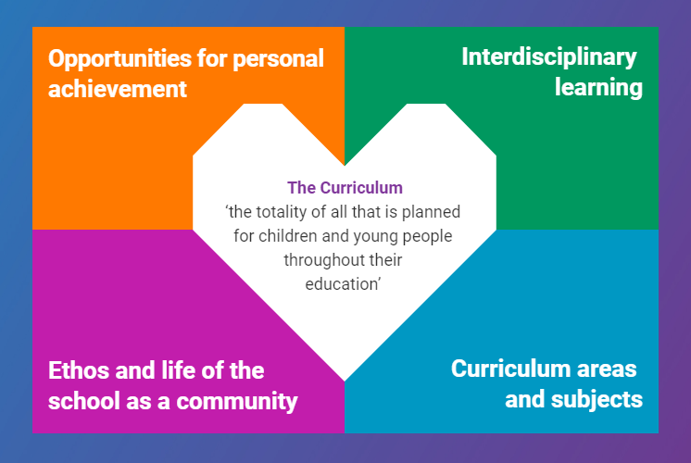
• Have specialised sessions to promote mindfulness and share experiences of positive relationships.

We engage in an annual whole school anti-bullying focus to refresh all pupils, parents and staff in our approaches and inclusive ethos. This may include anti-bullying days, anti-bullying assemblies, training for staff and information sessions for parents.

Further information is available from the following websites-
Respect Me: respectme.org.uk
Enquire – information and advice for parents: Enquire

This policy will be reviewed in session 26-27

.

