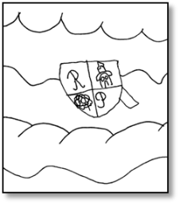

ROSEMOUNT
PRIMARY SCHOOL
HANDBOOK 2025/26

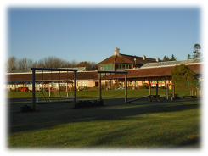

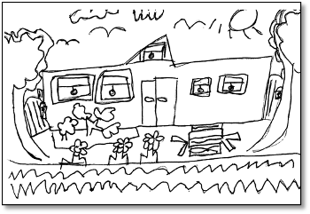

This document is available in alternative formats, on request
(Please contact the School Office)

Contents
VISITS OF PROSPECTIVE PARENTS 3
SCHOOL UNIFORM 4
PARENTAL CONCERNS 4
THE COMPLAINTS PROCEDURE 4
PARENTAL INVOLVEMENT 4
SCHOOL ETHOS 6
SCHOOL AND COMMUNITY LINKS 6
POSITIVE BEHAVIOUR MANAGEMENT 7
CELEBRATING ACHIEVEMENT 8
EXTRA-CURRICULAR ACTIVITIES 8
PUPIL COUNCIL 9
LEARNING OPPORTUNITIES 9
THE PUPILS’ AND PARENTS’ VOICE 10
THE CURRICULUM AT SCHOOL, LOCAL AND NATIONAL LEVEL 10
EARLY LEARNING AND CHILDCARE 10
LIAISON WITH SECONDARY SCHOOL 11
SCHOOL IMPROVEMENT (School Specific) 11
MAIN ACHIEVEMENTS 12
IMPROVING STANDARDS 12
SCHOOL IMPROVEMENT PLAN 12
READ, WRITE, COUNT 13
FIRST MINISTER’S READING CHALLENGE 13
PARENTZONE SCOTLAND 13
HEALTH CARE 13
DOGS IN SCHOOL GROUNDS 14
USEFUL LINKS AND CONTACT DETAILS 14
ANGUS COUNCIL WEBSITE 15
FINANCIAL ENTITLEMENT DIRECT LINKS 15
OTHER WEBSITES 15

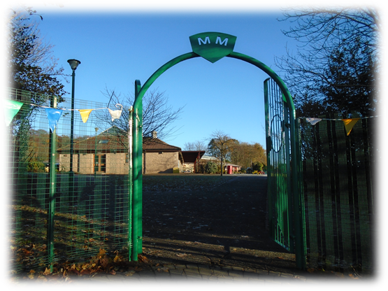
CONTACT DETAILS
Rosemount Primary School

Hospital Road, Hillside, Montrose, Angus, DD10 9JH

Telephone Number: 01674 907521

E-Mail: Rosemount@angusschools.org.uk

Website: https://blogs.glowscotland.org.uk/an/rosemount/

Head Teacher’s name: Georgina Mallie

Class Stages: Nursery and Primary 1-7

Present Roll: 197

Denominational Status (if any): N/A

The school does not teach by means of the Gaelic Language

The School Day -
Primary One to Seven

Morning Session 9.00 am to 12.30 pm

Morning Interval 10.45 am to 11.05 am

Afternoon Session 1.30 pm to 3.20 pm

VISITS OF PROSPECTIVE PARENTS

Choosing a school: a guide for parents (Scottish Government)

Prospective parents are welcome to visit us in order to see around the school and meet some of our staff. Please contact the Head Teacher to make an appointment.

Once your child has been allocated a place you will be invited along to meet the staff and children, to find out more about the curriculum and to share information about your child.

SCHOOL UNIFORM

Rosemount School Uniform


Orders for polo shirts, sweatshirts, ties, fleeces and bags are available to buy through the website https://schoolwearmadeeasy.com/collections/rosemount-primary throughout the year.

Black/grey skirts/trousers with white polo shirt and burgundy sweatshirt/cardigan

Children are required to have different footwear for outdoors.

Gym Kits

Dark shorts, light T-Shirt and indoor gym shoes advised and jogging bottoms and trainers for outdoor activities.

All clothing brought to school should be named or marked in some way, as it is difficult for children to distinguish their own clothing from others.

PARENTAL CONCERNS

Parents should contact the school immediately if they have a cause for concern. It is our wish to deal with all matters as early as possible preventing them from growing into significant concerns. Please contact your child’s class teacher in the first instance or if you would prefer to discuss the issue with a member of the management team, please contact Mrs Mallie or Mrs Davies.

The staff will listen to your concern and agree a way forward with you. They will follow-up the initial conversation with a telephone call approximately one week later to ensure all matters have been resolved satisfactorily.

THE COMPLAINTS PROCEDURE


Angus Council complaints procedure

If parents have cause for complaint, they should contact the school and make an appointment to meet the Head Teacher (Georgina Mallie), Depute Head Teacher (Jennifer Davies).

PARENTAL INVOLVEMENT
BECOMING INVOLVED IN SCHOOL

If you wish to be a regular parent helper, PVG (Protecting Vulnerable Groups) checks have to be completed. Please discuss this with Mrs Mallie.

We value the important part parents play in their children’s education. We see partnership with parents as way to enhance children’s achievements and promote better school ethos and communication.
Opportunities for Parental Involvement:

During the school day:

Helping in the nursery class
Art/Craft activities
Sharing knowledge and expertise in some aspect of the curriculum, e.g. topic talk, history, science, health
Practical activities in science, maths, social subjects, health education (e.g. first aid) or technology
Reading stories to groups of children, playing reading/phonics games
Supervising board games
Teaching playground games
Activities e.g. board games, art and craft in small groups
Running or assisting to run a lunchtime or after school club
Supporting educational visits/trips
School concerts – making costumes, props, supervision of children
Road safety – Cycle Training

Outwith the school day:

Fundraising events
Trips e.g. sporting events, concerts
Extra-curricular activities e.g. coaching, sports/art clubs/country dancing/school
Outdoor learning areas - maintenance of garden / woods areas.

Supporting Learning at Home

Parents are encouraged to be involved in home learning. Homework should be meaningful, manageable and consistent. In Rosemount all parents will receive an overview of the planned outcomes for the term in literacy, maths/numeracy, health and wellbeing and topic work. This will include any tasks linked to this learning.

What will my child have to do? Supporting your child’s learning at home can be done at any time using the termly overview. Occasionally teachers may ask for additional work to be done to extend or reinforce the learning done in school. This may not be every week and will vary from class to class. Reading should be a regular home learning activity, especially for our younger pupils who are learning to become fluent readers.

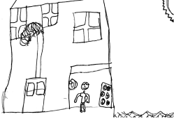
What are the benefits? This is a more flexible approach to homework which will fit around busy family life, children’s clubs and extra-curricular activities. There is reduced pressure to complete written tasks at home. Children will develop research skills and be able to talk about learning at home and at school.

Reading homework will continue to be given home to practise and for enjoyment of reading for all pupils at an appropriate level of challenge.

Improving Home-School Partnerships All parents are invited to attend Parents’ Evenings in November and March. At these meetings parents have the opportunity to meet their child’s class teacher for a 10 minute interview and hear about their child’s progress. This is also an opportunity for parents to hear how they can best support their child’s learning.

Open Mornings/Afternoons – Twice a year, parents are invited into school to view the learning and teaching at all stages of the school and to have the opportunity to see pupil’s work on display. Prior to going into the class areas, the Head Teacher provides a short presentation/workshop session which gives parents information on school developments e.g. building resilience, online/internet safety, restorative approaches, Growth Mindsets etc.

Parents may be invited to assemblies or presentations when classes have the opportunity to share their learning.

SCHOOL ETHOS
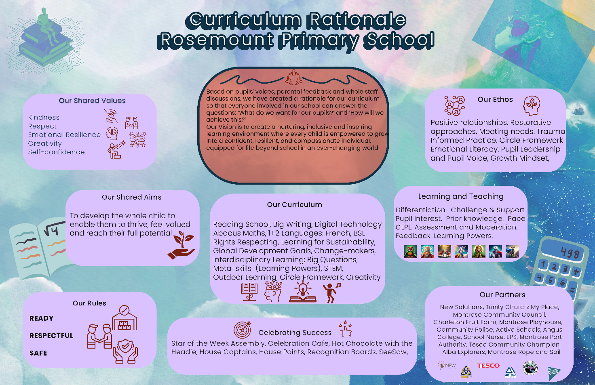

Based on parental feedback, pupils’ voices and whole staff discussions, we developed a core vision for everything we do in our school:
At Rosemount, our vision is to create a nurturing, inclusive and inspiring learning environment where every child is empowered to grow into a confident, resilient, and compassionate individual, equipped for life beyond school in an ever-changing world.

This influences all our planning, actions and relationships.
Our Values and our Aim
Our curriculum aims to develop the whole child, ensuring they grow academically, socially, and emotionally. Rooted in the four capacities of Scotland’s Curriculum for Excellence, we embed emotional resilience, kindness, respect, creativity, and self-confidence in all aspects of learning, enabling pupils to thrive, feel valued and reach their full potential.
- Successful Learners: who are curious, creative and motivated to achieve
- Confident Individuals: who believe in themselves and embrace challenges with resilience
- Responsible Citizens: who demonstrate kindness, respect and are committed to making a positive impact
- Effective Contributors: who work collaboratively, and can adapt to new situations by thinking innovatively to solve problems

We effectively achieve this by promoting the learner dispositions we value through all our activities. These ‘Learning Powers’ are integral to everything we do in school and also systematically cultivate habits and attitudes that prepares our children for life beyond school.
Our Curriculum
It is important that everyone involved in the school is clear about what it is we are trying to achieve through our curriculum. This is more than just the subjects we cover, it is the totality of everything pupils experience during their time here. To do this;
- We embrace the unique setting our school provides and enhance our learning and teaching both indoors and outside.
- Different learning styles are encouraged and celebrated by linking our Learning Powers* to everything we do.
- We understand the importance of play as part of the learning process and build in time to ensure this is meaningful.
- By considering ‘Big Questions’ we create learning opportunities which motivate and inspire
- We look at local and global issues and consider how we can make a difference through our Changemaker groups, our Right’s Respecting Schools plan and linking to Learning for Sustainability.
- We work with local businesses and organisations to establish meaningful contexts and access resources in our community.
- Pupil leadership - an intrinsic and organic element of our school's ethos, develops naturally at every stage and within diverse contexts. This child-led initiative is actively championed by staff.


SCHOOL AND COMMUNITY LINKS
We are always looking for ways to make links with the local and wider community. Here are some ways we do this:
- Junior Road Safety Officers (2 Primary 6 pupils and 2 Primary 7 and 1 member of staff) - work together to ensure our pupils are safe when out and about in the local community
- Pupil Advocacy Groups – Rosemount Changemakers
- Participation in local events and competitions such as Montrose Playhouse
- Links and partnerships with local businesses such as New Solutions, Montrose Port Authority, Alba Explorers and Montrose Community Trust.
- Support from local shops – Tesco, Lidl, Ink and Quill Bookstore
- Police and other emergency services
- School advertises events in the Hillside and Montrose community
- House of Dun and Montrose Wildlife Centre
- Links with Montrose Trinity Hillside Church and My Place
- Links with local sports clubs such as rugby, cricket and tennis etc.
- Montrose Community Council – pupil representatives on the Junior Community Council.

POSITIVE BEHAVIOUR MANAGEMENT
Angus Council anti-bullying policy
Our school rules:
- Be Ready (to learn)
- Be Respectful (of people and property)
- Be Safe

Restorative Approaches

All staff and pupils use Restorative Approaches strategies in the day-to-day interactions and relationships within schools.

These strategies enable those involved in incidents within school to be accountable for their behaviour and to be more aware of the effect it has on their relationship with others.
In situations where relationships have been damaged, (e.g. bullying, lack of respect) a problem-solving approach is taken, involving a discussion with an adult, in order to repair relationships and to try to prevent further problems. This discussion is called a Restorative Conversation/Meeting.

When there are situations in school where pupil behaviour involves clear cut rule breaking, e.g. being out of bounds in the school playground, the pupil will be given a straight forward consequence. The consequence will be decided by the class teacher and could include the loss of a privilege such as representing the school at an event. In this situation a Consequence Card is sent home to inform parents. This card should be signed by a parent and returned to school. If a pupil is involved in an incident which parents need to be told about immediately, parents will be contacted by phone.


CELEBRATING ACHIEVEMENT
- School foyer – the foyer displays a range of school and pupil achievements – certificates, trophies etc.
- In the news notice board – this is a board devoted to displaying photographs of children’s achievements that have been recorded by the ‘press’
- SeeSaw online journals provide families with a regular snapshot of pupil’s activities and learning.
- Assemblies – children’s achievements are frequently acknowledged at assemblies. Stars of the Week are awarded for those who have been using their Learning Powers. These ‘Stars’ then attend a celebration cafe to talk about their learning with the Head Teacher while enjoying a hot chocolate treat.
- Certificates – children are awarded certificates for being on different groups, contributing to the life of the school or achievements such as Bikeability Training or Swimming etc.

EXTRA-CURRICULAR ACTIVITIES
We offer a variety of extra-curricular activities for your child to participate in, these include:

Children are elected from their classes to be / representatives on:

- Pupil Leadership Groups or Change Makers – linked to Learning for Sustainability, Rights Respecting Schools, Social Enterprise and Global Development Goals
- Librarians
- Junior Road Safety Officers
- Buddies
- Sports Leaders
- House Captains and Vice House Captains

Other responsibilities that children have include:

- Monitors – P7 (lunch hall, nursery support, playground equipment)
- Young Leaders – P6 Organising playground games for younger child



Activity | Class/es | Leader
Football (boys and girls) | P5 - P7 | Parent Volunteers and Academy Sports Leaders
*Football (boys and girls) | P1 - P7 | Montrose Community Trust
Cross Country | P5 - P7 | Parent helpers
Choir | P4 - P7 | Mrs Mallie
BSL Choir | P4 and P5 | Mrs Smith
Netball | P5 - P7 | School Volunteers
Basketball | P5-7 | Montrose Academy Sports Leaders

* There is a charge for this privately run club.
For further details about Montrose Community Trust about football coaching sessions, contact (projects@montrosect.org.uk )

PUPIL COUNCIL

Our Pupil Council has been replaced by our Change Makers. This is a test of change and an opportunity for all our pupils to benefit from having their voices heard, their rights responded to and to enable them to make positive changes in their school, community and the wider world. This will be reviewed at the end of session 2025-26
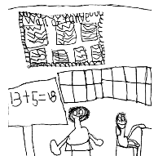

LEARNING OPPORTUNITIES
Your child will learn in a variety of different contexts and groups including ability, co-operative and social. We have beautiful grounds at Rosemount and regularly undertake outdoor learning. Personalisation and choice is one of the seven principles of curriculum design. Children and young people throughout their education will have the opportunity to discuss with their teacher the context in which they learn and how they will approach this.
Teachers will share information about your child’s learning and progress through termly overviews, class information sheets and pupil reports. Learning Journals for nursery and Seesaw for Primary classes are used to share snapshot of each child’s Learning journey. Parents are also encouraged to discuss these with their child and add comments. Open afternoons are organised to allow you to see the work your child has been involved in. You will also have the opportunity to comment on the school during these open mornings/afternoons and through parent surveys which are sent out for various reasons throughout the year.

THE PUPILS’ AND PARENTS’ VOICE

‘Personalisation and Choice’ is one of the seven principles of curriculum design and children and young people throughout their education will have the opportunity to discuss with their teacher the context in which they learn and how they will approach the learning. Staff will discuss new learning with the children at the beginning of a new topic and plan together the areas of specific focus. This will be shared with parents through the termly overview and parents will be invited to support the learning by sharing resources from home. Parents will be invited to share comment regarding the planned work for their child at various points throughout the year and are encouraged to feedback comment at any time through their child’s Seesaw profile.
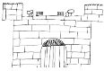

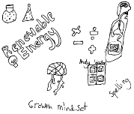

THE CURRICULUM AT SCHOOL, LOCAL AND NATIONAL LEVEL

The Curriculum for Excellence

Curriculum Areas

- Literacy/ Languages (French)
- Numeracy /Maths
- Health and Wellbeing
- Expressive Arts (Drama, Music, Dance and Art)
- Religious and Moral Education
- Science
- Social Studies
- Technologies

Curriculum Levels
From nursery to the end of S3 the levels are organised in the following three year blocks which permit depth as well as breadth of learning across the curriculum areas:

- Early = Nursery – P1
- First = P2 – P4
- Second = P5 – P7
- Third and Fourth = S1 – S3

EARLY LEARNING AND CHILDCARE
In Scotland all three and four year olds, and some two year olds, are eligible for up to 1,140 hours a year of funded early learning and childcare (ELC). Our ELC class offers sessions between 2 or 4 days a week, over 30 weeks of the year. Other attendance patterns are available in other Angus Council settings and in our wide range of partner nurseries, playgroups and child-minders. To find out more about the benefits of ELC and the options available, visit our dedicated ELC web pages at www.angus.gov.uk/earlyears.

- Our nursery is open to children aged 3-5 on Mondays – Thursdays each week for 7.5 hours per day. Children can be dropped off between 8.30am and 10am and picked up between 2.30pm and 4pm. This means we can offer flexibility to suit individual families. Children must attend between 10am and 2.30pm as a minimum.

Children are provided with a morning and afternoon snack as well as lunch.
Applications for places are online. Please go to:
https://www.angus.gov.uk/schools_and_young_people/early_learning_and_childcare/nursery_playgroups_and_childcare_ages_three_and_four

LIAISON WITH SECONDARY SCHOOL
Rosemount prides itself in its transition activities which support both academic and pastoral aspects of the curriculum. Staff liaise closely with colleagues in school as well as other cluster colleagues or staff from other settings to allow for smooth transitions. Parents/carers are invited to attend transition meetings held here or indeed at Montrose Academy. Visits are carefully arranged for our senior pupils moving on to secondary education.

Enhanced transition arrangements with Montrose Academy provide appropriate support for pupils both at group and individual levels in Primary 7. Parents and other agencies are closely involved in this process. Consultation opportunities are arranged for staff to discuss transition arrangements.

At the end of June, P7 profiles are forwarded on to Montrose Academy. Pupils transfer to Secondary School in August following completion of their P7 year.

For pupils who have an Individual Educational Programme due to specific learning or social needs a special plan for transition is produced. This plan is agreed by parents and pupils at a meeting with the Head Teacher and a member of the Academy’s Additional Support Needs team. This meeting takes place in the summer term.

The children’s academic and social welfare is at the heart of all we do here at Rosemount.

SCHOOL IMPROVEMENT (School Specific)

MAIN ACHIEVEMENTS
The school Newsletters, Groupcall and Seesaw messages and Website keeps everyone up-to-date with current school news and achievements. This session our main achievements included:
- A revised planning format for almost all curricular areas has been created by a short life working group and has been agreed by all staff to be implemented from August. This will provide consistency and continuity across all stages.
- Our work on creating a revised assessment policy has been delayed but will be continued into next session.
- Clear guidance and policy for key worker groups in ELCC has been agreed and successfully implemented by all early years staff.
- Circle Framework training has been completed by almost all teaching staff and implemented in classrooms to identify and support needs.
- “The Den” has been created in the former nursery to become a safe space for pupils to access when in need of alternative provision.
- Our newly refreshed Vision, Values and Aims has been developed with input from all stakeholders to align all our aspirations with our curriculum rationale.
- Almost all staff engaged with the Explicitly Teaching Writing training to explore and improve the ways we are teaching writing.
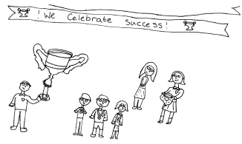

Further information can be found in the School Standard and Quality Report 2024/2025 which can be obtained from the school office or on our website.

IMPROVING STANDARDS
We improve our standards by:
· being reflective practitioners, we evaluate using How Good is Our School4 quality indicators. We decide where we are in our school development and what we have to do to improve.
· holding learning walks and visits where there is a focus set by staff and the SLT joins lessons which are discussed with staff afterwards.
· involving pupils in setting learning targets and also in assessing their work against given success criteria and then identifying their next steps for improving learning.
· seeking feedback, views and contributions from pupils, parents and staff.
· being aware of the importance of pupil wellbeing and strive to make our school an inclusive environment for all.
· using pathways for learning for all levels of the curriculum and our staff use these to inform their planning.
· using National Benchmarks by staff as a tool for planning and assessment and they help us ensure there is moderation within a curriculum level.
· use various opportunities to build on our learner’s knowledge of Children’s Rights as we work towards our Silver Award.

SCHOOL IMPROVEMENT PLAN
In session 2025/26, we are aiming to work on the following:
- Continue to gather evidence of our work to support silver accreditation of RRS and Reading Schools before the end of our 25th jubilee year.
- Undertake audit of resources, skills and pathways within our technologies curriculum plan and consider how to improve this.
- Revisit our positive Relationships policy to ensure alignment with our refreshed vision, values and aims and embed the SHANARRI wellbeing indicators within it.
- ·Consider how we plan, teach and assess listening and talking within our literacy pathways and plan for improvements in these processes.
- Continue to develop the processes around the changemaker groups by introducing more robust evaluative measures – pre and post activity, feedback from community partners and impact statements linked
to GDGs and UNCRC articles



HEALTH CARE

Our school nurse is Christina Forge. You can contact her at Links Health Centre:
Tel: 01674 675115.

DOGS IN SCHOOL GROUNDS
We understand walking your child(ren) to and from school/nursery is an ideal opportunity to walk dogs. However, the safety and wellbeing of our pupils, families, staff and community is paramount. Also, some children feel intimidated or unsure of dogs.
So, please ensure dogs (except for assistance dogs) are not brought into school grounds.
And if you are walking your dog to and from school, please remain at a reasonable distance from the school gate.
This will enable children and adults to enter and exit safely.
We'd ask you to pass this information on to other adults who bring and/or collect your child(ren) from school.
Child Protection Coordinator
If we think a child has come to harm as a consequence of possible abuse, we need to report it.
At least one member of staff in each school is responsible for child protection matters. They will have had special training in this area.
In our school the Child Protection Coordinator(s) are: Georgina Mallie and Jen Davies.
If you want to know more about child protection and the safety of children, contact the school. There is also information about child protection on the Angus Council website.
As a school we have good contacts with health professionals, social workers and the police. Any or all of them may offer support, or become involved, if concerns of abuse arise.

USEFUL LINKS AND CONTACT DETAILS
Angus Council
Angus House
Orchardbank Business Park
FORFAR
DD8 1AN
Tel: 03452 777 778
Email: ACCESSSchoolsLearnBSU@angus.gov.uk

ANGUS COUNCIL WEBSITE
Visit angus.gov.uk/schools for information that applies to schools across Angus on topics including:
- holidays
- meals
- school payments
- attendance and absence
- assessment and reporting
- transport
- drugs education
- religious and moral education
- transitions
- …and more

FINANCIAL ENTITLEMENT DIRECT LINKS
- Free School Meals and Clothing Grant
- EMA (Secondary Schools)
- Welfare Rights/Benefit Calculator

OTHER WEBSITES
Find useful links to other websites at angus.gov.uk/linksforparents
Find useful links on Parent Club such as Book Bug, Read Write Count and more.

