**Rosemount Primary School**

**Travel Plan**



**Rosemount Primary School**

**Hospital Road**

**Hillside**

**Montrose DD10 9JH**

**Tel: 01674 907521**

**E:** [**rosemount@angusschools.org.uk**](mailto:rosemount@angusschools.org.uk)

**Web:** [**https://blogs.glowscotland.org.uk/an/rosemount/**](https://blogs.glowscotland.org.uk/an/rosemount/)

**CONTENTS**

Introduction ………………………………….. P3

Aims …………………………………………… P4

School Description …………………………. P5

Car Parking ………………………………….. P6

Walking to School …………………………. P7

Park and Stride …………………………….. P7

Cycling and Scootering …………………. P7

Pupil Travel Data …………………………. P9

JRSOs ……………………………………….. P9

Targets for 24 - 27 ………………………….. P10

# Introduction

This is the Rosemount Primary School 2025 travel plan. A travel plan is a document which encourages people to travel to our school in a sustainable, healthy and safe way.

We hope to move the school community away from private car trips to and from school, towards more sustainable modes of travel such as walking, cycling and public transport.

As it involves the whole school community - pupils, teachers, parent council and parents. It should become integrated into the life and ethos of the school.

|  |
| --- |
| Our Aims  * To improve safety around the school gates and entrances * To improve the safety of our journeys to and from school * To promote road safety for everyone in our community * To encourage pupils and staff to walk, cycle or park and stride to school where appropriate * To decrease the amount of traffic within the school environment and surrounding area * To discourage dangerous and inconsiderate parking and reduce congestion outside the school gates   We need to all work together to keep our children safe. |

## School Description

We are situated in the village of Hillside on the northern outskirts of Montrose. Our school and nursery has 193 pupils and 23 members of staff.

Our catchment area extends from Craigo to Dun and the edge of Montrose. We also have 23% of our pupils who travel from outside this catchment area.

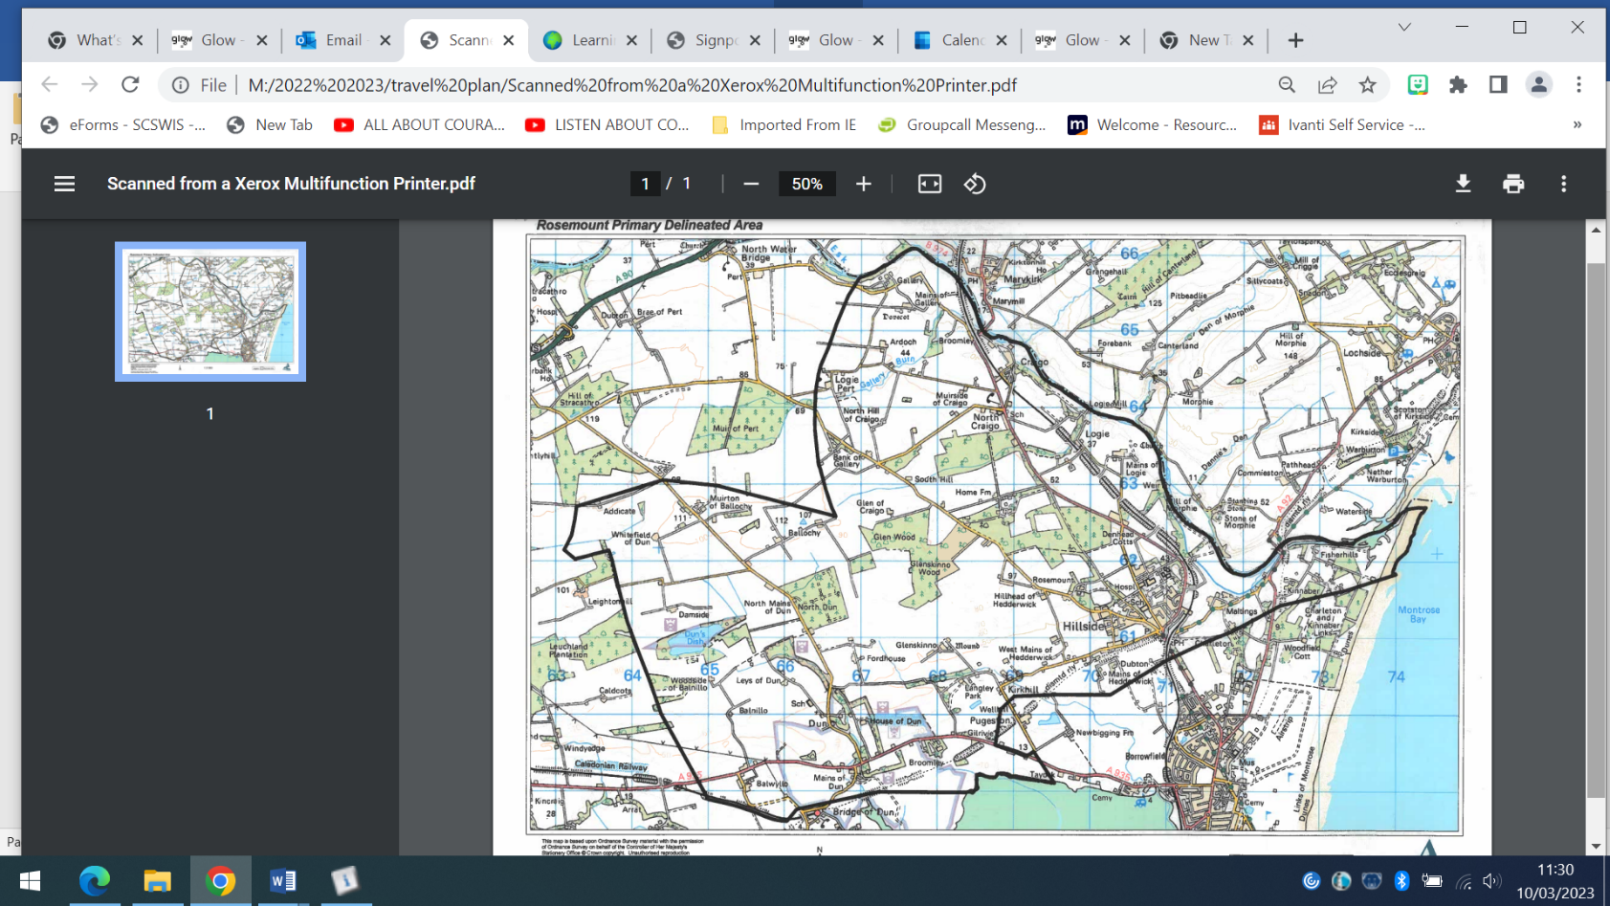

## Our Car Parking

The school car park is designated for use by staff and visitors to the school. There is also a small area designated for nursery parents (8 bays).

Parents may use any free spaces to park in the visitors section however, pupils must be met or taken to the gates and should not walk across the carpark alone.

There is very limited parking in the lay-bys on Hospital Road and Rosemount Road so parents looking for somewhere near the school entrances must be mindful of parking respectfully and safely:

* Away from the yellow zig-zags
* Avoiding residential driveways
* Allowing our school buses to be able to maneuver safely
* Remember it is **illegal** to park within 10m of a roundabout as well as very unsafe

## Walking to School

Rosemount Primary encourages pupils to walk to school to help the environment and encourage a healthy lifestyle.

Pupils walking to and from school are expected to behave in a responsible manner and should remember that their behaviour, both good and bad, reflects on the school.

Pupils should cross at safe crossing points whether this is a controlled crossing or with a school crossing patroller. At all times they must use the road safety rules.

Our school crossing patroller is located at the bottom of Main Road next to the bus stop.

## Park and Stride

Park and stride is a great way for pupils to improve their fitness, lessen traffic around the school and make the school entrances safer. If pupils are driven to school, finding a convenient drop off point near by the school and allowing pupils to walk the rest of the way is actively encouraged.

## Cycling and Scootering

Pupils are encouraged to cycle or scooter to school if appropriate. Anyone wishing to do so should get a **cycle permit** from the school. This explains the roles and responsibilities and helps ensure the safety of the child and their bicycle.

Bikes or scooters can be safely stored in the shelter that is situated in the back playground. Pupils should not ride their bike or scooter within the school playground.

## Pupil Travel Data

This shows how pupils travelled to school in September 2024

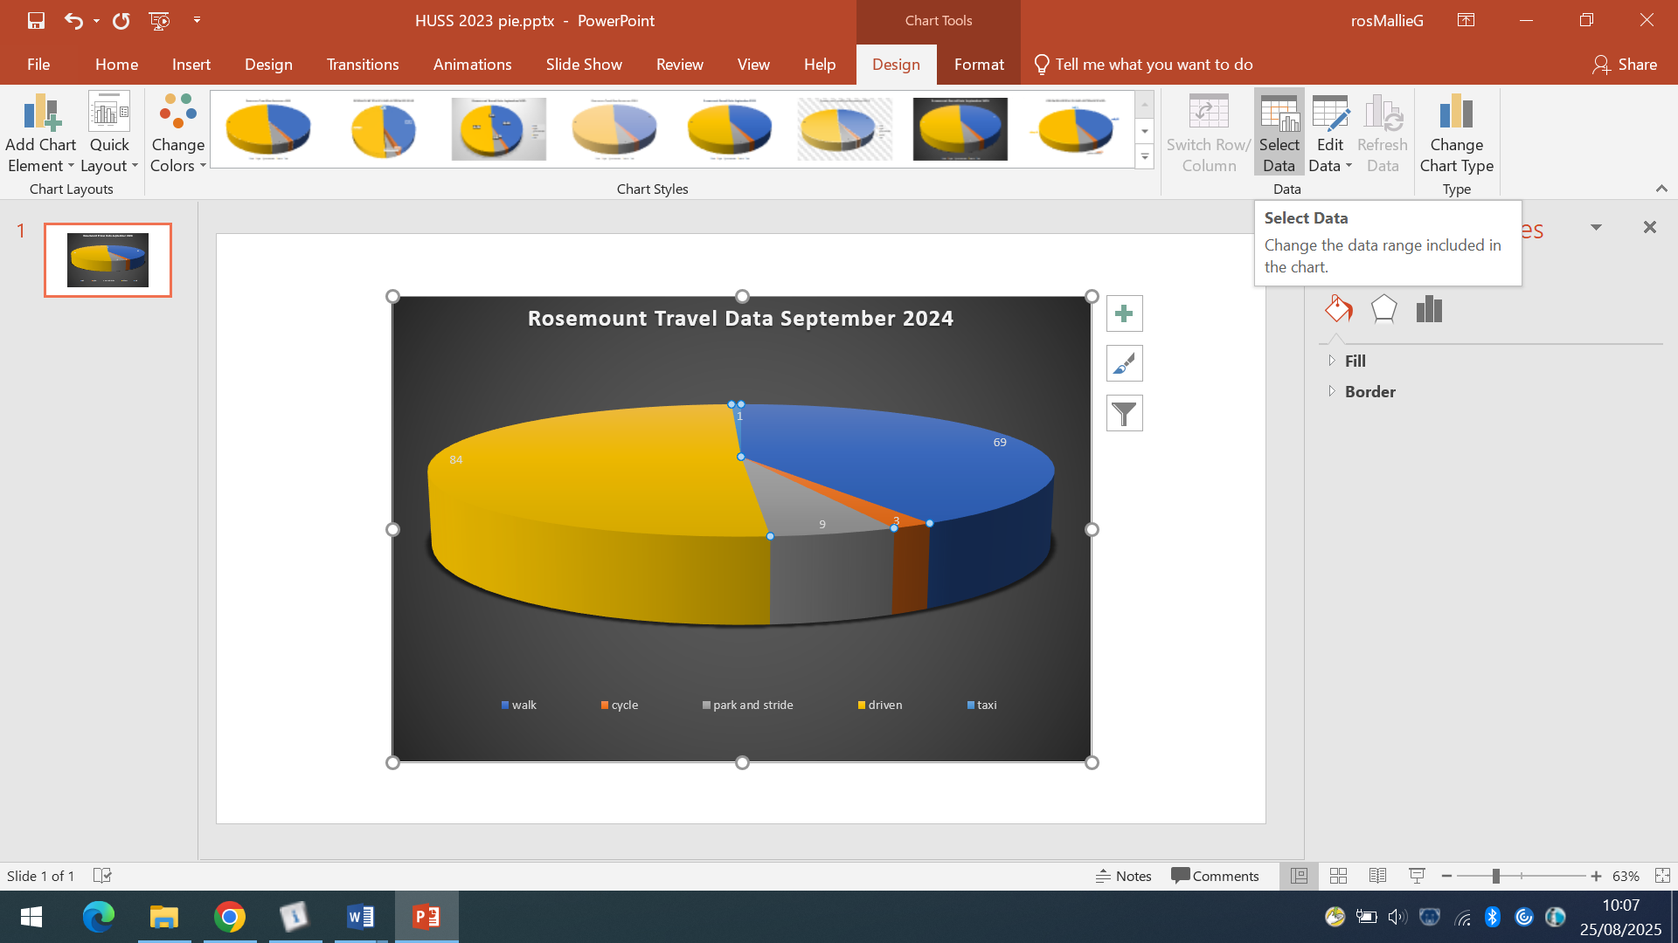

**JRSOs**

We have two P6 and two P7 children who are currently elected as Junior Road Safety Officers. It is their job to identify problems surrounding the school and bring them to the attention of other pupils through school assemblies.

**Targets for 2024-2027:**

* Continue to promote ways to travel to school in an active and sustainable way.
* Encourage the use of Park and Stride by identifying and sharing safe drop off points near to the school.
* JRSOs to raise the profile of road safety by presenting at assemblies and running competitions.
* Liaise with community police officers with regards to traffic safety and “pop up bairns”.
* Investigate potential of school sign to advertise ways to travel safely and the benefits.

This travel plan will be reviewed and updated in August 2027