

Rosemount Primary School and Nursery
Policy, Procedures and Protocols

Medical
- Administration of Medicines
- First Aid
- Contagion
- Asthma

Last Review- March 2023 Next Review- June 2024

Contents

Page 2 - Contents
Page 3 - Administration of Medicines and Review
Page 4 - Accidents and Emergencies – Minor Injuries and Head Bumps
Page 5 - Emergency Treatment
Page 6 - Asthma Treatment and Emergency Procedures
Page 7 - Suspected Contagious Ailment
Page 8 – Appendices

Administration of Medicines (from School Handbook)

(This policy does not cover specific first aid or CPR steps or sequences. Refer to training materials, skills learned, and/or directions on prescribed medications for specific guidance on treatment procedures.)

Many pupils will, at some time in their school careers, need to take medication. For the vast majority this will be a short-term requirement, with pupils simply finishing a course of medication which has been prescribed for them by their family doctor. Wherever possible parents are requested to ask for GP prescriptions which can be administered out with the school day, i.e. in the morning and evening.

However, pupils may have medical conditions such as asthma or diabetes which may require long-term support and, if their conditions are not properly managed by taking regular medication in school, their access to education could be limited. In addition, some children have conditions which may require occasional staff intervention e.g. severe allergic conditions such as anaphylaxis. Pupils with such conditions are regarded as having health care needs but, notwithstanding these, the vast majority of children with such needs are able to attend school regularly and, with some support from the school staff, are able to take part in most normal school activities.

In any of these circumstances parents (or young people themselves if they are over the age of 16) should discuss the matter with school staff and agree the arrangements which will be made to provide support for the pupil. A written
Request Form (Appendix 1a – short term) or (Appendix 1b - routine) must be completed in advance (available from school office) when any medication is to be administered or taken in school.

Administration of medication will be recorded on the Administration of Medication Record Form (Appendix 2)

Review Process:
All long term medications will be reviewed termly. A discussion with parents will take place and the medication review form (appendix 9) completed and signed by parents and the reviewing staff member.
Administration of Medicine

Any member of staff giving medicine to a pupil should on each occasion check and record:

1. The pupil’s name
2. Written instructions provided by parents or doctor
3. Prescribed dose
4. Dose frequency
5. Expiry date
6. Any additional or cautionary labels

If in doubt about any of the procedures the member of staff should check with HT, the parents or a health professional before taking further action.

Short term medication should be returned to parents on the last day of agreed administration. If parents are unsure of the end date a two week review will be automatically added to the form. Administration forms should be marked no longer required and placed in the red folder when the course of medication is complete.

Accidents and Emergencies

Minor Injuries
Within a school and nursery environment it is expected that children will on occasion require general first aid for minor injuries e.g. cuts, grazes, bruising, bumps etc. Any minor injuries will be attended to in school/nursery by trained first aiders see First Aider List (Appendix 3). Parents/carers will be notified by letter of any treatment given or injury received through the First Aid Note (Appendix 4). Treatment of an injury will be recorded in school in the Accident Record (First Aid Room) & Nursery Accident Record Sheet for nursery (Appendix 5)
Minor Injuries Procedures

Any member of staff discovering a minor injury should:

- Reassure the child and clarify the extent of injury(ies)
- Notify a trained first aider without leaving the child e.g. send other children or escort into building if another adult is present in the playground
- First aider follows first aid procedures as indicated by the nature of the accident and their training
- Parents notified of injury and treatment through First Aid Note/Phone call
- Consideration of notifying parents by phone (as well as First Aid Note discussed with HT if e.g. obvious injury, damage to property etc.)
- Staff witnessing the accident and/or providing first aid care should complete the First Aid Note and Accident record, these are available in the first aid folder in both school and nursery.

If in doubt about any of the procedures the member of staff should check with First Aider, HT, the parents or a health professional before taking further action.

Head Injuries and more Serious Injuries
Some more serious injuries including head injuries will also require more detailed treatment and information which will be delivered to parents/carers in a written format through a Minor Head Injury Form (Appendix 6) which will provide details of injury, treatment and possible further symptoms e.g. concussion. Any injury which requires monitoring should also be shared with parents/carers by phone with the decision to seek further treatment from medical professionals being given to parents/carers.
Head Injuries and more Serious Injuries Procedures

Any member of staff discovering a head or more serious injury should:

- Reassure the child and clarify the extent of injury(ies)
- Decide whether the child should remain still whilst awaiting first aid
- Notify a trained first aider without leaving the child e.g. send other children, walkie-talkie or escort into building if another adult is present in the playground and it is deemed safe to do so
- First aider follows first aid procedures as indicated by the nature of the accident and their training
- Parents notified of injury and treatment through Minor Head Injury Form and a phone call to emergency contact number(s)
- Staff witnessing the accident and/or providing first aid care should complete the Minor Head Injury Form and Accident record, these are available in the first aid room and Nursery Folder.
- PLEASE ENSURE THAT A PHONE CALL IS MADE TO ALERT PARENTS/CARERS TO POSSIBLE COMPLICATIONS
If in doubt about any of the procedures the member of staff should check with First Aider, HT, the parents or a health professional before taking further action.

Emergency Treatment
In the event of an accident or medical condition requiring immediate emergency treatment, the school will arrange for this promptly, either through the local Health Centre or nearest Accident and Emergency Dept. or in extreme circumstances by paramedic. Parents will be informed of such treatment as soon as possible through emergency contact details.

Emergency Treatment Procedures

Any member of staff discovering an injury/ailment that requires Emergency Treatment should:

- Call for support from another adult immediately
- Decide promptly whether Emergency Services need to be called
- Reassure the child and clarify the extent of injury(ies)
- Notify a trained first aider without leaving the child e.g. send other children, walkie-talkie or escort into building if another adult is present in the playground and it is deemed safe to do so
- First aider follows first aid procedures as indicated by the nature of the accident/ailment and their training
- Parents notified of injury/ailment and treatment as soon as possible through emergency contact number(s)
- Staff witnessing the accident and/or providing first aid care should complete the First Aid Note or Minor Head Injury Form and Accident record (this should be done after the person receives treatment), these are available in the school office.
- After the event and through the HT, staff will complete an Accident/Incident Form (available on Angus intranet front page)

If in doubt about any of the procedures the member of staff should check with First Aider, HT, the parents or a health professional before taking further action.

All accidents (and near miss incidents) requiring the child to leave the school or be treated by a medical professional should be recorded on and Accident/Incident Form via the link: https://app.uk.sheassure.net/EastScot/p/Angus

Asthma Treatment and Emergency Procedures
On average in the UK two children in every class may have asthma (NHS 2015), with treatment being necessary to prevent and stop asthma attacks for most of these children within their school life. Asthma is a life threatening condition and training will be given to staff regularly to help prevent and deal with difficulties.

All children (and adults) with asthma should have this recorded on their personal record and have asthma/inhaler protocols in place in school, along with a current in date inhaler. Inhalers should be kept in the class Inhaler/Fire Register container. Older children may be in charge of their own inhaler, if agreed with parents/carers through the written protocol (it is best to have a spare in school). The inhaler box and older children’s personal inhalers must go everywhere with the child (or be promptly accessible) e.g. PE, outdoor learning, school trips, playtimes etc.

The following procedures are taken from NHS training for schools 2017. See (Appendix 7) for full training slides. They advise that if any person treating a suspected asthma attack has any doubt, then contact emergency services on 999.
Asthma Treatment and Emergency Procedures

Any member of staff discovering a person with asthma difficulties should:
• keep calm – DO NOT PANIC
• call for another adult and notify a trained first aider without leaving the child e.g. send other children, walkie-talkie etc.
• encourage the child or young person to sit up and slightly forward – do not hug or lie them down
• make sure the child or young person takes two puffs of reliever inhaler (usually blue) immediately (preferably through a spacer)
• ensure tight clothing is loosened
• reassure the child

If there is no immediate improvement
- Continue to make sure the child or young person takes one puff of reliever inhaler every minute for five minutes or until their symptoms improve
- Call 999 or a doctor urgently if:
- you have any doubts about the child’s condition
- the child or young person’s symptoms do not improve in 5–10 minutes
- the child or young person is too breathless or exhausted to talk
- the child or young person’s lips are blue
Ensure the child takes one puff of their reliever inhaler every minute until the ambulance or doctor arrives (do not worry about overdosing).

- Parents notified of injury/ailment and treatment as soon as possible through emergency contact number(s)
- Staff witnessing the incident and/or providing first aid care should complete the First Aid Note/Accident Record
- After the event and through the HT, staff will complete an Accident/Incident Form (available on Angus intranet front page)

Important things to remember:

- Never leave a pupil having an asthma attack
- Call 999 urgently if you have any doubts about the child’s condition
- If the pupil does not have their inhaler and/or spacer with them, send another teacher or pupil to their classroom or assigned room to get their spare inhaler and/or spacer
- In an emergency situation school staff are required under common law, duty of care, to act like any reasonably prudent parent
- Reliever medicine is very safe. During an asthma attack do not worry about a pupil overdosing
- Send another pupil to get another teacher/adult if an ambulance needs to be called
- Contact the pupil’s parents or carers immediately after calling the ambulance/doctor
Suspected Contagious Ailment
If a child/ren are suspected of having a contagious condition or if an epidemic is suspected, authority guidance on school attendance should be followed (Appendix 8). Management should be notified and they will organise contact with the parents/carers to discuss the situation. Please note that specific medical conditions (suspected or otherwise) should not be discussed with anybody other than a child’s immediate authorised family. If other agencies or individuals need to be made aware of potential threats, this will be undertaken by the HT. For the NURSERY this would include notification to the Care Inspectorate and Health Agencies.

Suspected Contagious Ailment Procedures

Any member of staff discovering a suspected contagious ailment should:

- Inform the HT and First Aider immediately and discretely through card system, walkie talkie etc.
- All efforts to maintain confidentiality should be taken
- HT/First Aider follows authority guidance and procedures as indicated by the nature of the suspected condition
- Parents contacted to discuss concerns immediately through a phone call to emergency contact number(s)
- Parents/carers advised of suspected condition and authority guidance on school/nursery attendance times
- Consideration given for vulnerable individuals with conditions e.g. low immunity, pregnancy
- All possible/recommended counter measures applied to limit exposure whilst maintaining dignity/rights

If in doubt about any of the procedures the member of staff should check with HT, the parents or a health professional before taking further action.

Further details and guidance can be found in the school’s Risk Assessment Folder, Emergency Action Folder and Continuity Plan.

Appendices

Appendix 1a – Administration of Medication Request Form (short term)

Appendix 1b – Administration of Medication Request Form (routine)

Appendix 2 – Administration of Medication Record Form

Appendix 3 - First Aider List

Appendix 4 – First Aid Note

Appendix 5 – Nursery Accident Record Sheet

Appendix 6 – Minor Head Injury Form

Appendix 7 – Asthma Training for Schools NHS

Appendix 8 - Guidance on Epidemics and Contagious Conditions

Appendix 9 – Medication Review Form

Appendix 1a – Administration of Medication Request Form (short term)

 | FORM TO BE COMPLETED BY PARENTS WHO WISH SCHOOL STAFF TO ADMINISTER MEDICATION | APPENDIX 1(from Authority Guidance)

The school will not give your child medicine unless you complete and sign this form and the Head Teacher has agreed that school staff can administer the medicine.

School
Pupil’s full Name
Address
 |  | post code
Date of Birth |  | Male □ Female □
Condition or illness
Name / type of medication
(as described on the container)

For how long will your child take this medication?
Date dispensed
Dosage and method
Full directions for use and timing(s)

Special precautions
Possible side effects

Procedures to take in an emergency

First Dose administered by parents? Yes No

CONTACT INFORMATION
Family contact 1
Name
Phone no | (home) | (work)
Relationship

CONTACT INFORMATION
Family contact 2
Name
Phone no | (home) | (work)
Relationship

I understand that I must deliver the medicine personally to …………………………………… and accept that the requested administration is a service which the school is not obliged to provide.

Signature(s).………………………………………………………….
……………………………………………………………………………….
Date ……………………………………………………………………….

Current advice from the Scottish Executive recommends that pupils should also sign up, wherever appropriate, to this type of request. Although this is not an absolute requirement, parents may wish to involve their child in the process.

Signature of pupil ……………………………………………………….

Date ……………………………………………………….

Appendix 1b – Administration of Medication Request Form (routine)

 | PROTOCOL FOR  ROUTINE ADMINISTRATION  OF PRESCRIBED MEDICATION IN SCHOOL | APPENDIX 3 (from Authority Guidance)

School
Pupil’s Name
Address
post code
Date of Birth
Condition or illness

CONTACT INFORMATION
Family contact 1
Name
Phone no | (home) | (work)
Relationship

CONTACT INFORMATION
Family contact 2
Name
Phone no | (home) | (work)
Relationship

Name of GP
Phone no
Clinic / Hospital contact
Plan prepared by |  | Date
Distribution | GP  | School Health Service 
 | Parent  | other 

Medication is kept
Medication expiry date
(to be updated as appropriate)

1 BACKGROUND

  - ……………... is prescribed ……..………..by his/her GP/medical specialist and it has been agreed that … dose/s will be administered during the school day at …………… (time/s).

The medication is prescribed in the form of …………… and one dosage consists of ……………………..

  - The arrangements set out below are intended to assist …………………..., his/her parents and the school in achieving the least possible disruption to his/her education, but also to make appropriate provision for his/her medical requirements.
First Dose administered by parents? Yes No

2 DETAILS

2.1 The head teacher will arrange for appropriate staff in the school to be briefed about …………..…’s medication and about other arrangements contained in this document.

2.2 The school staff will take all reasonable steps to ensure that ………………. receives the medication at the appropriate point/s in the school day.

2.3 If there are any proposals which mean that …………….. may leave the school site on an educational excursion, prior discussions will be held between the school and …………’s parents in order to agree appropriate administration and safe handling of his/her medication.

2.4 The school will hold, under secure and appropriate conditions, prescribed medication showing an expiry date, clearly marked with the pupil’s name and for use by designated school staff or qualified personnel.

2.5 The parent/carer accepts responsibility for maintaining an appropriate supply of up-to-date medication in the school and for its safe delivery to school staff either personally or by another responsible adult.

2.6 The parent/carer accepts responsibility for advising school staff in writing of any changes made by the GP/medical specialist to the agreed medication.

3 IDENTIFICATION OF POSSIBLE PROBLEMS

3.1 In the event of any dosage being missed or omitted for any reason staff will note details on the record of medication form kept by the school and inform the Head Teacher of the circumstances.

3.2 In the event that significant side effects may arise as a result of administration of the medication, staff will be made aware of these and of what to do by the prescribing GP/medical specialist. Details of possible side effects are recorded below:-

Description of possible side effect or reaction | What to do in this case

STAFF INDEMNITY

The Council fully indemnifies its staff against claims for alleged negligence, providing they are acting within the scope of their employment, have been provided with adequate training and are following the Education Authority’s guidelines. For the purposes of indemnity, the administration of medicines falls within this definition and staff can be reassured about the protection provided by the Council. The indemnity covers the consequences that might arise where an incorrect dose is inadvertently given or where the administration is overlooked. In practice, indemnity means the Council and not the employee will meet the cost of damages should a claim for alleged negligence be successful. It is very rare for school staff to be sued for negligence and instead the action will usually be between the parent and employer.

AGREEMENT AND CONCLUSION

A copy of these notes will be held by the school and the parent/carer. A copy will be sent to the relevant School Health Office, the prescribing GP or medical specialist and the Education Authority for information.

Any necessary revisions will be the subject of further discussions between the school and the parents. Any changes in routine will be noted and circulated.

AGREED AND SIGNED

On behalf of the school

................................................ Head Teacher ................................. date

Parent(s)/Guardian(s) of ..............................................

................................................ ................................. date

................................................ ................................. date

On behalf of the Education Client Department

................................................ ................................. date

................................................ ................................. date

APPENDIX 8 (from Authority Guidance)
Appendix 2 – Administration of Medication Record Form

Form for schools to record details of medication given to pupils

Date | Pupil’s  Name | Time | Name of  Medication | Dose given | Dose missed/  reason | Any reactions | Signature  of Staff | Print Name


Appendix 3 - First Aider List
Rosemount Primary/Nursery First Aider List

Name of First Aider | Role/Position in School | Training Level | Expiry Date
Appendix 4 - Rosemount First Aid Note

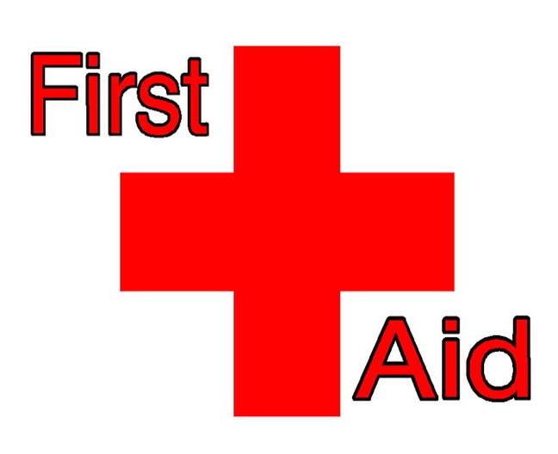
First Aid Note

Pupil Name_________________________ Signed by First Aider – _____________________

Date, time and nature of Incident ________________________________________________________
_____________________________________________________________________________________
_____________________________________________________________________________________

Treatment given – Injury Cleaned Y/N Ice Pack Y/N Dressing Applied Y/N

Other Notes –__________________________________________________________________________

First Aid Note

Pupil Name_________________________ Signed by First Aider – _____________________

Date, time and nature of Incident ________________________________________________________
_____________________________________________________________________________________
_____________________________________________________________________________________

Treatment given – Injury Cleaned Y/N Ice Pack Y/N Dressing Applied Y/N

Other Notes –__________________________________________________________________________

First Aid Note

Pupil Name_________________________ Signed by First Aider – _____________________

Date, time and nature of Incident ________________________________________________________
_____________________________________________________________________________________
_____________________________________________________________________________________

Treatment given – Injury Cleaned Y/N Ice Pack Y/N Dressing Applied Y/N

Other Notes –_________________________________________________________________________


Appendix 5 – Nursery Accident Record Sheet

Rosemount Nursery – Accident Record Sheet

Child’s Name
Accident Date and Time:

Details of Accident:

Treatment given:

Action Taken:

Signed:
Staff ______________________ Parent/Carer _______________________

Child’s Name
Accident Date and Time:

Details of Accident:

Treatment given:

Action Taken:

Signed:
Staff ______________________ Parent/Carer _______________________

Appendix 6 - Minor Head Injury Form


Date:
Name:
Class:
Incident: …………………………………………………………………..
………………………………………………………………….
………………………………………………………………….

Dear Parent/Carer

It is the policy of Rosemount Primary School to inform Parent/Carers when a child has sustained an injury to the head.

The bump to the head was treated at the time, and was not deemed to require any further treatment or investigation.

Head injuries can often appear harmless at the time of the incident however, they may gradually get worse over the next few hours and days.

This note is to alert you of the bump your child received to the head, and to inform you to the possible symptoms of a worsening condition.

Should your child suffer from the following symptoms, please seek medical advice:
- Drowsiness when the child would normally be wide awake
- Worsening headache – which does not go away with paracetamol
- Confusion, strange behaviour, any problems understanding or speaking
- Vomiting
- Loss of use of part of the body – e.g. weakness in an arm or leg
- Dizziness, loss of balance or walking strangely
- Fitting (convulsions) or collapse
- Any visual problems, such as blurring of vision or double vision
- Blood or clear fluid leaking form the nose or ear
- New deafness in one or both ears
- Unusual breathing patterns

For any further information, please contact NHS 24 Scotland on (Telephone No: 111) or on their website (www.nhs24.scot)

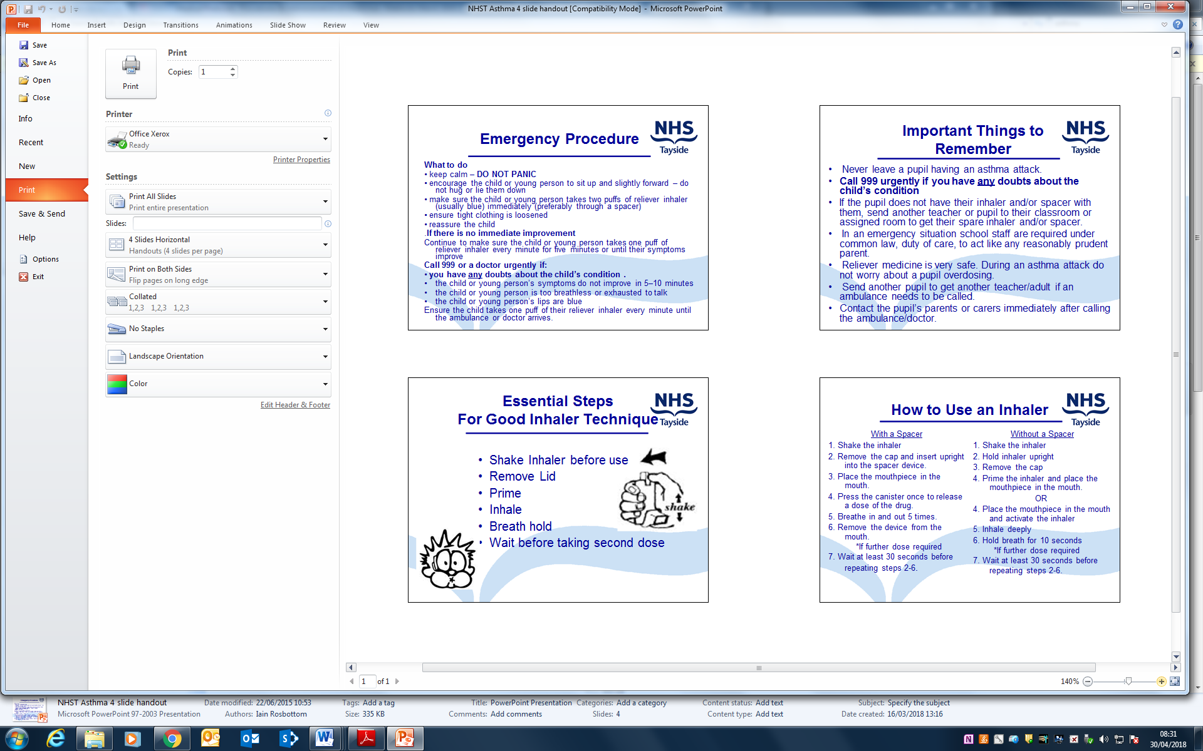
Appendix 7 - Asthma Training for Schools NHS

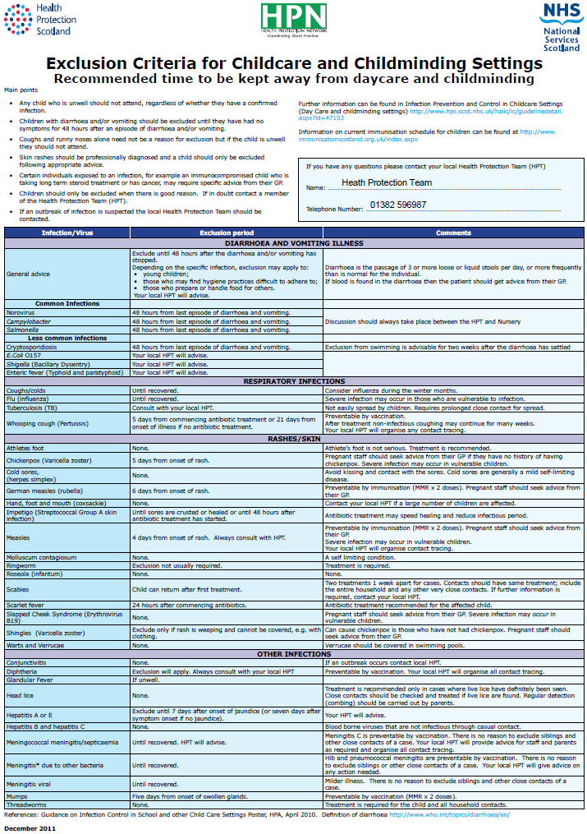
Appendix 8 -Guidance on Epidemics and Contagious Conditions

