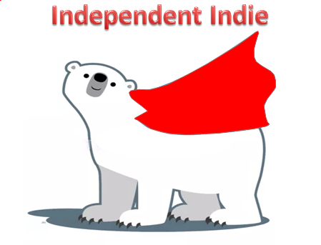 | I always like to check with someone before starting a task. I don’t like doing things on my own in case I make a mistake. | I can work independently on tasks I am confident with. When there are things I’m not so sure of I still like to ask someone rather than have a go myself. | I am aware of the strategies I can use if I don’t know how to do something and I will use these first before I ask for support. I enjoy being independent and doing things for myself. | I will always complete tasks on my own before asking for support. I use a number of strategies to help me if I get stuck.
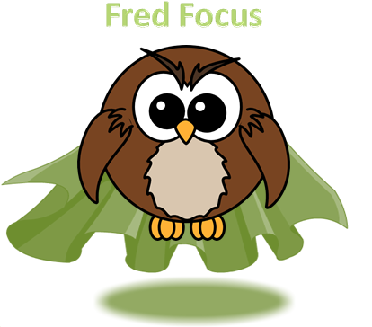 | I cannot concentrate when other things are going on round about me | I can concentrate for short periods of time but need regular reminders to stay on task | I am usually able to complete a task despite other activities going on nearby. | I am able to manage all distractions and focus on the task I am doing
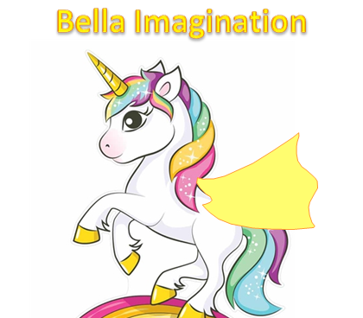 | I don’t really understand what being creative means. | I sometimes have good ideas but prefer to use the ideas of others. | I can use my imagination to come up with good ideas. I can make connections and learn from mistakes. | I am able to solve problems in new and imaginative ways. I can change my perspective. I can break with routine and do something different.
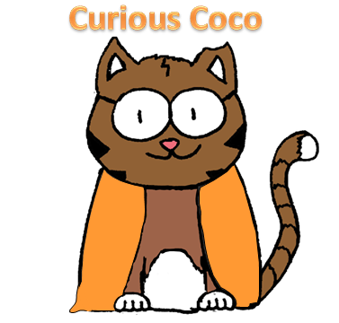 | I am not sure what it means to be curious | There are times when I am curious and want to know more. I don’t always follow this through into action | I am often curious and know what to do if I want to find out more. I like to learn new things | I am always curious about the world around me and enjoy learning. I ask lots of questions and regularly do my own research to find things out.
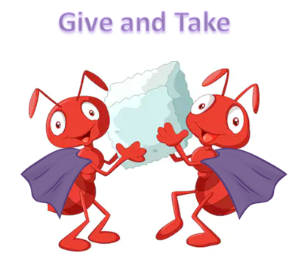 | I don’t like working with others and find it difficult when I’m not in control | I can work with others but still need to get better at things like taking turns, listening and compromising. | I enjoy working with others and am able to take turns and share. I understand the importance of listening and compromise. | Even when others are difficult, I am able to work cooperatively and use a variety of strategies to get to our end goal.
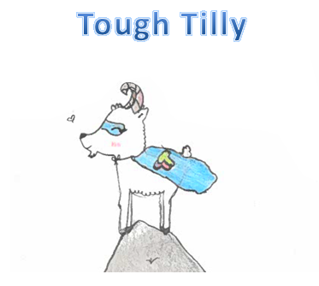 | If things are too tricky I will probably give up. I can find it hard to recover from setbacks | I am able to show perseverance with tasks that are a little tricky and can motivate myself to keep going for a period of time. I can sometimes bounce back after a setback . | I have a number of strategies that help me to persevere when tasks are challenging. I enjoy challenges and the feeling of persevering with something until the end. I have strategies to help me bounce back and understand bad times don’t last. | I am determined to self-improve to achieve my very best. I choose from a range of strategies to overcome obstacles and problem solve. I identify and commit to achieving next learning steps. I have a range of coping strategies to help me deal with difficult situations.

